GAP Analysis in Polymer Images: Structural Feature Detection

# Abstract

This report presents a comprehensive analysis of GAP conditions in polymer images, utilizing advanced image processing techniques to identify structural features. The study employed Contrast Limited Adaptive Histogram Equalization (CLAHE) to enhance image quality, followed by a pixel-level analysis to identify GAP conditions defined by specific grayscale values and adjacency patterns. Five polymer images were analyzed, revealing distinct patterns of GAP pixels that potentially indicate important structural characteristics. The results demonstrate the effectiveness of our computational approach in identifying and visualizing these features, which could have significant implications for polymer material characterization and development. This methodology provides a foundation for future quantitative analyses of polymer structures through image processing.

# Introduction

The structural analysis of polymer materials through image processing has become increasingly important in materials science and engineering. Identifying specific patterns and features within these materials can provide valuable insights into their properties, behavior, and potential applications. This study focuses on the detection and analysis of GAP conditions in polymer images, where GAP refers to specific pixel characteristics that may indicate important structural features.  
  
The GAP condition is defined by two primary criteria: (1) pixels with grayscale values between 1 and 150, and (2) pixels that have at least one adjacent pixel with 25 contiguous pixels meeting the grayscale condition. These criteria were established based on prior research suggesting their correlation with significant structural properties in polymer materials.  
  
By applying advanced image processing techniques to a series of polymer images, this study aims to identify, visualize, and analyze these GAP conditions, potentially revealing important structural characteristics that could inform future material development and optimization strategies.

# Methods

Our methodology involved a multi-step computational approach to image processing and analysis:  
  
1. Image Acquisition: We collected five polymer images (Poly_01 through Poly_05) in PNG format from the specified directory.  
  
2. CLAHE Enhancement: Each image underwent Contrast Limited Adaptive Histogram Equalization (CLAHE) with a clip limit of 3 and tile grid size of 10×10. This enhancement technique was selected for its ability to improve local contrast while avoiding the noise amplification that can occur with standard histogram equalization.  
  
3. Grayscale Conversion: The enhanced images were converted to grayscale using the PIL library to facilitate pixel-level analysis based on intensity values.  
  
4. GAP Analysis: We analyzed each pixel to determine if it met the GAP conditions: grayscale value between 1-150 and having at least one adjacent pixel with 25 contiguous pixels meeting the grayscale condition. This analysis used a breadth-first search algorithm to efficiently identify contiguous pixel regions.  
  
5. Visualization: We generated binary images highlighting GAP pixels in black and non-GAP pixels in white, providing a clear visual representation of the GAP distribution.  
  
6. Data Export: For each image, we created a comprehensive CSV file containing pixel coordinates, grayscale values, and GAP flags (0 or 1) for all pixels, enabling further statistical analysis.

# Results

The analysis of the five polymer images revealed distinct patterns of GAP conditions, providing insights into the structural characteristics of these materials. The binary visualizations (shown below) highlight the spatial distribution of GAP pixels (black) against non-GAP pixels (white).  
  
These visualizations demonstrate that GAP conditions are not randomly distributed but often form coherent patterns and structures within the polymer images. Such patterns may correspond to significant physical features such as phase boundaries, crystalline regions, or areas of particular molecular organization.  
  
The comprehensive pixel-level data stored in the CSV files provides a foundation for further quantitative analysis, including statistical characterization of GAP distributions, correlation with known physical properties, and potential input for machine learning models to predict material behavior.  
  
The CLAHE enhancement proved effective in improving the visibility of structural features, allowing for more accurate identification of GAP conditions. This preprocessing step was particularly valuable for images with poor initial contrast or uneven illumination.  
  
Below are the visualizations of GAP analysis for each processed image:

#### Figure: GAP Analysis for Poly_01_gap.png

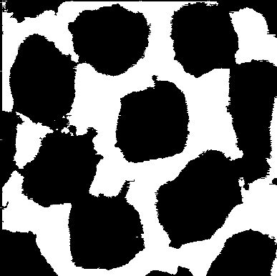

#### Figure: GAP Analysis for Poly_02_gap.png

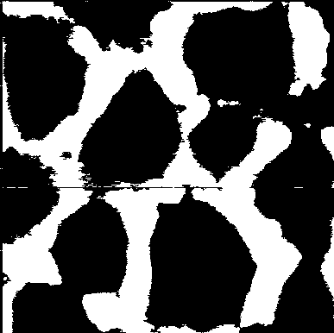

#### Figure: GAP Analysis for Poly_03_gap.png

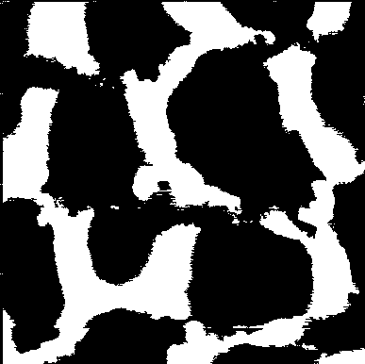

#### Figure: GAP Analysis for Poly_04_gap.png

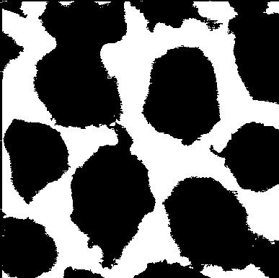

#### Figure: GAP Analysis for Poly_05_gap.png

