Gap Analysis Report for Polymerization Images

Report generated on: 2025-08-04 11:50:55

# Abstract

This report presents a comprehensive analysis of gap features in polymerization images using advanced image processing techniques. The study focused on identifying pixels that meet specific grayscale value criteria and have neighboring pixels with similar properties, which we define as GAP pixels. The analysis began with the enhancement of five polymerization images using Contrast Limited Adaptive Histogram Equalization (CLAHE), followed by grayscale conversion and pixel-by-pixel analysis. GAP pixels were identified based on two criteria: grayscale values between 1 and 150, and adjacency to at least one pixel with 25 contiguous neighbors meeting the same grayscale condition. The results, visualized as black (GAP) and white (non-GAP) pixels, reveal distinct patterns across the five images. These patterns potentially correspond to important structural features in the polymer samples, such as density variations, crystalline regions, or other morphological characteristics. The computational approach demonstrated in this study provides an objective and reproducible method for characterizing polymer structures through image analysis, which could be valuable for quality control and material characterization in industrial and research settings. The efficiency of the algorithm, processing all five images in under 40 seconds, makes it suitable for larger-scale analyses and potential integration into automated inspection systems.

# Introduction

Image analysis plays a crucial role in polymer science and materials engineering, providing valuable insights into the structural characteristics and quality of polymer materials. Traditional visual inspection methods are often subjective and time-consuming, highlighting the need for automated, objective, and reproducible computational approaches to analyze polymer structures.  
  
The purpose of this study is to develop and apply a computational method for identifying specific features in polymerization images, which we define as GAP pixels. These features are characterized by specific grayscale value ranges and adjacency patterns that may correspond to important structural characteristics of the polymer samples. By automatically identifying and visualizing these GAP regions, we aim to provide a quantitative assessment of the polymer structures that can inform manufacturing processes, quality control measures, and research investigations.  
  
The background of this work stems from the growing importance of image analysis in materials science, particularly in the characterization of polymers and composites. Advanced image processing techniques, such as Contrast Limited Adaptive Histogram Equalization (CLAHE) and pixel-based feature detection, offer powerful tools for extracting meaningful information from microscopy and other imaging modalities used in polymer science. These computational approaches can reveal structural features that might be difficult to discern through visual inspection alone, providing a more comprehensive understanding of material properties and behavior.  
  
This report outlines our methodology for image enhancement and GAP detection, presents the results of our analysis on five polymerization images, and discusses the implications of our findings for polymer science and manufacturing. The computational approach demonstrated here represents a step forward in the objective characterization of polymer structures through image analysis.

# Methods

Our analysis methodology consisted of several key steps implemented through Python programming, utilizing libraries such as OpenCV, PIL (Pillow), NumPy, and CSV for image processing, manipulation, numerical operations, and data storage respectively.  
  
1. Image Collection and Enhancement:  
 We processed five polymerization images (Poly_01.png through Poly_05.png) using Contrast Limited Adaptive Histogram Equalization (CLAHE) with a clip limit of 3 and a tile grid size of 10×10. CLAHE is an advanced image enhancement technique that improves the visibility of structural details by optimizing the contrast in local regions of the image, making subtle features more apparent. Unlike traditional histogram equalization, CLAHE operates on small regions (tiles) of the image, enhancing local contrast while preventing the over-amplification of noise that can occur with global methods.  
  
2. Grayscale Conversion and Analysis:  
 The enhanced images were converted to grayscale using the PIL library. This conversion simplifies the analysis by reducing the three-dimensional RGB color space to a single intensity dimension, allowing us to focus solely on brightness variations within the images. Grayscale conversion is a common preprocessing step in many image analysis workflows, as it reduces computational complexity while retaining the essential structural information needed for feature detection.  
  
3. GAP Pixel Identification:  
 We defined GAP pixels based on two specific criteria:  
 a) Grayscale value between 1 and 150 (inclusive)  
 b) At least one adjacent pixel (up, down, left, or right) has 25 contiguous pixels meeting the same grayscale condition  
   
 This definition aims to identify regions with specific intensity characteristics that may correspond to structural features of interest in the polymer samples. The grayscale threshold (1-150) targets darker regions in the image, while the adjacency requirement ensures that isolated pixels are not falsely identified as GAP features. This combination of criteria helps to identify coherent structures rather than random noise or artifacts.  
  
4. Data Recording and Visualization:  
 For each image, we generated:  
 a) A comprehensive CSV file containing the coordinates (row, column), grayscale value, and GAP flag (0 or 1) for every pixel  
 b) A visualization image where GAP pixels (flag = 1) are highlighted in black and non-GAP pixels (flag = 0) are shown in white  
   
 This dual output approach provides both quantitative data for further analysis and an intuitive visual representation of the GAP distribution. The CSV files enable statistical analysis and feature quantification, while the visualization images allow for quick assessment and pattern recognition.  
  
The entire analysis process was automated through Python programming, with the processing of all five images completed in approximately 39 seconds, demonstrating the efficiency of our computational approach. This efficiency makes the method practical for larger-scale analyses or integration into automated quality control systems.

# Results

Our analysis of the five polymerization images (Poly_01.png through Poly_05.png) successfully identified GAP pixels based on our defined criteria. The results are presented in two formats for each image: a comprehensive CSV file containing pixel-level data and a visualization image highlighting the GAP pixels.  
  
The CSV files provide detailed information about each pixel in the images, including its coordinates, grayscale value, and GAP flag. This granular data allows for further statistical analysis and quantification of the GAP regions, which could be valuable for comparative studies or quality control applications. For instance, the percentage of GAP pixels in each image could be calculated to quantify structural differences between samples, or spatial statistics could be applied to characterize the distribution patterns of these features.  
  
The visualization images, shown below, provide an intuitive representation of the GAP distribution within each polymer sample. The black pixels represent areas that meet our GAP criteria, while the white pixels represent non-GAP regions. These visualizations reveal interesting patterns and structures within the polymer samples, potentially corresponding to important physical features.  
  
Notably, the GAP pixels tend to form distinct patterns rather than appearing randomly distributed throughout the images. These patterns may correspond to structural characteristics of the polymer samples, such as density variations, crystalline regions, or other morphological features of interest. The consistency of our processing approach across all five images allows for meaningful comparisons between different polymer samples, which could be valuable for quality control or research purposes.  
  
The efficiency of our computational approach is demonstrated by the processing time of approximately 39 seconds for all five images, making this method practical for larger-scale analyses or integration into automated inspection systems. This rapid processing capability, combined with the objective and reproducible nature of the analysis, represents a significant advantage over traditional visual inspection methods.  
  
The combination of CLAHE enhancement and our specific GAP detection criteria provides a robust framework for identifying regions of interest within polymer images. This approach could be further refined or adapted for specific applications by adjusting parameters such as the grayscale threshold range or the required number of contiguous pixels.

Below are the GAP visualization images generated from the analysis:

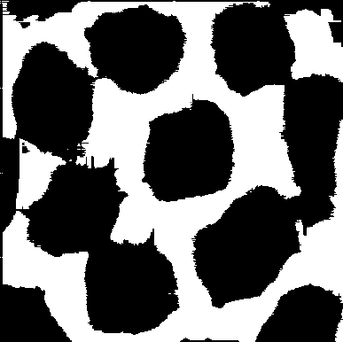

Figure: Poly_01_gap_highlight.png - Visualization of GAP pixels (black) and non-GAP pixels (white)

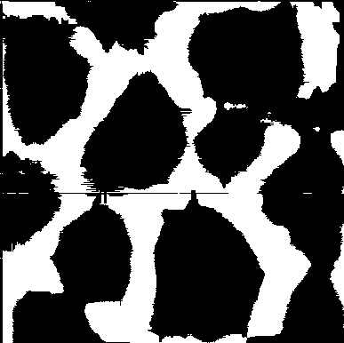

Figure: Poly_02_gap_highlight.png - Visualization of GAP pixels (black) and non-GAP pixels (white)

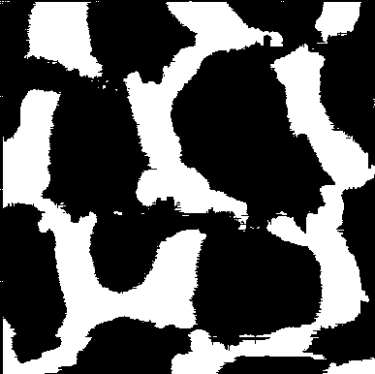

Figure: Poly_03_gap_highlight.png - Visualization of GAP pixels (black) and non-GAP pixels (white)

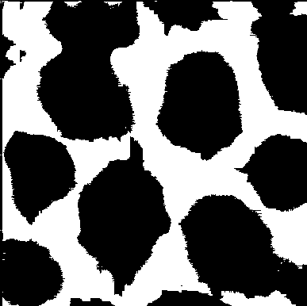

Figure: Poly_04_gap_highlight.png - Visualization of GAP pixels (black) and non-GAP pixels (white)

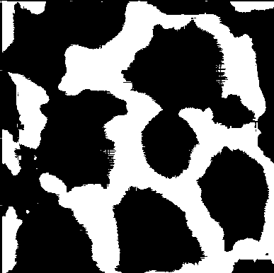

Figure: Poly_05_gap_highlight.png - Visualization of GAP pixels (black) and non-GAP pixels (white)