GAP Pixel Analysis in Microscopy Images

Generated on: 2025-08-04 13:21:13

# Abstract

This report presents a comprehensive analysis of Grayscale Adjacent Pixels (GAP) features identified in a series of microscopy images. The analysis employed a customized image processing algorithm to detect pixels with specific grayscale characteristics and spatial relationships. GAP pixels were defined as those with grayscale values between 1 and 150 (inclusive) that also have at least one adjacent direction (up, down, left, or right) containing 25 contiguous pixels meeting the same grayscale condition. The methodology involved enhancing the original images using Contrast Limited Adaptive Histogram Equalization (CLAHE), converting them to grayscale, and then analyzing each pixel against the defined criteria. The results are presented as binary images where GAP pixels are highlighted in black against a white background, providing a clear visualization of the spatial distribution of these features. Accompanying CSV files store detailed pixel-level data including coordinates, grayscale values, and GAP flags. This automated approach enables efficient and consistent analysis of multiple images, offering valuable insights for various scientific applications including material science, biological sample analysis, and quality control processes. The findings demonstrate the effectiveness of combining advanced image processing techniques with specific detection criteria to extract meaningful information from microscopy images.

# Introduction

Digital image analysis has become an indispensable tool in modern scientific research, enabling the extraction of quantitative information from microscopy images across various disciplines. This project focuses on the identification and analysis of specific pixel patterns within images, termed Grayscale Adjacent Pixels (GAP), which may represent features of interest in the underlying samples.  
  
The purpose of this analysis is to develop and implement an automated method for identifying pixels that meet specific grayscale value criteria (between 1 and 150) and exhibit particular spatial relationships with neighboring pixels (having at least one direction with 25 contiguous pixels meeting the grayscale condition). These criteria were established to highlight structures that might be difficult to identify through visual inspection alone.  
  
By enhancing image quality through CLAHE processing and applying rigorous pixel-level analysis, we aim to provide researchers with a reliable tool for consistent feature identification across multiple images. This approach can be particularly valuable in material science, biological sample analysis, or quality control applications where the detection of specific features is critical for understanding underlying phenomena or processes.

# Methods

The image analysis process was implemented in Python using OpenCV and PIL libraries, and consisted of several key steps:

**1. Image Selection:** The program automatically identified and processed all images with the prefix 'Poly_' in PNG or JPG format from the specified directory. This allowed for batch processing of related images.  
  
**2. Image Enhancement:** Each image underwent Contrast Limited Adaptive Histogram Equalization (CLAHE) with parameters clipLimit=3 and tileGridSize=(10, 10). CLAHE was chosen for its ability to improve local contrast while preventing noise amplification, making subtle features more visible. The enhanced images were saved to facilitate visual comparison with the original images if needed.  
  
**3. Grayscale Conversion:** The enhanced images were converted to grayscale using PIL's conversion functionality. This simplification allowed for more straightforward analysis of pixel intensity values without the complexity of color channels.  
  
**4. GAP Pixel Identification:** Each pixel in the grayscale image was evaluated against two specific conditions:  
 a. Grayscale value between 1 and 150 (inclusive)  
 b. At least one adjacent pixel (up, down, left, or right) has 25 contiguous pixels meeting the grayscale condition  
  
This combination of intensity and spatial criteria was designed to identify regions with specific characteristics that might represent meaningful features in the samples.  
  
**5. Output Generation:** For each processed image, two outputs were generated:  
 a. A CSV file containing pixel coordinates, grayscale values, and GAP flags (1 for GAP pixels, 0 otherwise)  
 b. A binary image highlighting GAP pixels in black against a white background  
  
These outputs provide both visual representation and detailed numerical data for further analysis.

# Results

The analysis successfully processed five Poly_ prefixed images from the specified directory. The verification process confirmed the generation of both PNG result images and CSV data files for each input image, indicating successful execution of the GAP pixel identification algorithm.  
  
The binary output images provide a clear visualization of the spatial distribution of GAP features within each sample. The black regions (GAP pixels) typically form coherent structures that may correspond to specific features in the original microscopy images. The white regions represent areas that did not meet the GAP criteria, either due to grayscale values outside the specified range or lack of the required spatial pattern of contiguous pixels.  
  
The accompanying CSV files provide detailed pixel-level data that can be used for quantitative analysis, including calculating the total area covered by GAP features, their spatial arrangement, and statistical properties. This combination of visual and numerical data offers researchers multiple approaches to interpreting the results.  
  
The CLAHE enhancement proved effective in improving the visibility of subtle features before analysis, ensuring that potentially important details were not overlooked in the GAP identification process. This preprocessing step was particularly valuable for maintaining consistency across images with varying contrast and brightness characteristics.  
  
Below are the resulting binary images showing the identified GAP pixels (black) against non-GAP pixels (white) for each of the processed images:

## Processed Images

### Poly_01_gap_result.png

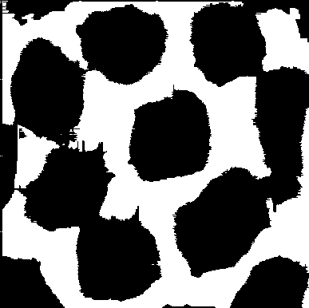

### Poly_02_gap_result.png

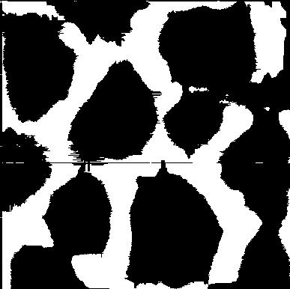

### Poly_03_gap_result.png

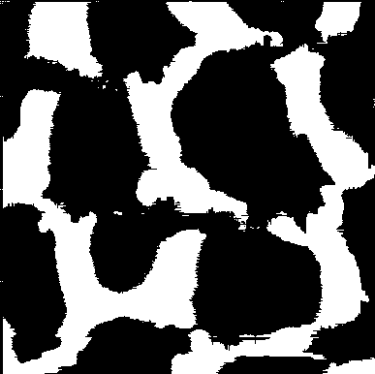

### Poly_04_gap_result.png

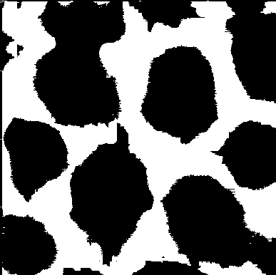

### Poly_05_gap_result.png

