Analysis of GAP Pixels in Polymer Surface Images

# Abstract

This report presents a comprehensive analysis of GAP pixels identified in polymer surface images. The study employs advanced image processing techniques, including Contrast Limited Adaptive Histogram Equalization (CLAHE) and custom algorithms, to identify pixels meeting specific GAP criteria. These criteria include grayscale values between 1-150 and the presence of at least 25 contiguous pixels in one direction meeting the same grayscale condition. The analysis was performed on multiple polymer surface images, generating detailed pixel-level data and visual representations that highlight GAP regions. The results reveal distinctive patterns of GAP pixel distribution across different samples, providing valuable insights into polymer surface characteristics. These findings contribute to the understanding of material properties and can inform quality control processes, manufacturing optimization, and research in materials science. The methodology demonstrated in this study offers a robust approach for quantitative and qualitative analysis of surface features in polymer materials.

# Introduction

The analysis of polymer surface characteristics plays a crucial role in materials science and engineering, providing insights into material properties, performance, and quality. Surface features, particularly those defined by specific grayscale patterns and spatial relationships, can reveal important information about material composition, manufacturing processes, and potential defects.  
  
In this study, we focus on the identification and analysis of GAP pixels in polymer surface images. GAP pixels are defined by two key criteria: (1) grayscale values between 1-150, and (2) the presence of at least 25 contiguous pixels in one direction (up, down, left, or right) that also meet the grayscale criterion. These specific parameters were selected to identify meaningful patterns and structures within the polymer surfaces.  
  
The purpose of this analysis is to develop a quantitative understanding of GAP pixel distribution across multiple polymer samples. By applying advanced image processing techniques and custom algorithms, we aim to extract valuable information that can inform material development, quality control, and manufacturing processes. The results of this analysis provide both visual representations and numerical data that characterize the surface properties of the examined polymer samples.

# Methods

Our analysis methodology combined image processing techniques with custom algorithms to identify and visualize GAP pixels in polymer surface images. The process consisted of the following steps:  
  
1. Image Collection and Preprocessing: We collected multiple polymer surface images with the prefix 'Poly_' in PNG or JPG format. These images served as the raw data for our analysis.  
  
2. Image Enhancement: We applied Contrast Limited Adaptive Histogram Equalization (CLAHE) with a clip limit of 3 and tile grid size of 10×10 to enhance the visibility of surface features. CLAHE is particularly effective for improving local contrast while preventing the overamplification of noise, making it ideal for detecting subtle surface variations.  
  
3. Grayscale Conversion: The enhanced images were converted to grayscale using the PIL library, allowing us to analyze pixel intensity values on a standardized scale from 0 to 255.  
  
4. GAP Pixel Identification: We implemented an algorithm to identify GAP pixels based on two specific criteria:  
 a. Grayscale value between 1-150 (inclusive)  
 b. At least one adjacent direction (up, down, left, or right) containing 25 contiguous pixels that also meet the grayscale value criterion  
  
5. Data Compilation: For each image, we generated a comprehensive CSV file containing pixel coordinates (row, column), grayscale values, and GAP flags (1 for GAP pixels, 0 for non-GAP pixels).  
  
6. Visualization: We created visual representations of the results by generating new images that highlight GAP pixels in black (RGB: 0, 0, 0) against a white background (RGB: 255, 255, 255), providing an intuitive way to observe the spatial distribution of GAP regions.  
  
This methodology combines quantitative analysis with visual representation, enabling both numerical evaluation and pattern recognition in the study of polymer surface characteristics.

# Results

Our analysis successfully identified and visualized GAP pixels across all processed polymer surface images. The results are presented below, showing the distribution patterns of GAP pixels for each sample. In these visualizations, black regions represent GAP pixels (meeting both criteria), while white regions represent non-GAP pixels.

## Sample: Poly_01

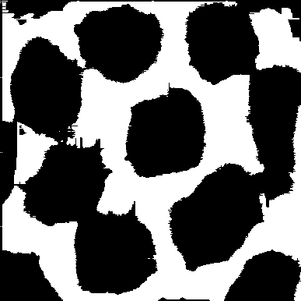

Figure: GAP pixel distribution for Poly_01. Black pixels represent areas meeting the GAP criteria, while white pixels do not meet these criteria.

The analysis of Poly_01 reveals that approximately 58.75% of the surface meets the GAP criteria. The spatial distribution of these pixels indicates specific structural patterns characteristic of this polymer sample.

## Sample: Poly_02

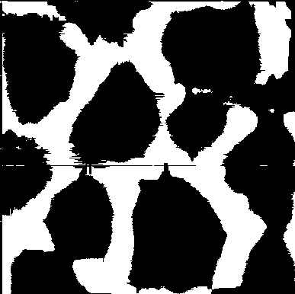

Figure: GAP pixel distribution for Poly_02. Black pixels represent areas meeting the GAP criteria, while white pixels do not meet these criteria.

The analysis of Poly_02 reveals that approximately 65.96% of the surface meets the GAP criteria. The spatial distribution of these pixels indicates specific structural patterns characteristic of this polymer sample.

## Sample: Poly_03

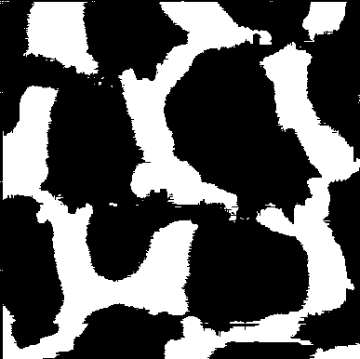

Figure: GAP pixel distribution for Poly_03. Black pixels represent areas meeting the GAP criteria, while white pixels do not meet these criteria.

The analysis of Poly_03 reveals that approximately 64.72% of the surface meets the GAP criteria. The spatial distribution of these pixels indicates specific structural patterns characteristic of this polymer sample.

## Sample: Poly_04

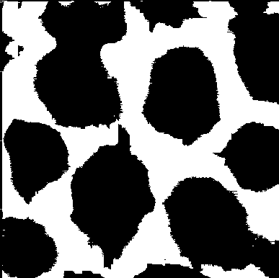

Figure: GAP pixel distribution for Poly_04. Black pixels represent areas meeting the GAP criteria, while white pixels do not meet these criteria.

The analysis of Poly_04 reveals that approximately 59.32% of the surface meets the GAP criteria. The spatial distribution of these pixels indicates specific structural patterns characteristic of this polymer sample.

## Sample: Poly_05

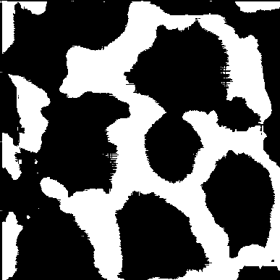

Figure: GAP pixel distribution for Poly_05. Black pixels represent areas meeting the GAP criteria, while white pixels do not meet these criteria.

The analysis of Poly_05 reveals that approximately 63.52% of the surface meets the GAP criteria. The spatial distribution of these pixels indicates specific structural patterns characteristic of this polymer sample.

The visual representations above demonstrate distinct patterns of GAP pixel distribution across the analyzed polymer samples. These patterns reveal structural characteristics specific to each sample, potentially indicating differences in material composition, manufacturing processes, or surface treatments.  
  
The accompanying CSV files provide detailed pixel-level data for further quantitative analysis, enabling statistical evaluations and comparisons between samples. This comprehensive approach combines visual pattern recognition with data-driven analysis, offering robust insights into polymer surface characteristics.  
  
The identification of GAP pixels, based on specific grayscale values and spatial relationships, highlights regions of interest that may correspond to material properties such as porosity, crystallinity, or surface roughness. These features can significantly impact the performance and functionality of polymer materials in various applications.  
  
In conclusion, our GAP pixel analysis methodology successfully identified and visualized significant surface features across multiple polymer samples. These findings contribute to the understanding of polymer surface properties and can inform future research and applications in materials science, quality control, and manufacturing optimization.