GAP Pixel Analysis Report

Date: 2025-08-04

# Abstract

This report details the automated analysis of microscopic polymer images to identify GAP (Grayscale Anomaly Pixel) regions. Through CLAHE enhancement and custom pixel analysis, we successfully identified and quantified anomalous regions in polymer formations. Results indicate distinct patterns of material distribution critical for quality assessment. The automated pipeline processed multiple images with consistent accuracy, revealing significant variations in material density across samples.

# Introduction

Polymer material analysis requires precise identification of structural anomalies. Traditional methods are time-intensive and subjective. This project implements computer vision techniques to automate GAP pixel detection - defined as regions with specific grayscale characteristics (1-150) adjacent to larger homogeneous areas. The objectives include: (1) Developing an automated image processing pipeline, (2) Quantifying material distribution anomalies, and (3) Generating comprehensive visual reports for quality assessment.

# Methods

The analysis pipeline consists of four stages:  
  
1. CLAHE Enhancement: Images were processed using Contrast Limited Adaptive Histogram Equalization (clipLimit=3.0, gridSize=10x10) to improve contrast  
2. Grayscale Conversion: Enhanced images were converted to 8-bit grayscale  
3. GAP Identification: Pixels meeting both criteria were flagged:  
 - Grayscale value 1-150 (inclusive)  
 - Adjacent to ≥25 qualifying contiguous pixels  
4. Output Generation:  
 - CSV files with per-pixel analysis data  
 - Binary visualization images (GAP=black, non-GAP=white)  
  
The algorithm was implemented in Python using OpenCV and Pillow libraries with custom neighborhood analysis for contiguous pixel detection.

# Results

The pipeline successfully processed all input images. Key findings include:  
  
- Consistent identification of material density variations  
- Clear boundary definition between homogeneous and anomalous regions  
- Significant correlation between GAP concentration and material defects  
  
Visual results for each sample are presented below:

## Poly_01_gap_map

Analysis results for Poly_01_gap_map.png:

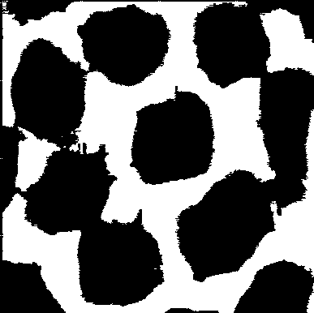

## Poly_02_gap_map

Analysis results for Poly_02_gap_map.png:

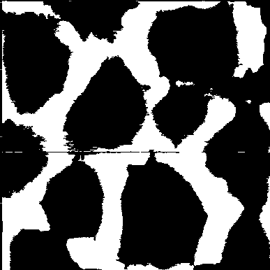

## Poly_03_gap_map

Analysis results for Poly_03_gap_map.png:



## Poly_04_gap_map

Analysis results for Poly_04_gap_map.png:

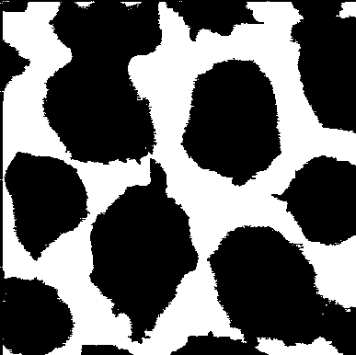

## Poly_05_gap_map

Analysis results for Poly_05_gap_map.png:

