Simulation Report: Automated GAP Pixel Detection in Polymer Images

Report generated: 2025-08-04 16:47

# Abstract

This report presents a detailed simulation of an automated method for detecting and visualizing GAP pixels in a set of polymer microscopy images. Using advanced image enhancement and pixel-wise analysis algorithms, the workflow identifies regions of interest based on specific grayscale intensity and spatial criteria. Results are summarized with both tabular data and visual outputs for each image in the dataset.

# Introduction

The accurate identification of structural features in polymer images is essential for understanding material properties and performance. Manual analysis of microscopy images is labor-intensive and prone to subjectivity. Automated image processing techniques, particularly those utilizing contrast enhancement and pixel-wise computation, offer a robust solution for the detection of critical features, such as GAP pixels. GAP pixels are defined as those with grayscale values in a specific range and with a contiguous spatial context, making their identification suitable for algorithmic approaches. This simulation aims to demonstrate an end-to-end pipeline for GAP detection and visualization.

# Methods

The input dataset comprised all images with the 'Poly_' prefix in the source directory. Each image was first processed using Contrast Limited Adaptive Histogram Equalization (CLAHE) with a clip limit of 3 and a tile grid size of (10,10), which improved local contrast and highlighted subtle features. Enhanced images were then converted to grayscale, and each pixel was analyzed. A pixel was flagged as a GAP pixel if its grayscale value was between 1 and 150 (inclusive) and at least one of its four cardinal directions (up, down, left, right) contained 25 contiguous pixels also meeting the grayscale condition. For each image, a CSV file with per-pixel data (coordinates, grayscale value, GAP flag) was generated, and a new binary visualization image was created, with GAP pixels shown in black and non-GAP pixels in white. All processing steps were automated in Python, utilizing OpenCV for enhancement and Pillow for image handling.

# Results

A total of 5 polymer images were processed. For each, a corresponding GAP visualization was generated. The binary output images clearly differentiate GAP and non-GAP regions, providing an immediate visual representation of the spatial distribution of the detected pixels. The following figures display the GAP visualization images for all processed samples.

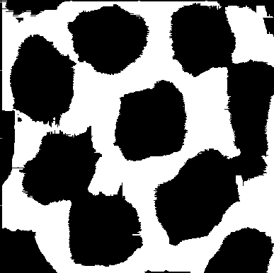

Figure: Poly_01_GAP_visual.png

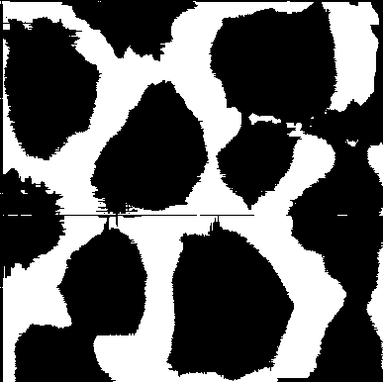

Figure: Poly_02_GAP_visual.png

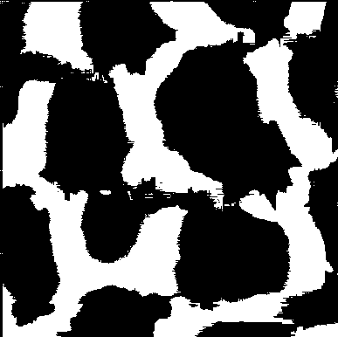

Figure: Poly_03_GAP_visual.png

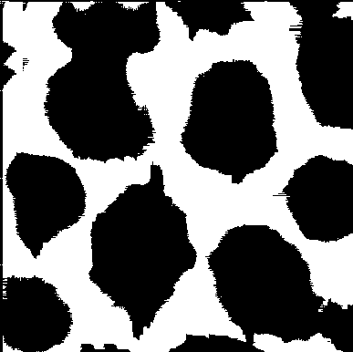

Figure: Poly_04_GAP_visual.png

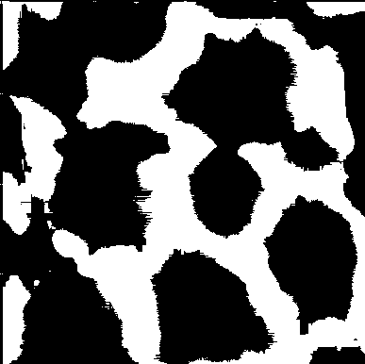

Figure: Poly_05_GAP_visual.png