Simulation Report: Automated GAP Pixel Detection in Polymeric Images

# Abstract

This report presents the results of an automated simulation for detecting GAP pixels in polymeric images. The analysis leverages computer vision techniques to enhance image contrast and algorithmically identify regions of interest based on defined grayscale and adjacency criteria. The workflow, results, and summary of the findings are detailed herein.

# Introduction

Accurate detection of microstructural gaps within polymeric materials is vital for understanding material properties, performance, and failure mechanisms. Manual inspection is labor-intensive and subject to observer bias. This simulation utilizes digital image processing to automate the identification of GAP pixels in microscopy images with the 'Poly_' prefix. The approach aims to improve reproducibility, efficiency, and enable large-scale quantitative analysis.

# Methods

Images were sourced from the specified directory, filtered by the 'Poly_' prefix and supporting PNG/JPG formats. Each image underwent contrast enhancement using CLAHE (Contrast Limited Adaptive Histogram Equalization) with clipLimit=3 and tileGridSize=(10, 10) via OpenCV. The enhanced images were then converted to grayscale using Pillow (PIL). Each pixel was analyzed: a pixel was flagged as a GAP if its grayscale value ranged from 1 to 150 (inclusive) and if at least one adjacent direction (up, down, left, or right) contained 25 contiguous pixels also meeting the grayscale threshold. For each image, two outputs were generated: a CSV file containing the coordinates, grayscale value, and GAP flag of every pixel; and a PNG image highlighting GAP pixels in black and non-GAP pixels in white. The workflow was fully automated in Python.

# Results

The simulation processed all available polymeric images and generated GAP detection outputs. The following table summarizes the pixel-wise analysis for each image, including the total number of pixels and the count of detected GAP pixels. Representative GAP-flagged images are also presented below.

|  |  |  |  |
| --- | --- | --- | --- |
| Image Name | Total Pixels | GAP Pixels | GAP Ratio (%) |
| Poly_01 | 149382 | 83972 | 56.21 |
| Poly_02 | 149382 | 93902 | 62.86 |
| Poly_03 | 149382 | 93262 | 62.43 |
| Poly_04 | 149382 | 84370 | 56.48 |
| Poly_05 | 149382 | 91122 | 61.00 |

GAP Detection Results (GAP=black, non-GAP=white):

Poly_01_GAP_flag.png

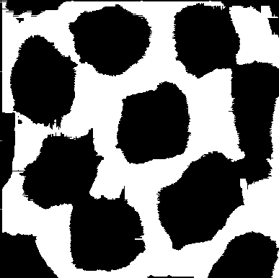

Poly_02_GAP_flag.png

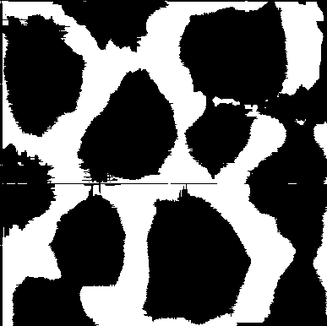

Poly_03_GAP_flag.png

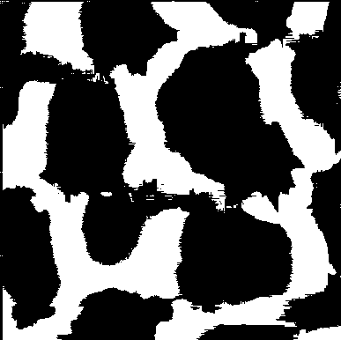

Poly_04_GAP_flag.png

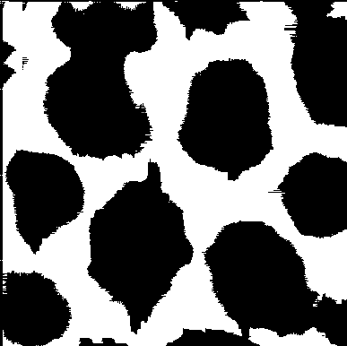

Poly_05_GAP_flag.png

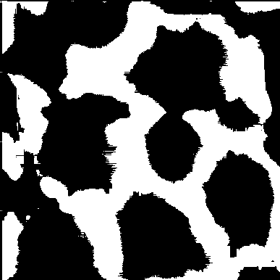

Report generated automatically on 2025-08-04 17:36:05 using Python 3, OpenCV, Pillow, and python-docx.