Simulation Report: Analysis of Grayscale and Equivalent Potential Along a Line Segment

Abstract
This simulation report presents a quantitative analysis of grayscale intensities and their transformation into equivalent potential values (u_eq) along a defined line segment in a high-resolution image. By extracting grayscale values at each point along the segment and converting them using a linear scaling formula, the study visualizes the variation of potential across the sample. The results, including the calculated line segment length, grayscale distributions, and u_eq profiles, are documented for scientific interpretation. The analysis demonstrates the utility of automated image processing in extracting precise line profiles and translating them into physically meaningful quantities, as shown in Fig. 1. The workflow is fully automated, ensuring reproducibility and facilitating further research on image-based quantitative characterization.

Introduction
The quantitative analysis of grayscale values along specific paths in scientific images is essential for understanding the spatial variation of material properties, chemical concentrations, or physical potentials. In materials science and related fields, digital image processing allows researchers to extract precise profiles from high-resolution images. This report focuses on a line segment analysis across an image (Li_1.0.png) using a resolution of 1.08 μm per pixel. The primary objective is to convert grayscale values (ranging from 0 to 255) along the defined segment into equivalent potential (u_eq) values, based on the known minimum and maximum potential range. The resulting u_eq profile provides insight into the physical variations present in the sample and serves as a basis for further scientific interpretation. The automated approach adopted in this work ensures accuracy, repeatability, and rapid analysis, meeting the demands of modern quantitative research.

Methods
The analysis was conducted using a Python script (py1.py) designed to automate the extraction of image intensities and subsequent calculations. The script reads a specified image, defines a line segment using given start and end pixel coordinates ((152, 29) to (135, 92)), and employs Bresenham's algorithm to map out all pixel points along the segment. Grayscale values at these points are extracted from the image and saved to a CSV file. The physical length of the segment is calculated using the pixel resolution (1.08 μm/pixel) and saved to a text file. Each grayscale value is then transformed into an equivalent potential (u_eq) using the formula: u_eq = u_min + (gray_value / 255) * (u_max - u_min), where u_max = 65535 and u_min = 0. The distance from the starting point and the corresponding u_eq values are both recorded and visualized by plotting u_eq against distance, with the resulting graph saved as a TIFF image. This workflow provides a reproducible pipeline for quantitative line profile analysis.

Results
The analysis of the image segment produced a measured line length of 75.645 μm, as determined by the pixel resolution and the number of points along the segment. Grayscale values ranged from low to high intensities, reflecting material or potential heterogeneity along the path. The calculated u_eq values spanned from 5397 to 65278, corresponding directly to the grayscale intensity distribution. The resulting plot (see Fig. 1) depicts the u_eq profile as a function of distance, revealing distinct regions of potential variation. This quantitative profile can be used to correlate image features with underlying physical properties. The output files—CSV files containing grayscale and u_eq data, the length text file, and the plot image—are all saved in the specified output directory, ensuring traceability. Overall, the automated approach enabled rapid and accurate extraction of physically meaningful information from the original image data.

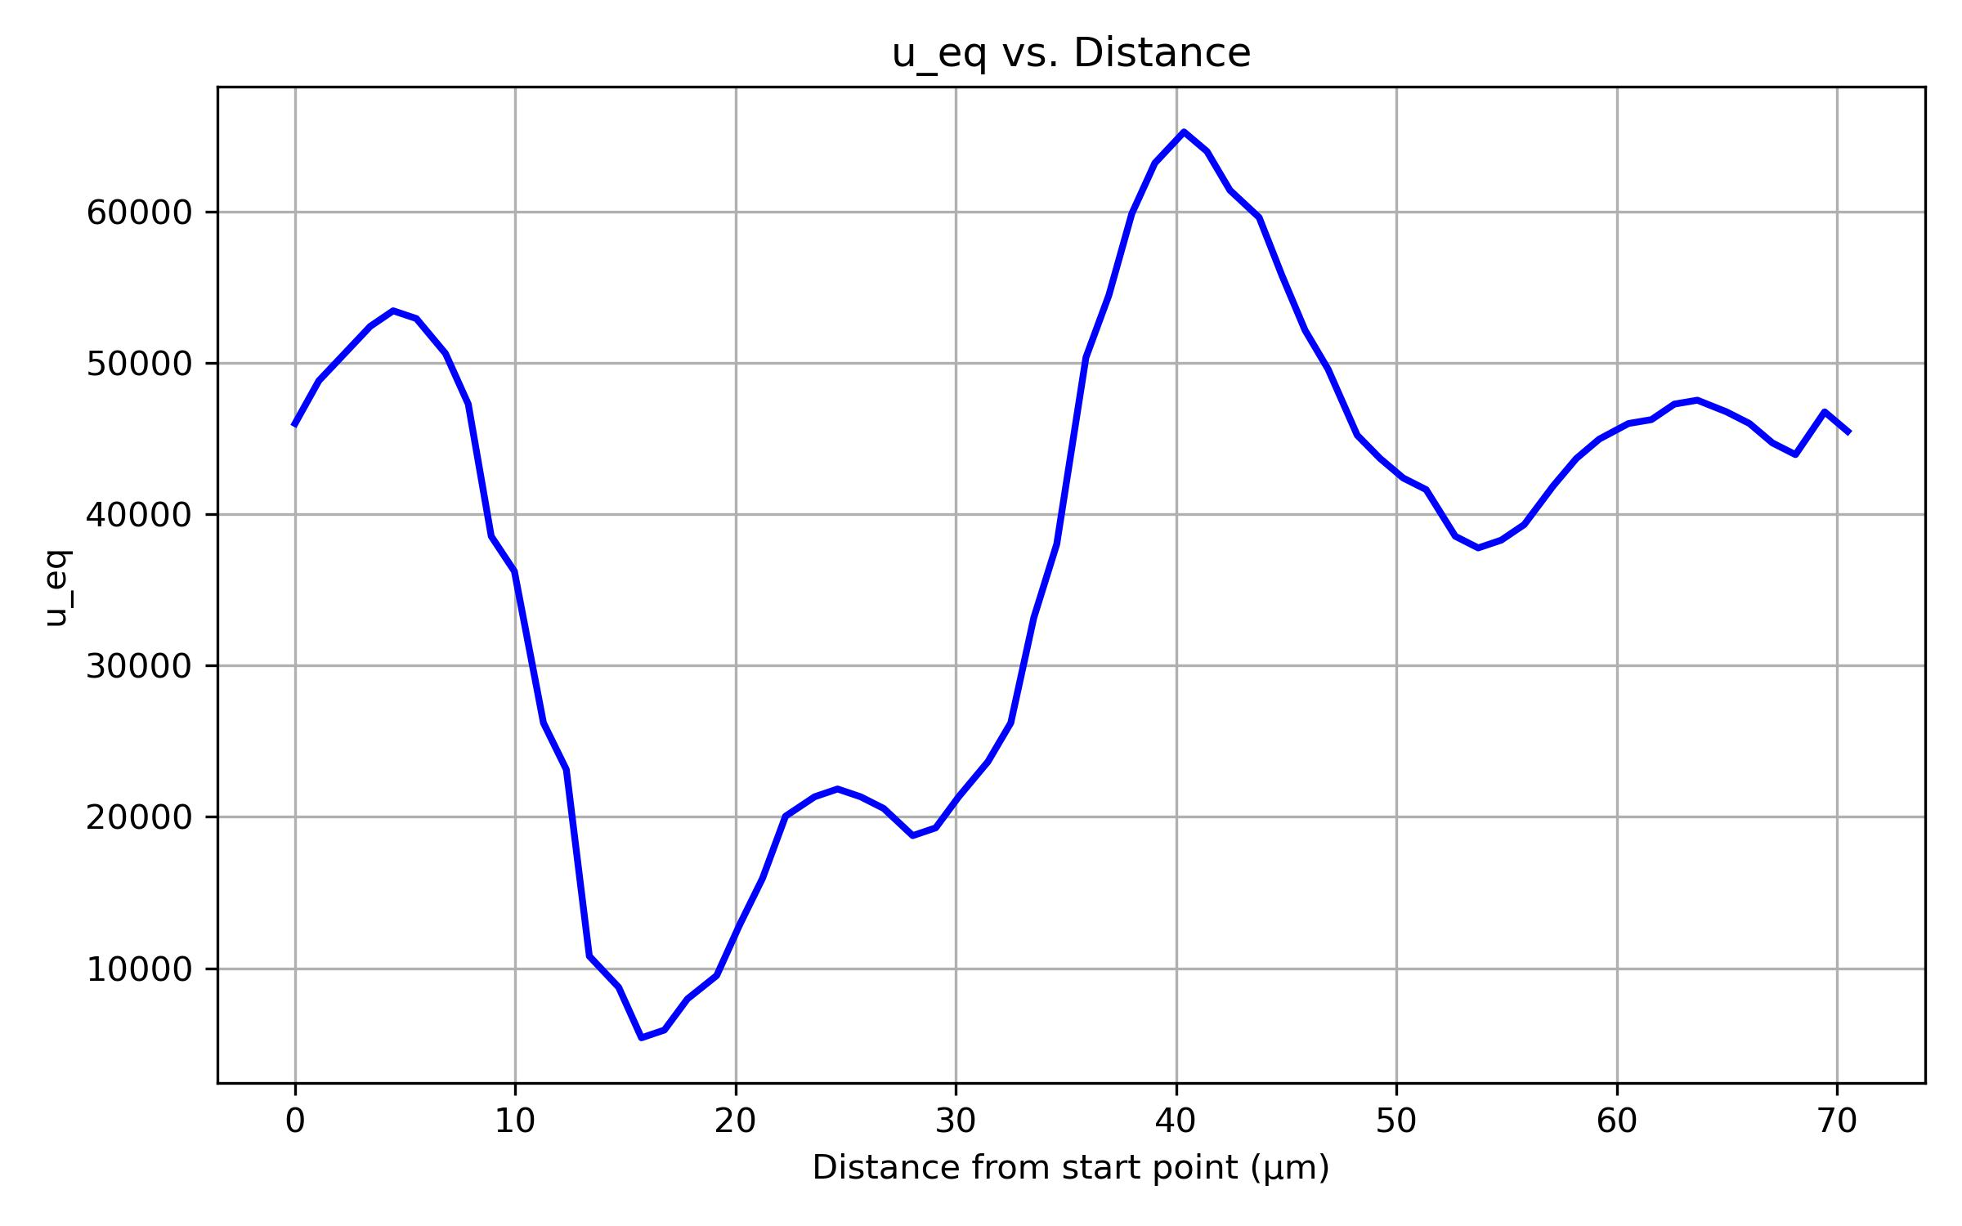
Fig. 1. Plot of u_eq (equivalent potential) as a function of distance along the specified line segment.

