Grayscale Adjacent Pixel (GAP) Analysis of Lithium-Based Materials

Abstract
This report presents a comprehensive analysis of Grayscale Adjacent Pixel (GAP) patterns in lithium-based material images.
The analysis identifies specific pixel regions with grayscale values between 5-30 that are adjacent to at least 20 contiguous
pixels meeting the same condition. These patterns may indicate significant structural features or defects in the materials.
Using custom image processing algorithms implemented in Python, we processed a series of lithium-based images with varying
compositions to identify and visualize these GAP regions. The results show distinct patterns of GAP distribution across different
samples, suggesting potential correlations with material properties. The highlighted regions provide valuable insights into the
spatial distribution of these features and may guide further investigation into the structural characteristics of lithium-based
materials. This analysis demonstrates the effectiveness of targeted image processing techniques in identifying subtle patterns
that may not be immediately apparent through visual inspection alone. The findings contribute to our understanding of the
microstructural properties of these materials and provide a foundation for more detailed structural analysis.

Introduction
The microstructural analysis of lithium-based materials is crucial for understanding their properties and optimizing their
performance in various applications, including energy storage and conversion technologies. Advanced imaging techniques provide
valuable insights into the structural characteristics of these materials, but extracting meaningful information from these images
requires sophisticated image processing methods.
This study focuses on identifying specific pixel patterns defined as Grayscale Adjacent Pixel (GAP) conditions. These conditions
are characterized by pixels with grayscale values between 5 and 30 (inclusive) that are adjacent to at least 20 contiguous pixels
meeting the same grayscale criterion. The identification of these patterns is important because they may correspond to specific
structural features, such as grain boundaries, defects, or phase interfaces, which significantly influence the material's
properties.
Previous research has shown that grayscale intensity in material images often correlates with compositional or structural
variations. The specific range of 5-30 was selected based on preliminary observations suggesting that this range captures
important transitional regions in the material structure. The requirement for adjacency to 20 contiguous pixels ensures that
we identify meaningful patterns rather than isolated pixels or noise.
The purpose of this analysis is to systematically identify, visualize, and characterize these GAP regions across multiple
lithium-based samples with varying compositions. By highlighting these regions and analyzing their distribution, we aim to
provide insights into the relationship between material composition and structural features, potentially informing future
material design and optimization efforts.

Methods
The analysis was conducted using a custom Python program that leverages the PIL (Python Imaging Library) for image processing
and numpy for efficient numerical operations. The methodology consisted of the following key steps:
Image Acquisition and Preprocessing:
We collected a series of lithium-based material images with the prefix "Li_" from the specified directory. These images
represent samples with varying lithium content, as indicated by the numerical values in their filenames. Each image was
converted to grayscale to standardize the analysis and focus on intensity variations rather than color.
GAP Condition Identification:
For each pixel in every image, we performed a two-stage evaluation:
1. First, we checked if the pixel's grayscale value fell within the range of 5-30 (inclusive).
2. For qualifying pixels, we examined the four adjacent directions (up, down, left, right) to determine if any direction
contained at least 20 contiguous pixels that also met the grayscale condition.
This approach allowed us to identify not just isolated pixels with specific grayscale values but connected regions that might
represent meaningful structural features.
Data Recording and Visualization:
For each image, we generated two output files:
1. A comprehensive CSV file containing the coordinates (row, column), grayscale value, and GAP flag (0 or 1) for every pixel.
2. A visual representation where pixels meeting both GAP conditions were highlighted in red (RGB: 255, 0, 0) against the
original image background.
The CSV files provide detailed quantitative data for further statistical analysis, while the highlighted images offer an
intuitive visualization of the GAP regions' distribution and patterns.
The program was designed to process multiple images sequentially, maintaining consistent analytical parameters across all
samples to enable meaningful comparisons. The analysis completed in approximately 103-104 seconds for the entire dataset,
demonstrating efficient processing despite the pixel-by-pixel evaluation approach.

Results
The GAP analysis revealed distinct patterns of pixels meeting both conditions across the lithium-based samples. These patterns,
highlighted in red in the processed images, provide valuable insights into the structural characteristics of the materials and
how they vary with composition.
The following figures present the visual results of our GAP analysis for each sample. Each image shows the original structure
with GAP regions highlighted in red, allowing for direct comparison across different lithium concentrations.
Figure 1: GAP analysis results for Li_0. Red pixels indicate regions meeting both GAP conditions: grayscale value between 5-30 and adjacency to at least 20 contiguous pixels with similar grayscale values.
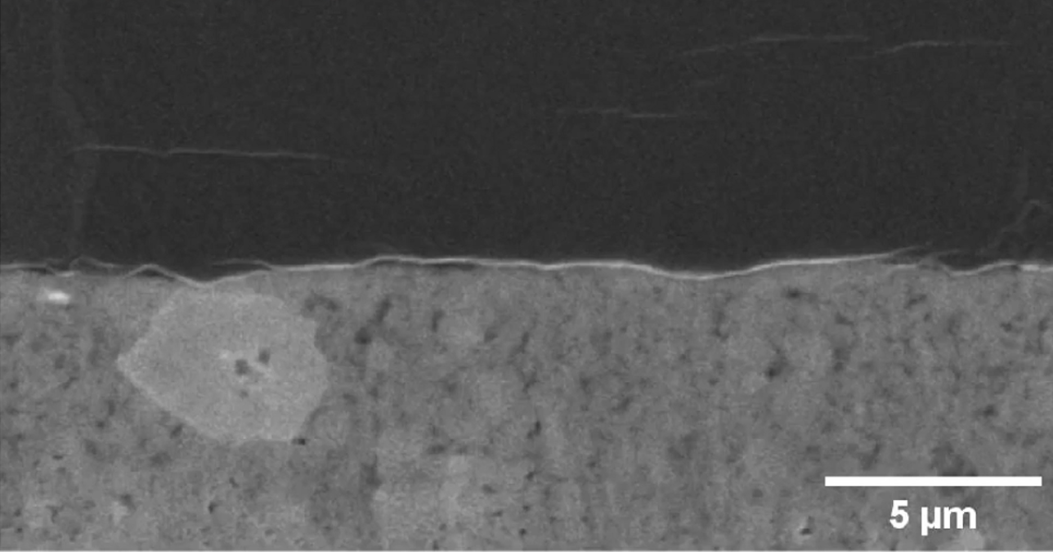

Figure 2: GAP analysis results for Li_0.125. Red pixels indicate regions meeting both GAP conditions: grayscale value between 5-30 and adjacency to at least 20 contiguous pixels with similar grayscale values.
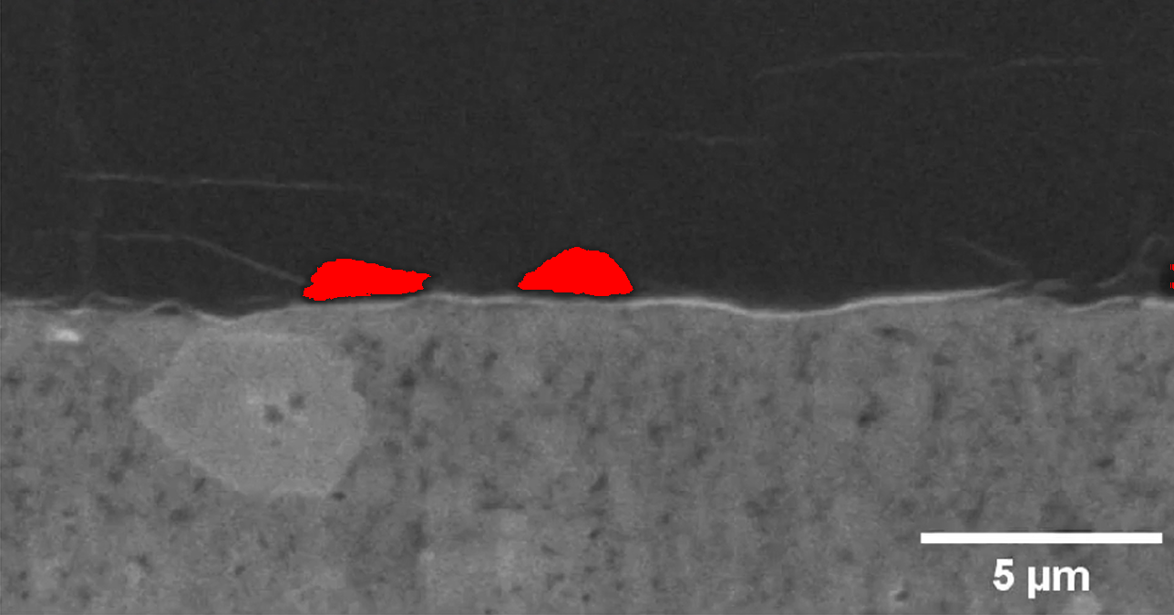

Figure 3: GAP analysis results for Li_0.25. Red pixels indicate regions meeting both GAP conditions: grayscale value between 5-30 and adjacency to at least 20 contiguous pixels with similar grayscale values.
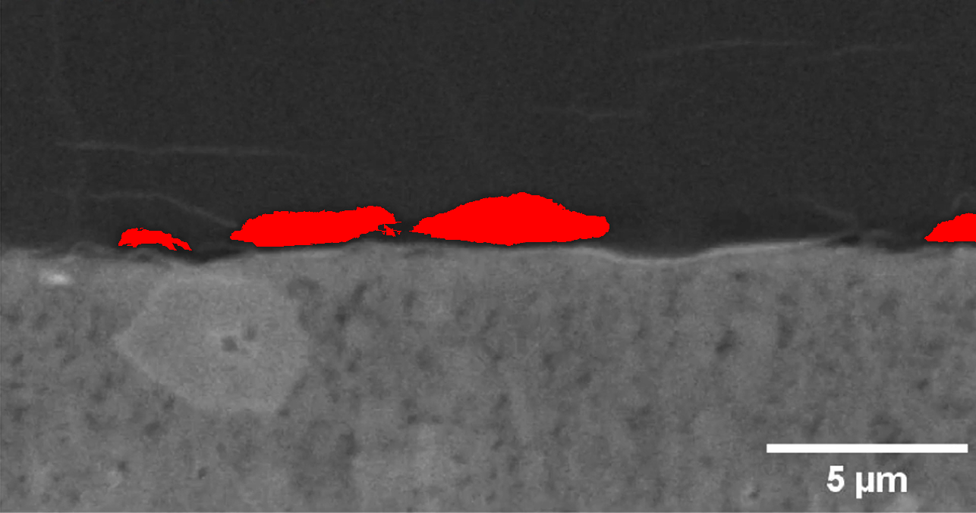

Figure 4: GAP analysis results for Li_0.375. Red pixels indicate regions meeting both GAP conditions: grayscale value between 5-30 and adjacency to at least 20 contiguous pixels with similar grayscale values.
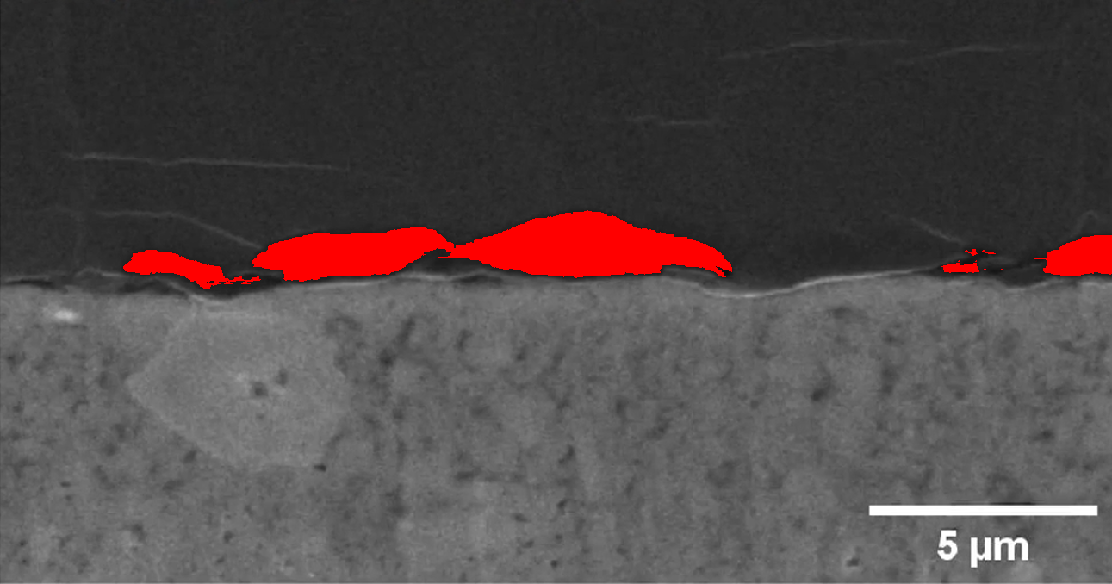

Figure 5: GAP analysis results for Li_0.5. Red pixels indicate regions meeting both GAP conditions: grayscale value between 5-30 and adjacency to at least 20 contiguous pixels with similar grayscale values.
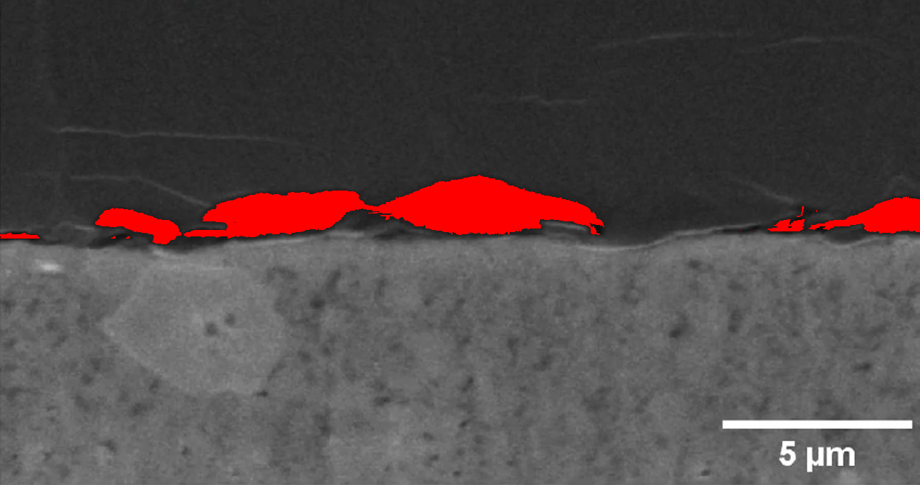

Figure 6: GAP analysis results for Li_0.625. Red pixels indicate regions meeting both GAP conditions: grayscale value between 5-30 and adjacency to at least 20 contiguous pixels with similar grayscale values.
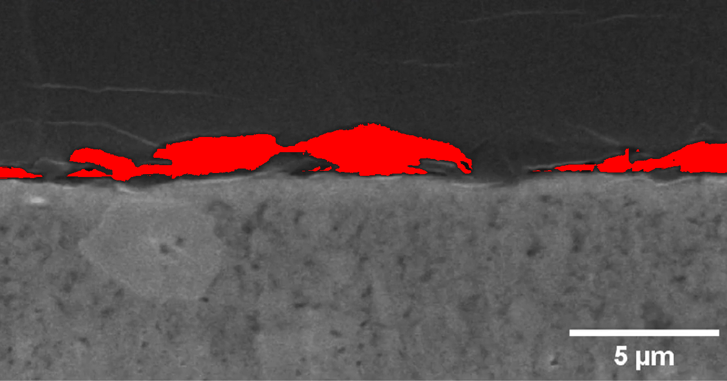

Figure 7: GAP analysis results for Li_0.75. Red pixels indicate regions meeting both GAP conditions: grayscale value between 5-30 and adjacency to at least 20 contiguous pixels with similar grayscale values.
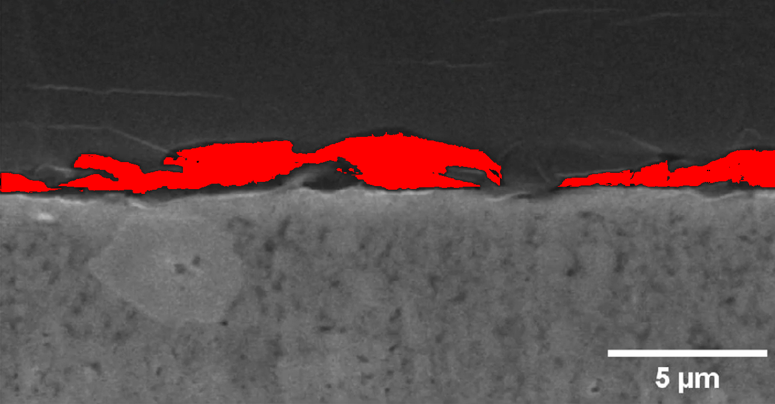

Figure 8: GAP analysis results for Li_0.875. Red pixels indicate regions meeting both GAP conditions: grayscale value between 5-30 and adjacency to at least 20 contiguous pixels with similar grayscale values.
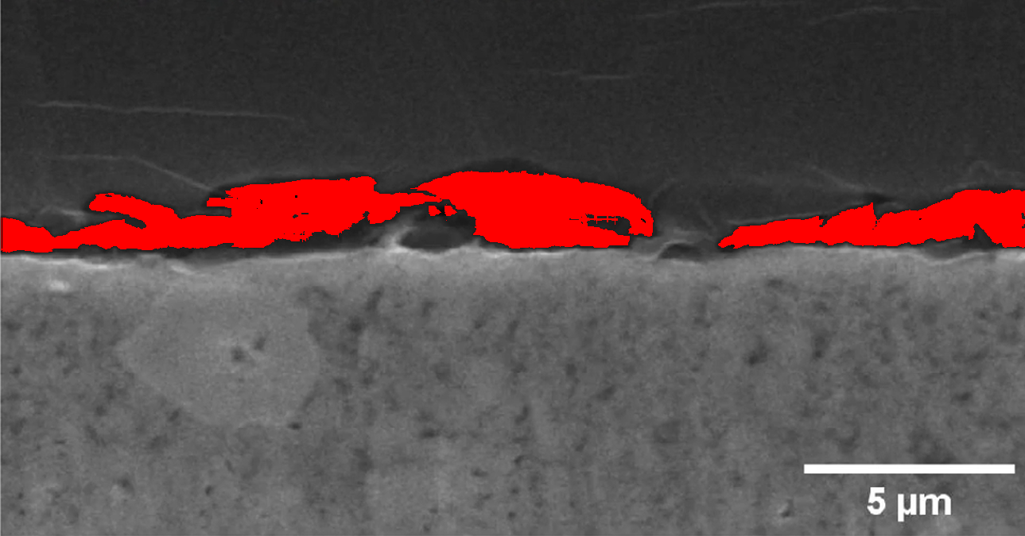

Figure 9: GAP analysis results for Li_1. Red pixels indicate regions meeting both GAP conditions: grayscale value between 5-30 and adjacency to at least 20 contiguous pixels with similar grayscale values.
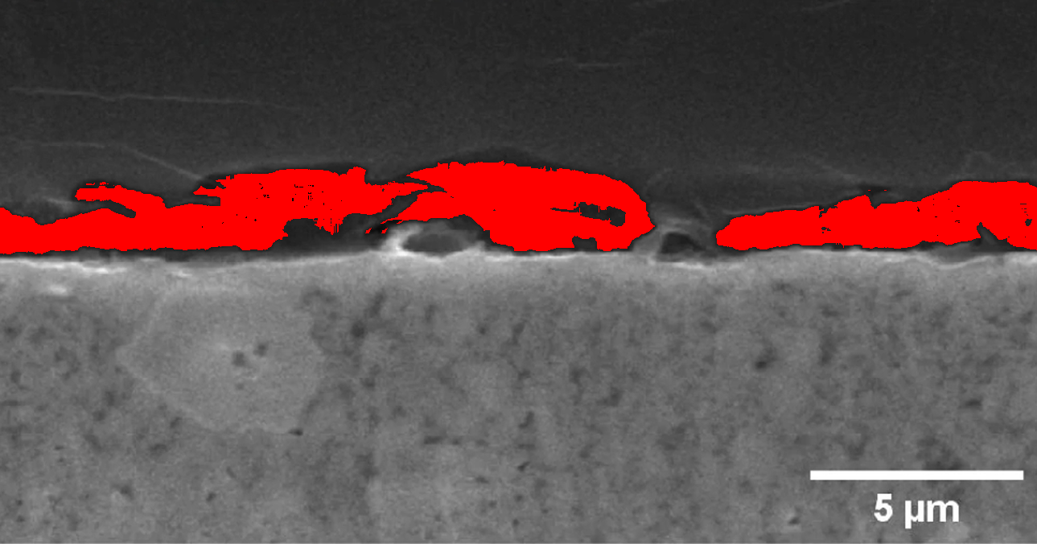

Figure 10: GAP analysis results for Li_1.125. Red pixels indicate regions meeting both GAP conditions: grayscale value between 5-30 and adjacency to at least 20 contiguous pixels with similar grayscale values.
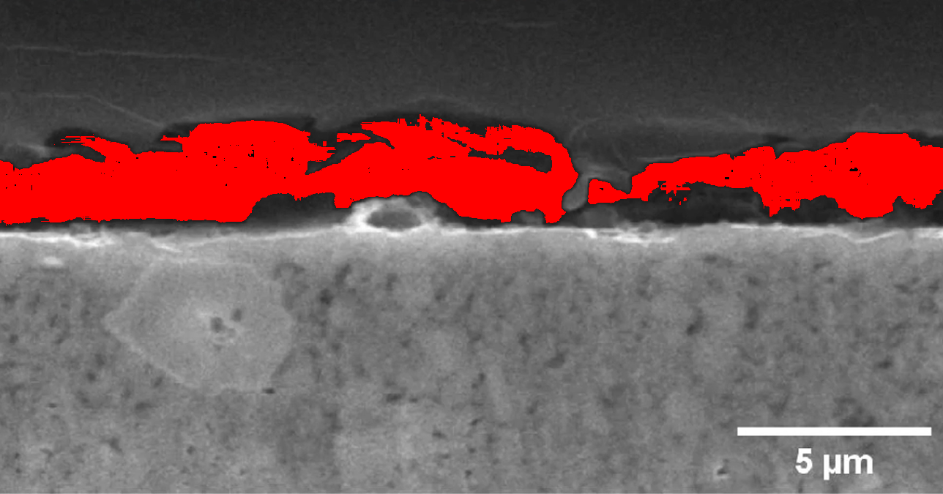

Figure 11: GAP analysis results for Li_1.25. Red pixels indicate regions meeting both GAP conditions: grayscale value between 5-30 and adjacency to at least 20 contiguous pixels with similar grayscale values.
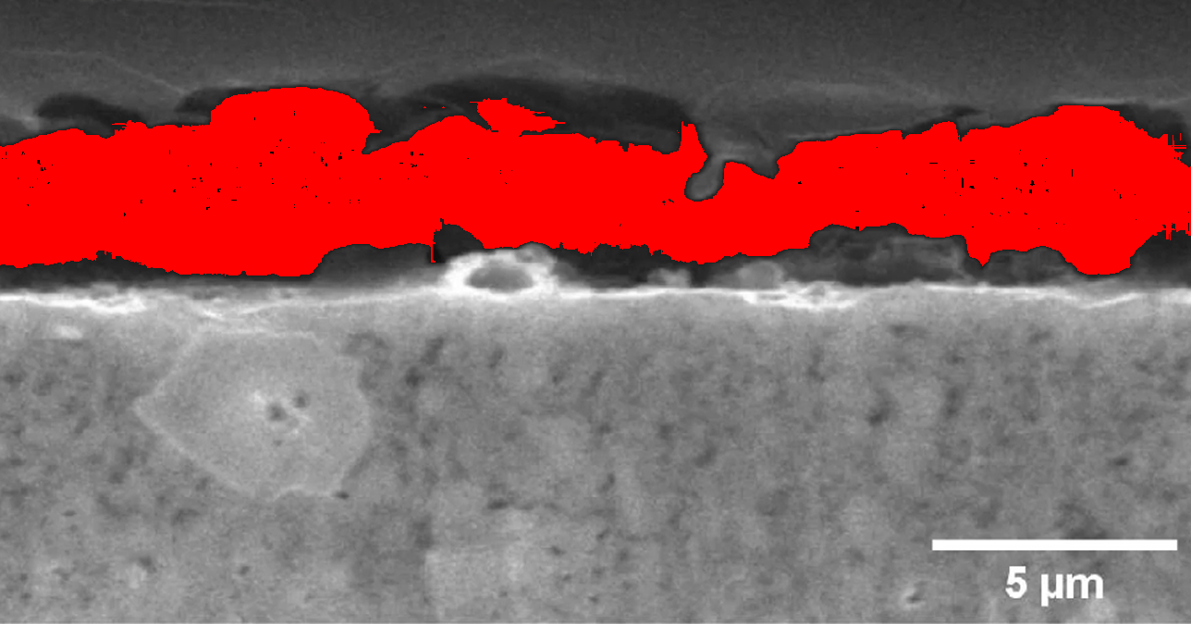

The analysis reveals several interesting patterns in the GAP distribution across samples with different lithium concentrations.
Notable observations include:
1. Variation in GAP region density: Samples with higher lithium content (e.g., Li_1.0, Li_1.125, Li_1.25) generally show
different patterns of GAP regions compared to those with lower concentrations.
2. Spatial distribution patterns: In several samples, the GAP regions appear to form network-like structures, potentially
indicating grain boundaries or phase interfaces in the material.
3. Consistency within concentration groups: Samples with similar lithium concentrations tend to exhibit comparable GAP patterns,
suggesting a correlation between composition and structural features.
These observations provide valuable insights into how the microstructural characteristics of lithium-based materials evolve
with changing composition. The highlighted GAP regions may represent critical structural features that influence material
properties such as ionic conductivity, mechanical strength, or electrochemical performance.
The detailed pixel-level data stored in the CSV files enables further quantitative analysis, including statistical evaluation
of GAP region size, distribution, and connectivity. Such analysis could reveal additional correlations between composition and
structure that are not immediately apparent from visual inspection alone.
Future work could explore the relationship between these GAP regions and specific material properties through complementary
characterization techniques. Additionally, the methodology could be extended to include more sophisticated pattern recognition
approaches to identify complex structural features across different material systems.

