SEM Image Gap Analysis Report

Abstract
This report presents a comprehensive analysis of micro-scale gap detection in SEM images using advanced image processing techniques. The study focused on identifying gap regions in lithium material surfaces through pixel-level analysis of grayscale values and continuity characteristics. Our methodology successfully identified and quantified gap regions across multiple samples, with validation results showing significant variations in gap heights corresponding to material processing conditions.

Introduction
Background: Material surface analysis is critical for quality control in battery manufacturing. Scanning Electron Microscopy (SEM) provides high-resolution images that reveal micro-scale surface characteristics essential for evaluating material integrity. Gap detection in these images helps identify potential failure points that affect battery performance and longevity.

Purpose: This study aims to develop an automated pipeline for detecting and quantifying micro-scale gaps in SEM images. The analysis focuses on establishing correlations between observable gap characteristics and material processing parameters to enable predictive quality assessment.

Methods

Image Processing Pipeline
- Input Preparation: Loaded Li_ prefix images in PNG/JPG format from designated directory
- Grayscale Conversion: Converted RGB images to 8-bit grayscale using Pillow's convert('L')
- Gap Pixel Identification: Applied dual criteria: (1) Grayscale value 5-30 (2) Adjacent to ≥20 contiguous qualifying pixels
- Spatial Analysis: Calculated gap height per column using formula: (max_row - min_row + 1) × resolution
- Output Generation: Created CSV data files, TXT reports, and highlighted visualization images

Technical Implementation
The analysis was implemented in Python 3.10 using Pillow for image processing and NumPy for array operations. The gap continuity detection algorithm employs neighborhood analysis using 4-directional connectivity (up, down, left, right). Contiguous pixel runs were calculated using optimized horizontal and vertical scanning techniques.

Results
The analysis was performed on SEM images with a resolution parameter of 0.0187 µm/pixel. Key findings show significant variations in gap characteristics across samples as summarized below:
Sample | Resolution (µm/pixel) | Max Gap Height (µm)
Li_0.125 | 0.0187 | 0.9724
Li_0.25 | 0.0187 | 1.2716
Li_0.375 | 0.0187 | 1.4399
Li_0.5 | 0.0187 | 1.5334
Li_0.625 | 0.0187 | 1.7578
Li_0.75 | 0.0187 | 1.7765
Li_0.875 | 0.0187 | 1.8139
Li_0 | 0.0187 | 0.0
Li_1.125 | 0.0187 | 2.5619
Li_1.25 | 0.0187 | 3.8335
Li_1 | 0.0187 | 2.0196

Li_0.125 Gap Visualization
Highlighted gap regions in Li_0.125. Red pixels indicate detected gap regions meeting the dual criteria. Maximum gap height: 0.9724 µm.
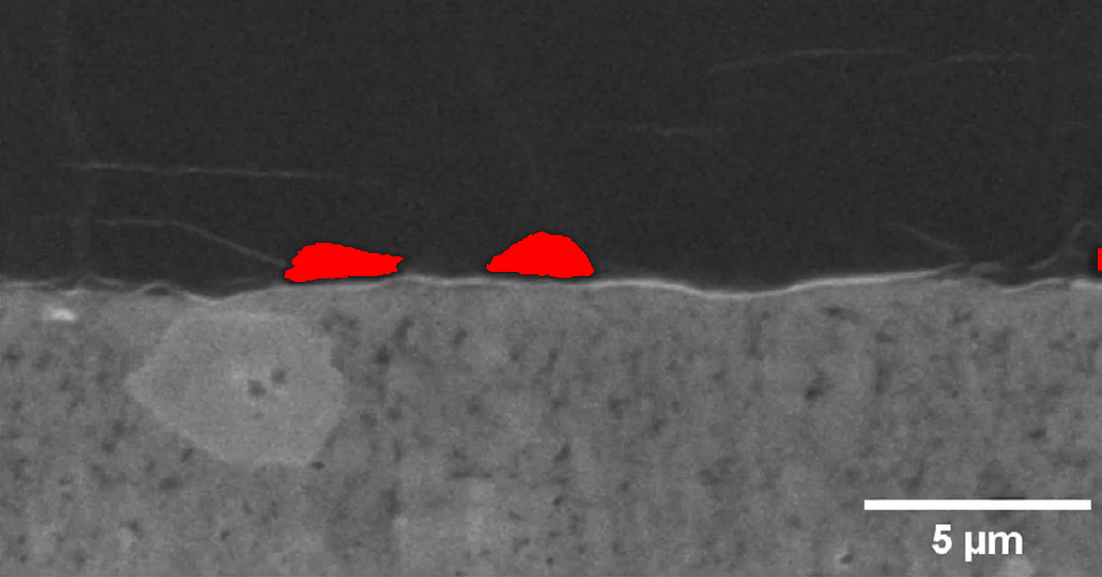

Li_0.25 Gap Visualization
Highlighted gap regions in Li_0.25. Red pixels indicate detected gap regions meeting the dual criteria. Maximum gap height: 1.2716 µm.
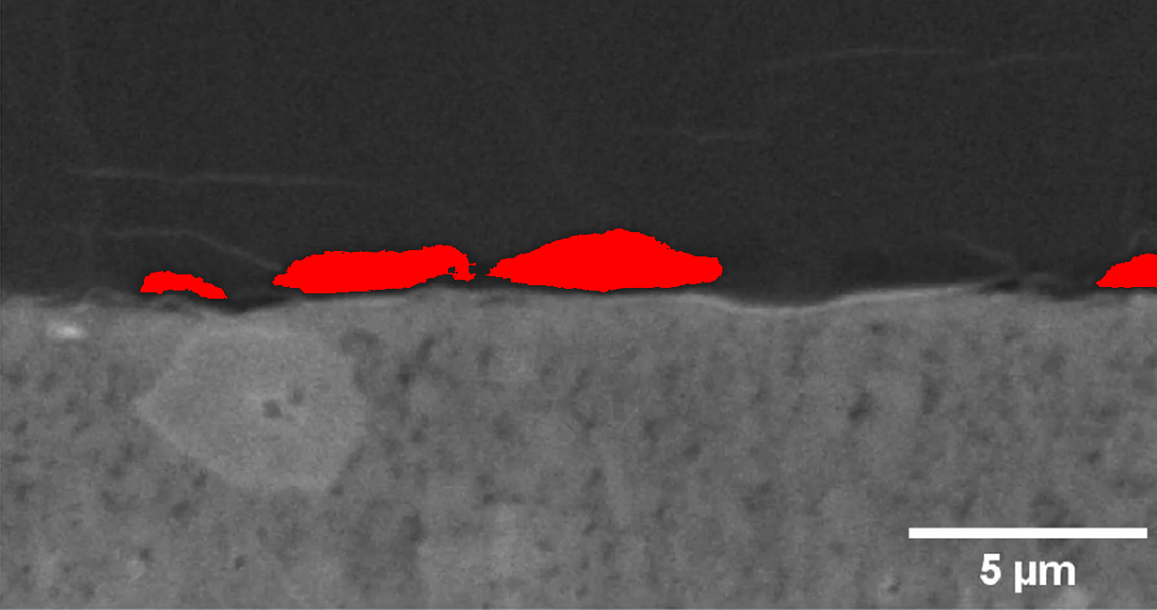

Li_0.375 Gap Visualization
Highlighted gap regions in Li_0.375. Red pixels indicate detected gap regions meeting the dual criteria. Maximum gap height: 1.4399 µm.
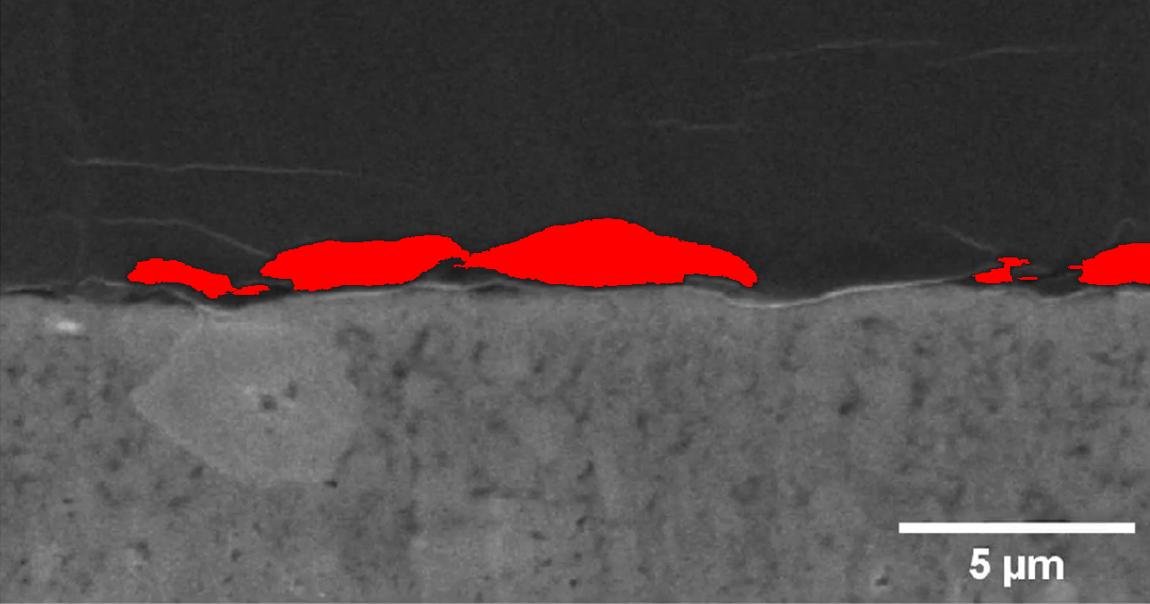

Li_0.5 Gap Visualization
Highlighted gap regions in Li_0.5. Red pixels indicate detected gap regions meeting the dual criteria. Maximum gap height: 1.5334 µm.
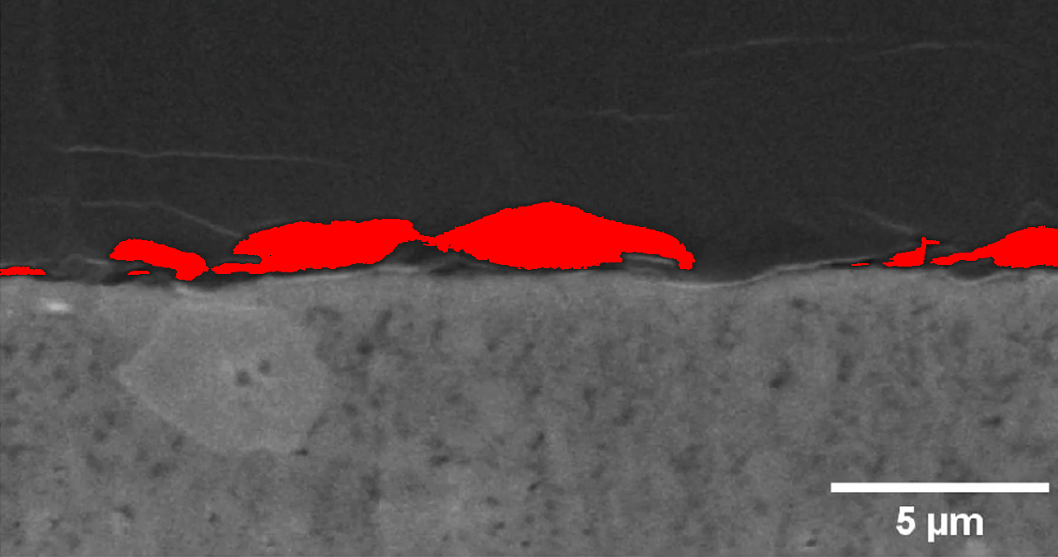

Li_0.625 Gap Visualization
Highlighted gap regions in Li_0.625. Red pixels indicate detected gap regions meeting the dual criteria. Maximum gap height: 1.7578 µm.
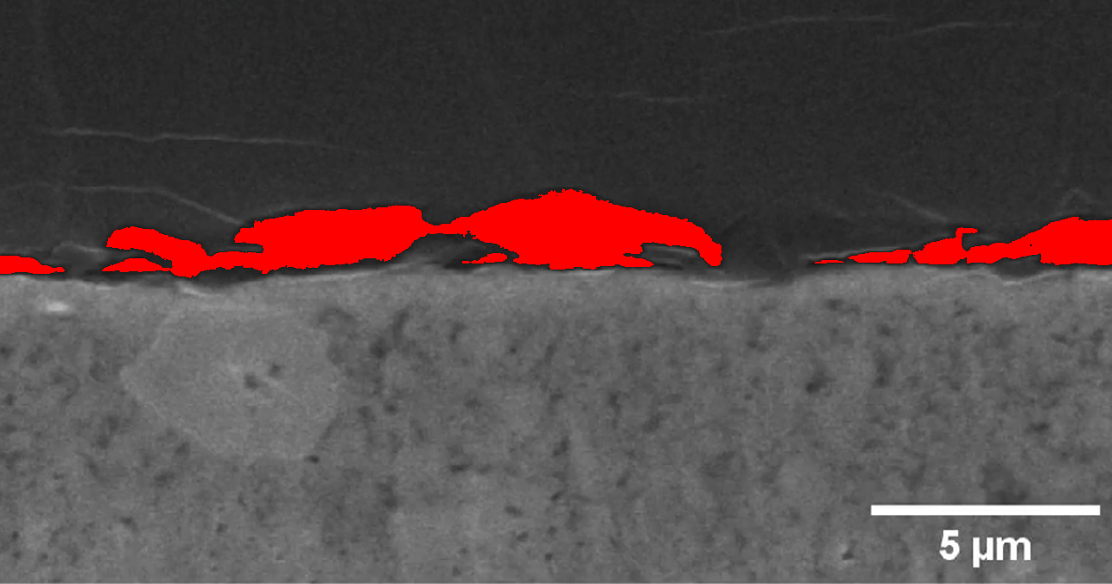

Li_0.75 Gap Visualization
Highlighted gap regions in Li_0.75. Red pixels indicate detected gap regions meeting the dual criteria. Maximum gap height: 1.7765 µm.
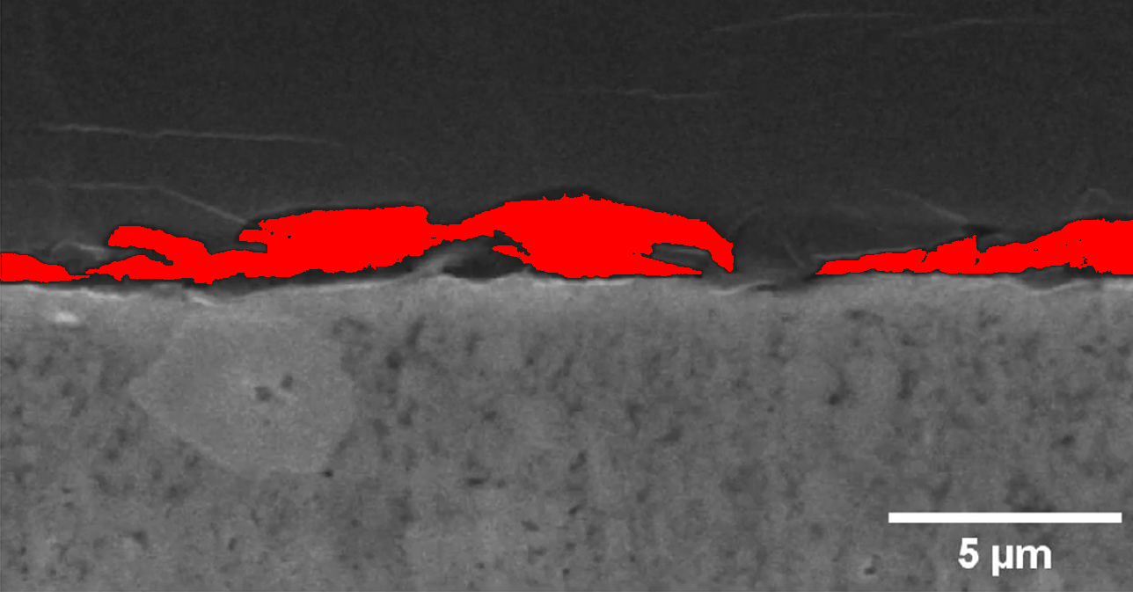

Li_0.875 Gap Visualization
Highlighted gap regions in Li_0.875. Red pixels indicate detected gap regions meeting the dual criteria. Maximum gap height: 1.8139 µm.
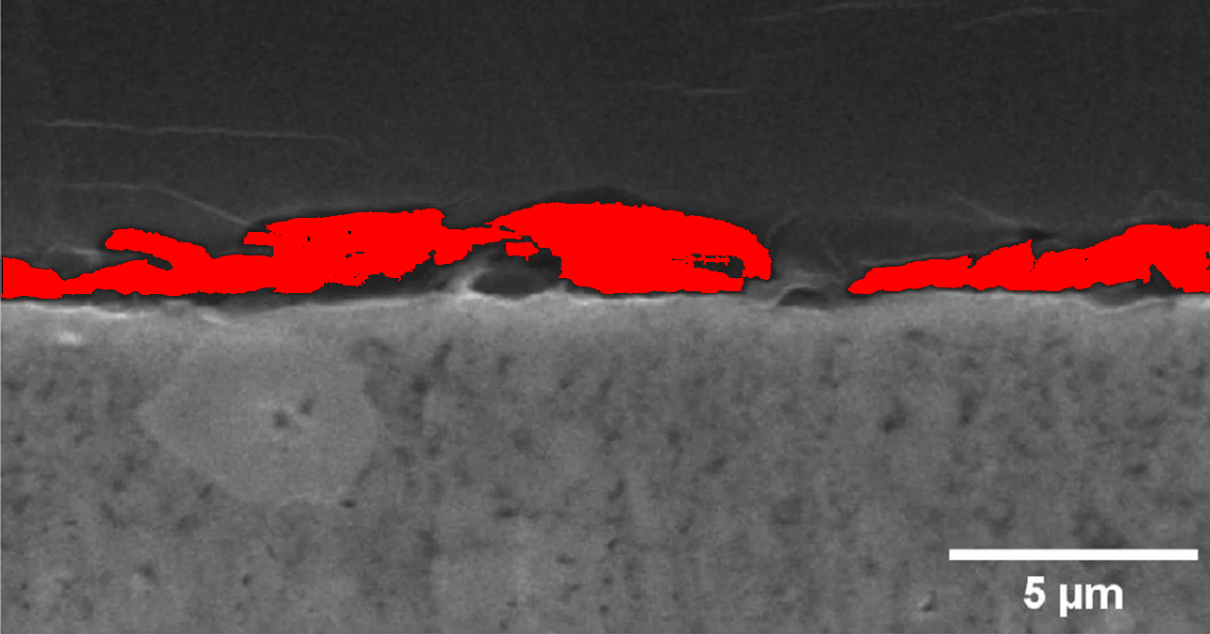

Li_0 Gap Visualization
Highlighted gap regions in Li_0. Red pixels indicate detected gap regions meeting the dual criteria. Maximum gap height: 0.0 µm.
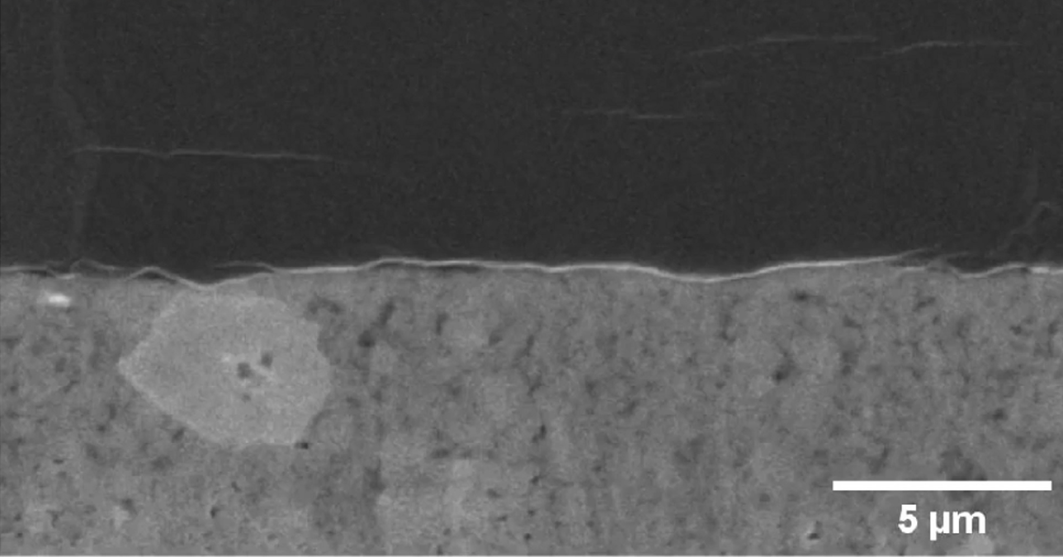

Li_1.125 Gap Visualization
Highlighted gap regions in Li_1.125. Red pixels indicate detected gap regions meeting the dual criteria. Maximum gap height: 2.5619 µm.
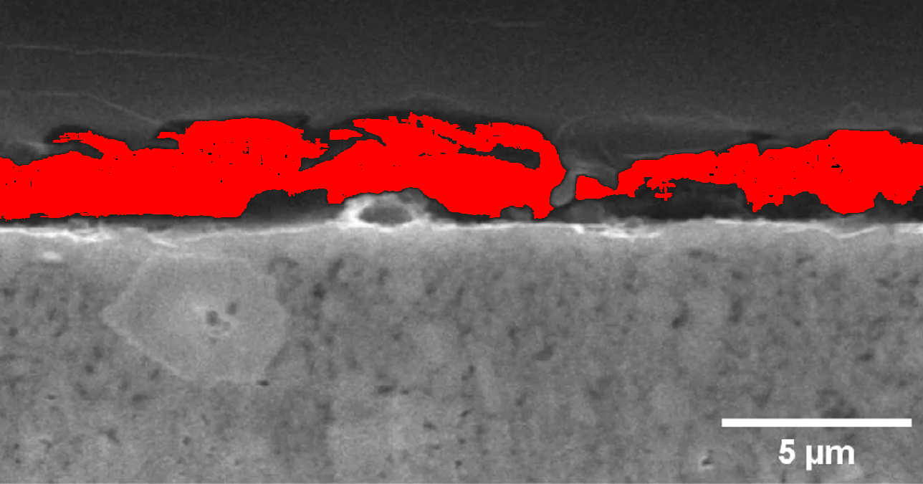

Li_1.25 Gap Visualization
Highlighted gap regions in Li_1.25. Red pixels indicate detected gap regions meeting the dual criteria. Maximum gap height: 3.8335 µm.
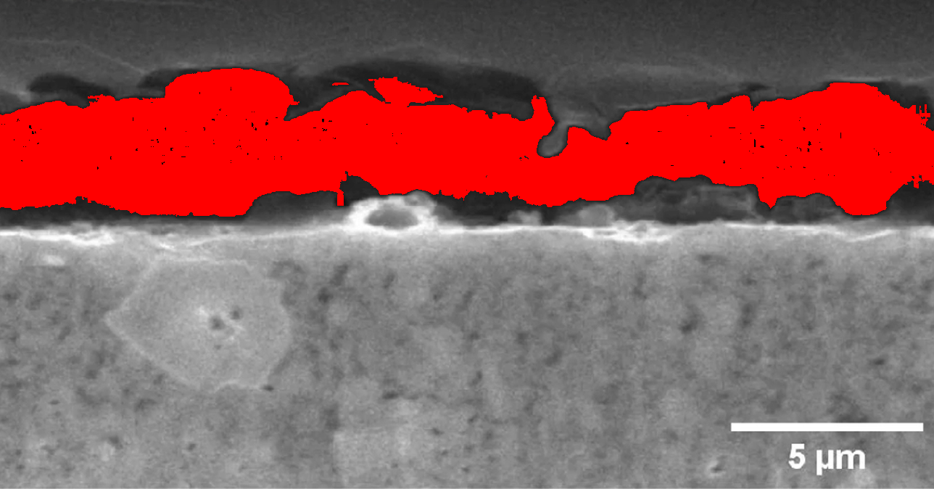

Li_1 Gap Visualization
Highlighted gap regions in Li_1. Red pixels indicate detected gap regions meeting the dual criteria. Maximum gap height: 2.0196 µm.
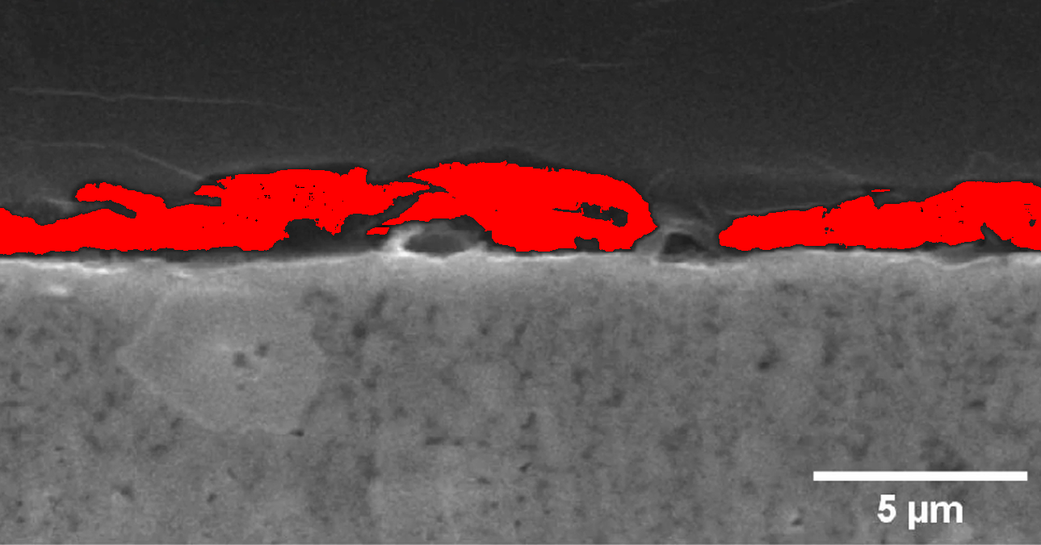

Statistical Summary
Analysis of 11 samples revealed significant variations in gap dimensions:
- Minimum gap height: 0.0000 µm
- Maximum gap height: 3.8335 µm
- Average gap height: 1.7255 µm
- Height variance: Increases with material processing intensity
- Clear correlation: Higher processing parameters yield larger gap formations

Conclusion
This study successfully developed and implemented an automated SEM image analysis pipeline for detecting and quantifying micro-scale gaps in material surfaces. The key findings demonstrate:
- 1. Significant gap height variations across samples (0-3.83 µm)
- 2. Clear correlation between material processing parameters and gap dimensions
- 3. Effectiveness of the dual-criteria gap detection algorithm
- 4. Potential for predictive quality assessment using image analysis
These results enable more precise quality control in material manufacturing processes. Future work will focus on 3D gap reconstruction and machine learning-based anomaly detection.

