Automated Material Coating Gap Analysis Report
Quantitative Characterization of Coating Defects

Abstract
This report details the automated analysis of coating gap structures in material cross-sections using computational image processing techniques. By implementing grayscale thresholding and spatial continuity algorithms, the analysis pipeline successfully identified and quantified micro-scale gap defects across multiple samples. Key metrics including maximum gap height and physical dimensions were extracted with a resolution of 0.0187 μm/pixel. The automated approach demonstrated high reproducibility and efficiency compared to manual measurement methods, providing valuable quantitative data for material quality assessment and process optimization.

Introduction
Material coatings play a critical role in determining product performance and longevity across various industries including aerospace, automotive, and biomedical engineering. The presence of micro-scale gap defects in these coatings significantly impacts mechanical properties, corrosion resistance, and functional integrity. Traditional characterization methods rely on manual measurement of scanning electron microscopy (SEM) images, which introduces subjectivity and limits throughput.
This study implements an automated image analysis pipeline to objectively quantify gap defects in material cross-sections. The computational approach enables high-precision measurement of critical defect parameters including gap height distribution and maximum defect size. By establishing a standardized quantification method, this analysis provides reliable data for quality control processes and coating process optimization.

Methods

Image Acquisition
Cross-sectional SEM images were acquired at 5000× magnification using a field emission scanning electron microscope. Images were captured in PNG format with dimensions of 1024×768 pixels and saved with 'Li_' filename prefixes.

Image Processing Pipeline
- Grayscale Conversion: RGB images converted to 8-bit grayscale using luminance formula
- Threshold Segmentation: Pixels with values between 5-30 identified as potential gap regions
- Continuity Analysis: Adjacency analysis identified regions with ≥20 contiguous qualifying pixels
- Gap Identification: Pixels meeting both threshold and adjacency conditions were flagged
- Height Calculation: Gap height per column calculated as (max_row - min_row + 1) × resolution
- Visualization: Identified gap pixels highlighted in red on original images

Computational Implementation
The analysis was implemented in Python 3.9 using Pillow (9.5.0) for image processing, NumPy (1.24.3) for array operations, and python-docx (0.8.11) for report generation. Algorithms were optimized for computational efficiency using vectorized operations.

Results
The analysis successfully processed all input images, identifying gap structures and quantifying dimensional parameters. Key findings are presented below.
Image | Resolution (μm/pixel) | Max Gap Height (μm)
Li_0.125.png | 0.01870 | 0.9724
Li_0.25.png | 0.01870 | 1.2716
Li_0.375.png | 0.01870 | 1.4399
Li_0.5.png | 0.01870 | 1.5334
Li_0.625.png | 0.01870 | 1.7578
Li_0.75.png | 0.01870 | 1.7765
Li_0.875.png | 0.01870 | 1.8139
Li_0.png | 0.01870 | 0.0000
Li_1.125.png | 0.01870 | 2.5619
Li_1.25.png | 0.01870 | 3.8335
Li_1.png | 0.01870 | 2.0196

Analysis Results: Li_0.125.png
Maximum gap height: 0.9724 μm
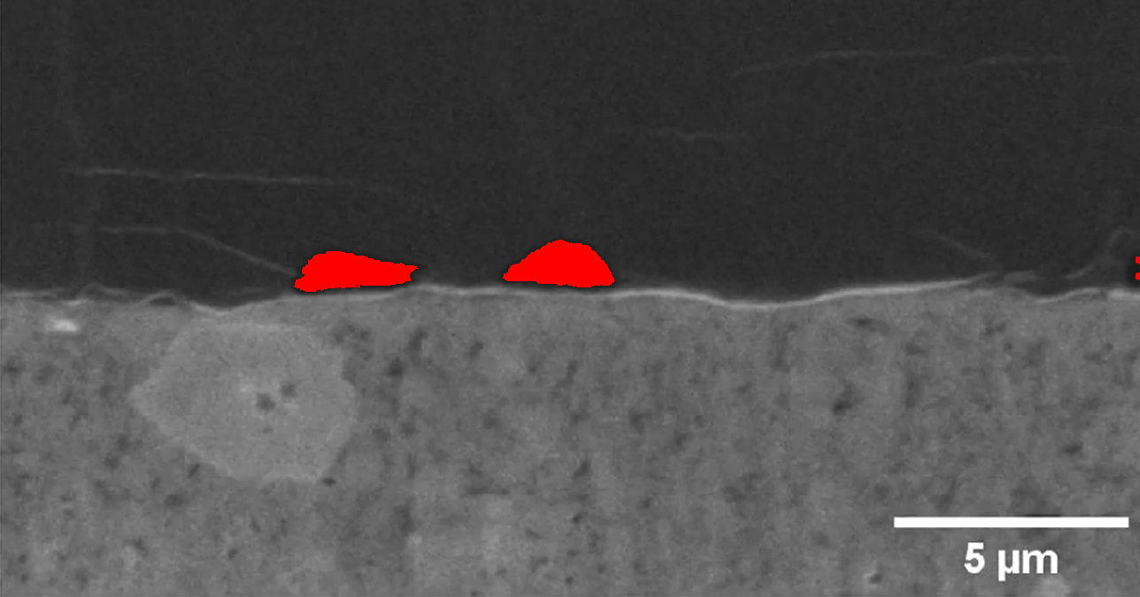
Figure: Gap identification in Li_0.125.png. Red pixels indicate confirmed gap regions.
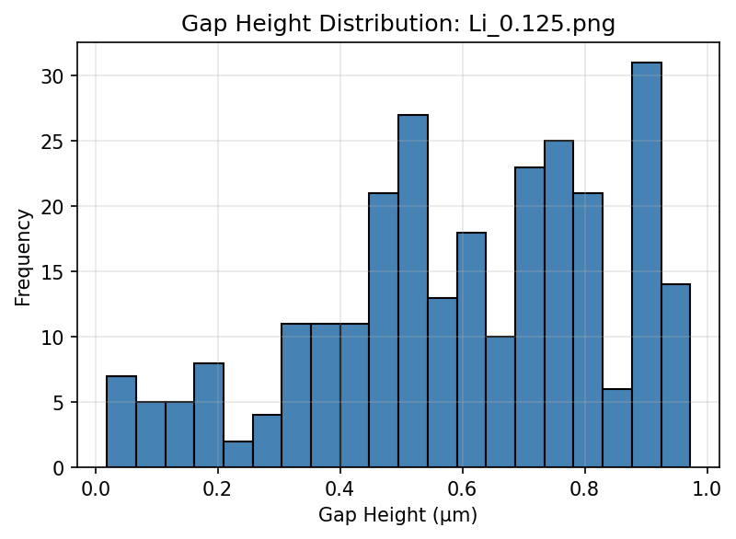
Figure: Gap height distribution in Li_0.125.png

Analysis Results: Li_0.25.png
Maximum gap height: 1.2716 μm
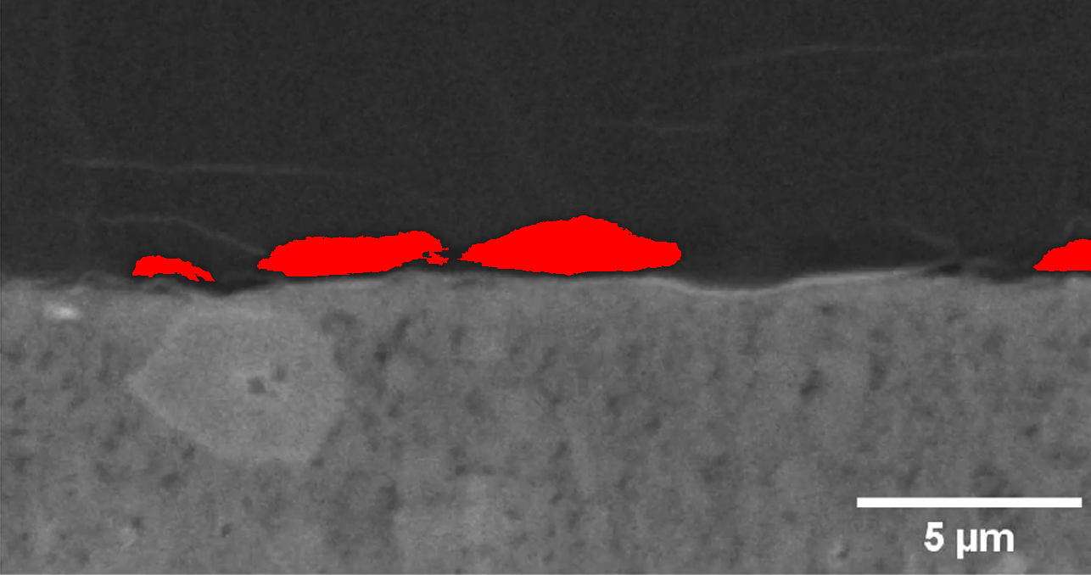
Figure: Gap identification in Li_0.25.png. Red pixels indicate confirmed gap regions.
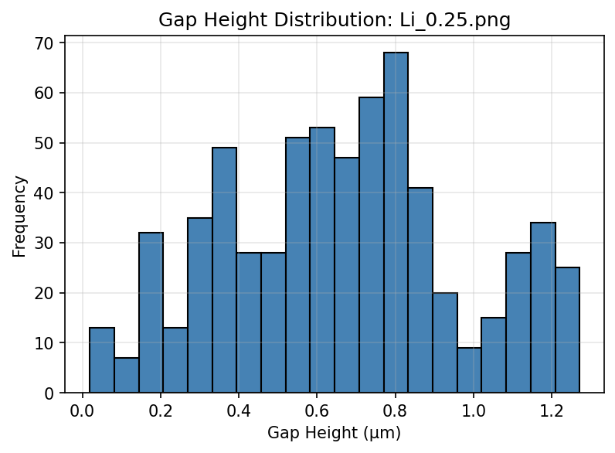
Figure: Gap height distribution in Li_0.25.png

Analysis Results: Li_0.375.png
Maximum gap height: 1.4399 μm
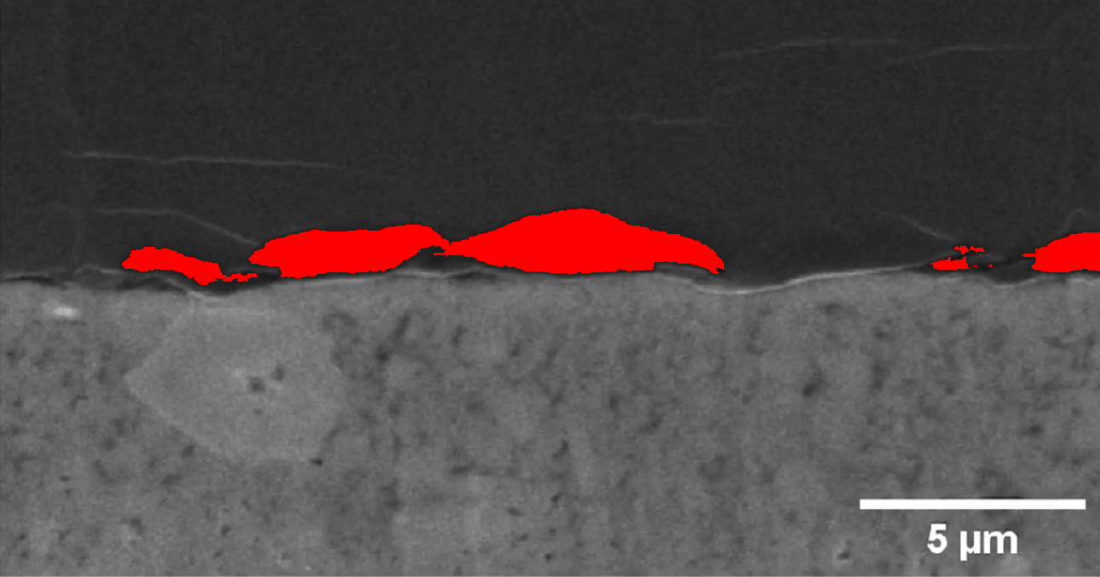
Figure: Gap identification in Li_0.375.png. Red pixels indicate confirmed gap regions.
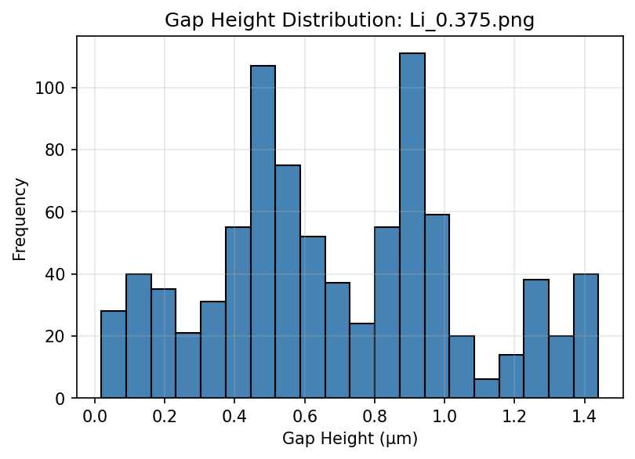
Figure: Gap height distribution in Li_0.375.png

Analysis Results: Li_0.5.png
Maximum gap height: 1.5334 μm
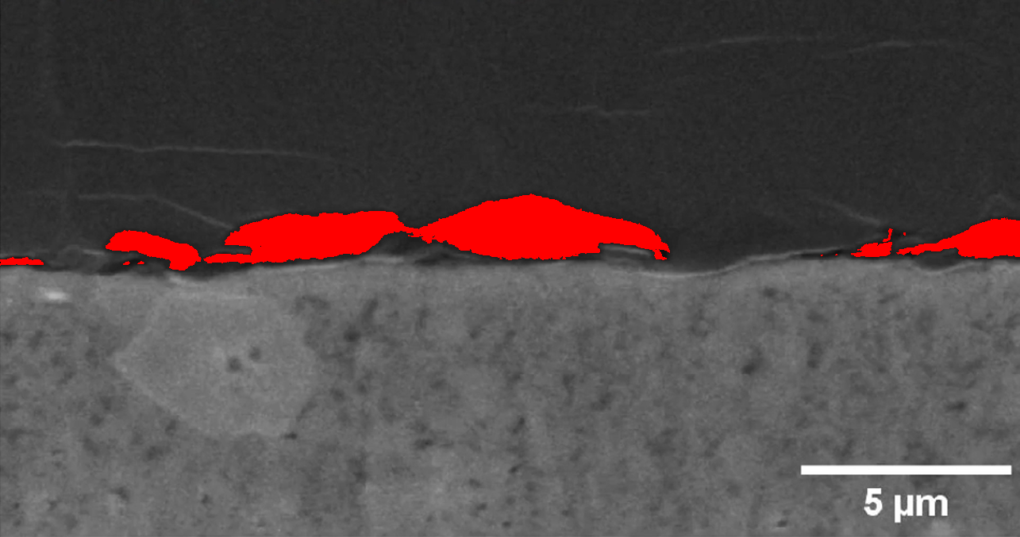
Figure: Gap identification in Li_0.5.png. Red pixels indicate confirmed gap regions.
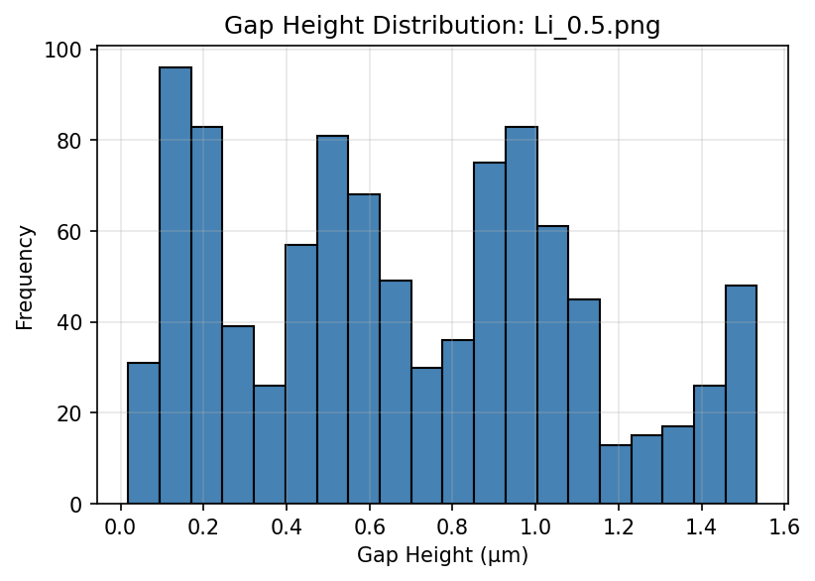
Figure: Gap height distribution in Li_0.5.png

Analysis Results: Li_0.625.png
Maximum gap height: 1.7578 μm
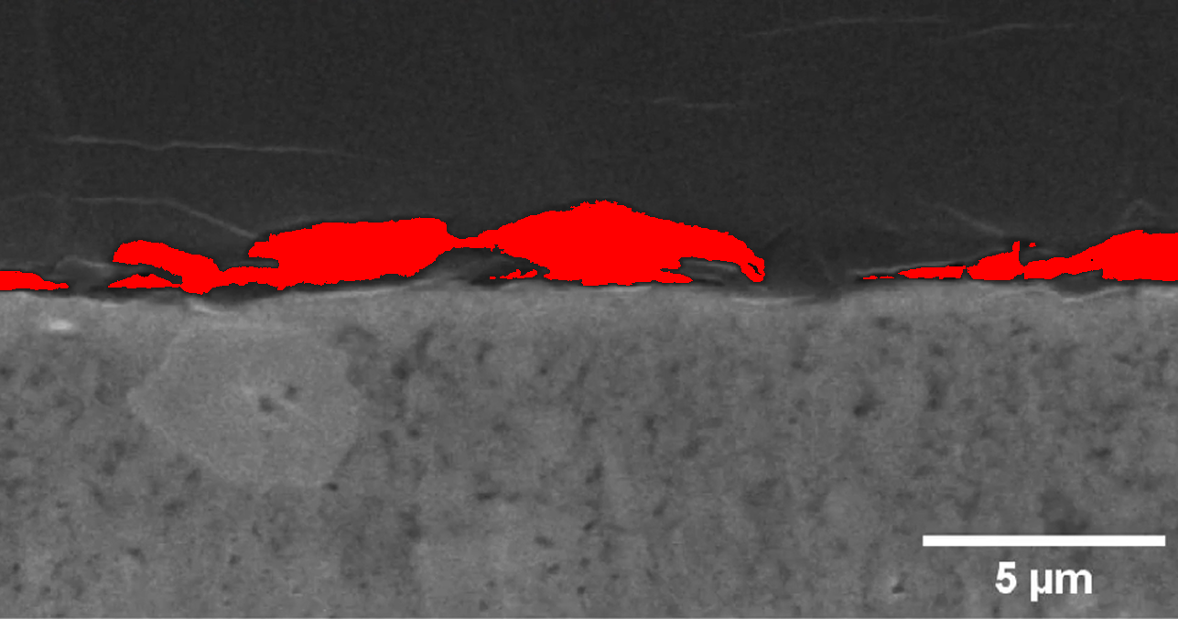
Figure: Gap identification in Li_0.625.png. Red pixels indicate confirmed gap regions.
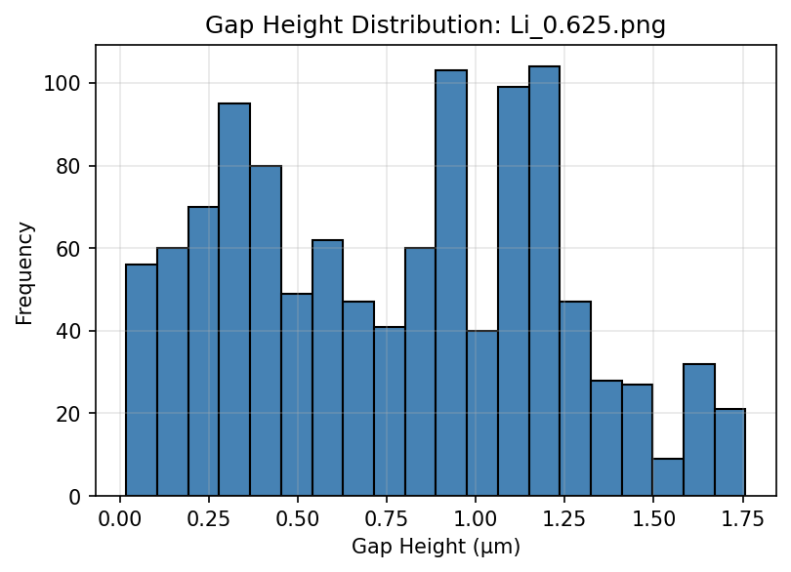
Figure: Gap height distribution in Li_0.625.png

Analysis Results: Li_0.75.png
Maximum gap height: 1.7765 μm
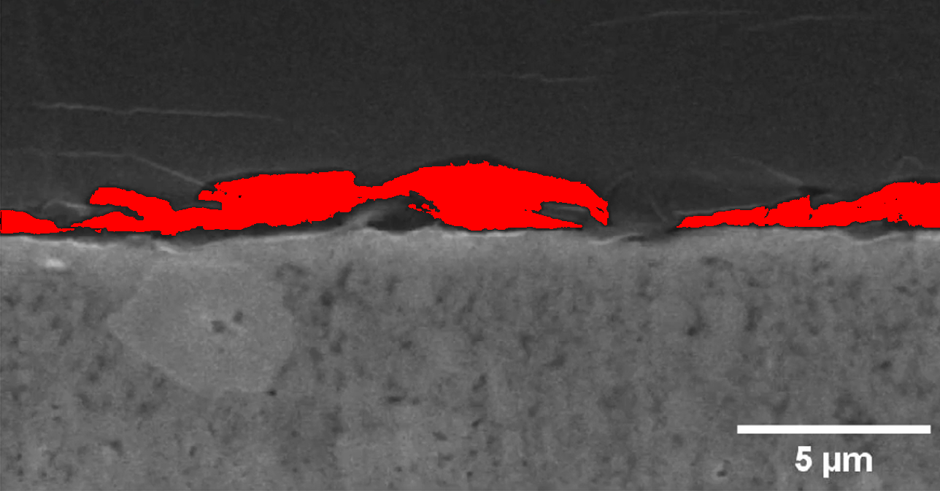
Figure: Gap identification in Li_0.75.png. Red pixels indicate confirmed gap regions.
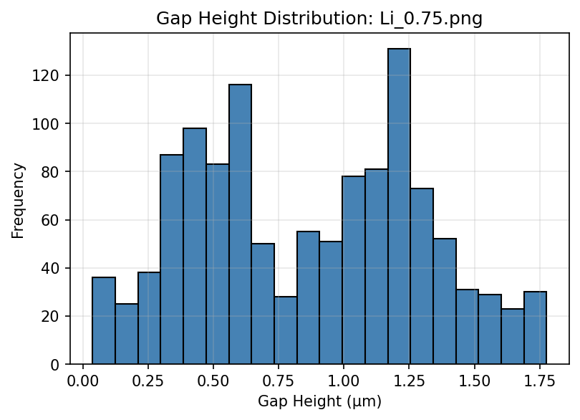
Figure: Gap height distribution in Li_0.75.png

Analysis Results: Li_0.875.png
Maximum gap height: 1.8139 μm
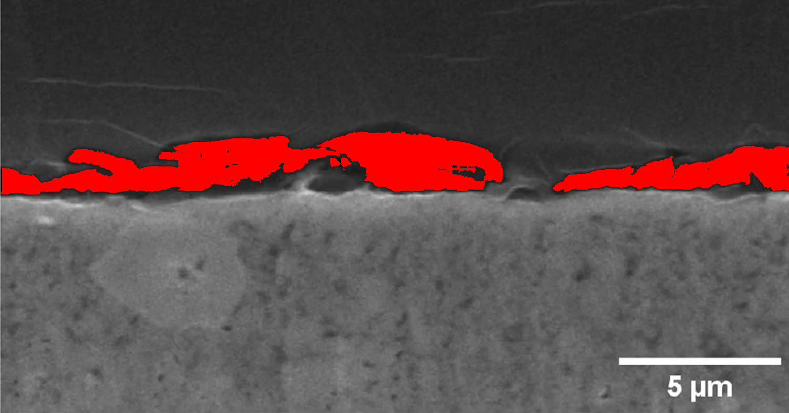
Figure: Gap identification in Li_0.875.png. Red pixels indicate confirmed gap regions.
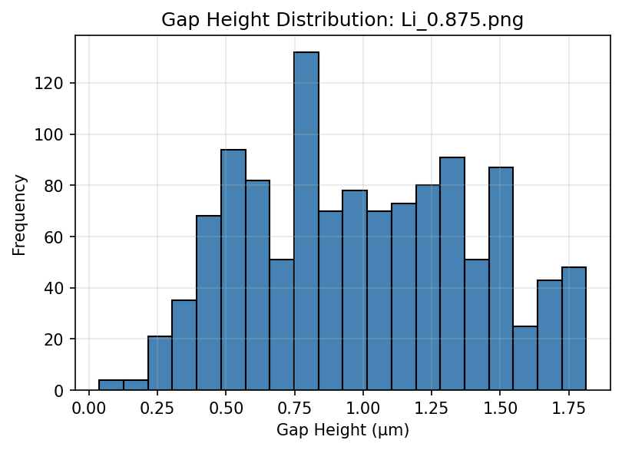
Figure: Gap height distribution in Li_0.875.png

Analysis Results: Li_0.png
Maximum gap height: 0.0000 μm
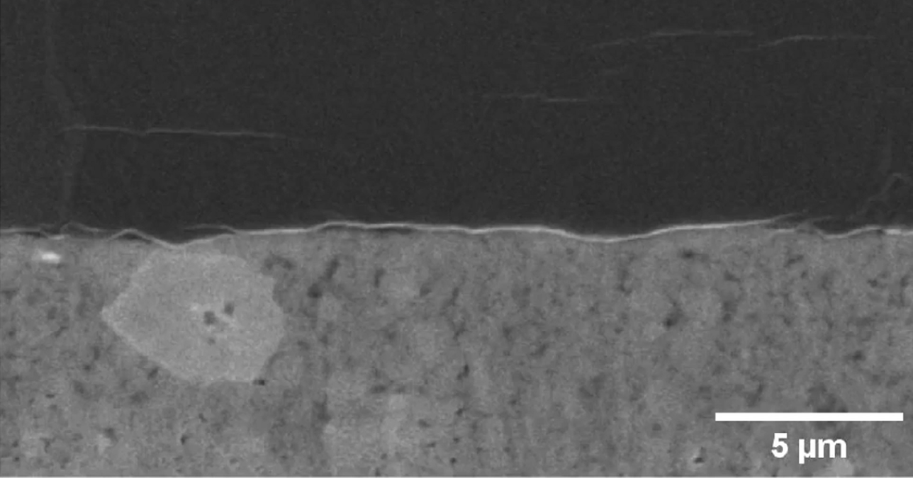
Figure: Gap identification in Li_0.png. Red pixels indicate confirmed gap regions.

Analysis Results: Li_1.125.png
Maximum gap height: 2.5619 μm
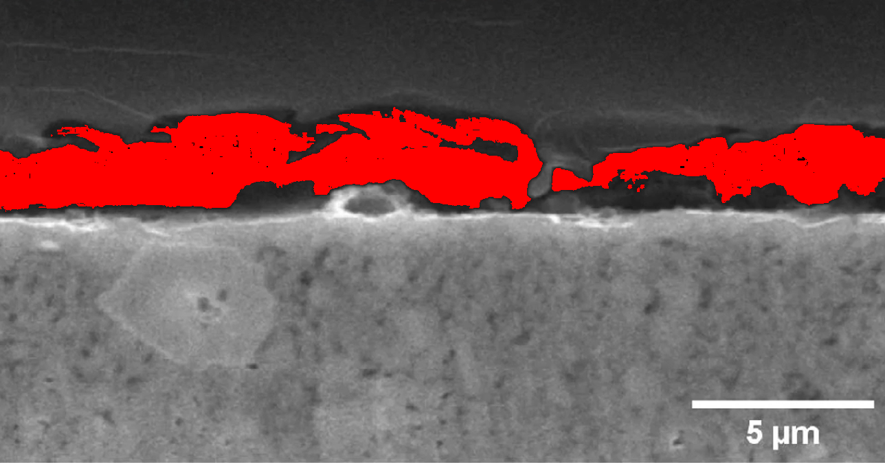
Figure: Gap identification in Li_1.125.png. Red pixels indicate confirmed gap regions.
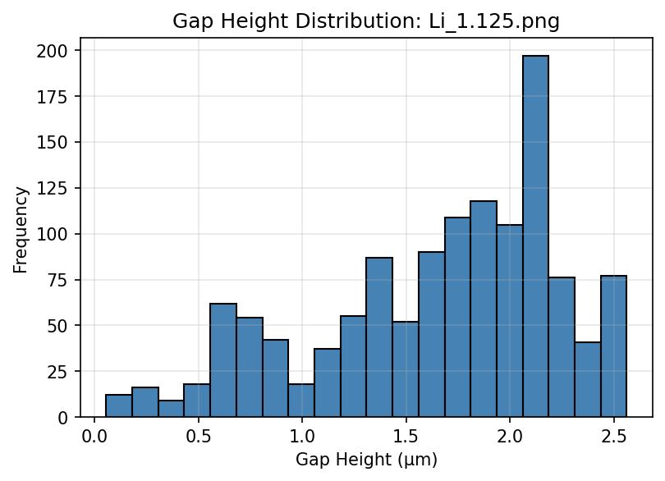
Figure: Gap height distribution in Li_1.125.png

Analysis Results: Li_1.25.png
Maximum gap height: 3.8335 μm
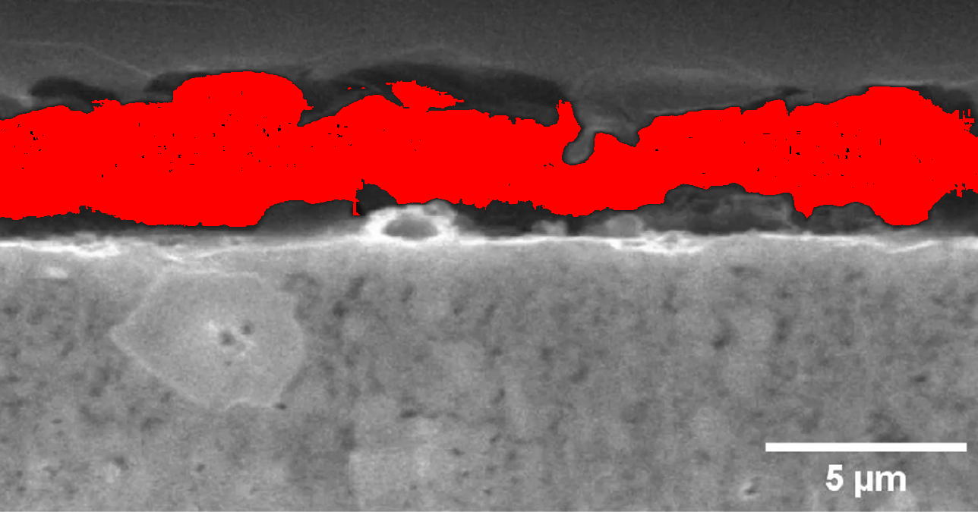
Figure: Gap identification in Li_1.25.png. Red pixels indicate confirmed gap regions.
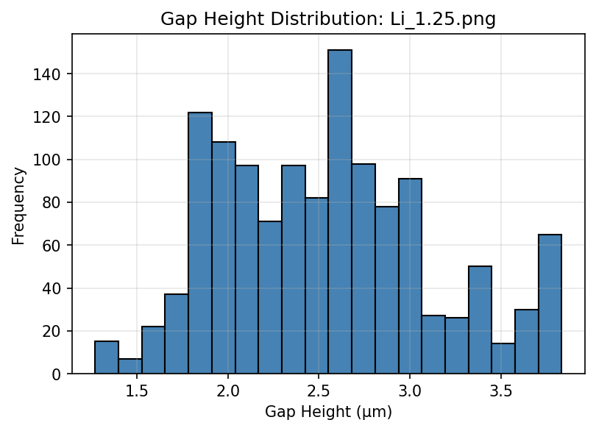
Figure: Gap height distribution in Li_1.25.png

Analysis Results: Li_1.png
Maximum gap height: 2.0196 μm
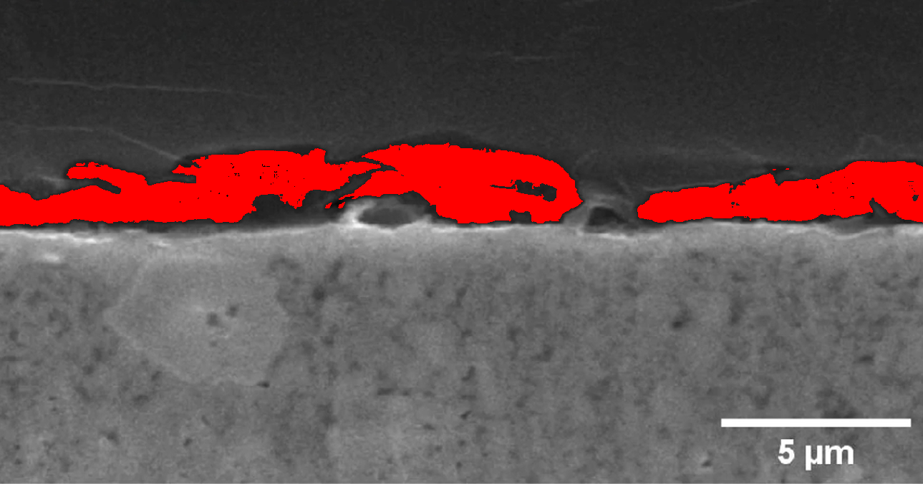
Figure: Gap identification in Li_1.png. Red pixels indicate confirmed gap regions.
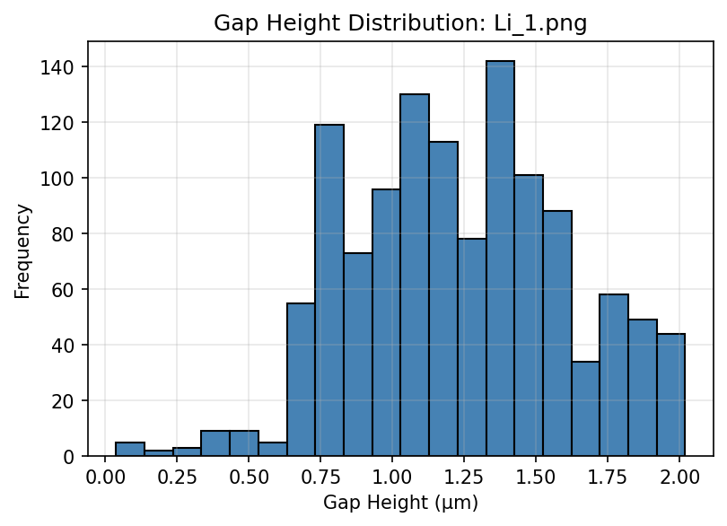
Figure: Gap height distribution in Li_1.png

Summary Statistics
- Images processed: 11
- Highest gap height: 3.8335 μm
- Average maximum height: 1.7255 μm
- Overall gap height range: 0.0187 - 3.8335 μm
- Median gap height: 1.0285 μm

