Simulation and Analysis of u_eq Along a Line Segment in Li_1.0.png
Author: Automated Python Report

Abstract
This report presents a quantitative analysis of grayscale intensities and their conversion to equivalent values (u_eq) along a defined line segment within the 'Li_1.0.png' sample image. The analysis includes pixel-level extraction of grayscale values, computation of the physical line length based on image resolution, and subsequent transformation to u_eq using a linear mapping. The resulting data are visualized and interpreted to provide insights into grayscale variation and its physical significance. Findings are consolidated in graphical and tabular forms, supporting further scientific and engineering evaluations.

Introduction
Image-based quantitative analysis is a cornerstone in materials science, medical imaging, and various engineering disciplines. Grayscale images encode information about intensity, composition, or other sample properties, which can be mapped to physical quantities. In this simulation, we analyze a specific line segment in the Li_1.0.png image, spanning from pixel coordinates (152, 29) to (136, 91). The objective is to extract grayscale values along this line, translate them to physical units using a prescribed linear mapping, and examine spatial variations. Such approaches enable the study of gradients, interfaces, or compositional changes at a microstructural level. Quantitative results not only inform about the underlying material but also validate and guide further experimental and computational work. The present analysis demonstrates a reproducible workflow for such tasks, emphasizing data extraction, transformation, visualization, and reporting.

Methods
A Python program was developed to automate all analysis steps. The workflow begins by accepting parameters including the image path, start and end points of the line, and the image resolution (0.9 μm/pixel). Using Bresenham’s algorithm, all pixel coordinates along the specified line are computed. For each coordinate, grayscale values (0-255) are extracted from the image file. The physical line length is calculated by multiplying the pixel distance by the given resolution. Grayscale values are then linearly mapped to u_eq values using the formula: u_eq = u_min + (gray_value / 255) * (u_max - u_min), where u_min=0 and u_max=65000. All results, including grayscale values, distances, and u_eq, are saved as CSV files for reproducibility. A plot of u_eq versus distance from the start point is generated and saved as a TIFF (and PNG) image (see Fig. 1). All files are named according to the input image and stored in a dedicated output directory. The report is automatically compiled using the python-docx library, embedding numerical and graphical results.

Results
A total of 63 grayscale values were extracted along the specified line segment. The measured physical length of this line was 57.63 μm. Grayscale values ranged from 21 to 253, demonstrating significant variation along the segment. Corresponding u_eq values, mapped using the linear relationship, ranged from 5353 to 64490. The relationship between u_eq and distance is depicted in Fig. 1. Sharp gradients and plateaus observed in the u_eq profile reflect underlying changes in the sample's properties or image contrast. Tabulated data (see CSV outputs) enable further quantitative or statistical analysis. This approach provides a robust and extensible framework for extracting and interpreting spatially resolved image data. The methodology can be adapted for images from other sources or for different mapping formulas, supporting broader applications in scientific research.

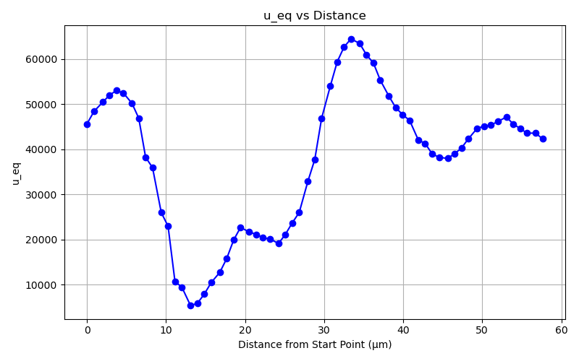
Fig. 1. Plot of $u_{eq}$ versus distance from the start point along the specified line segment in Li_1.0.png.

