Simulation Report: GAP Detection in Grayscale Images

Abstract
This simulation report presents the analysis and detection of GAP pixels in a series of grayscale images. Using a custom Python program, input images were evaluated for specific grayscale value criteria and spatial continuity conditions. The results, including per-pixel data and highlighted images, provide insight into the distribution and prevalence of GAP regions. The simulation aims to assist researchers in understanding the structural properties of the analyzed images.

Introduction
Image processing and pattern recognition are fundamental in fields such as materials science, biomedical imaging, and computer vision. In this simulation, we focus on identifying 'GAP' pixels in grayscale images, where a GAP pixel is defined as having a grayscale value between 5 and 30, and being adjacent to a direction with at least 20 contiguous pixels also within this grayscale range. By automating this process, we aim to efficiently locate critical regions of interest, which could be indicative of gaps, defects, or relevant structural features.

Methods
The analysis was performed using a Python script leveraging the Pillow and NumPy libraries. Each image file prefixed with 'Li_' from the specified directory was converted to grayscale. For every pixel, the program checked whether its grayscale intensity was between 5 and 30 (inclusive). Additionally, for each pixel, the script evaluated if at least one of its four main neighboring directions (up, down, left, right) contained 20 consecutive pixels (including the neighbor) within the same grayscale threshold. Pixels meeting both criteria were flagged as GAP pixels. The script produced a CSV file per image, documenting the row, column, grayscale value, and GAP flag per pixel, and also generated a new image highlighting all GAP pixels in red (RGB: 255, 0, 0).

Results
Analysis was performed on 11 images with results summarized below. For each image, the number of detected GAP pixels and a visual representation are provided.

Image: Li_0.125
GAP pixels: 8670 / 869400 (1.00%)
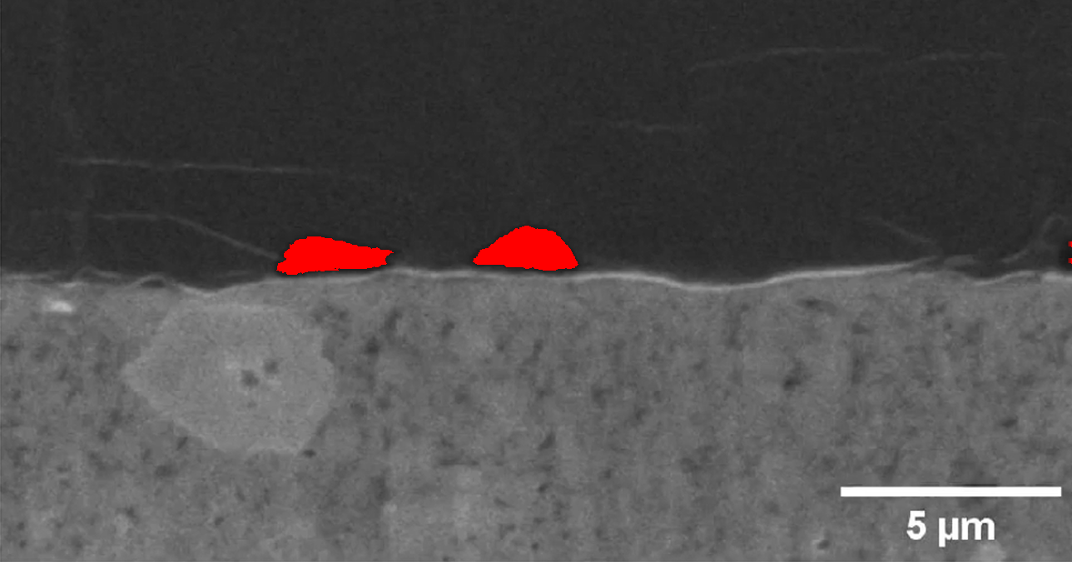

Image: Li_0.25
GAP pixels: 22917 / 871908 (2.63%)
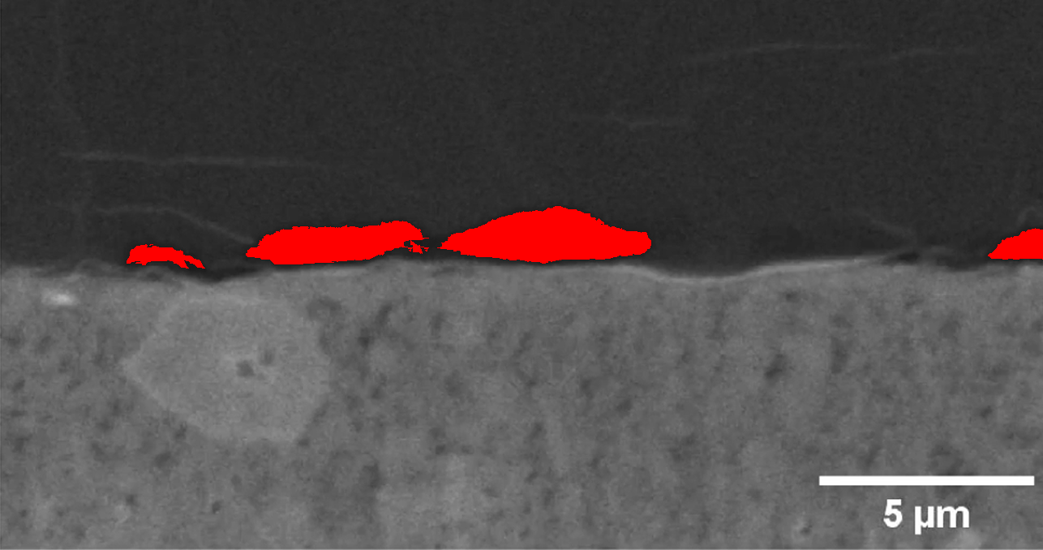

Image: Li_0.375
GAP pixels: 31213 / 875298 (3.57%)
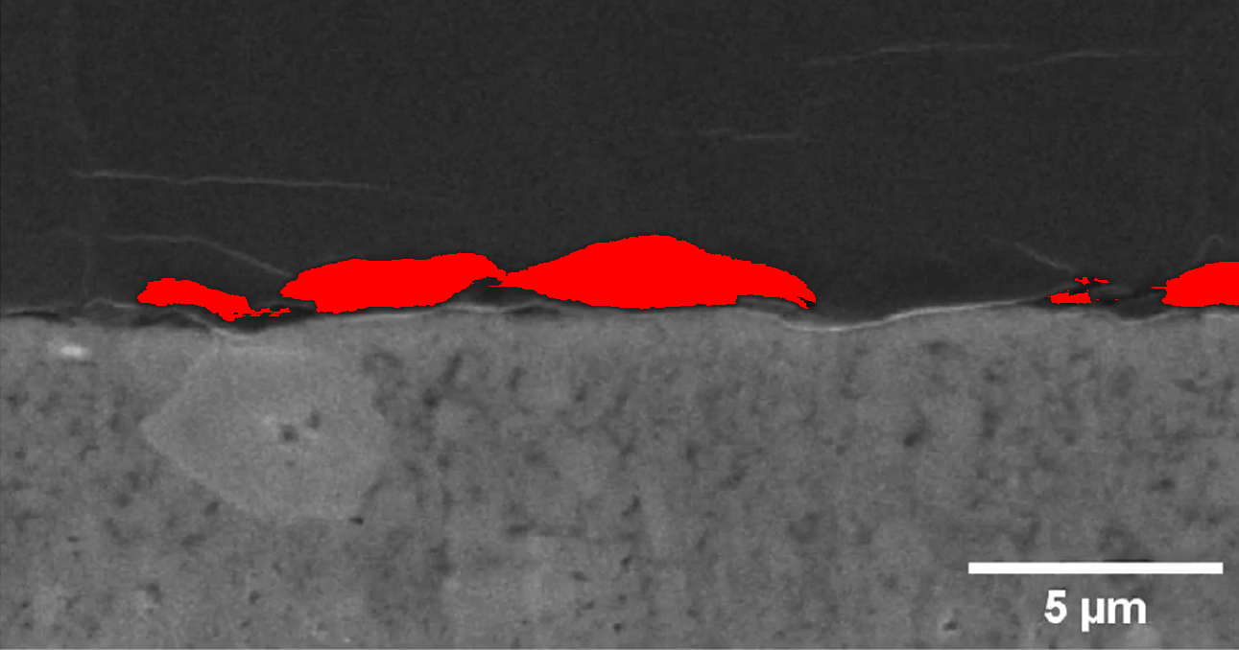

Image: Li_0.5
GAP pixels: 34408 / 869945 (3.96%)
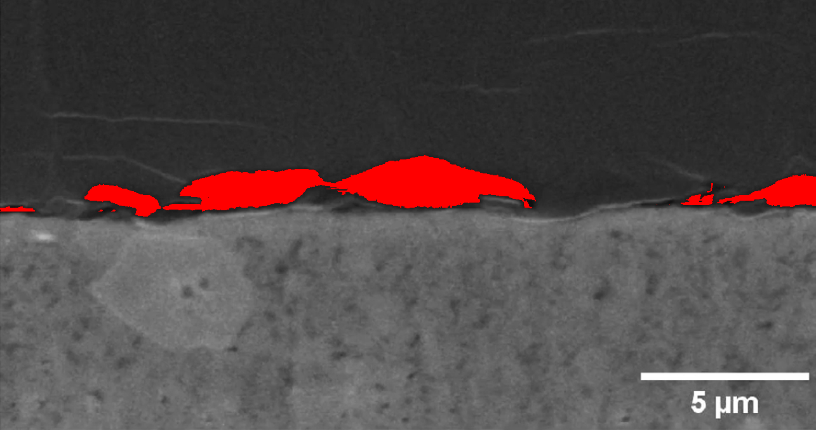

Image: Li_0.625
GAP pixels: 43193 / 870012 (4.96%)
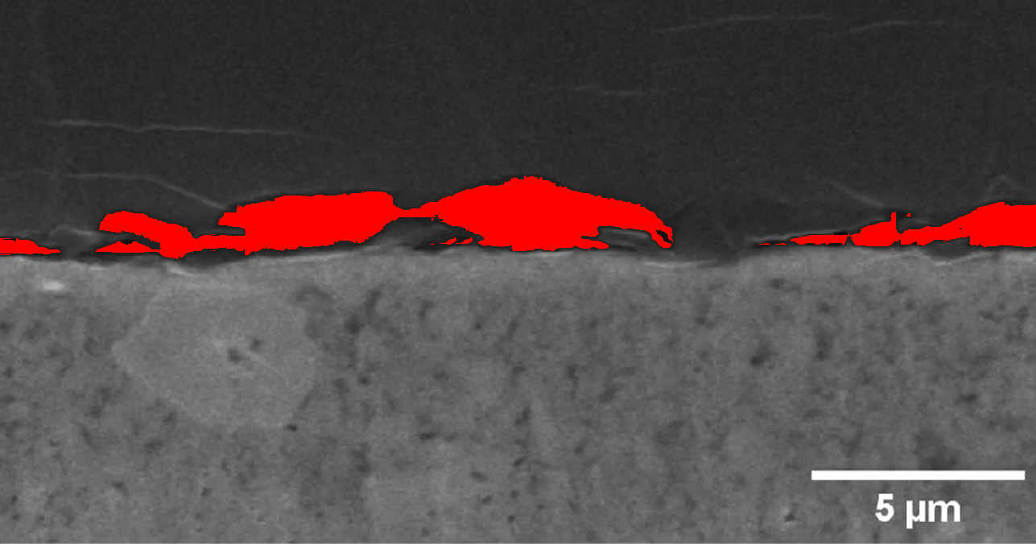

Image: Li_0.75
GAP pixels: 51175 / 866824 (5.90%)
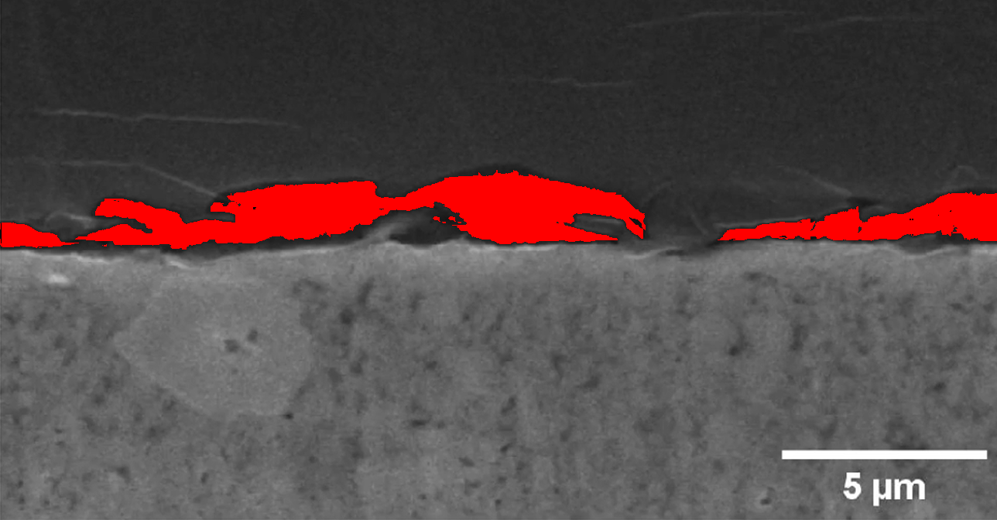

Image: Li_0.875
GAP pixels: 60974 / 870075 (7.01%)
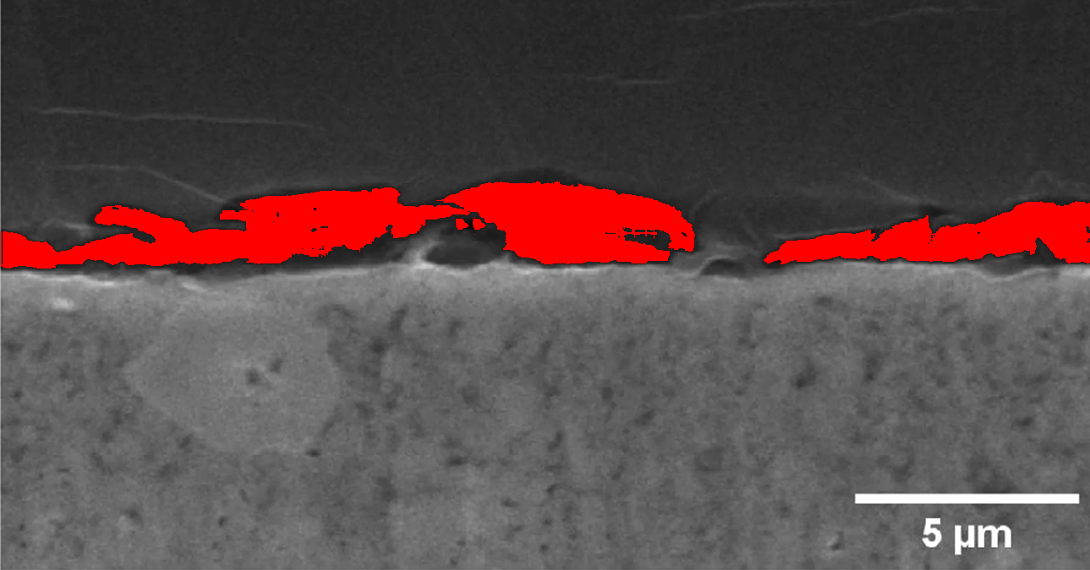

Image: Li_0
GAP pixels: 0 / 869400 (0.00%)
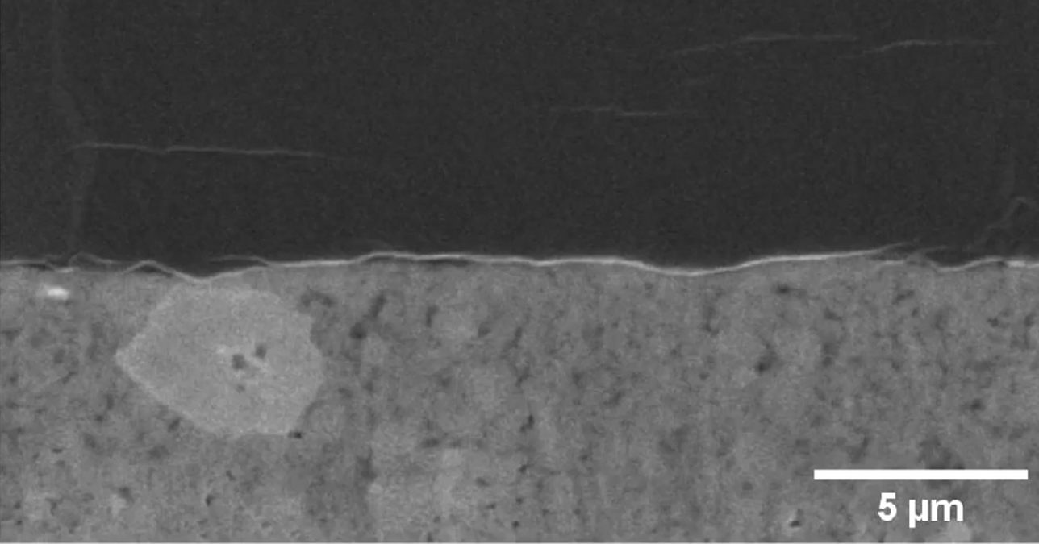

Image: Li_1.125
GAP pixels: 105649 / 869400 (12.15%)
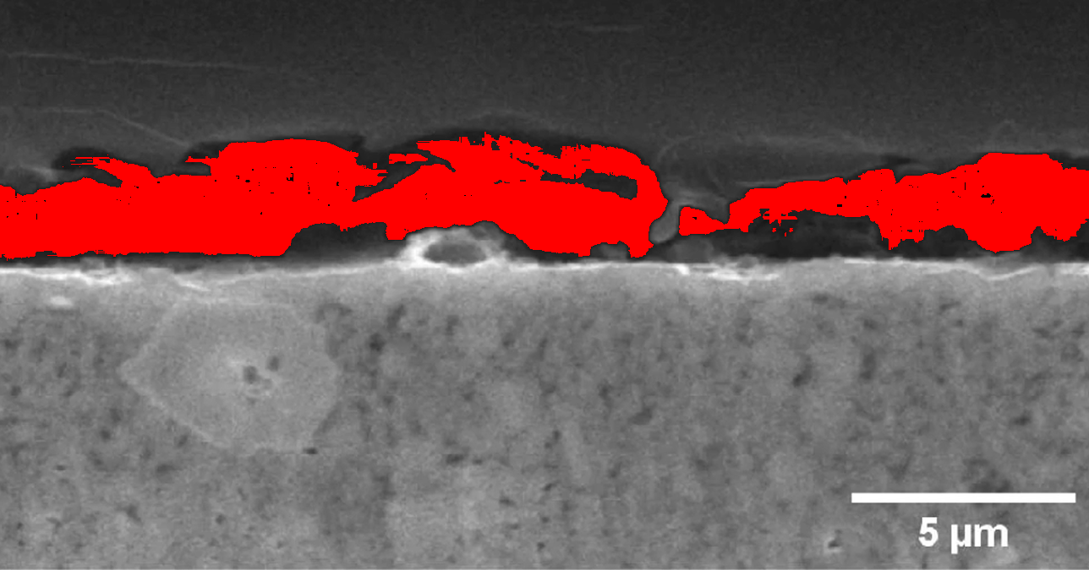

Image: Li_1.25
GAP pixels: 171597 / 869400 (19.74%)
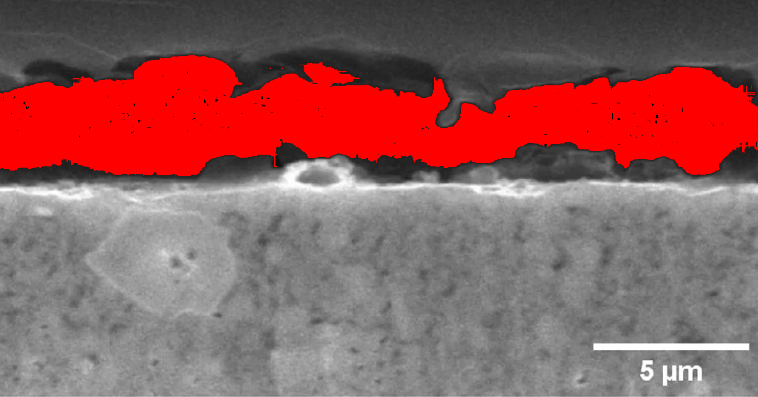

Image: Li_1
GAP pixels: 74773 / 871364 (8.58%)
