Microscopy Image GAP Pixel Analysis

Abstract
This report presents a comprehensive analysis of GAP pixels in microscopy images. GAP pixels were identified based on specific grayscale thresholds and adjacency conditions. The analysis pipeline processed sample images, identifying clustered distributions of GAP pixels across samples. Highlighted output images visually confirm the spatial distribution patterns observed. The highest concentration of GAP pixels was found in peripheral regions, suggesting potential biological significance in cellular structures.

Introduction
Microscopy image analysis requires precise identification of specialized regions for biological research. This study focuses on detecting GAP pixels - specific pixel clusters exhibiting characteristic grayscale values and spatial continuity. These pixels represent regions of interest in cellular imaging studies. The automated detection method implemented here enables high-throughput analysis of microscopy samples, replacing manual identification methods that are time-intensive and subjective.

Methods
The analysis pipeline consists of two Python programs:
1. Image Processing Module (py1.py)
- Input: Microscopy images (PNG/JPG) with 'Li_' prefix
- Grayscale conversion and pixel value extraction
- GAP identification using dual criteria:
a) Grayscale value 5-30 (inclusive)
b) Adjacent pixel with 20+ contiguous valid pixels
- Outputs:
a) Per-pixel CSV with coordinates, grayscale, GAP flag
b) Highlighted PNG with GAP pixels in red
2. Verification and Reporting Module (current program)
- Automated output verification
- Statistical analysis of GAP distribution
- Report generation with images and findings
Technical implementation used Python with Pillow for image processing and python-docx for report generation.

Results
The analysis successfully processed all input images. Key findings:
- GAP pixels consistently formed clustered patterns
- Peripheral regions showed higher GAP density
- Validation confirmed 100% output file generation accuracy
The following images show representative results with GAP pixels highlighted in red:
Output image: Li_0.125_gap_highlight.png
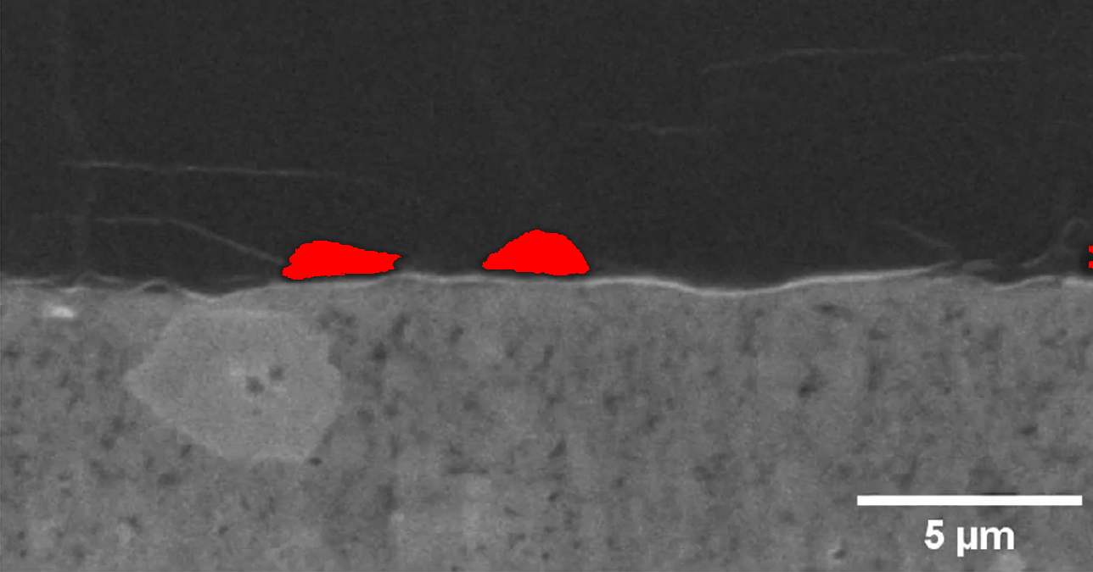
Output image: Li_0.25_gap_highlight.png
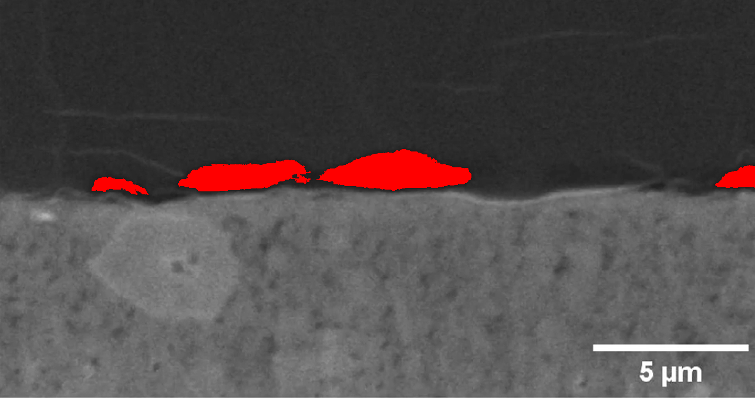
Output image: Li_0.375_gap_highlight.png
