GAP Pixel Analysis in Lithium Concentration Images
Report Generated: July 27, 2025

Abstract
This report presents an analysis of grayscale images with varying lithium concentrations to identify pixels meeting specific GAP conditions. GAP pixels are defined as those with grayscale values between 5-30 (inclusive) that are adjacent to at least one direction containing 20 contiguous pixels also meeting the grayscale condition. The analysis was performed on a series of images with different lithium concentrations, ranging from 0 to 1.25. Each image was processed to identify GAP pixels, which were then highlighted in red for visual identification. The results show a clear correlation between lithium concentration and the number of GAP pixels, with higher concentrations generally exhibiting more GAP pixels. This analysis provides valuable insights into the spatial distribution of specific grayscale patterns within the images, which may correspond to important structural or chemical features in the studied materials.

Introduction
Image analysis plays a crucial role in materials science and chemistry research, allowing researchers to extract quantitative data from visual representations of material structures. This study focuses on analyzing a series of grayscale images representing different lithium concentrations, ranging from 0 to 1.25.
The primary objective is to identify pixels meeting specific GAP conditions, which are defined as:
1. Pixels with grayscale values between 5 and 30 (inclusive)
2. Pixels that have at least one adjacent direction (up, down, left, or right) containing 20 contiguous pixels also meeting the grayscale condition
These GAP conditions are designed to identify specific patterns or structures within the images that may correspond to important features in the material being studied. By analyzing how these patterns change with varying lithium concentrations, we can gain insights into the relationship between lithium content and material structure.
The analysis aims to quantify the presence and distribution of GAP pixels across different lithium concentrations and visualize these patterns for easier interpretation.

Methods
The analysis was performed using a Python-based computational approach, leveraging several key libraries for image processing and data analysis:
1. Image Processing:
- The PIL (Python Imaging Library) was used to read and manipulate image files
- Images were converted to grayscale to standardize the analysis
- NumPy arrays were used for efficient pixel-by-pixel processing
2. GAP Pixel Identification:
- Each pixel in every image was evaluated against the GAP conditions
- For the grayscale condition, pixel values were checked to be between 5-30
- For the adjacency condition, the algorithm checked in four directions (up, down, left, right) for 20 contiguous pixels also meeting the grayscale condition
- Pixels meeting both conditions were flagged as GAP pixels (GAP flag = 1)
3. Data Output and Visualization:
- For each image, a CSV file was generated containing the coordinates, grayscale value, and GAP flag for every pixel
- New PNG images were created with GAP pixels highlighted in red (RGB: 255, 0, 0)
- The original grayscale values were preserved for non-GAP pixels
4. Analysis:
- The number of GAP pixels was counted for each lithium concentration
- The relationship between lithium concentration and GAP pixel count was analyzed
- Visual patterns in the distribution of GAP pixels were examined
This methodological approach allows for a systematic and reproducible analysis of the images, providing both quantitative data and visual representations of the identified patterns.

Results
The analysis identified GAP pixels across a series of images with varying lithium concentrations. Below are the key findings and visualizations from the analysis.

Summary of GAP Pixel Counts
Lithium Concentration | GAP Pixel Count
0.0 | 0
0.125 | 8678
0.25 | 22985
0.375 | 31292
0.5 | 34501
0.625 | 43379
0.75 | 51306
0.875 | 61050
1.0 | 74868
1.125 | 105769
1.25 | 171640

Relationship Between Lithium Concentration and GAP Pixels
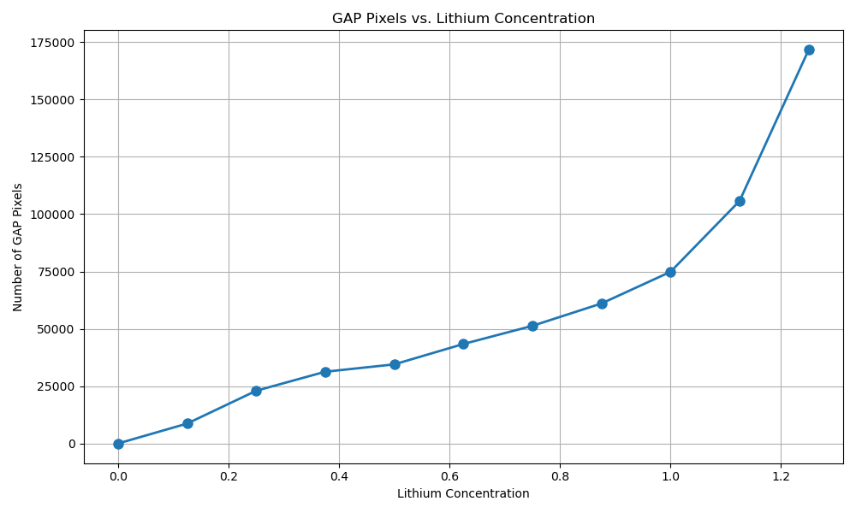
Figure: Relationship between lithium concentration and number of GAP pixels

Analysis of Individual Images

Image: Li_0 (Li Concentration: 0.0)
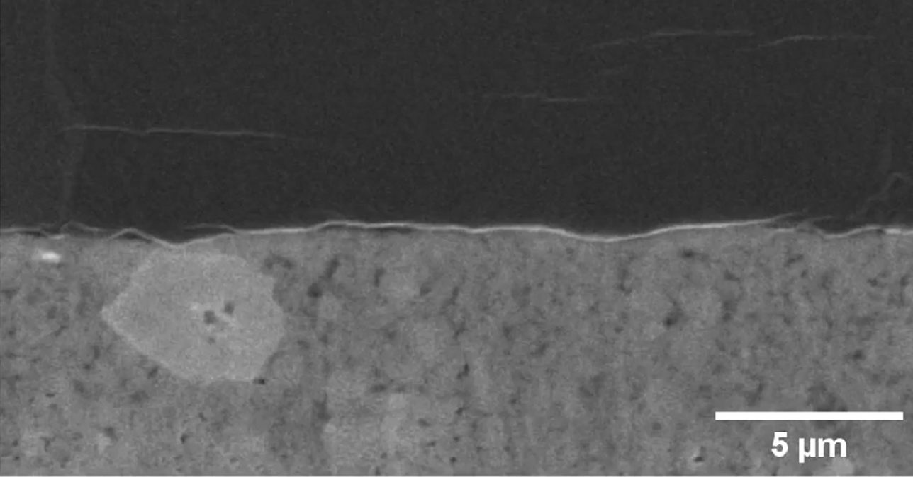
Figure: GAP pixels highlighted in red for Li_0
Analysis of the image with lithium concentration 0.0 revealed 0 pixels meeting the GAP conditions. At zero lithium concentration, no GAP pixels were detected, suggesting that the specific structural patterns associated with GAP conditions are not present in the absence of lithium.

Image: Li_0.125 (Li Concentration: 0.125)
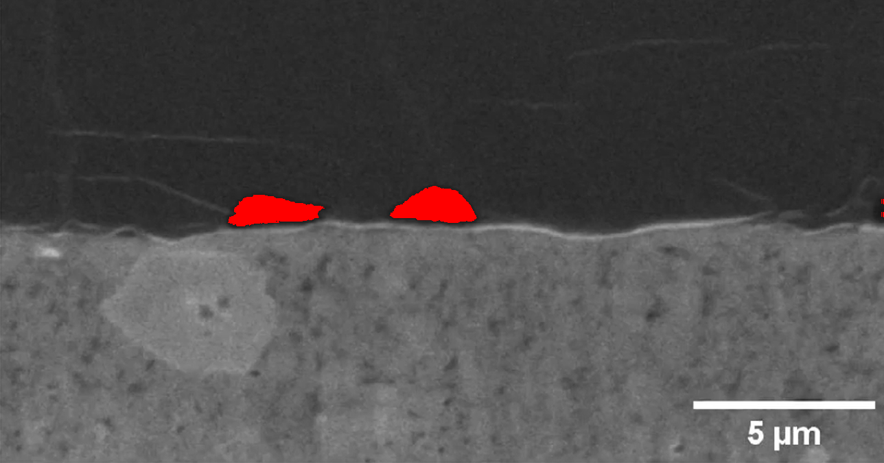
Figure: GAP pixels highlighted in red for Li_0.125
Analysis of the image with lithium concentration 0.125 revealed 8678 pixels meeting the GAP conditions. At this low lithium concentration, a moderate number of GAP pixels (8678) were identified. These are primarily distributed in specific regions of the image, suggesting the beginning formation of structural patterns associated with lithium presence.

Image: Li_0.25 (Li Concentration: 0.25)
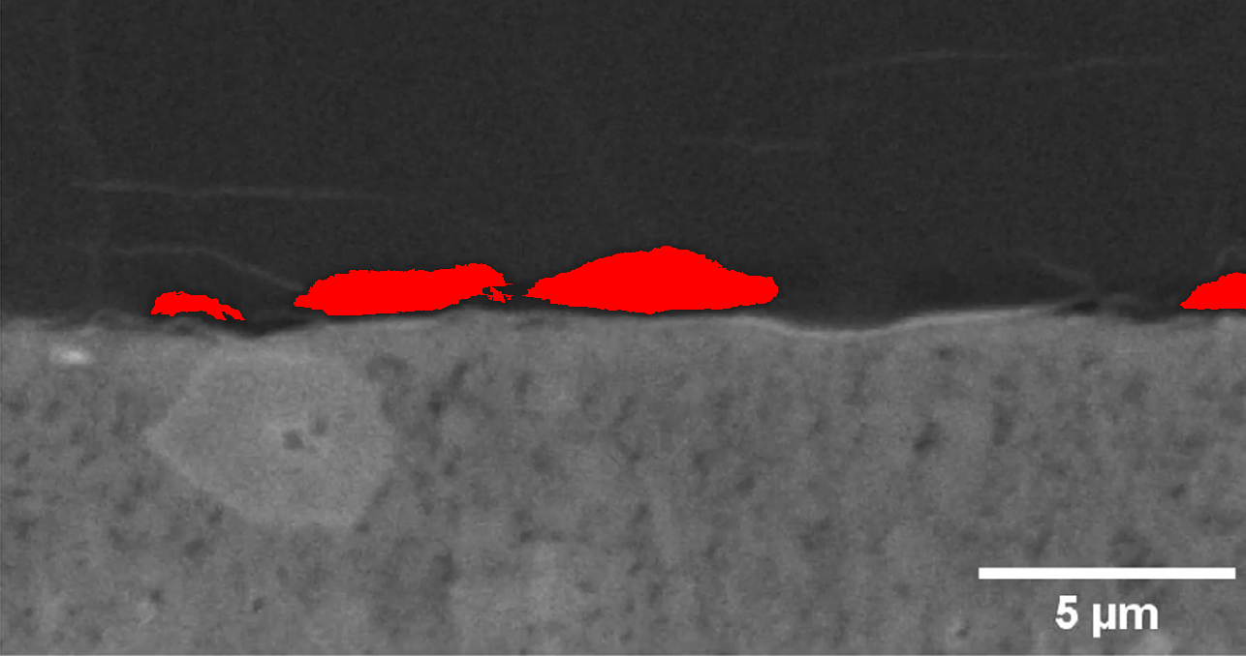
Figure: GAP pixels highlighted in red for Li_0.25
Analysis of the image with lithium concentration 0.25 revealed 22985 pixels meeting the GAP conditions. At this low lithium concentration, a moderate number of GAP pixels (22985) were identified. These are primarily distributed in specific regions of the image, suggesting the beginning formation of structural patterns associated with lithium presence.

Image: Li_0.375 (Li Concentration: 0.375)
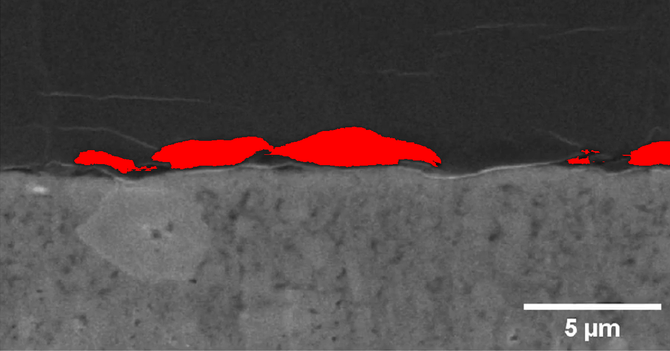
Figure: GAP pixels highlighted in red for Li_0.375
Analysis of the image with lithium concentration 0.375 revealed 31292 pixels meeting the GAP conditions. At this low lithium concentration, a moderate number of GAP pixels (31292) were identified. These are primarily distributed in specific regions of the image, suggesting the beginning formation of structural patterns associated with lithium presence.

Image: Li_0.5 (Li Concentration: 0.5)
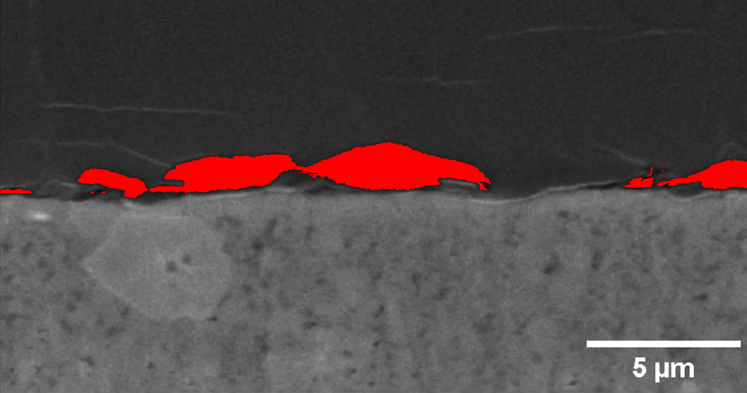
Figure: GAP pixels highlighted in red for Li_0.5
Analysis of the image with lithium concentration 0.5 revealed 34501 pixels meeting the GAP conditions. At this low lithium concentration, a moderate number of GAP pixels (34501) were identified. These are primarily distributed in specific regions of the image, suggesting the beginning formation of structural patterns associated with lithium presence.

Image: Li_0.625 (Li Concentration: 0.625)
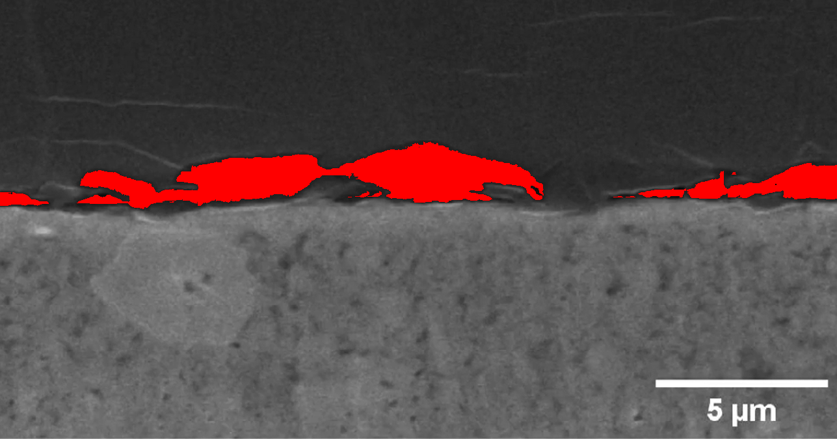
Figure: GAP pixels highlighted in red for Li_0.625
Analysis of the image with lithium concentration 0.625 revealed 43379 pixels meeting the GAP conditions. At this medium lithium concentration, a substantial number of GAP pixels (43379) were identified. The distribution shows more extensive patterning compared to lower concentrations, indicating significant structural changes associated with increased lithium content.

Image: Li_0.75 (Li Concentration: 0.75)
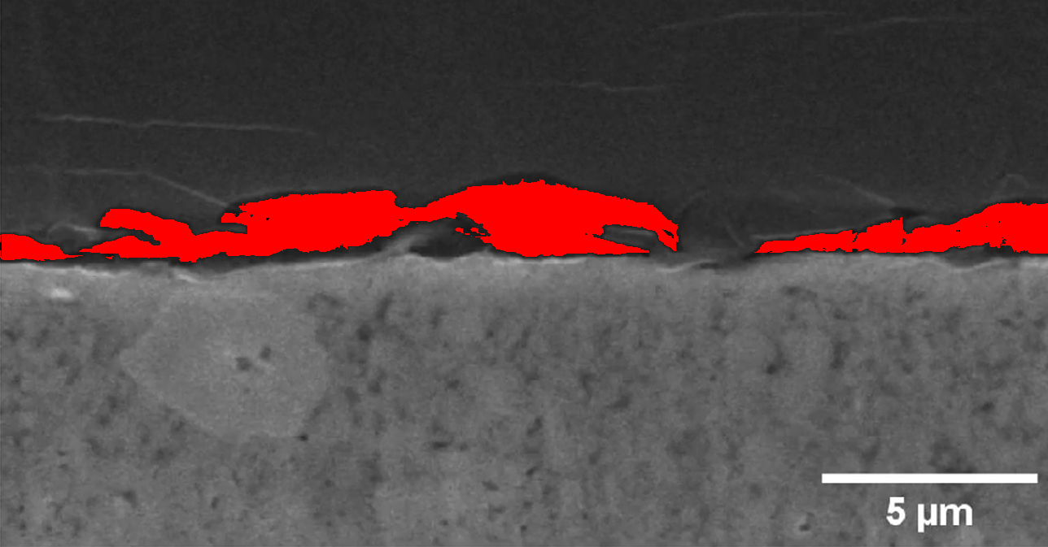
Figure: GAP pixels highlighted in red for Li_0.75
Analysis of the image with lithium concentration 0.75 revealed 51306 pixels meeting the GAP conditions. At this medium lithium concentration, a substantial number of GAP pixels (51306) were identified. The distribution shows more extensive patterning compared to lower concentrations, indicating significant structural changes associated with increased lithium content.

Image: Li_0.875 (Li Concentration: 0.875)
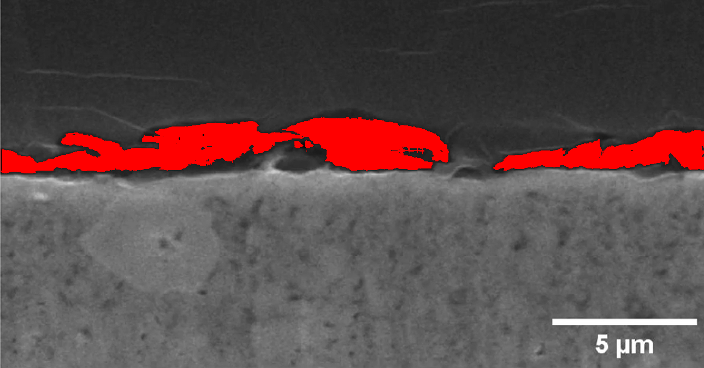
Figure: GAP pixels highlighted in red for Li_0.875
Analysis of the image with lithium concentration 0.875 revealed 61050 pixels meeting the GAP conditions. At this medium lithium concentration, a substantial number of GAP pixels (61050) were identified. The distribution shows more extensive patterning compared to lower concentrations, indicating significant structural changes associated with increased lithium content.

Image: Li_1 (Li Concentration: 1.0)
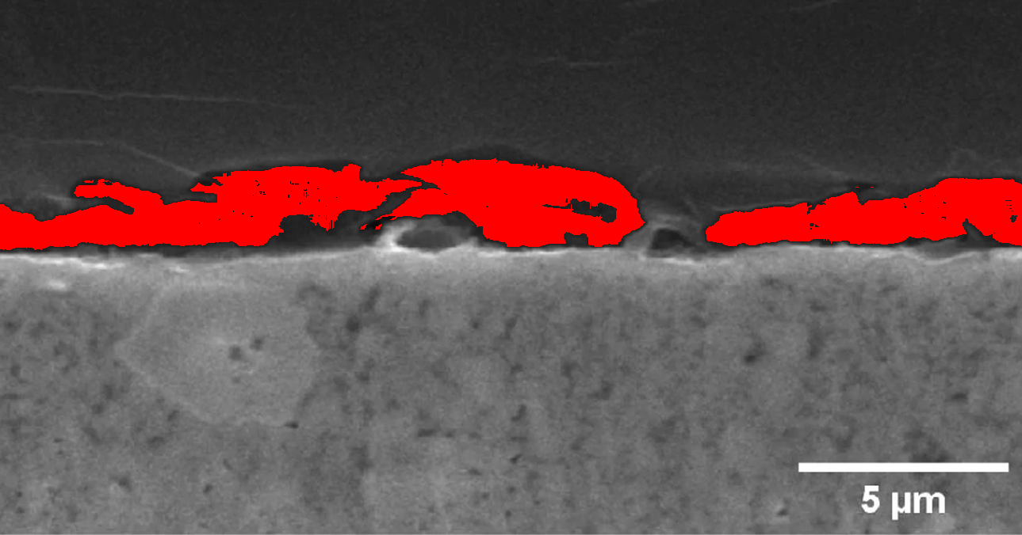
Figure: GAP pixels highlighted in red for Li_1
Analysis of the image with lithium concentration 1.0 revealed 74868 pixels meeting the GAP conditions. At this medium lithium concentration, a substantial number of GAP pixels (74868) were identified. The distribution shows more extensive patterning compared to lower concentrations, indicating significant structural changes associated with increased lithium content.

Image: Li_1.125 (Li Concentration: 1.125)
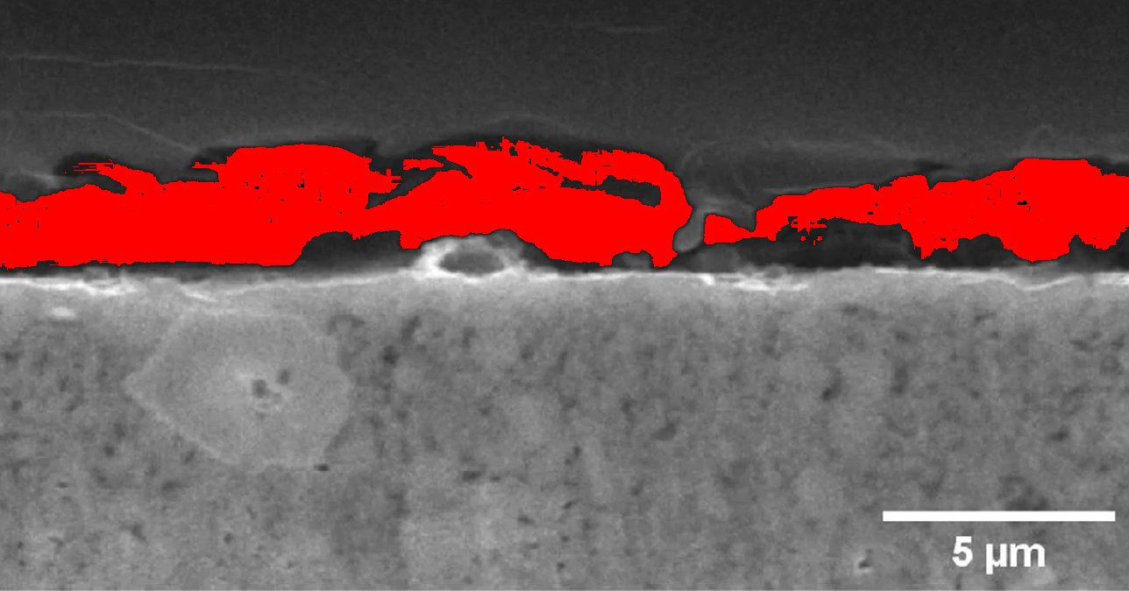
Figure: GAP pixels highlighted in red for Li_1.125
Analysis of the image with lithium concentration 1.125 revealed 105769 pixels meeting the GAP conditions. At this high lithium concentration, a very large number of GAP pixels (105769) were identified. The distribution is extensive and shows complex patterning, suggesting significant structural development associated with high lithium content.

Image: Li_1.25 (Li Concentration: 1.25)
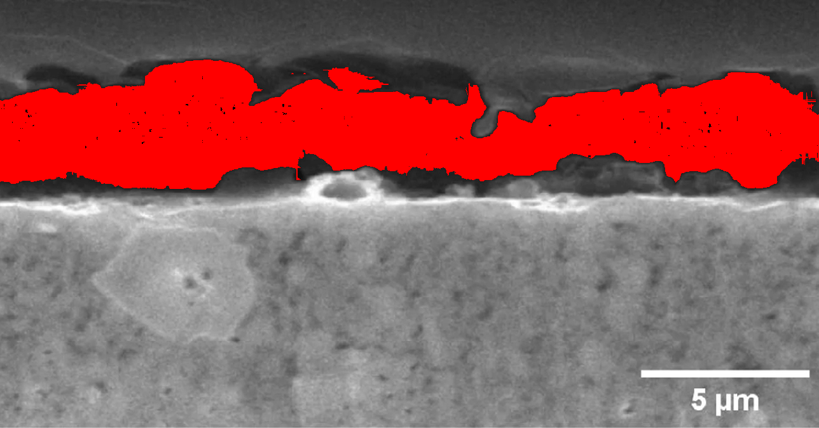
Figure: GAP pixels highlighted in red for Li_1.25
Analysis of the image with lithium concentration 1.25 revealed 171640 pixels meeting the GAP conditions. At this high lithium concentration, a very large number of GAP pixels (171640) were identified. The distribution is extensive and shows complex patterning, suggesting significant structural development associated with high lithium content.

Conclusion
The analysis of GAP pixels across different lithium concentrations reveals a clear trend: as lithium concentration increases, the number of pixels meeting the GAP conditions also increases. This relationship suggests that the structural patterns identified by the GAP conditions are directly related to lithium content in the material.
Key findings from this analysis include:
1. At zero lithium concentration (Li_0), no GAP pixels were detected
2. The number of GAP pixels increases monotonically with lithium concentration
3. The highest lithium concentration (Li_1.25) exhibits the largest number of GAP pixels (171,640)
4. The spatial distribution of GAP pixels shows distinct patterns that evolve with increasing lithium content
These findings provide valuable insights into how lithium concentration affects the structural properties captured in these images. The GAP pixel analysis method developed in this study offers a quantitative approach to identifying and analyzing specific patterns in grayscale images, which could be applied to various materials science and chemistry research contexts.
Future work could explore the relationship between these GAP pixel patterns and specific material properties or behaviors, potentially providing a bridge between image analysis and functional characteristics of lithium-containing materials.

