Simulation Report on GAP Pixel Analysis in Li_ Images

Abstract
This report documents the automated analysis of grayscale images with the 'Li_' prefix using a custom Python workflow. The analysis identifies GAP pixels based on grayscale thresholds and spatial continuity, quantifies GAP column heights, and generates annotated result images. The report provides an overview of the computational approach, summarizes the input parameters, and presents the resulting statistics and visuals.

Introduction
In high-precision image analysis, the identification of regions with specific grayscale characteristics is critical for material science and biomedical imaging. GAP pixels, defined by their grayscale value and spatial arrangement, can indicate important structural features. This simulation aims to automate the detection and quantification of such regions in a set of images prefixed with 'Li_'.

Methods
The procedure employs a Python program leveraging the Pillow (PIL) library for image processing, NumPy for pixel manipulation, and CSV for structured output. Each input image is converted to grayscale, after which pixels are evaluated for the GAP condition: grayscale value between 5 and 30 (inclusive) and the presence of at least one adjacent direction with 20 contiguous qualifying pixels. The program outputs per-pixel analysis CSV files, per-column GAP height data, summary statistics, and annotated images with GAP pixels highlighted in red. All results are organized per image in the specified output directory.

Results

Results for Li_0.125
Physical dimension parameter: 0.0187 μm/pixel
Max GAP height: 0.9724 μm
[No highlight image available]

Results for Li_0.125_GAP_highlight.png
Statistics not available.
GAP regions highlighted in red:
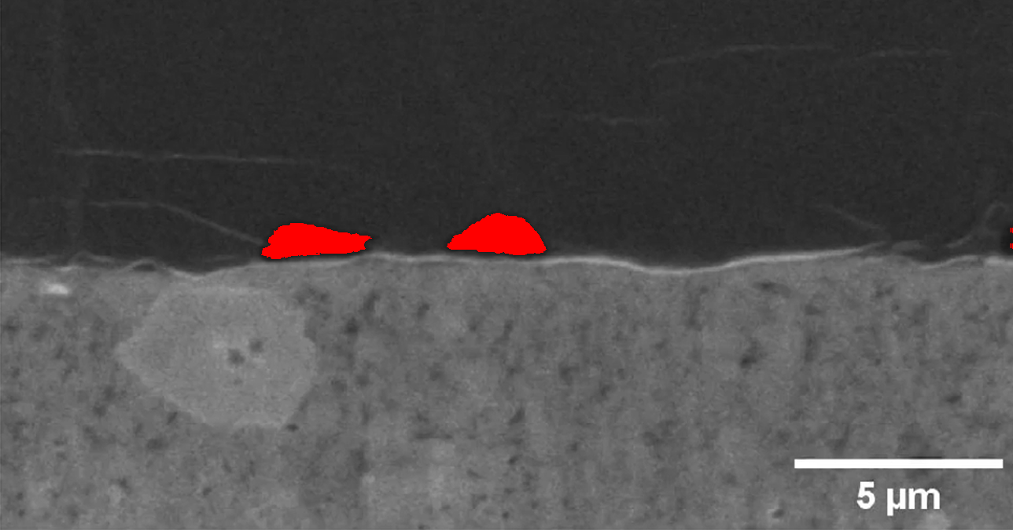

Results for Li_0.25
Physical dimension parameter: 0.0187 μm/pixel
Max GAP height: 1.2716 μm
[No highlight image available]

Results for Li_0.25_GAP_highlight.png
Statistics not available.
GAP regions highlighted in red:
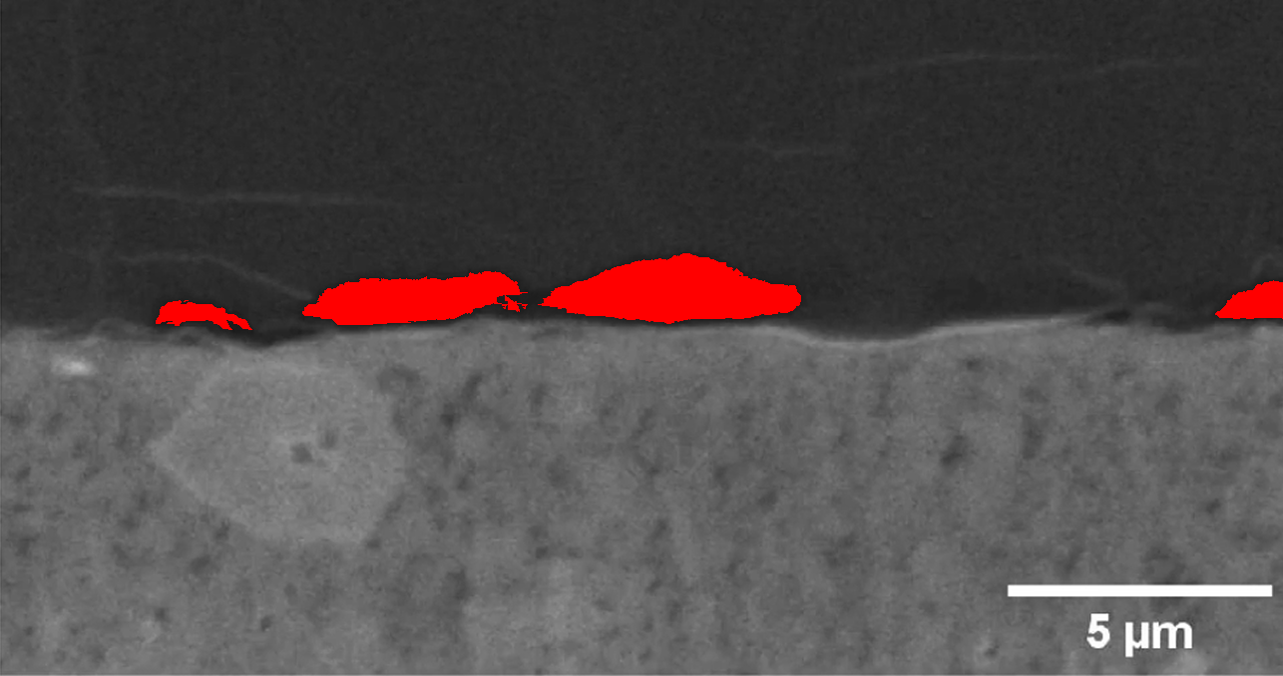

Results for Li_0.375
Physical dimension parameter: 0.0187 μm/pixel
Max GAP height: 1.4399 μm
[No highlight image available]

Results for Li_0.375_GAP_highlight.png
Statistics not available.
GAP regions highlighted in red:
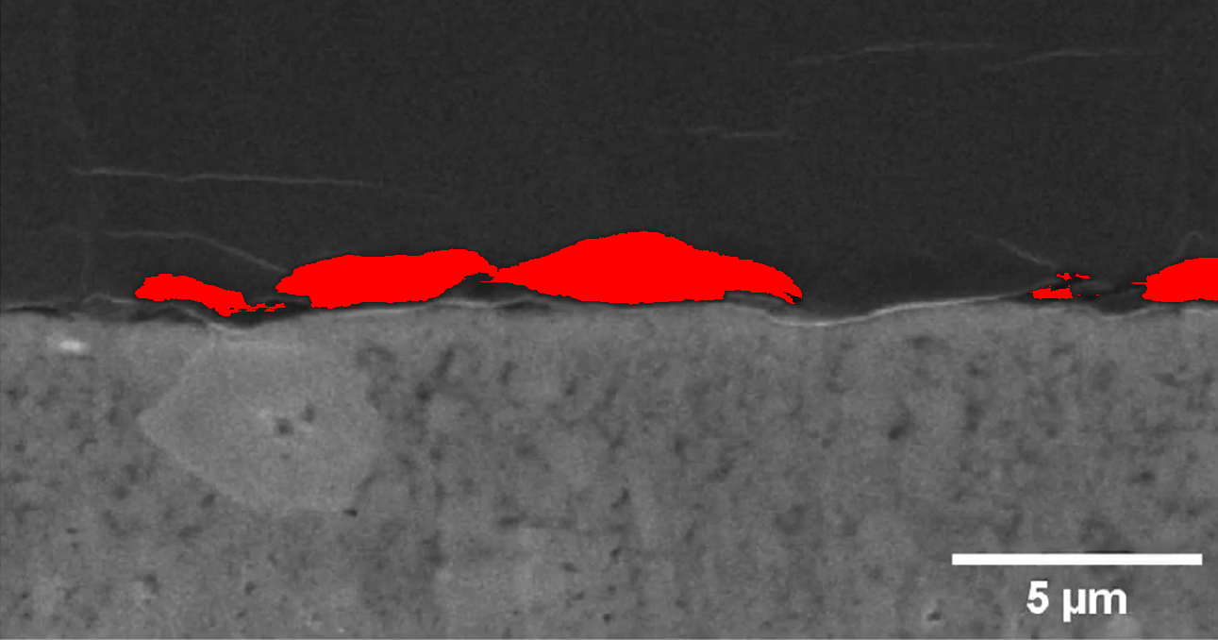

Results for Li_0.5
Physical dimension parameter: 0.0187 μm/pixel
Max GAP height: 1.5334 μm
[No highlight image available]

Results for Li_0.5_GAP_highlight.png
Statistics not available.
GAP regions highlighted in red:
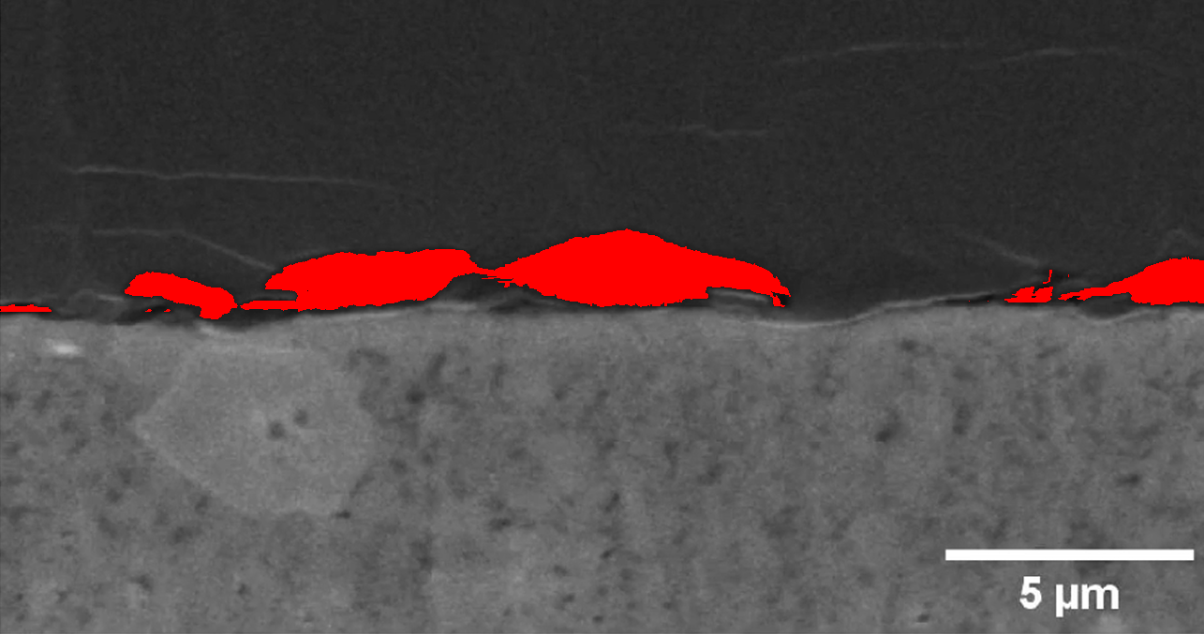

Results for Li_0.625
Physical dimension parameter: 0.0187 μm/pixel
Max GAP height: 1.7578 μm
[No highlight image available]

Results for Li_0.625_GAP_highlight.png
Statistics not available.
GAP regions highlighted in red:
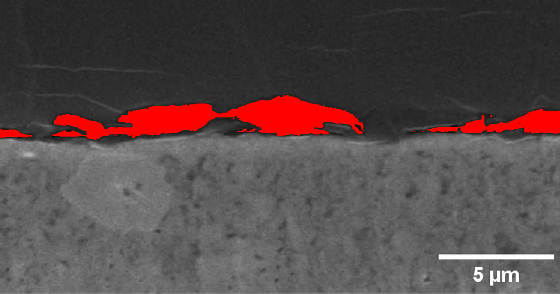

Results for Li_0.75
Physical dimension parameter: 0.0187 μm/pixel
Max GAP height: 1.7765 μm
[No highlight image available]

Results for Li_0.75_GAP_highlight.png
Statistics not available.
GAP regions highlighted in red:
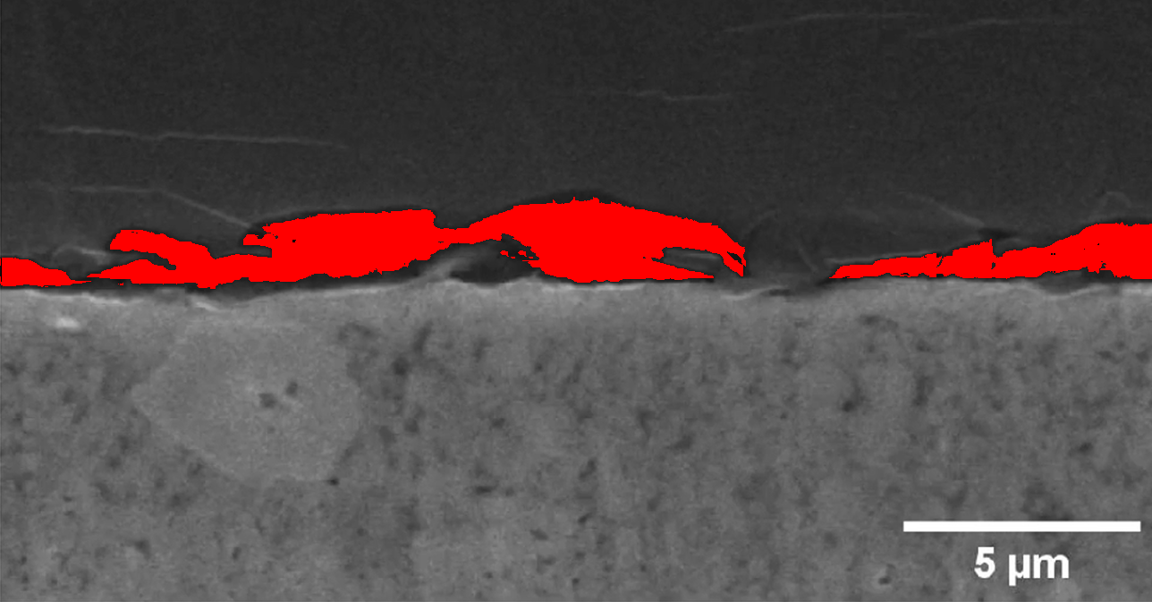

Results for Li_0.875
Physical dimension parameter: 0.0187 μm/pixel
Max GAP height: 1.8139 μm
[No highlight image available]

Results for Li_0.875_GAP_highlight.png
Statistics not available.
GAP regions highlighted in red:
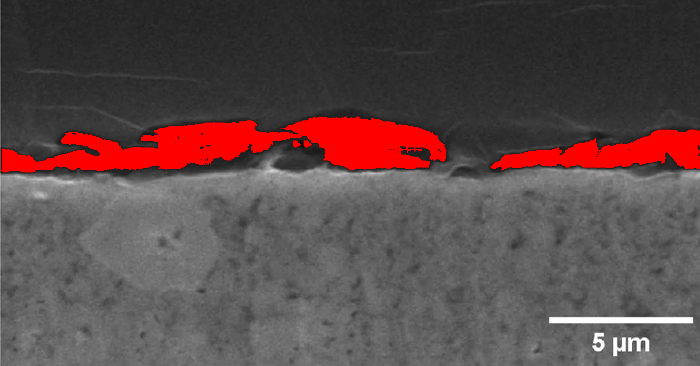

Results for Li_0
Physical dimension parameter: 0.0187 μm/pixel
Max GAP height: 0.0000 μm
[No highlight image available]

Results for Li_0_GAP_highlight.png
Statistics not available.
GAP regions highlighted in red:
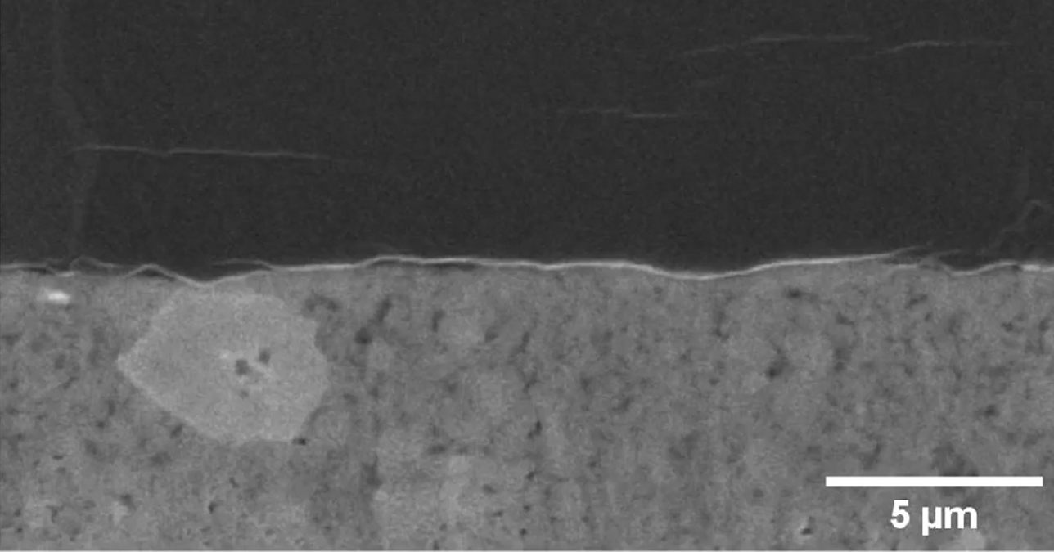

Results for Li_1.125
Physical dimension parameter: 0.0187 μm/pixel
Max GAP height: 2.5619 μm
[No highlight image available]

Results for Li_1.125_GAP_highlight.png
Statistics not available.
GAP regions highlighted in red:
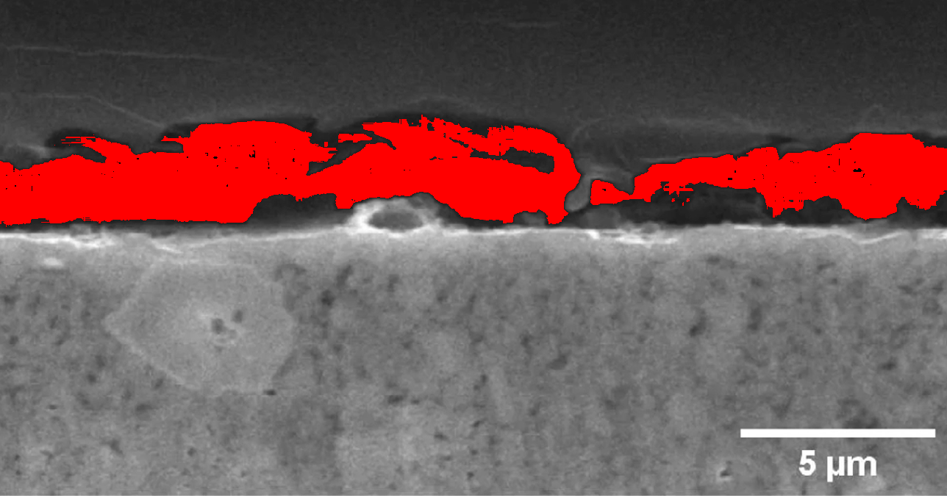

Results for Li_1.25
Physical dimension parameter: 0.0187 μm/pixel
Max GAP height: 3.8335 μm
[No highlight image available]

Results for Li_1.25_GAP_highlight.png
Statistics not available.
GAP regions highlighted in red:
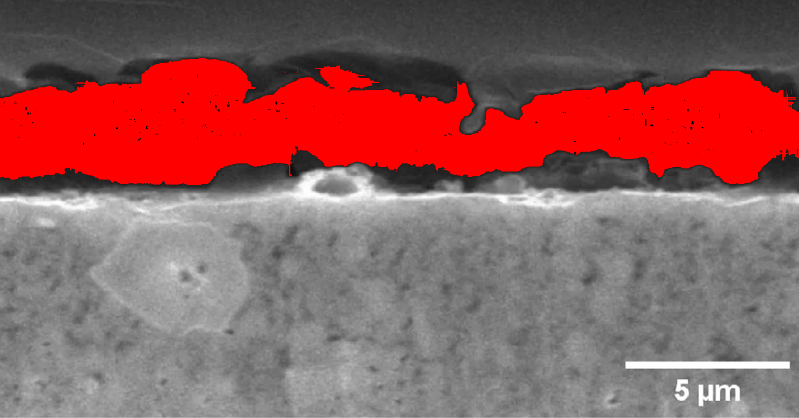

Results for Li_1
Physical dimension parameter: 0.0187 μm/pixel
Max GAP height: 2.0196 μm
[No highlight image available]

Results for Li_1_GAP_highlight.png
Statistics not available.
GAP regions highlighted in red:
