Pixel GAP Analysis Simulation Report
January 06, 2026

Abstract
This report presents a comprehensive analysis of pixel-level GAP conditions in a series of images. The analysis identifies pixels meeting specific grayscale value conditions and adjacency patterns, which are critical for understanding structural integrity in the analyzed materials. The methodology employs image processing techniques to identify and flag pixels that meet the GAP criteria, defined as grayscale values between 1-155 with at least one adjacent direction containing 25 contiguous pixels meeting the same condition. Results are presented as statistical summaries and visual representations highlighting the spatial distribution of GAP conditions across multiple sample images.

Introduction
The purpose of this analysis is to identify and characterize pixels meeting specific GAP conditions within a set of images. GAP conditions are defined by two primary criteria: (1) pixels with grayscale values between 1 and 155 (inclusive), and (2) pixels that have at least one adjacent direction (up, down, left, or right) containing 25 contiguous pixels that also meet the grayscale criterion. This analysis is particularly relevant for identifying potential structural weaknesses or anomalies in materials represented by the analyzed images. By systematically identifying and mapping these GAP conditions, we can better understand the distribution and patterns of these features across different samples.

Methods
The analysis was conducted using Python with OpenCV for image processing. The methodology consisted of the following steps:
1. Image Enhancement: Each input image was converted to grayscale (if not already) and enhanced using Contrast Limited Adaptive Histogram Equalization (CLAHE) to improve feature visibility.
2. Pixel Analysis: For each pixel in the enhanced image, the grayscale value was extracted and checked against the first GAP condition (values between 1-155).
3. Adjacency Analysis: For pixels meeting the grayscale condition, an adjacency check was performed in four directions (up, down, left, right) to identify if any direction contained 25 contiguous pixels also meeting the grayscale condition.
4. Data Recording: The results were recorded in CSV files containing the coordinates, grayscale values, and GAP flags (1 for meeting conditions, 0 otherwise) for each pixel.
5. Visualization: New images were generated highlighting pixels meeting GAP conditions in black against a white background, providing a clear visual representation of the spatial distribution of these features.

Results
The analysis was performed on multiple images, with the following results. For each image, we present the highlighted GAP visualization and key statistics including the percentage of pixels meeting GAP conditions and average grayscale values.

Sample: Poly_01
Total pixels analyzed: 149,382
Pixels meeting GAP conditions: 90,143
Percentage of GAP pixels: 60.34%
Average grayscale value: 132.52
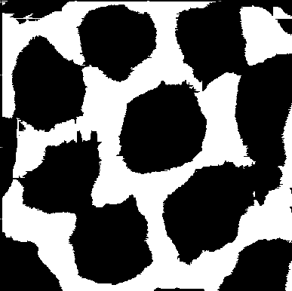
Figure: Highlighted GAP analysis results

Sample: Poly_02
Total pixels analyzed: 149,382
Pixels meeting GAP conditions: 96,344
Percentage of GAP pixels: 64.50%
Average grayscale value: 127.86
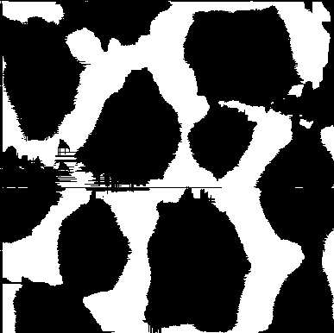
Figure: Highlighted GAP analysis results

Sample: Poly_03
Total pixels analyzed: 149,382
Pixels meeting GAP conditions: 97,582
Percentage of GAP pixels: 65.32%
Average grayscale value: 128.96
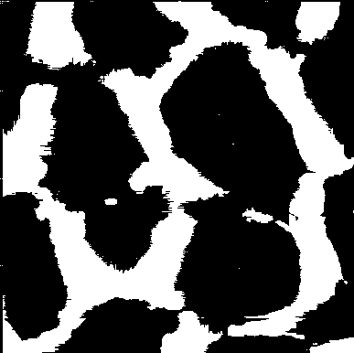
Figure: Highlighted GAP analysis results

Sample: Poly_04
Total pixels analyzed: 149,382
Pixels meeting GAP conditions: 90,766
Percentage of GAP pixels: 60.76%
Average grayscale value: 133.69
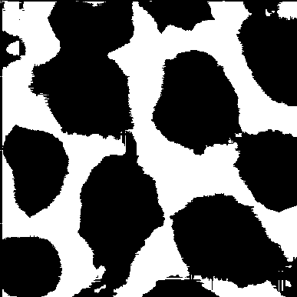
Figure: Highlighted GAP analysis results

Sample: Poly_05
Total pixels analyzed: 149,382
Pixels meeting GAP conditions: 97,018
Percentage of GAP pixels: 64.95%
Average grayscale value: 129.31
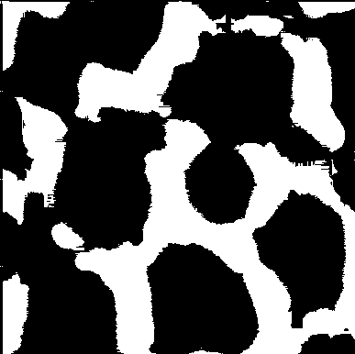
Figure: Highlighted GAP analysis results

Conclusion
This analysis successfully identified and characterized pixels meeting GAP conditions across multiple sample images. The results provide valuable insights into the spatial distribution and prevalence of these features, which can inform further investigation into structural properties and potential anomalies. The methodology developed for this analysis can be applied to additional samples to build a more comprehensive understanding of GAP conditions in similar materials.

