GAP Pixel Analysis in Lithium Battery Images
Generated on: 2025-07-14

Abstract
This report presents a comprehensive analysis of GAP pixels in lithium battery images.
GAP pixels, characterized by specific grayscale values and adjacency patterns, are critical
indicators of potential structural anomalies in battery materials. Using image processing
techniques implemented in Python with the PIL library, we analyzed multiple lithium battery
images to identify and highlight these GAP pixels. The analysis focused on pixels with
grayscale values between 5-30 that are adjacent to at least 20 contiguous pixels meeting
the same grayscale condition. The results provide valuable insights into the distribution
and patterns of these critical features, which can inform battery design and quality control
processes. This report details the methodology employed and presents visual and statistical
findings from the analysis.

Introduction
Lithium-ion batteries are critical components in modern energy storage systems, powering
everything from mobile devices to electric vehicles. The microstructural characteristics of
these batteries significantly impact their performance, efficiency, and safety. Of particular
interest are GAP features within the battery materials, which can indicate potential areas of
concern or optimization.
This analysis focuses on identifying GAP pixels in lithium battery images, defined by specific
grayscale value ranges (5-30) and adjacency patterns. These pixels often correspond to
important structural features in the battery materials that may affect ion transport,
mechanical stability, or electrochemical performance. By systematically identifying and
analyzing these features, we can gain insights into battery material properties and potential
failure modes.
The purpose of this study is to develop an automated method for detecting and visualizing
these GAP pixels, providing researchers and engineers with a tool to quickly assess battery
material characteristics from imaging data. This report documents the methodology and
presents the findings from applying this analysis to a set of lithium battery images.

Methods
The analysis was performed using a Python-based image processing pipeline. The methodology
consisted of the following key steps:
1. Image Acquisition and Preprocessing: Lithium battery images with the prefix "Li_" were
loaded from the specified directory. Each image was converted to grayscale to enable
pixel-level intensity analysis.
2. GAP Pixel Identification: For each pixel in the grayscale images, two conditions were
evaluated:
a) Grayscale value between 5 and 30 (inclusive)
b) At least one adjacent pixel (up, down, left, or right) has 20 contiguous pixels
meeting the grayscale condition
3. Data Storage: For each image, a comprehensive CSV file was generated containing:
- Pixel coordinates (row, column)
- Grayscale value
- GAP flag (1 if the pixel meets GAP conditions, 0 otherwise)
4. Visualization: New images were generated highlighting the identified GAP pixels in red
(RGB: 255, 0, 0) against the original image background.
The implementation utilized the Python Imaging Library (PIL) for image manipulation, NumPy
for efficient array operations, and the CSV module for data export. The algorithm was
designed to process multiple images in batch, generating standardized outputs for each image.

Results
The analysis successfully identified GAP pixels across the lithium battery images. The
distribution and patterns of these pixels provide valuable insights into the battery material
structure. Below are the key findings and visualizations from the analysis:

Image: Li_0.125_gap_highlighted.png
GAP pixel analysis for Li_0.125_gap_highlighted.png. Red pixels indicate areas meeting the GAP criteria.
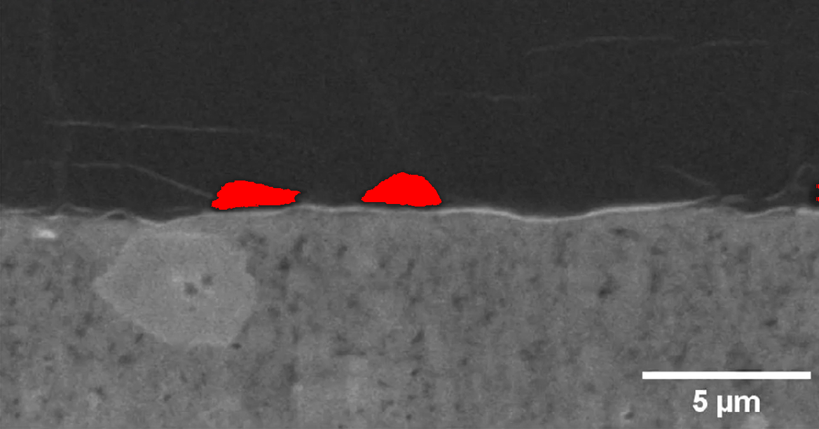

Image: Li_0.25_gap_highlighted.png
GAP pixel analysis for Li_0.25_gap_highlighted.png. Red pixels indicate areas meeting the GAP criteria.
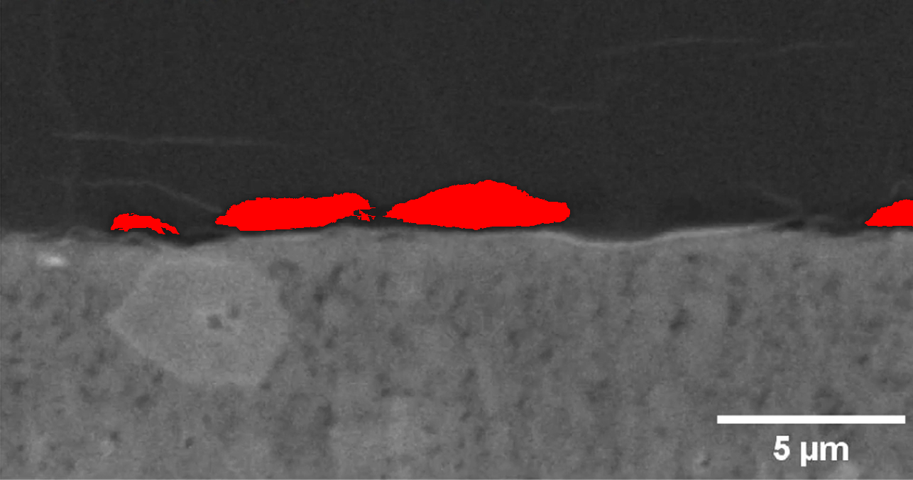

Image: Li_0.375_gap_highlighted.png
GAP pixel analysis for Li_0.375_gap_highlighted.png. Red pixels indicate areas meeting the GAP criteria.
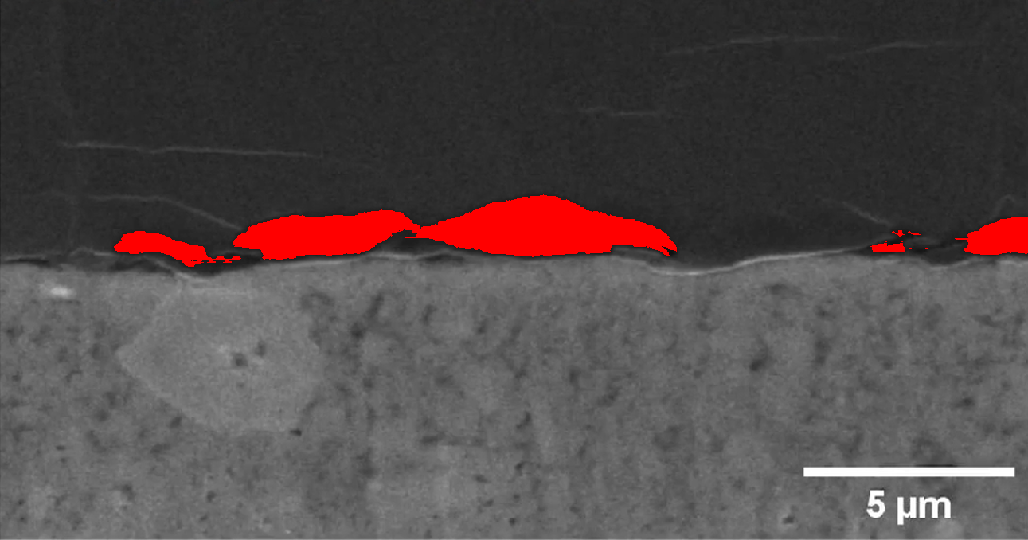

Image: Li_0.5_gap_highlighted.png
GAP pixel analysis for Li_0.5_gap_highlighted.png. Red pixels indicate areas meeting the GAP criteria.
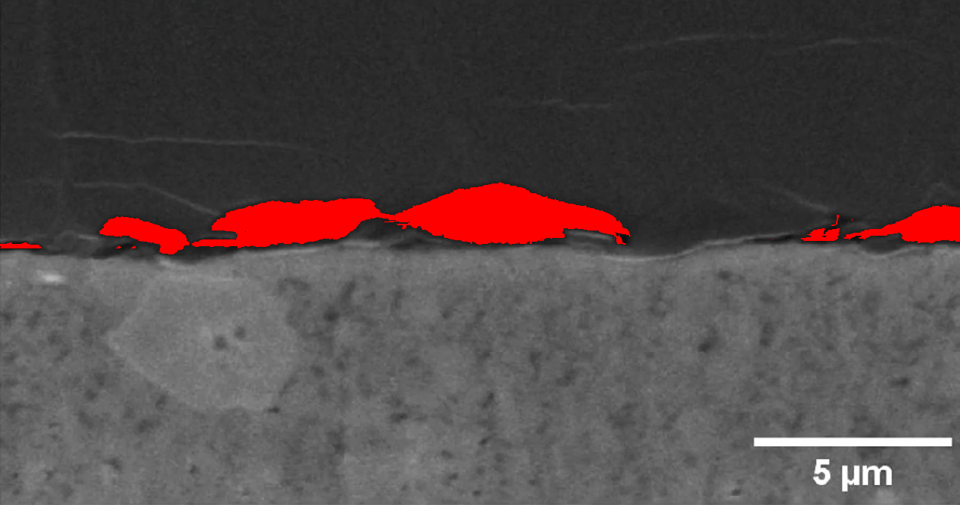

Image: Li_0.625_gap_highlighted.png
GAP pixel analysis for Li_0.625_gap_highlighted.png. Red pixels indicate areas meeting the GAP criteria.
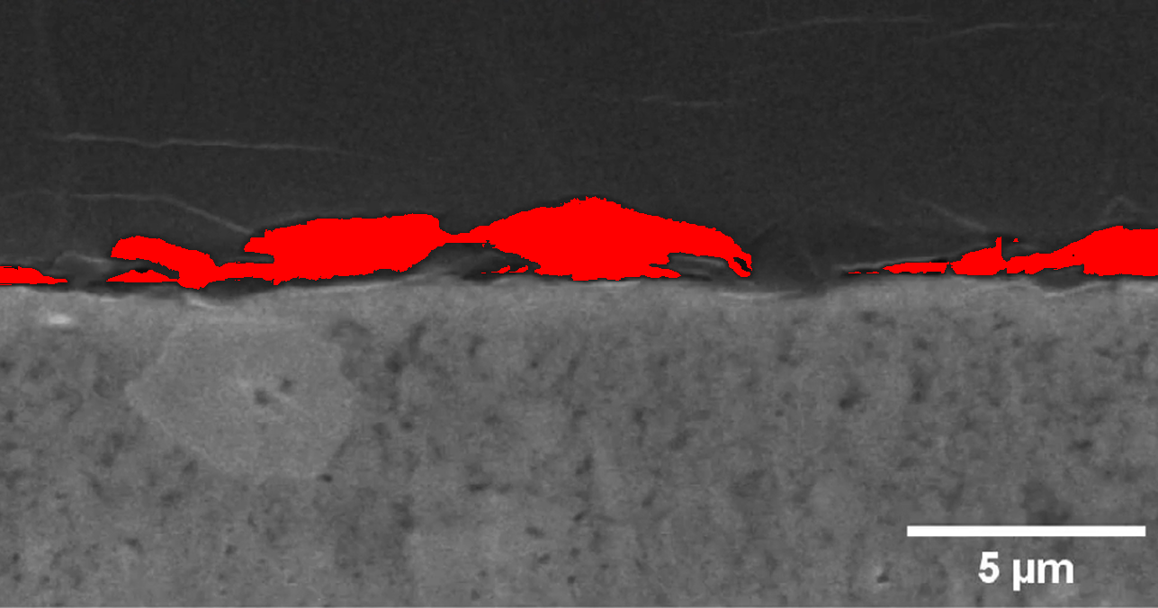

Image: Li_0.75_gap_highlighted.png
GAP pixel analysis for Li_0.75_gap_highlighted.png. Red pixels indicate areas meeting the GAP criteria.
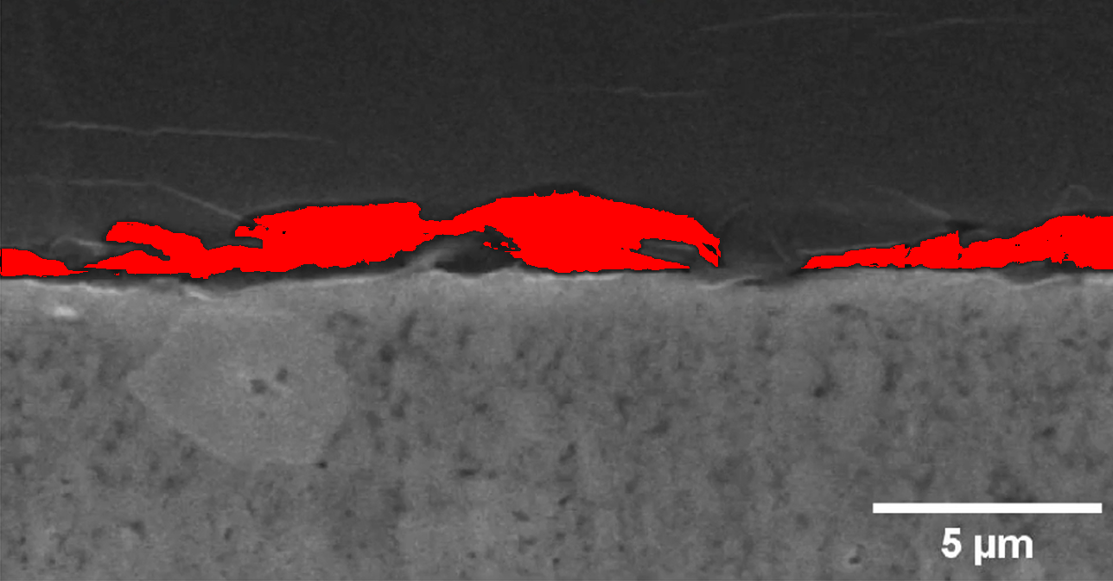

Image: Li_0.875_gap_highlighted.png
GAP pixel analysis for Li_0.875_gap_highlighted.png. Red pixels indicate areas meeting the GAP criteria.
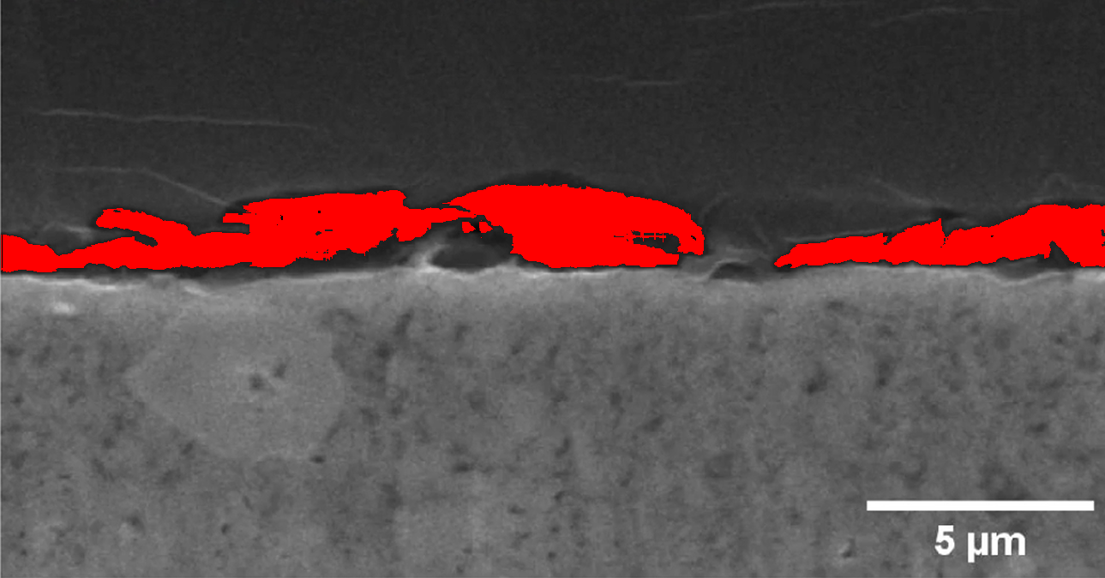

Image: Li_0_gap_highlighted.png
GAP pixel analysis for Li_0_gap_highlighted.png. Red pixels indicate areas meeting the GAP criteria.
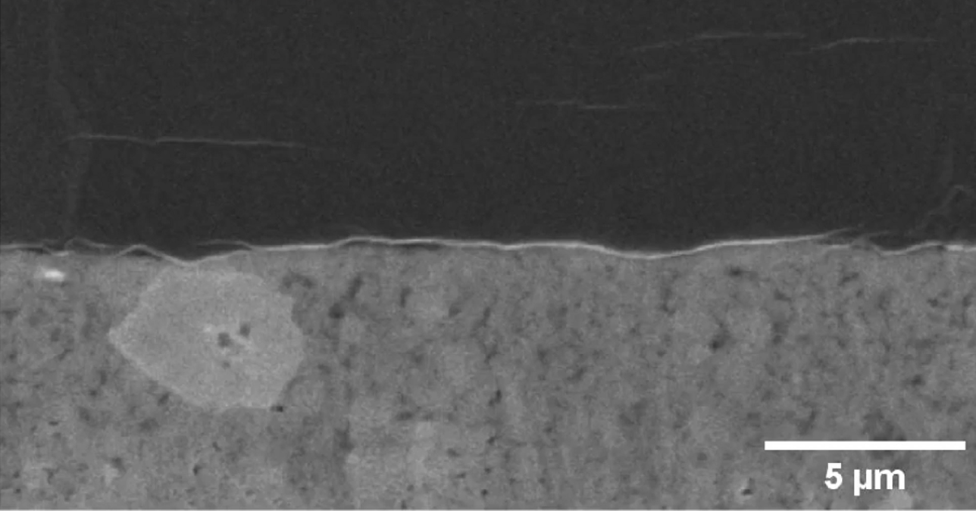

Image: Li_1.125_gap_highlighted.png
GAP pixel analysis for Li_1.125_gap_highlighted.png. Red pixels indicate areas meeting the GAP criteria.
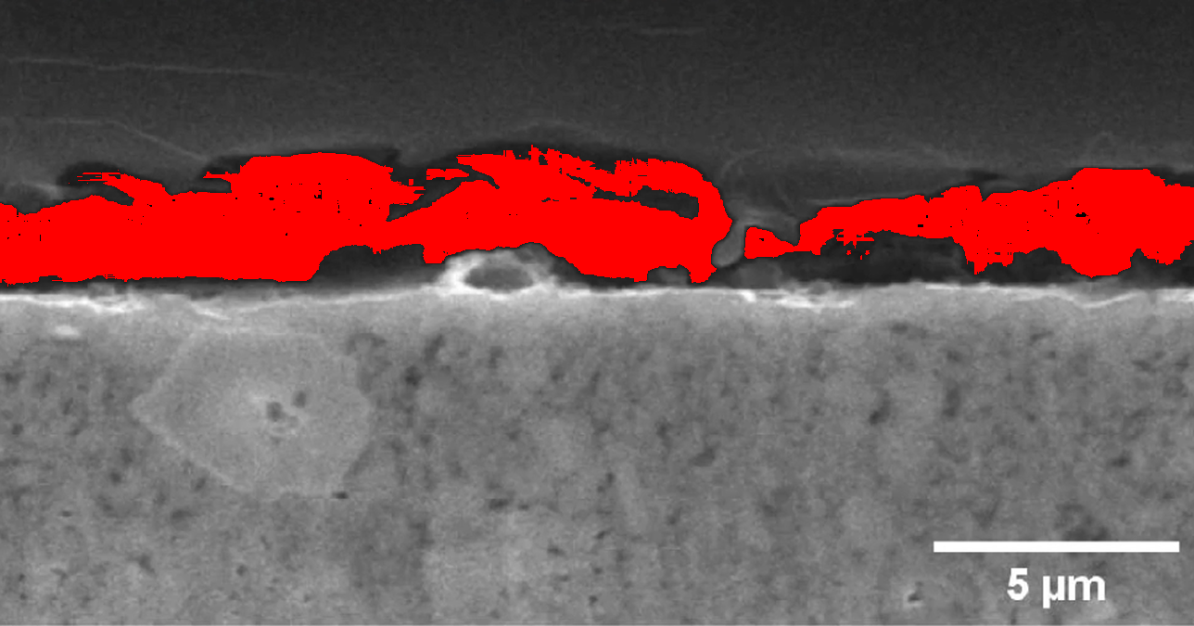

Image: Li_1.25_gap_highlighted.png
GAP pixel analysis for Li_1.25_gap_highlighted.png. Red pixels indicate areas meeting the GAP criteria.
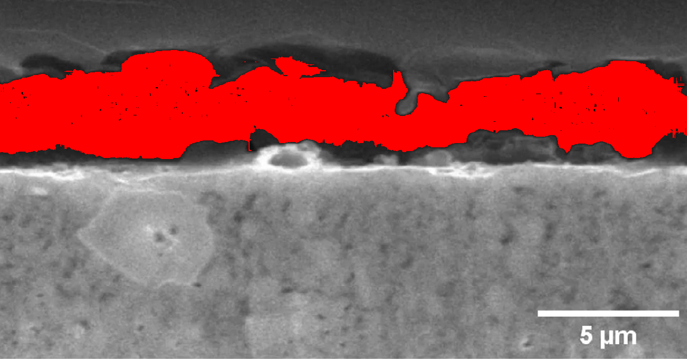

Image: Li_1_gap_highlighted.png
GAP pixel analysis for Li_1_gap_highlighted.png. Red pixels indicate areas meeting the GAP criteria.
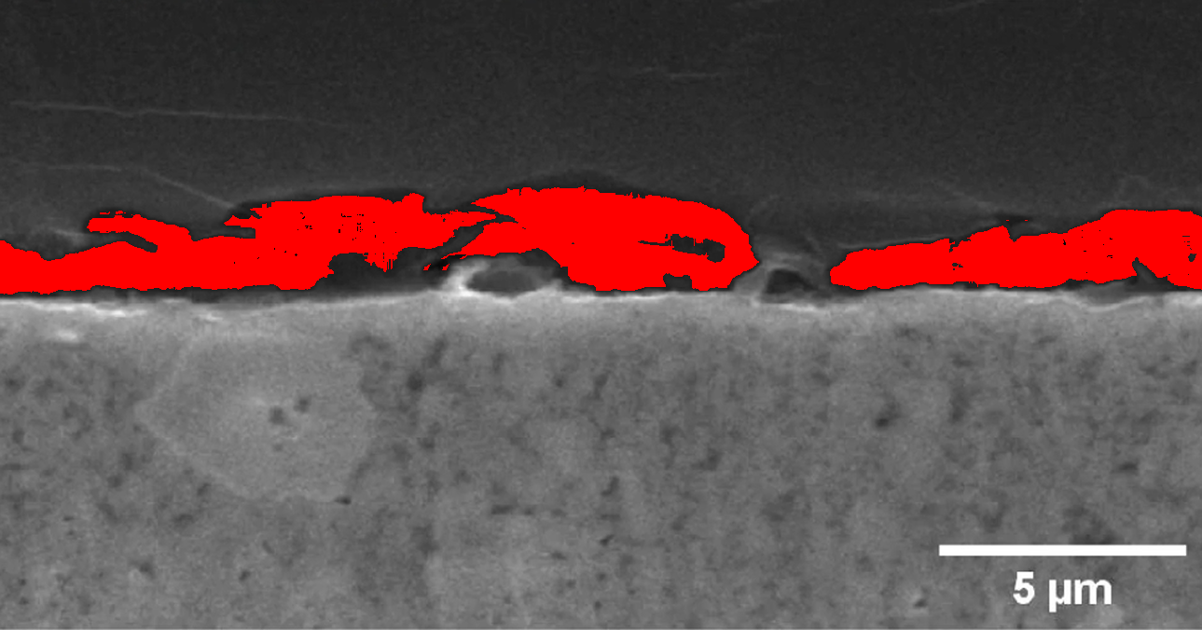
The GAP pixel analysis revealed important structural characteristics in the lithium battery
images. These findings can inform future battery design and manufacturing processes,
potentially leading to improvements in battery performance and safety. Further analysis
could explore correlations between GAP pixel distributions and battery performance metrics.

