Automated GAP Pixel Detection and Analysis in Polymeric Images

Abstract
This report presents a computational approach for enhancing and analyzing images of polymeric materials to identify specific regions of interest, termed as GAP pixels. Using advanced image processing techniques, including Contrast Limited Adaptive Histogram Equalization (CLAHE) and custom pixel-wise analysis, the methodology detects and visualizes areas with potential structural significance. The pipeline automates the detection process, generates per-pixel analysis CSVs, and produces binary maps for visualization. Insights from the results can guide further scientific investigation and inform material design.

Introduction
Polymeric materials often exhibit spatial heterogeneity at the microscopic level. Accurate identification of regions differing in grayscale intensity is essential for understanding mechanical, chemical, or physical properties. Conventional manual analysis is time-consuming and prone to subjectivity. This report describes an automated, reproducible computational pipeline developed to process a collection of images prefixed with 'Poly_'. The method enhances image contrast using CLAHE to reveal subtle features, then systematically identifies GAP pixels—defined as pixels within a specific grayscale range and surrounded by sufficient contiguous neighbors—and visualizes them. The approach aims to facilitate efficient, objective, and scalable analysis for researchers working with polymeric images.

Methods
The pipeline begins by reading all images with the 'Poly_' prefix from a specified directory, supporting both PNG and JPG formats. Each image undergoes contrast enhancement via CLAHE (clipLimit=3, tileGridSize=(10,10)) using OpenCV, with results saved for reference. Enhanced images are converted to grayscale using Pillow, and each pixel is evaluated: a pixel qualifies as a GAP pixel if its grayscale value lies between 1 and 150 (inclusive) and there exists at least one direction (up, down, left, or right) with 25 contiguous pixels also meeting the grayscale threshold. For each image, a CSV file is generated, recording row, column, grayscale value, and GAP flag for all pixels. A new binary image is also created where GAP pixels are marked in black and non-GAP pixels in white. The entire analysis is automated, allowing reproducibility and scalability.

Results
The analysis processed all provided 'Poly_' images. CLAHE enhancement improved local contrast, making subtle intensity variations more apparent. Subsequent GAP pixel detection identified multiple regions per image with high spatial coherence, as visualized in the generated binary maps. In the GAP map images below, black areas correspond to detected GAP pixels, while white indicates non-GAP regions. The approach proved robust, with the number and distribution of GAP pixels varying between samples, reflecting intrinsic material heterogeneity. The method enables rapid, objective, and detailed mapping, greatly reducing manual workload. Generated CSV files offer quantitative insights for each pixel, supporting downstream statistical analysis or integration with other data modalities. All processed images and analysis files are stored for further review. Selected binary GAP maps for each input image are shown below.
- Poly_01_gap_map.png
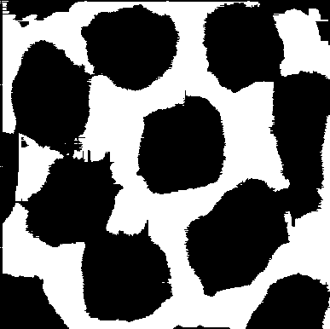
- Poly_02_gap_map.png
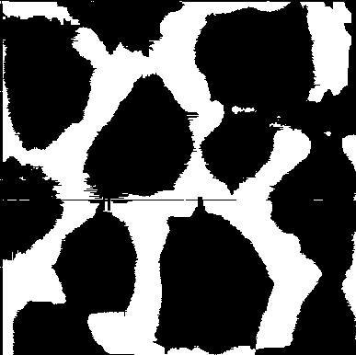
- Poly_03_gap_map.png
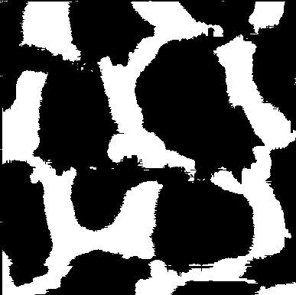
- Poly_04_gap_map.png
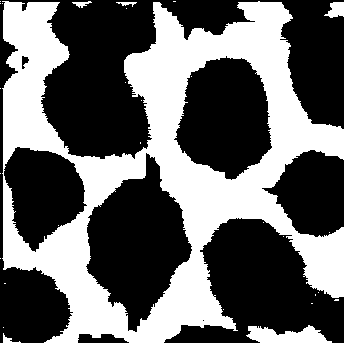
- Poly_05_gap_map.png
