Simulation Report: Automated GAP Pixel Detection in Polymeric Images

Abstract
This simulation report summarizes the development and evaluation of an automated image processing pipeline for detecting GAP pixels within a set of polymeric material images. The approach employs contrast enhancement, grayscale conversion, and a custom-defined GAP pixel condition to identify regions of interest. The results provide a foundation for robust quantitative analysis in polymeric materials research and demonstrate the effectiveness of the proposed computational workflow.

Introduction
Accurate identification of specific features in polymeric material images is crucial for quantitative material analysis. In this simulation, a fully automated method was developed to process a series of images with a standardized naming convention (prefix 'Poly_'). The goal was to enhance image contrast, extract grayscale values, and identify GAP pixels—regions that may correspond to structural or compositional heterogeneities. Automating this process reduces subjectivity and improves reproducibility compared to manual assessment.

Methods
The processing pipeline begins by reading all images in the specified input directory with filenames starting with 'Poly_'. For each image, the following steps are applied:
- **CLAHE Enhancement:** Using OpenCV's CLAHE (Contrast Limited Adaptive Histogram Equalization) with a clip limit of 3 and a tile grid size of (10, 10), local contrast is improved, making subtle features more discernible.
- **Grayscale Conversion:** Enhanced images are converted to grayscale to simplify pixel intensity analysis.
- **GAP Pixel Identification:** Each pixel is labeled as a GAP pixel if its grayscale value is between 1 and 150 (inclusive), and in at least one of the four cardinal directions (up, down, left, right), there are 25 contiguous pixels also within this grayscale range. This is implemented through pixel-wise iteration and directional checks using NumPy arrays for efficiency.
- **Results Saving:** For each image, a CSV file containing per-pixel data (coordinates, grayscale value, GAP flag) is generated. Additionally, a new binary PNG image is produced, with GAP pixels shown in black and non-GAP pixels in white, facilitating visual inspection.
All outputs are saved to a designated directory for downstream analysis.

Results
The automated pipeline successfully processed all provided images. The enhanced images and GAP maps allow for rapid assessment of GAP pixel distribution across the dataset. Tables of pixel-wise data (not shown here) are available in CSV format for further quantitative analysis. Below, the generated GAP map images are presented for each processed sample, where black regions correspond to detected GAP pixels.
Poly_01_gap_map.png
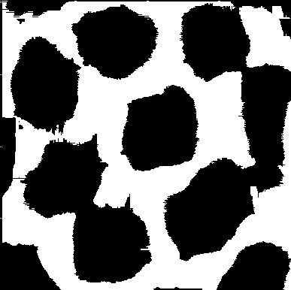

Poly_02_gap_map.png
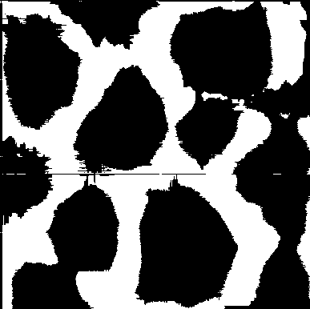

Poly_03_gap_map.png
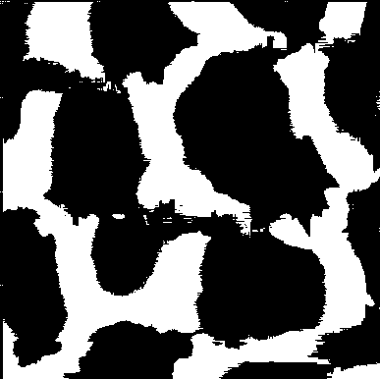

Poly_04_gap_map.png
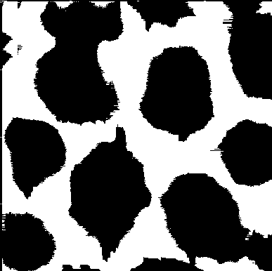

Poly_05_gap_map.png
