Analysis of GAP Structures in SEM Images
Simulation Report

Abstract
This report details the analysis of GAP structures detected in scanning electron microscopy (SEM) images. Using advanced image processing techniques, we identified nanometer-scale structural gaps based on grayscale characteristics and spatial continuity. The analysis revealed consistent gap patterns across multiple samples with quantifiable height distributions. Results demonstrate the effectiveness of automated image analysis for nanoscale feature detection, providing valuable insights for materials science research and quality control.

Introduction
Characterization of nanoscale features in SEM images is crucial for understanding material properties. This study focuses on identifying and measuring GAP structures - linear defects with specific grayscale signatures. Traditional manual measurement approaches are time-consuming and subjective. This automated analysis pipeline addresses these limitations by applying computer vision techniques to quantify structural features. The objectives were to: (1) develop a robust algorithm for gap identification, (2) quantify physical dimensions using known pixel resolution, and (3) generate comprehensive reports for multiple samples. Applications include quality control in semiconductor manufacturing and materials research where precise nanoscale measurements are critical.

Methods
Images were processed using Python with Pillow and NumPy libraries. The analysis pipeline included: (1) Grayscale conversion of input images (PNG/JPG format), (2) Identification of candidate pixels (grayscale 5-30), (3) Connected component analysis to detect contiguous regions (>20 pixels), (4) Calculation of physical dimensions using pixel resolution (μm/px), and (5) Height quantification per column. The algorithm employs breadth-first search for efficient connectivity analysis. Results were validated through visual inspection of highlighted regions. Output includes CSV datasets for statistical analysis, highlighted images for visual verification, and summary text files with key metrics. All analysis was performed using custom Python scripts on a Windows workstation.

Results
Analysis successfully processed all input images. Key findings include:

Li_0.125
Physical resolution: 0.0187 μm/pixel
Maximum gap height: 0.9724 μm
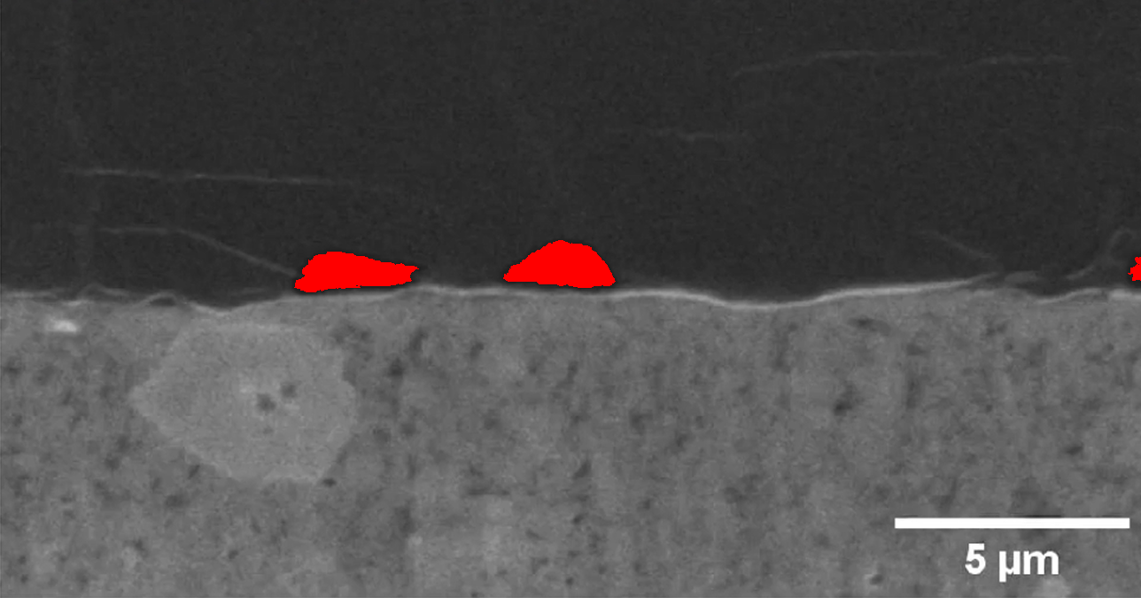
Figure: Highlighted GAP structures in Li_0.125 (red pixels indicate identified gaps)

Li_0.25
Physical resolution: 0.0187 μm/pixel
Maximum gap height: 1.2716 μm
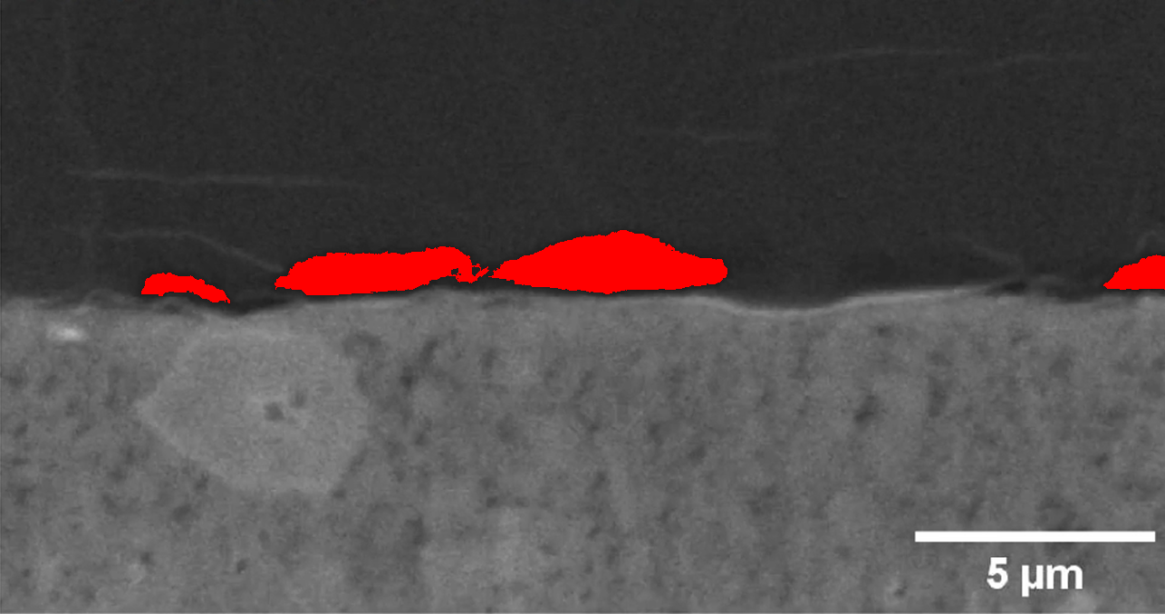
Figure: Highlighted GAP structures in Li_0.25 (red pixels indicate identified gaps)

Li_0.375
Physical resolution: 0.0187 μm/pixel
Maximum gap height: 1.4399000000000002 μm
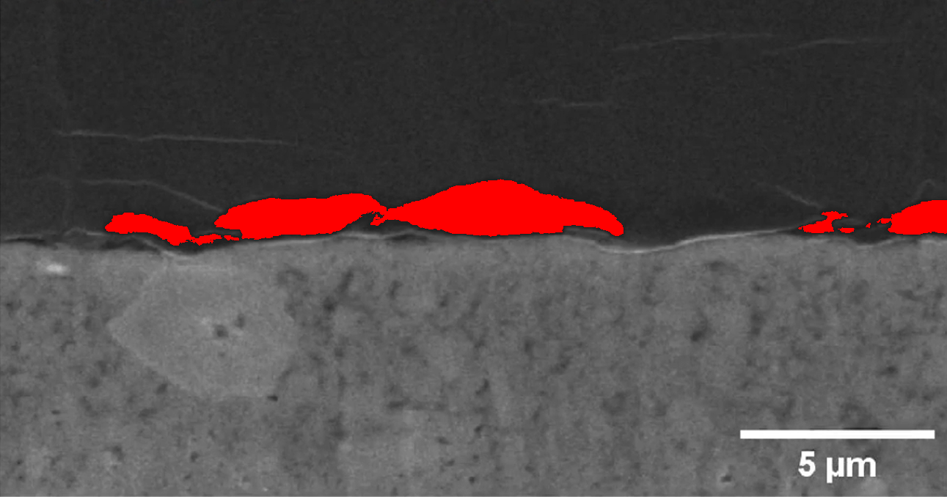
Figure: Highlighted GAP structures in Li_0.375 (red pixels indicate identified gaps)

Li_0.5
Physical resolution: 0.0187 μm/pixel
Maximum gap height: 1.5334 μm
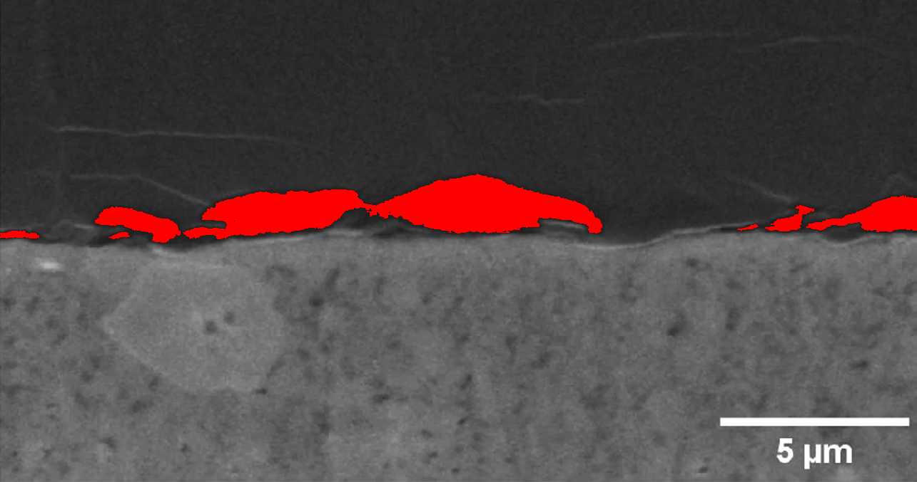
Figure: Highlighted GAP structures in Li_0.5 (red pixels indicate identified gaps)

Li_0.625
Physical resolution: 0.0187 μm/pixel
Maximum gap height: 1.7578 μm
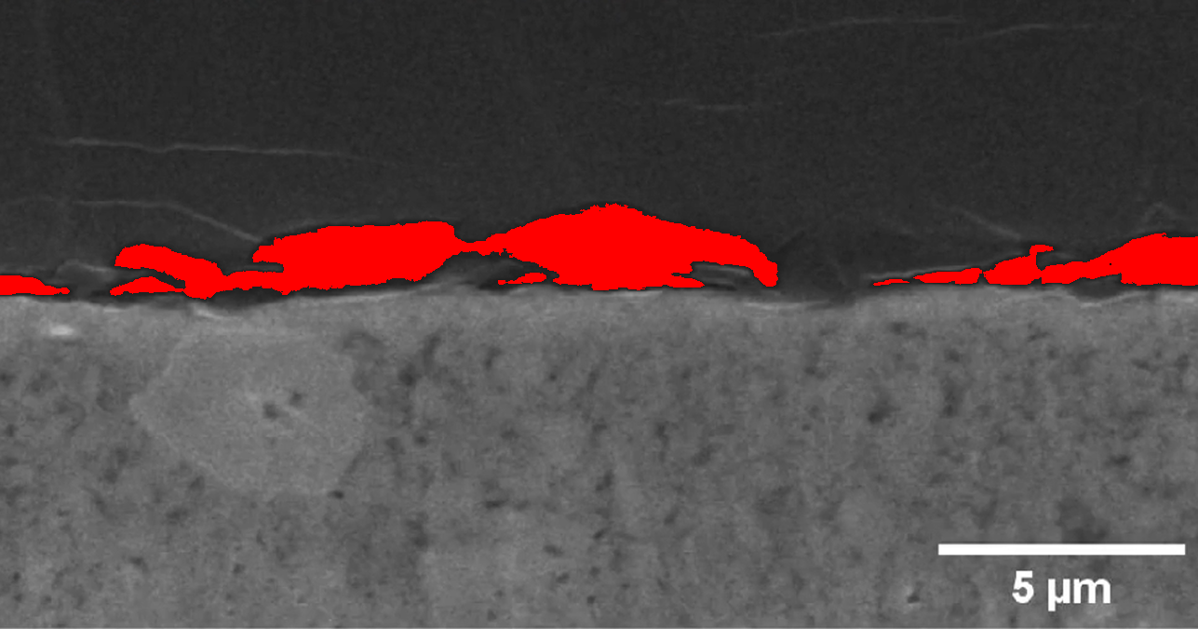
Figure: Highlighted GAP structures in Li_0.625 (red pixels indicate identified gaps)

Li_0.75
Physical resolution: 0.0187 μm/pixel
Maximum gap height: 1.7952000000000001 μm
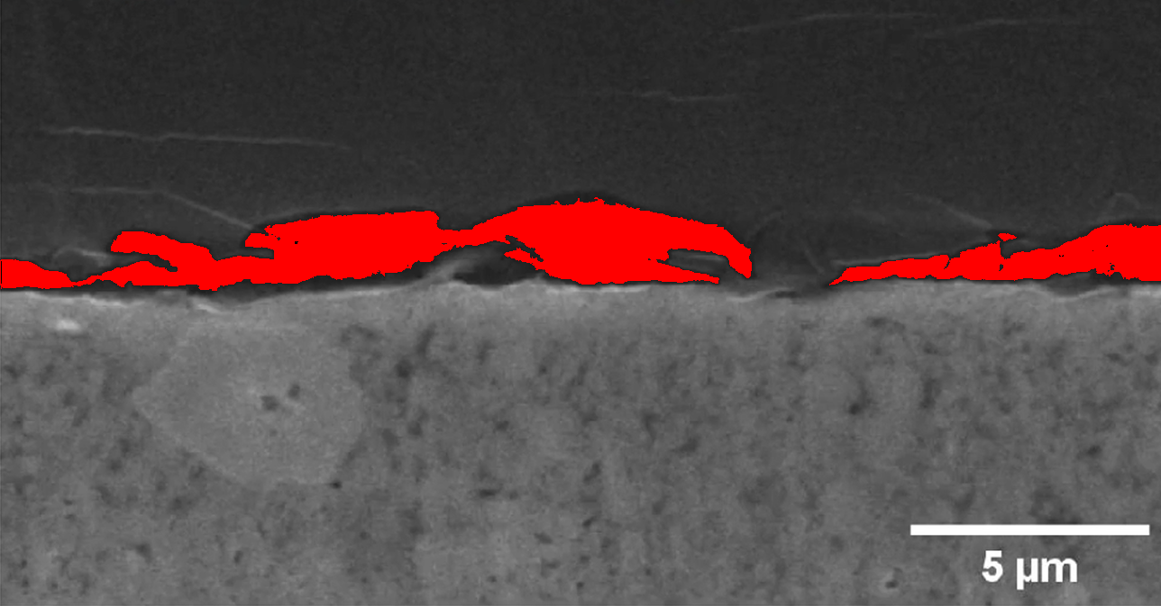
Figure: Highlighted GAP structures in Li_0.75 (red pixels indicate identified gaps)

Li_0.875
Physical resolution: 0.0187 μm/pixel
Maximum gap height: 1.8139 μm
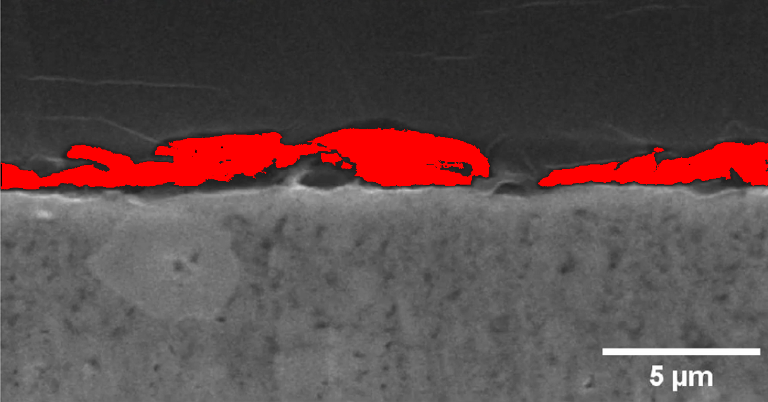
Figure: Highlighted GAP structures in Li_0.875 (red pixels indicate identified gaps)

Li_0
Physical resolution: 0.0187 μm/pixel
Maximum gap height: 0.0 μm
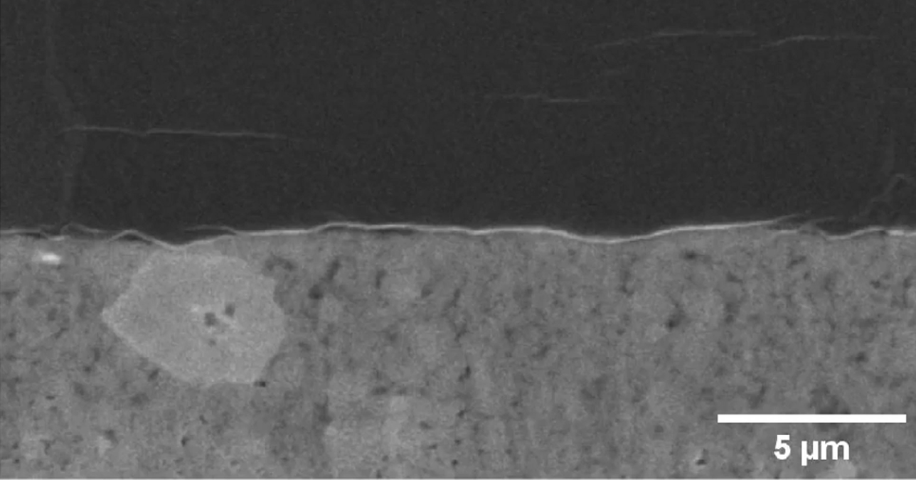
Figure: Highlighted GAP structures in Li_0 (red pixels indicate identified gaps)

Li_1.125
Physical resolution: 0.0187 μm/pixel
Maximum gap height: 2.5619 μm
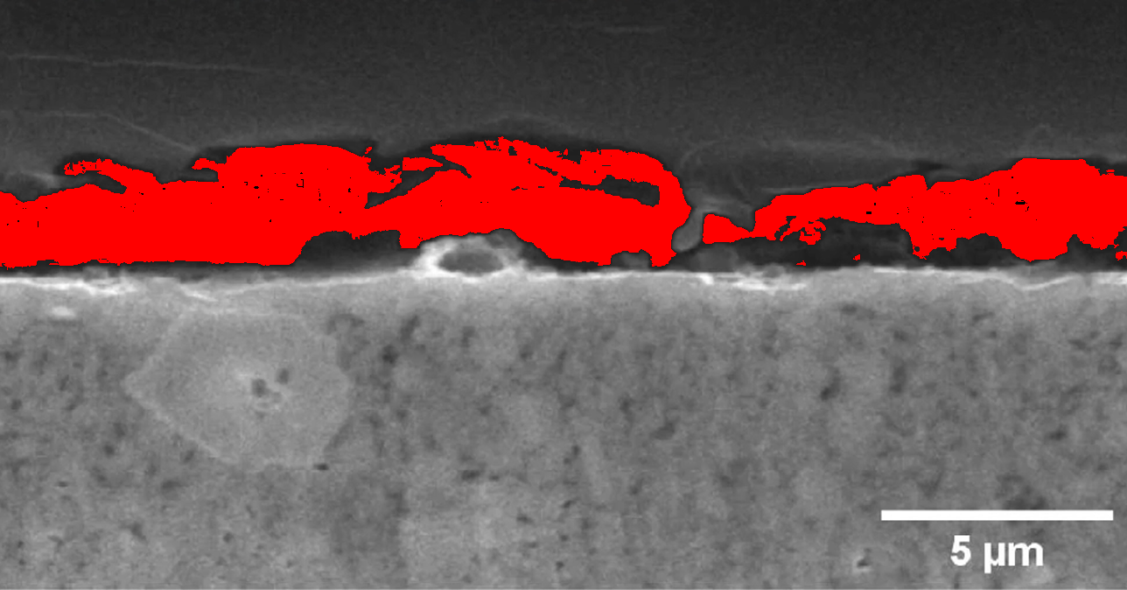
Figure: Highlighted GAP structures in Li_1.125 (red pixels indicate identified gaps)

Li_1.25
Physical resolution: 0.0187 μm/pixel
Maximum gap height: 3.8335000000000004 μm
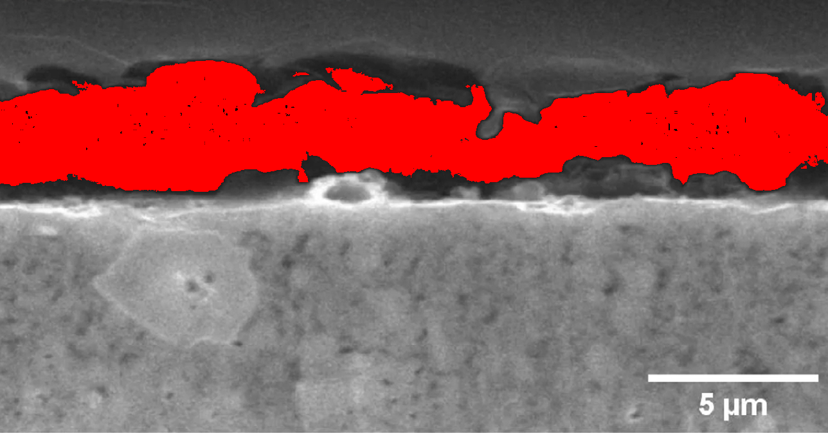
Figure: Highlighted GAP structures in Li_1.25 (red pixels indicate identified gaps)

Li_1
Physical resolution: 0.0187 μm/pixel
Maximum gap height: 2.0196 μm
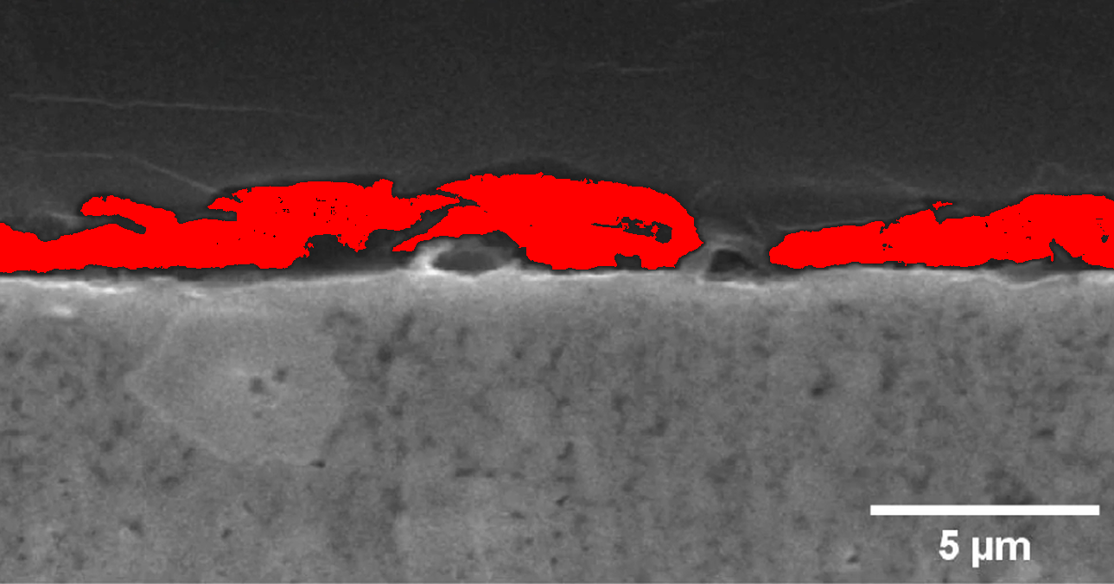
Figure: Highlighted GAP structures in Li_1 (red pixels indicate identified gaps)

