Simulation Report on Pixel GAP Analysis in Grayscale Images

Abstract
This report presents a detailed simulation analysis of grayscale images performing per-pixel GAP detection. GAP detection identifies pixels that meet specific grayscale intensity criteria and adjacency conditions, highlighting regions of interest within the images. The analysis involved generating CSV data files and corresponding gap-highlighted images indicating detected GAP pixels. The resultant outputs facilitate further understanding of the spatial distribution and characteristics of GAP regions across various sample images. This report outlines the background, methodology, and key findings derived from the processed data.

Introduction
The purpose of this simulation is to analyze grayscale images at the pixel level to detect GAP regions, defined by pixels having a grayscale value between 1 and 155 inclusive, and adjacency to regions of at least 25 contiguous pixels meeting the same grayscale conditions. This process is crucial for applications requiring the identification of critical features or anomalous areas in images, such as materials analysis, medical imaging, and pattern recognition. By automating the detection and visualization of these areas, this analysis supports enhanced accuracy and efficiency in interpreting image data.

Methods
The methodology employed involves processing images located in the designated 'Images' directory, focusing on files prefixed with 'Poly_'. Each image underwent grayscale reading followed by enhancement using CLAHE (Contrast Limited Adaptive Histogram Equalization) to improve local contrast. The GAP detection algorithm then identified pixels meeting the grayscale intensity criteria coupled with adjacency checks for contiguous pixel groups of size 25 or greater within specified thresholds. The output includes two key files per image: a CSV file detailing per-pixel data (coordinates, grayscale value, and GAP flag), and a new PNG image highlighting GAP pixels in black and non-GAP pixels in white. This structured approach ensures systematic and reproducible analysis across all input samples.

Results
The results present the effectiveness of the GAP detection algorithm through visual and tabular representation. The gap-highlighted PNG images clearly distinguish GAP pixels, allowing intuitive assessment of detected regions. The accompanying CSV files provide granular per-pixel detail for in-depth analysis or further processing. Below are the key processed images generated during the simulation.
Figure: Poly_01_gap.png
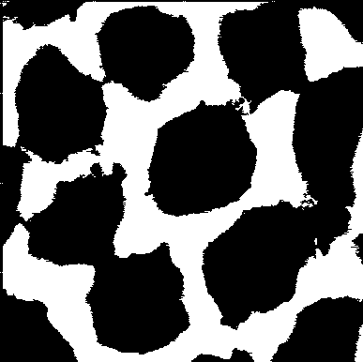
Figure: Poly_02_gap.png
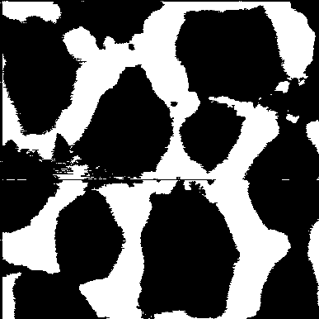
Figure: Poly_03_gap.png
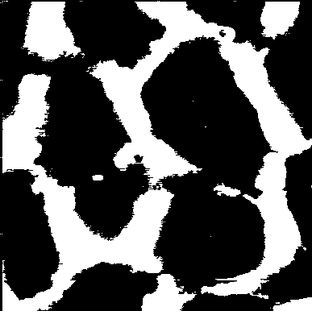
Figure: Poly_04_gap.png
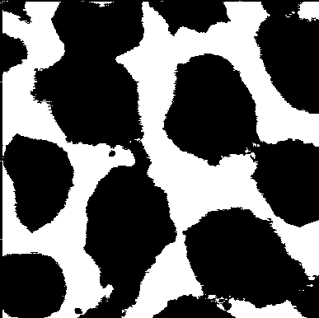
Figure: Poly_05_gap.png
