FOODIE MOBILE ORDERING SYSTEM
ERD • DFD • Backend Project Structure Guide
Spring Boot REST API + PostgreSQL + JWT
Following the teacher's Bearer Authentication project structure

1. Entity Relationship Diagram (ERD)
This ERD represents the actual Foodie backend database. It focuses on the tables used by authentication, food products, favorites, customers, orders, and order items.
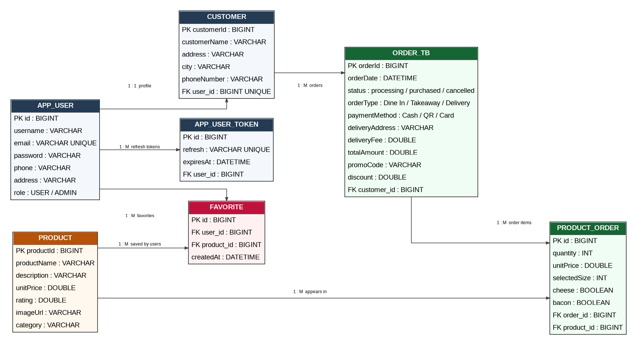

2. ERD Relationship Summary
Relationship | Cardinality | Meaning
APP_USER → CUSTOMER | 1 : 1 | One login account has one customer profile.
APP_USER → APP_USER_TOKEN | 1 : M | One user can have refresh-token records.
APP_USER → FAVORITE | 1 : M | One user can save many favorite foods.
PRODUCT → FAVORITE | 1 : M | A food product can be favorited by many users.
CUSTOMER → ORDER_TB | 1 : M | One customer can create many orders.
ORDER_TB → PRODUCT_ORDER | 1 : M | One order contains multiple order items.
PRODUCT → PRODUCT_ORDER | 1 : M | One product can appear in many orders.

3. Data Flow Diagram (DFD) Level 0
Level 0 shows the Foodie application as one complete system. The main external entities are the User and Admin. The system reads and writes the PostgreSQL database.
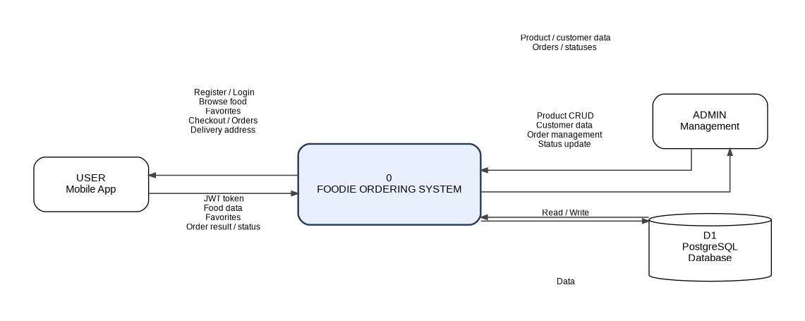

4. DFD Level 1
Level 1 breaks the system into the main processes used by the Foodie application. The processes are kept simple so the diagram is suitable for a school System Analysis document.
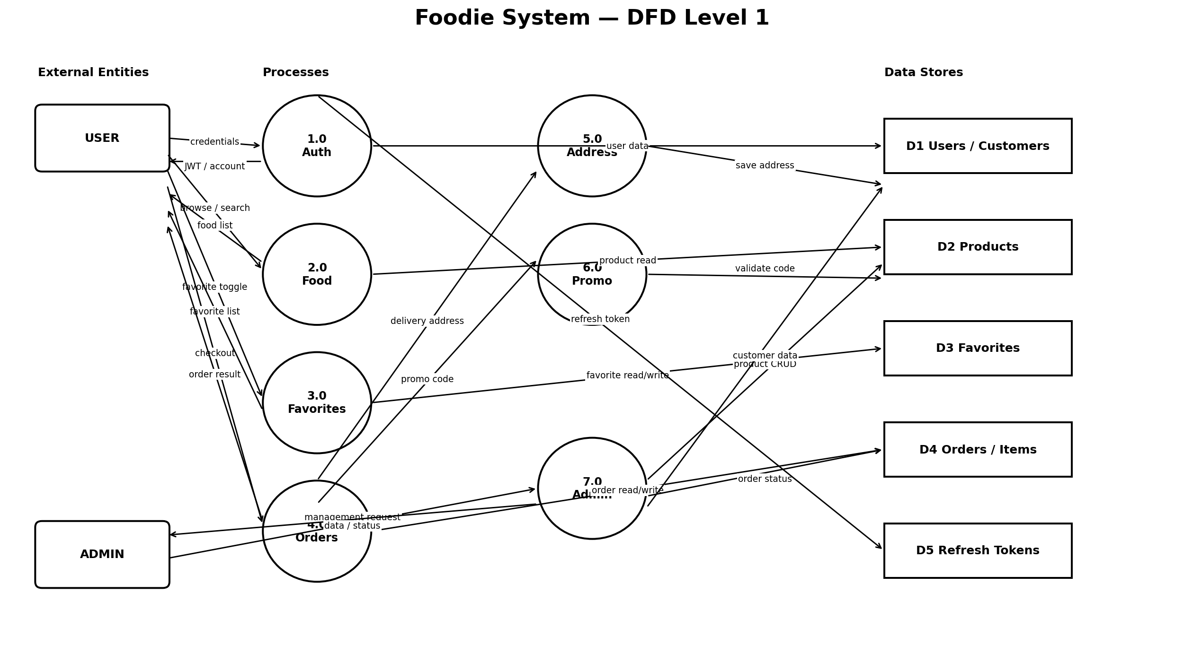

5. DFD Process Meaning
Process | Handles
1.0 Authentication | Register, login, refresh JWT token, logout and get current user.
2.0 Food & Category | Browse food, search food, filter by category and view food detail.
3.0 Favorites | Save/remove favorite food and load the user's favorite list.
4.0 Checkout & Orders | Create, view, update and delete orders. The backend calculates the final amount.
5.0 Delivery Address | Save and retrieve the user's delivery address, city and phone.
6.0 Promo | Validate FOODIE10 and calculate the 10% discount.
7.0 Admin Management | Admin manages products/customers and changes order status.

6. Backend Project Structure
The project keeps the teacher's structure. Each package has one clear responsibility:
src/main/java/com/api/v1/bearerauth/
├── common/
│ ├── constant/ → common constants/messages
│ ├── exception/ → custom exception + global error handling
│ └── response/ → standard API response classes
├── config/ → security, Swagger, password, seed data, application config
├── controller/ → REST API endpoints
├── model/
│ ├── entity/ → database tables
│ ├── enumerate/ → roles/status/type/payment enums
│ ├── request/ → request JSON from Flutter
│ └── response/ → response JSON to Flutter
├── repository/ → PostgreSQL/JPA database access
├── security/ → JWT filter, current user, authentication
├── service/ → business-logic interfaces
│ └── impl/ → business-logic implementations
└── util/ → reusable API helpers

7. What Each Main Folder Does
Folder | Meaning
controller | Receives HTTP requests and sends HTTP responses.
service | Contains the business rules and calculations.
repository | Reads and writes data in PostgreSQL using JPA.
entity | Defines the database tables and relationships.
request | Defines the data the client sends to the API.
response | Defines the data the API returns to the client.
security | Checks JWT Bearer tokens and identifies the current user.
config | Configures Spring Boot, Security, Swagger and initial data.
common | Shared responses, exceptions and constants.
util | Small reusable helper classes.

8. Main Foodie API Modules
Module | Base Endpoint | Purpose
Authentication | /api/v1/auth/* | Register, login, refresh
User | /api/v1/user/* | Profile and logout
Products | /api/v1/products/* | Browse/search + admin CRUD
Favorites | /api/v1/favorites/* | Favorite food
Orders | /api/v1/orders/* | Customer order operations
Delivery | /api/v1/user/delivery-address | Delivery address
Promo | /api/v1/promos/validate | FOODIE10 validation
Admin Orders | /api/v1/admin/orders/* | Admin status changes
Customers | /api/v1/customers/* | Admin customer management

9. Foodie Business Rules
- Large size adds $2.00.
- Cheese adds $1.00.
- Bacon adds $1.50.
- Delivery adds $2.00.
- FOODIE10 gives 10% off the food subtotal.
- The backend calculates the final order total instead of trusting the client total.
- Public registration creates USER only.
- Product create/update/delete is ADMIN only.
- A normal user can access only their own orders.
- Admin can view all orders and change order status.

10. Database Setup
Create the PostgreSQL database:
CREATE DATABASE foodie_db;
Default application configuration:
URL: jdbc:postgresql://localhost:5432/foodie_db
Username: postgres
Password: 123
Driver: org.postgresql.Driver

11. Default Admin
Email: admin@foodie.com
Password: Admin@12345
Role: ADMIN

12. What You Need To Add Yourself
The backend architecture is already prepared. You mainly need to enter or edit your own food data through the admin product API/Swagger. You can add food name, subtitle, price, rating, image URL and category.
Recommended workflow:
- Start PostgreSQL and create foodie_db.
- Run the Spring Boot backend.
- Open Swagger.
- Login as admin.
- Use POST /products to add your food data.
- Use PUT /products/{id} to edit food.
- Use DELETE /products/{id} to remove food.
- Use the user APIs to test registration, favorites, address and orders.

13. Run the Backend
gradlew.bat clean classes
gradlew.bat bootRun
Swagger: http://localhost:8080/swagger-ui/index.html

Foodie Backend — ready for PostgreSQL data entry and Flutter API integration

