# Capstone project

# Toronto McDonald’s Location analysis and recommendation for new business location

By Joyce

Contents

Capstone project 1

Toronto McDonald’s Location analysis and recommendation for new business location 1

Background: 3

Purpose of this analysis 3

Data source: 3

Data stream: 3

Methodology: 3

Analysis: 3

Conclusion and recommendation: 6

Limitation of this analysis: 6

## Background:

McDonald is very popular for all age people, very profitable as well. Assume there is a business man trying to invest to open new McDonald restaurant in Toronto and trying to find the best district to be successful.

Previous analysis we have figure out the number of restaurant has a strong correlation with population.

## Purpose of this analysis

In this analysis, Toronto population will be analyzed and McDonald’s location data will also be analyzed. By doing this analysis we could find some location potentially ideal for a new restaurant.

## Data source:

Wiki:

Canada Statistics

## Data stream:

Toronto population

Toronto location data

Toronto McDonald’s number and location

## Methodology:

Prepare and clean the data, remove null value records (using foursquare, matplotlib, beautifulsoup )

Manipulate data, join population with district information

Visualize data; validate reasonability, data quality and QC

Find out restaurant data and join with previous prepared data

Using the result to make recommendation for a new restaurant location

## Analysis:

Find out Toronto district information from wiki, transform the data and present in map.

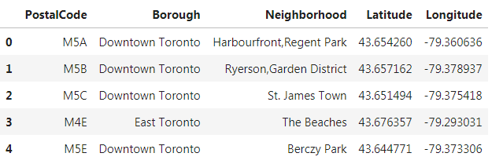

Convert to map as below:

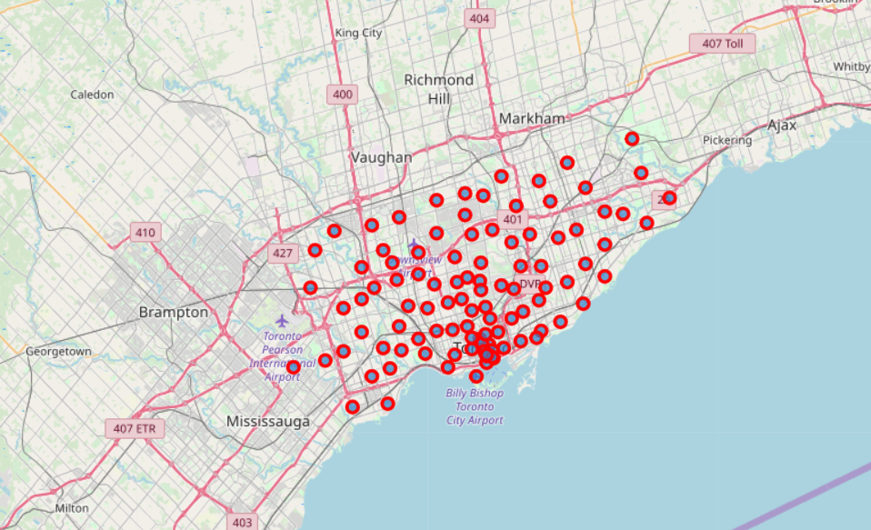

Find out Toronto population data from Canada Statistics website, remove NaN data, filtered out only Toronto district data, and prepare the columns name to be used in further steps.

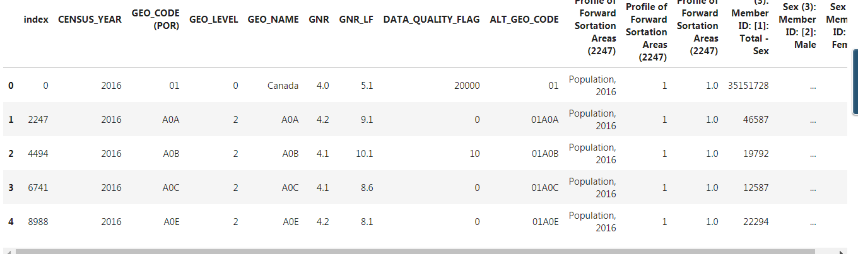

After manipulate:

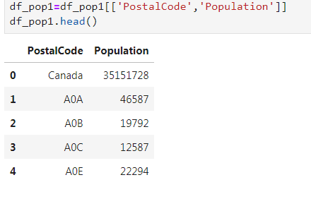

Step 3:

Find out Toronto McDonald’s restaurant data information and counted by FSA, using Foursquare data source

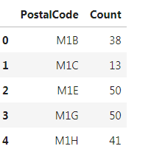

Step 4:

After all the data preparation and cleaning in previous steps, finally we are able to get a summarized information about Toronto’s current McDonald’s by district, average number of McDonald’s restaurant per 1000 people.

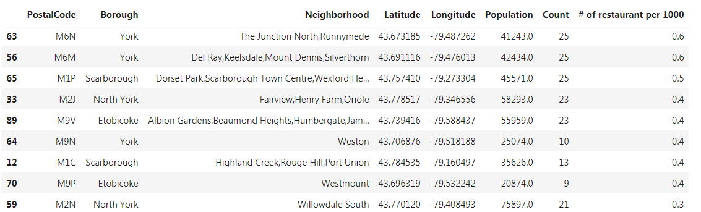

## Conclusion and recommendation:

After all these data analysis and manipulation we recommend **M7N North York Willowdale** area. This is the lowest district of number of McDonald’s per 1000 people. This district may be an ideal area to invest a new restaurant.

## Limitation of this analysis:

This analysis only consider the relationship between population and restaurant, there are multiple factors effect business, E.G. Income, age, area, competition, transportation, rental fee, safety etc..

Only using this result to make a decision may be short vision.