<https://subscription.packtpub.com/book/web-development/9781838645571/7/ch07lvl1sec50/curve-functions>

**curve types**

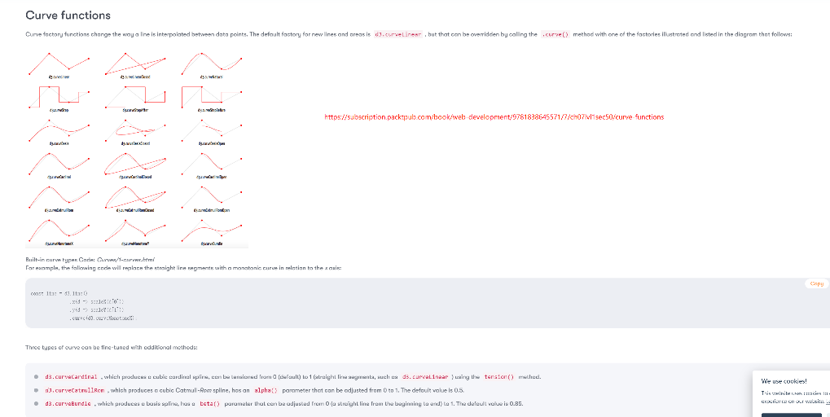

<https://observablehq.com/@dnarvaez27/d3-curves-interpolation>

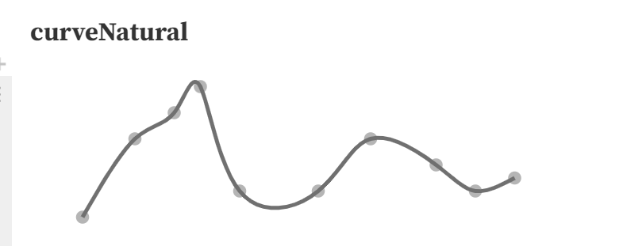 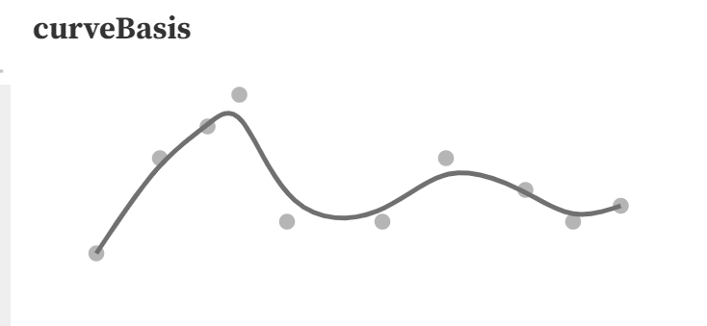

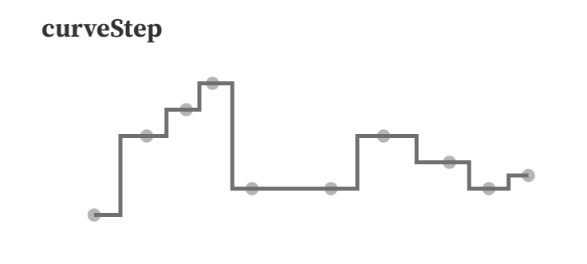

d3 Curve Visualizer

<https://www.d3indepth.com/examples-merged/shapes/curve-explorer/>

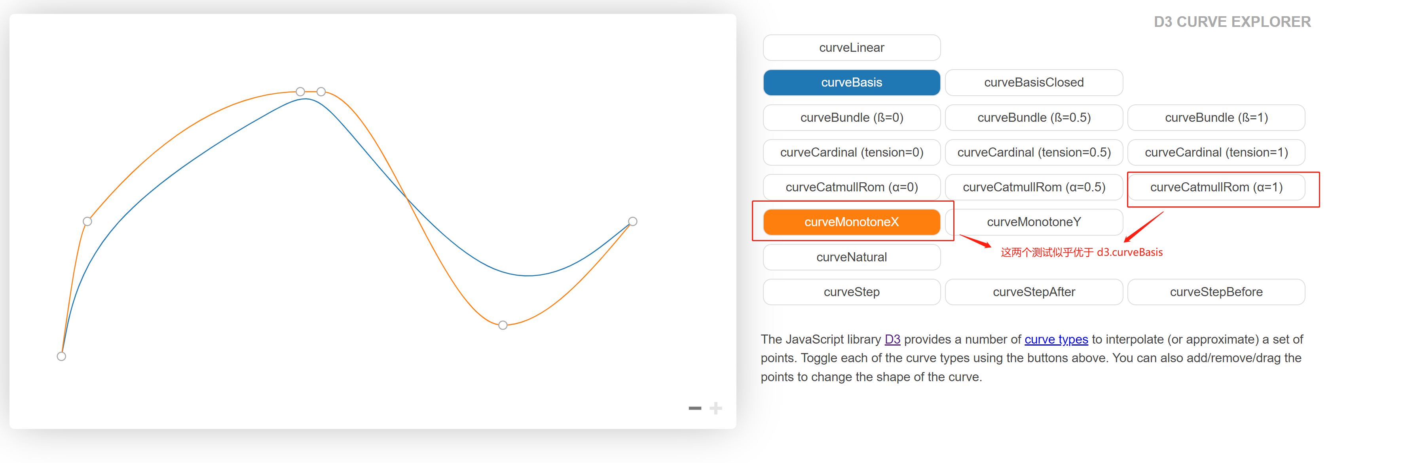

<https://cemrajc.github.io/d3-curve-comparison/>

