Edges are too thin for hit detection.

Suggestions on edges with doWhy.

causality effects of reverse directions.

Use different hues for subgraphs. Colorbrewer categorical color maps:

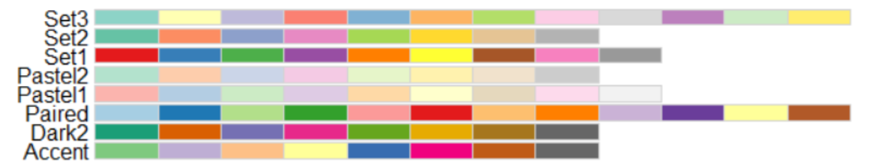

Keep coordinates in text for subgraph compaction for comparison.

Add ring (or other augmentations) for outcome nodes in subgraphs.

\*\*\*TODO:

Comparing two and more plots in a single view with edge encoding?