2.2” TFT Display Assembly

Steve Gunn, Mark Temple & Jeff Hooker

These instructions guide you through the construction of a TFT display board, which can be used with your microcontroller board that you developed in X2. The assembly techniques are designed so that they can be undertaken with simple tools that you will have readily available.

# Introduction

Surface Mount Technology (SMT) is now the preferred method of constructing electronic circuits in industry, due to lower cost and higher component density. Consequently, many devices are now only available in surface mount packages, and therefore you must learn to understand how, and when, they can be used. This exercise aims to:

1. Introduce you to SMT concepts.
2. Develop familiarity with commonly used packages.
3. Teach you basic techniques for constructing circuits with Surface Mount Devices (SMDs).
4. Give you the confidence and understanding to design and construct circuits with SMDs.
5. Enable you to use SMDs in projects during your degree.

## Tools of the trade

For the purposes of prototyping SMDs, the tools for soldering are more specialised than conventional 'through-hole' tooling. Typically a wand style soldering iron will accommodate a very fine tip - e.g. 0.2mm diameter. For simultaneous heating of the ends of two-terminal packages it is useful to use a tweezer style soldering iron. In this exercise you will use a normal wand type iron with a relatively small tip and small diameter solder (0.23mm).

|  |  |  |
| --- | --- | --- |
|  | Tools from left to right:   1. Soldering iron - wand type 2. Soldering iron - tweezer type 3. Temperature controller for 1 & 2 4. Hot air controller 5. Hot air wand   Note the all-important safety goggles,  ALWAYS to be worn when soldering. | |
| Figure 1: SMD Soldering Equipment. | |

## Components

SMDs are normally supplied to manufacturers on rolls to facilitate automated build (auto pick'n'place). The rolls are loaded with a bandolier tape containing the pre-aligned components - often thousands are on a tape.

|  |  |  |
| --- | --- | --- |
|  |  |  |
| Figure 2a: SMD reel. | Figure 2b: SMD tape with removable film covering visible. |  |

After receiving an order from Onecall/R.S. for a small amount of an SMD, often only a strip of populated tape is supplied. Note that the taped component is 'sealed' in place with a shiny film. For prototype work, we peel the shiny film away using tweezers to release the component. If there are many devices to unpack before mounting, this can be a time consuming process. Organising the components in a clearly labeled sequence can save a lot of time. Smaller SMDs (generally passive devices) can have no markings making them indistinguishable from one another. You can use a multimeter to distinguish them.

## Passives

Passives are typically supplied in two-terminal rectangular packages. These range in size from large power devices in 2512 packages (6.35mm x 3.0mm) down to tiny low power devices in 01005 packages (0.4mm x 0.2mm). In this exercise you will work with 0603 packages which are the smallest package that we recommend working with. Once you have mastered this you will find it straightforward to work with larger packages (e.g. 0805 and 1206).

## Fine pitch ICs

ICs are supplied in a [wide range of packages](http://ics.nxp.com/packages/). The most common packages are: Small Outline Package (SOP), Quad Flat Pack (QFP), Quad Flat No leads (QFN) and Ball Grid Array (BGA). SOPs are rectangular devices with pins on two opposite sides of the package, QFPs are square or rectangular devices with pins on all four sides, QFNs are square or rectangular devices with pads under the edge of the device and BGAs are square or rectangular devices with a matrix of solder balls under the package.

|  |  |  |  |
| --- | --- | --- | --- |
|  |  |  |  |
| SOP | QFP | QFN | BGA |
| Figure 4: Common IC packages (Images courtesy of digikey.com) | | | |

In this exercise you will not work with any ICs, but the FPC connector that you will solder is essentially a one-sided QFP and can be assembled as such. The FPC has a pin spacing of 0.5mm; to put this in perspective, that is five times the density over standard 0.1" spacing on regular through hole ICs. Once you have mastered this you will find it possible to work with ICs having a pitch spacing of 0.5mm and above, which includes nearly all devices in a SOP or a QFP. QFNs are [more difficult](http://store.curiousinventor.com/guides/Surface_Mount_Soldering/QFN/), but we do have the equipment to work with them. BGAs require more specialised tools.

# Preparation

Before you arrive at the lab you should watch the [Surface Mount Construction Tutorial](http://www.youtube.com/embed/3NN7UGWYmBY) video. You should be familiar with the techniques for assembling 0603 passives (1:47s into the video) and for QFPs (4:02s into the video).

# Laboratory Work

## Attaching the FPC connector

Solder the TFT1 socket onto the PCB. The pitch spacing is 0.5mm.

Secure the PCB to the work surface (you do not want any movement of the PCB during the socket alignment procedure).

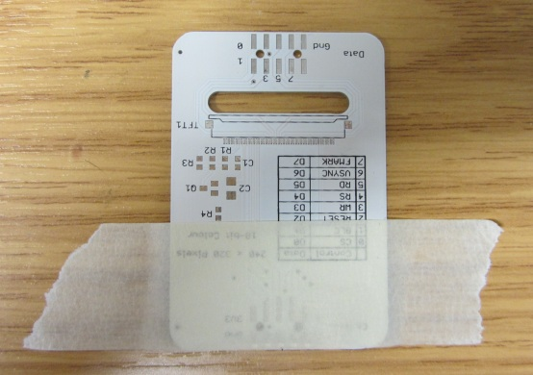

Apply plenty of flux using a flux dispensing pen onto the pads of TFT1

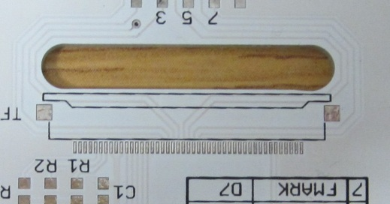

Place the Kapton tape vertically over the socket. Lift the socket holding each end of the tape with both hands. Using a magnifying glass or microscope position the socket so that the pins are centered on the pads on the PCB.

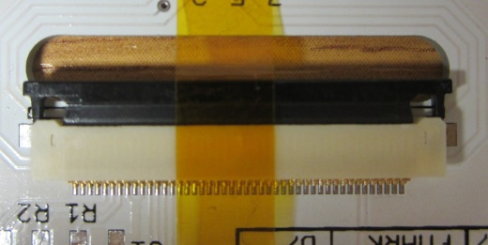

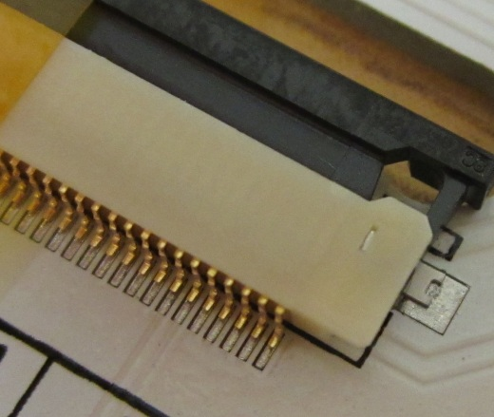

Note position of right lug

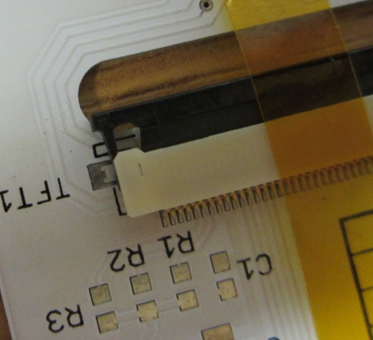

Note position of left lug

The alignment is critical. Trying to solder the socket if not aligned will be very difficult.

Carefully solder both lugs on the socket. Try not to touch the lug with the iron tip because you may move the socket. Allow the solder to flow from the pad onto the lug. Once you have soldered the lugs and secured the socket you can remove the Kapton tape.

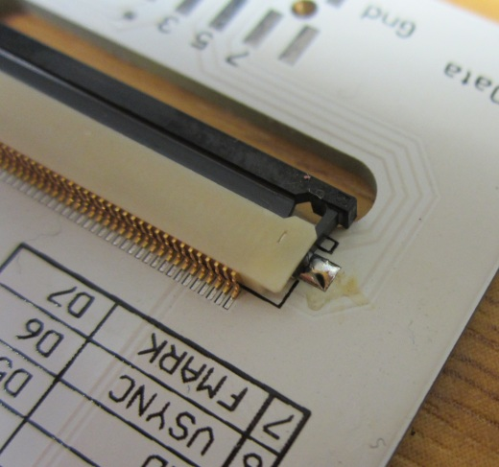

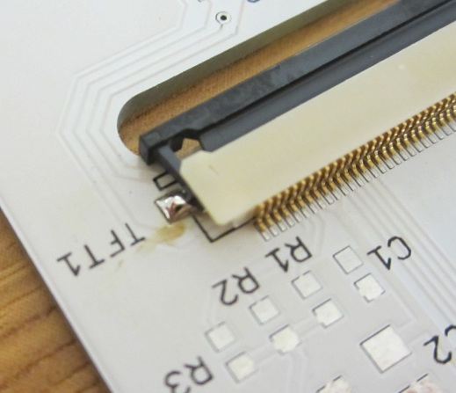

Now solder the pins of the socket. Use 0.23mm diameter solder. The pitch spacing is 0.5mm so you are likely to put solder bridges across some of the pins. Continue to solder all of the pins and then remove the solder bridges at the end.

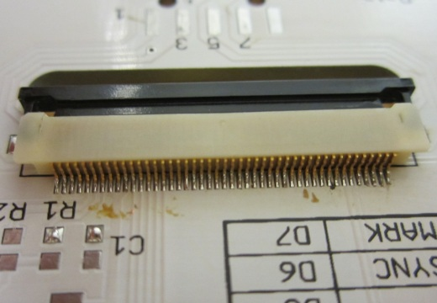

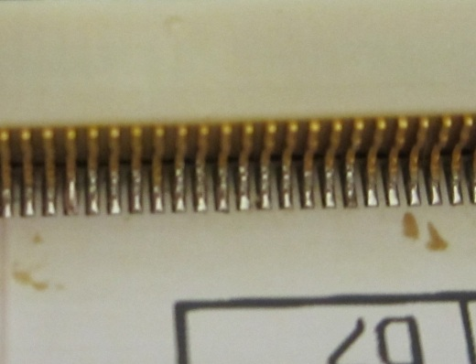

Note. Avoid applying solder onto the vertical part of the pins. You may start to melt the plastic when trying to remove any solder bridges.

Remove any solder bridges using solder braid/wick. You will need to use a medium size tip as a minimum to generate enough heat for the solder to melt when the braid/wick is placed on the soldered pins. Remove the braid/wick while the solder is in the melting state. Braid/wick should be easily removed from the pins. Never pull the braid/wick away from the pins if the solder is not in the melting state because you may possibly lift the pads or bend the pins.

## Attaching the Passives (R1-R4, C1,C2)

Follow the technique described in the tutorial to attach R1, R2 & R3 = 10R - R4 = 1K - C1 = 100nF C2 = 10uF

## Attaching the transistor (Q1)

Solder Q1 using the same technique as for the passives.

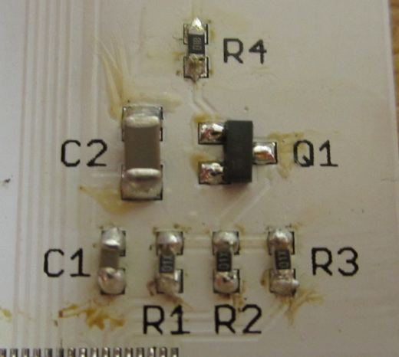

## Attaching the board Headers

Fit the 2 plastic lugs of the connectors into the holes and solder the pins of the Data and Control connectors.

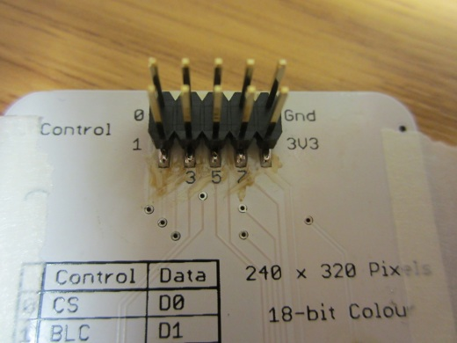

You have now completed all the soldering in the assembly process.

## Attaching the Display

Feed the flex connector of the screen through the slot in the PCB.

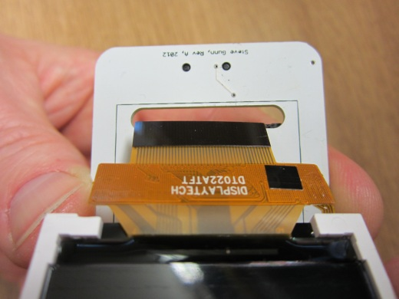

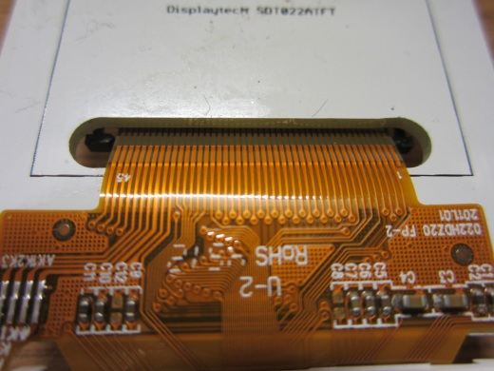

Ensure the connector retaining clip is pulled out fully at both ends.

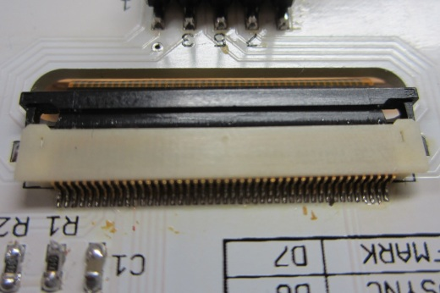

Push the flex cable under the retaining clip into the socket. (Be patient the flex cable may not initially seem as though it will slide in).

When the flex cable is fully inserted you can lock the socket retaining clip.

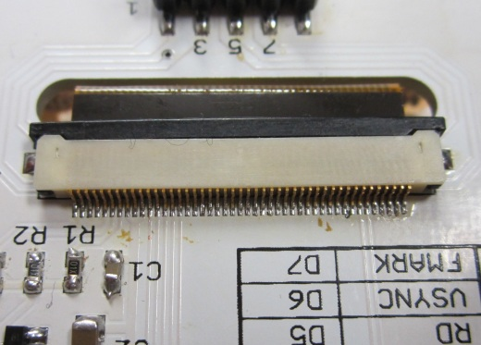

## Testing

Attach the TFT Display board Control port to Port A (Il Matto), Data port to Port C (Il Matto).

Download [pacman.hex](https://secure.ecs.soton.ac.uk/notes/ellabs/1/x2r/pacman.hex) to your Il Matto using avrdude.

## Finishing Up

If all works successfully you can fix the display panel to the PCB by peeling off the two white strips on the back of the TFT and attaching the display to the PCB. Note that there are two small holes in the PCB which aid with alignment of the display by locating the two small plastic pillars on two corners of the display housing.

## Appendix A – Schematic

