Supplementary material

A comparison of spatial and non-spatial methods in statistical modelling of NO2: prediction accuracy, uncertainty quantification, and model interpretation

Meng Lu, Joaquin Cavieres, Paula Moraga

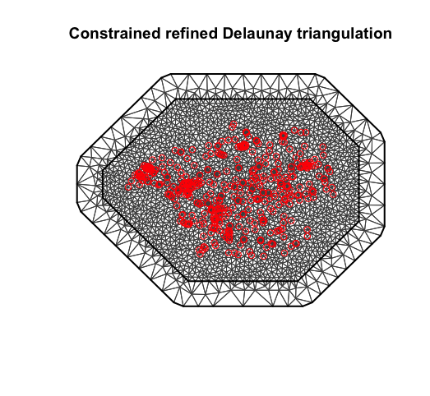

Figure 1, the mesh that is used in the INLA model.

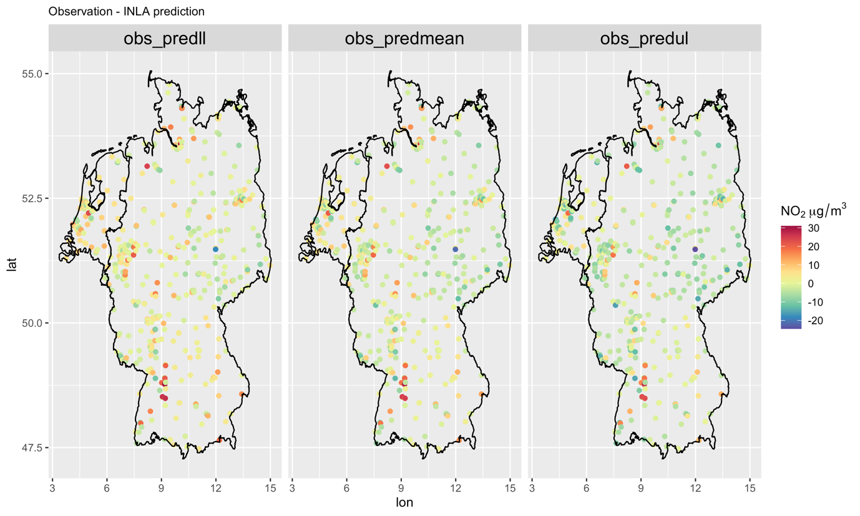

Figure 2. Differences between INLA predicted NO2, from left to right, at lower quantiles (0.025), mean, higher quantiles (0.975) and the observed NO2. The differences (dif) is calculated as subtracting predictions (pred) from the observations (obs), i.e., dif = obs - pred.

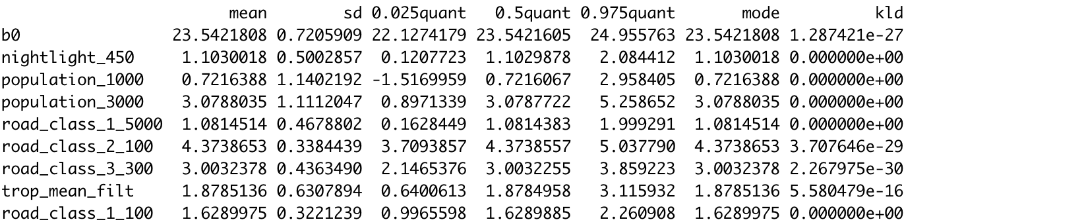

Figure 3. Fixed effect of the INLA model, normalised covariates

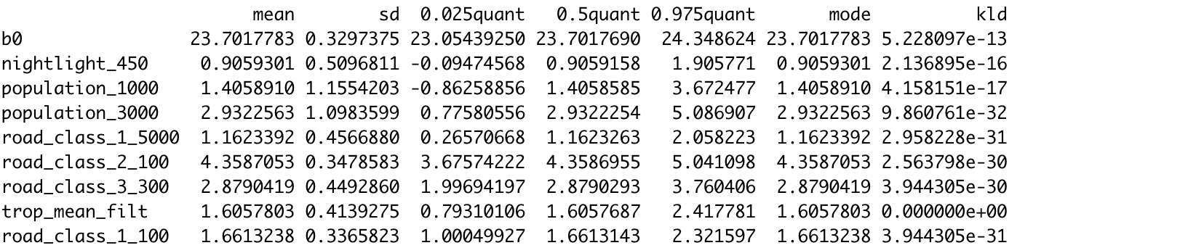

Figure 4. Fixed effect of the INLA model without fitting the spatial random field, normalised covariates.

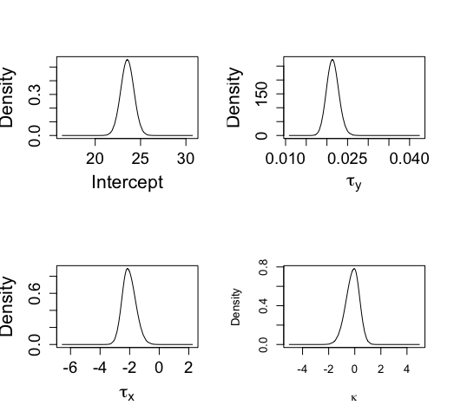

Figure 5. Posteriors of the hyperparameters.