Supplementary material

A comparison of geostatistical and non-spatial machine learning methods in NO2 modelling: prediction accuracy, uncertainty quantification, and model interpretability

Meng Lu, Joaquin Cavieres, Paula Moraga

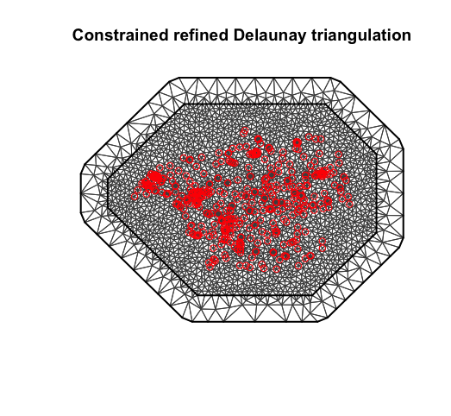

Figure 1, the mesh that is used in the INLA model

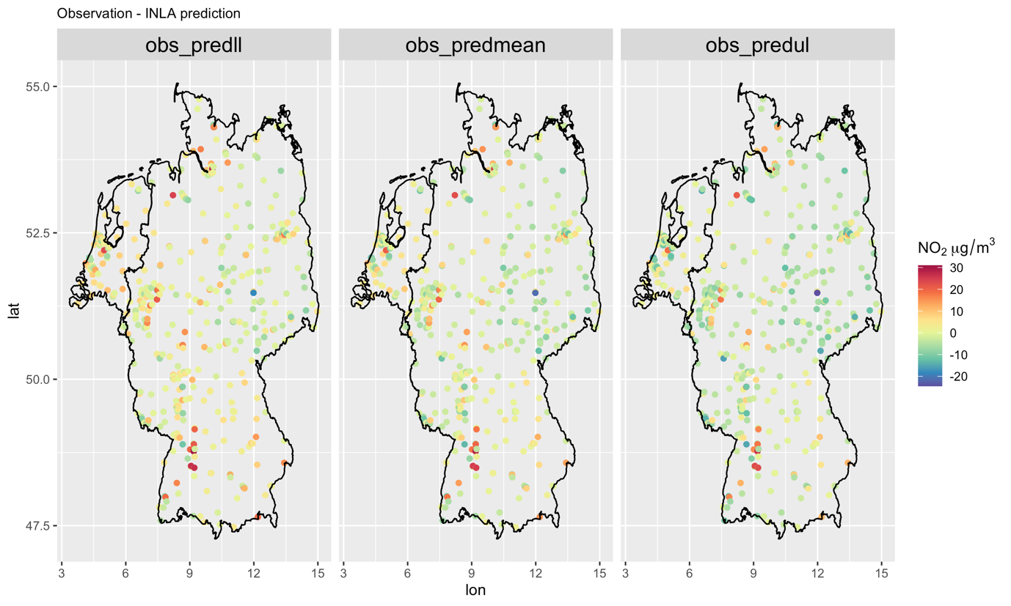

Figure 2. Differences between INLA predicted NO2, from left to right, at lower quantiles (0.025), mean, higher quantiles (0.975) and the observed NO2. The differences (dif) is calculated as subtracting predictions (pred) from the observations (obs), i.e., dif = obs - pred.

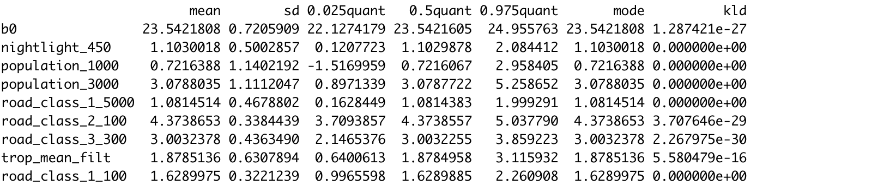

Figure 3. Fixed effect of the INLA model, normalised covariates

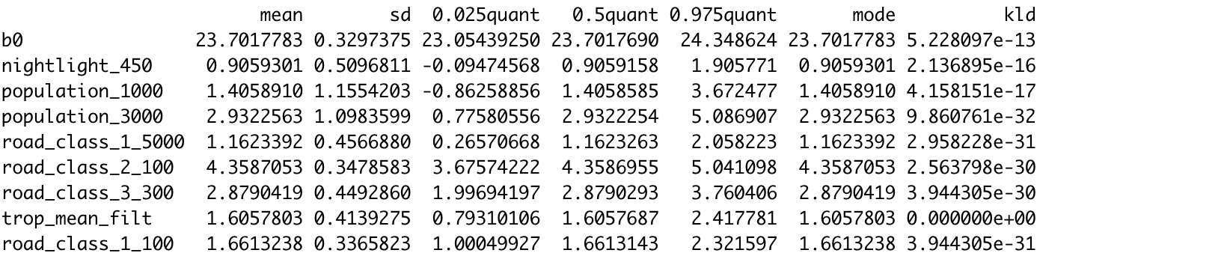

Figure 4. Fixed effect of the INLA model without fitting the spatial random field, normalised covariates.

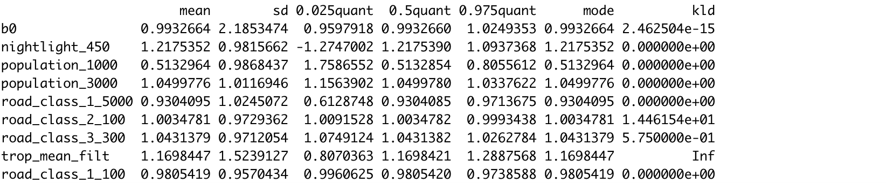

Figure 5. Ratio of the covariates’ coefficients between the INLA model and the INLA without fitting the spatial random field: INLA / nonspatial INLA. Normalised covariates.