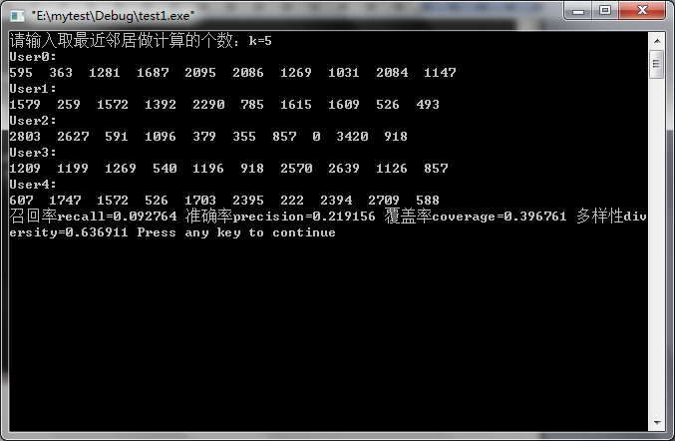

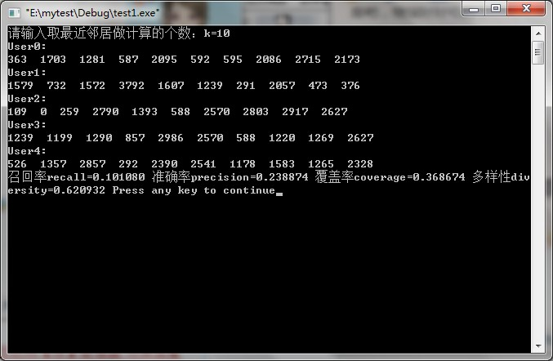

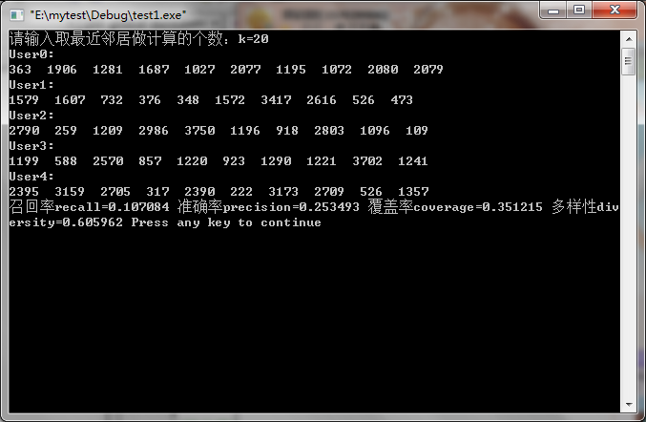

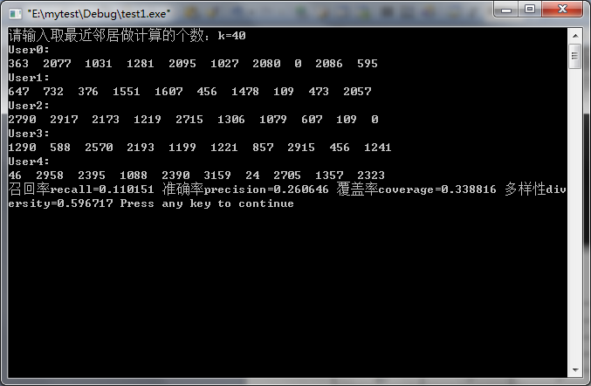
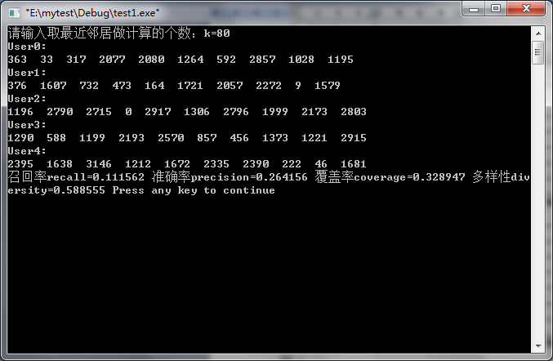
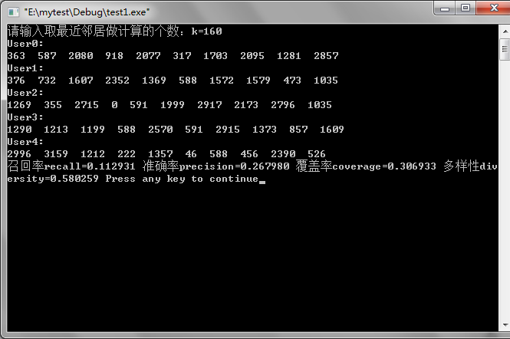

实验次数 | 准确率 | 召回率 | 覆盖率 | 多样性
1 | 21.9156% | 9.2764% | 39.6761% | 0.636911
2 | 22.3444% | 9.4462% | 40.2328% | 0.638378
3 | 22.1440% | 9.3462% | 38.6134% | 0.639489
4 | 22.1871% | 9.3771% | 39.4844% | 0.636579
5 | 22.0116% | 9.3156% | 39.6255% | 0.638495
平均 | 22.1205% | 9.3563% | 39.5264% | 0.637970
表1 k=5时的实验结果

实验次数 | 准确率 | 召回率 | 覆盖率 | 多样性
1 | 23.8874% | 10.1080% | 36.8674% | 0.620934
2 | 23.9123% | 10.1241% | 37.2723% | 0.621756
3 | 23.9702% | 10.1086% | 37.3482% | 0.621243
4 | 24.0464% | 10.1769% | 37.0951% | 0.619769
5 | 23.9454% | 10.1282% | 37.5253% | 0.619534
平均 | 23.9527% | 10.1292% | 37.2217% | 0.620647
表2 k=10时的实验结果

实验次数 | 准确率 | 召回率 | 覆盖率 | 多样性
1 | 25.3493% | 10.7084% | 35.1215% | 0.605962
2 | 25.1573% | 10.6567% | 35.2986% | 0.606227
3 | 25.1358% | 10.6613% | 35.5010% | 0.608327
4 | 25.1093% | 10.6287% | 35.9565% | 0.606171
5 | 25.4321% | 10.7747% | 34.9949% | 0.606631
平均 | 25.2368% | 10.6860% | 35.3745% | 0.606664
表3 k=20时的实验结果

实验次数 | 准确率 | 召回率 | 覆盖率 | 多样性
1 | 26.0646% | 11.0151% | 33.8816% | 0.596717
2 | 25.9785% | 10.9990% | 33.8563% | 0.596123
3 | 26.1242% | 11.0895% | 33.9828% | 0.598355
4 | 26.1225% | 11.0017% | 34.3370% | 0.596327
5 | 26.2003% | 11.0757% | 34.0081% | 0.596033
平均 | 26.0980% | 11.0362% | 34.0132% | 0.596711
表4 k=40时的实验结果

实验次数 | 准确率 | 召回率 | 覆盖率 | 多样性
1 | 26.4156% | 11.1562% | 32.8947% | 0.588555
2 | 26.3609% | 11.0982% | 32.5405% | 0.587993
3 | 26.2003% | 11.0843% | 32.7935% | 0.589113
4 | 26.4089% | 11.1571% | 32.5152% | 0.589569
5 | 26.3891% | 11.1479% | 32.1103% | 0.589191
平均 | 26.3550% | 11.1287% | 32.5708% | 0.588884
表5 k=80时的实验结果

实验次数 | 准确率 | 召回率 | 覆盖率 | 多样性
1 | 26.7980% | 11.2931% | 30.6933% | 0.580259
2 | 26.5199% | 11.2559% | 30.5921% | 0.580030
3 | 26.6589% | 11.2977% | 30.5668% | 0.580352
4 | 26.6689% | 11.2807% | 30.8451% | 0.582107
5 | 26.6275% | 11.2534% | 29.9089% | 0.579989
平均 | 26.6546% | 11.2762% | 30.5212% | 0.580547
表6 k=160时的实验结果

K | 准确率 | 召回率 | 覆盖率 | 多样性
5 | 22.1205% | 9.3563% | 39.5264% | 0.637970
10 | 23.9527% | 10.1292% | 37.2217% | 0.620647
20 | 25.2368% | 10.6860% | 35.3745% | 0.606664
40 | 26.0980% | 11.0362% | 34.0132% | 0.596711
80 | 26.3550% | 11.1287% | 32.5708% | 0.588884
160 | 26.6546% | 11.2762% | 30.5212% | 0.580547
320 | 26.2318% | 11.1188% | 27.2773% | 0.545686
表7 取均值实验结果

