Manual
1. How to install 3
2. How to play 4
3. Publish Settings 5
3.1 Setup buddle id 5
3.2 Setup Chartboost id 5
3.3 Setup in-app purchase 5
4. About reskin 7
4.1 Hero animations 7
4.2 Enemy animations 9
5. More advanced scripts 10
5.1 Describe a wave 10
5.2 How to add enemies 11
5.2.1 Duplicate an exist enemy 11
5.2.2 Add him a new script 12
5.2.3 Reskin 14
5.2.4 Give new enemy an Id 14
5.2.5 Call the new enemy 15
5.3 Create a new level 15
5.3.1 Set up totalLevels 15
5.3.2 Set wave details 15
6.Localizations 17
6.1 Read localization string 17
6.2 Detect your language 18
7. Basic knowledge of Developers 20
7.1 build and submit a game on app store with unity. 20
7.2 How to Set up a chartboost id 20
8. support 21

1. How to install
- Import the package to a new created project. The game has already been set up with the default android platform.
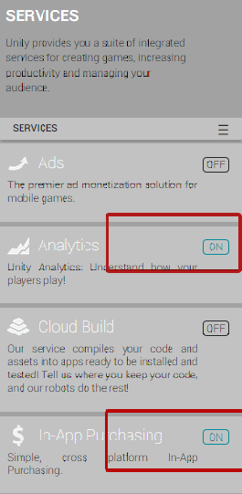
- Find windows->Services from Unity menu.
And make sure the in-app purchasing service turned on.
- Find the Scene file named Game and double click on it if not activated.
- Press the run button on the top bar of unity editor should be able to play the game on a PC/MAC now.

2. How to play
This game was a mad rush-to-win defense game. It was quite easy to get started but requires agile and strategy quite a lot.
Building heroes to rush into enemies’ territory and keeps your own basement not to be destroyed.
With special power and upgrade system, the battle could be more and more exciting.
Each time you win a level, there will be a chance to upgrade and an interstitial ads would be shown.
The superbox would support your team a great quantity of resources. And the in app purchase shop would be activated after you consumed all of them.

3. Publish Settings

3.1 Setup buddle id
Each game must have a different Bundle id. So you must made the id to fit the id you request from your apple.
From File->build setting, open the build setting panel. Find and click player setting button.
On inspector panel ,click other settings panel. Change buddle id in bundle identifier section.

3.2 Setup Chartboost id
Find on unity editor from Chartboost->edit setting.
On the inspector panel on right. You should find where to setting up the chartboost id.

3.3 Setup in-app purchase
First you need to active the unity serverice (Window->services) and turn the iap service on.
You need to setup product id if you decide publish to any store. Open Gamemanager.cs the script and find:
public const string CONSUMABLE0 = "xxxxx";
The orange words are the values you must change to fit the id you required from your appstore or goolgeplay developer website.
Iap always return true by test mode.
To disable it, find
public bool test = true;
And set it to
public bool test = false;

4. About reskin

4.1 Hero animations
Select any hero on the Scene and check your animation panel. Each hero is combined with 2 parts. The body parts and the leg parts.
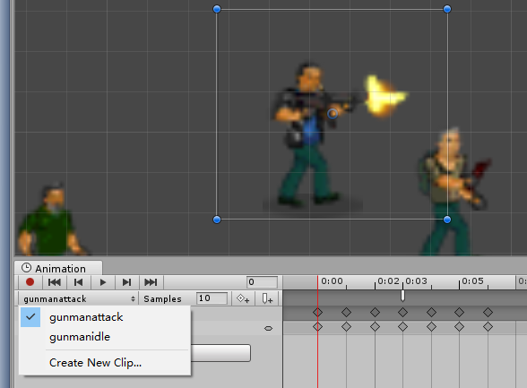
The body parts.
Body parts contains 2 upper torso animations like the graphics showed.
Each man got an attack animation and an idle animation. The first is when the man attacks. But the second is for when the man walks(not idle).
We see in the illustration there is a white mark in the red circle. This is a callback trigger.
Remember when your hero acts an attack motion, then it should export hurts.
So make sure this trigger is exist and exactly at the position when the gun fires or the blade drops.
But remember,the grenadier does not have a attack trigger frame. Because it does not hit enemys by himself but with the bomb.
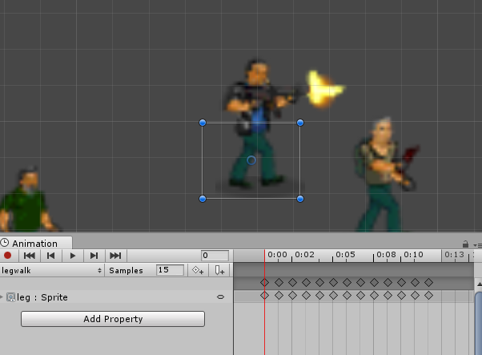
The leg parts.
To makes things easier,all the sources files of heroes is under source->soilder folder.
Just overwrite the pictures your want to change.

4.2 Enemy animations
Deal with enemy was the same. But enemies does not combine with 2 parts. So things could be easier.
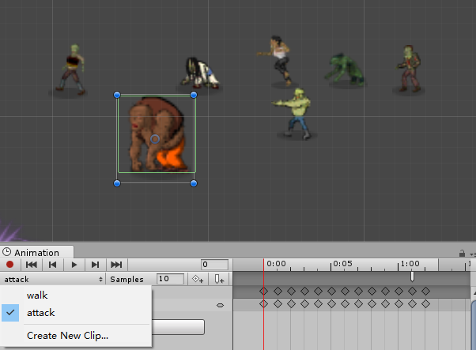
Just don’t forget to set the attack trigger the same way of hero as I just said.
To makes things easier,all the sources files of heroes is under source->enemys folder.
Just overwrite the pictures your want to change.

5. More advanced scripts

5.1 Describe a wave
LevelGenerator.cs
We see there are generatorLevel1-6() totally 6 functions in this class which means each level uses one function to describe the wave of enemy.
void generateLevel1(){
//how much enemy would be created each time
int zombiePerSec = Random.Range(1,3);

//after 8-12 seconds randomly,there would be a huge wave
int hugeGap1 = Random.Range (8, 12);

//how much would be created each huge wave.
int hugeNum1 = Random.Range (8, 12);
//after serval senconds randomly,create a special enemy(always strong in this level);
int specialGap1 = Random.Range (4, 8);
int specialGap2 = Random.Range (6, 15);
int specialNum1 = Random.Range (1, 4);
int specialNum2 = Random.Range (1, 3);
//the special enemy type is No.2(faster zombie) or the No.3(wolf)
int[] speicalType1 = {2,3};
int[] speicalType2 = {3};

At the start of each function,there’re always several parameters. The describe when and how many enemies would be created for waves.

The scripts afterwards would use this parameters to generate enemies.
Like
//create a huge
if(nGameTime % hugeGap1 == 0 && nGameTime > 0){

So we see a huge wave would be created after the setting time gap upon.(8-12 randomly)

If you want make your own level. Just copy these already-have functions and change to your own settings.

5.2 How to add enemies

5.2.1 Duplicate an exist enemy
On the scene stage, pickup 1 enemy type which you feel likes your new enemy. Like if range, choose a thrower. If melee, choose a zombie. Then just copy/paste of it.
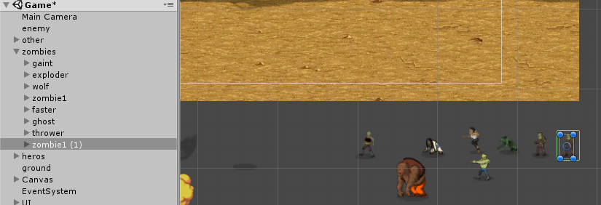

Duplicated a zombie
You must assign him a unique name so that the system could find him. Here is zombie1(1);

5.2.2 Add him a new script
See its inspector.
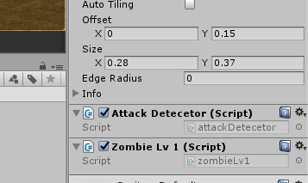
We see there is a zombieLv1.cs attached on the ducplicated guy.
We can not make him the same as origin one. So we must give him a new script.
So duplicate the zombielv1.cs in enemy folder
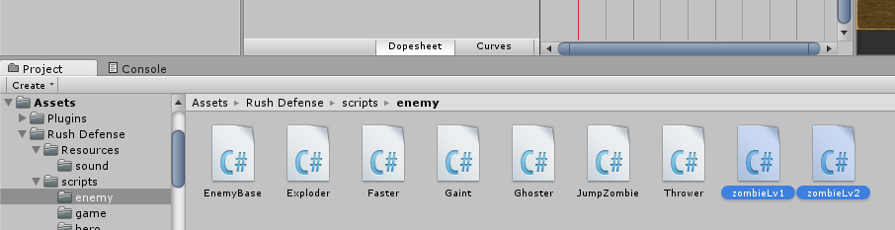
The duplicated class named zombieLv2.But this does not enough. You must the the class name exactly the same with the file name.
Open zombieLv2.cs
Set public class zombieLv1 :EnemyBase {
To public class zombieLv2 :EnemyBase {
So now the new enemy script would be work.
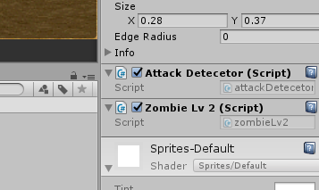
Now we attached the new script to the new guy.

5.2.3 Reskin
See chapter 3.2 and 3.1 for details.

5.2.4 Give new enemy an Id
LevelGenerator.cs
See function createZombie() GameObject createZombie(int zombieType){

In this function,we got 7 cases.Eash refers to a type of enemy.So we got 7 types different types of enemies already.
Now we add 1.So we add new case brach for the new enemy.
Like:
case 8:
tzombie = GameObject.Find("zombieLv1(1)");
toffsetY = Random.Range(-.05f,0.05f);
...
The zombieLv1(1) is the name of gameObject of the new enemy created in 4.2.1
So now the enemy got a new id of 8

5.2.5 Call the new enemy
In chapter 4.1,we see how to generate a wave.
The most use of a function is createZombie in each generator functions.
So just give the createZombie the types you want to pick up, system would create the enemy as you wish.
Like:
GameObject tnewZombie = createZombie (8);
In this script, the value tnewZombie would get and create enemy type 8,the enemy you just created.

5.3 Create a new level

5.3.1 Set up totalLevels
LevelGenerator.cs
public int totalLevel = 6;
Now we only got 6 levels.It you need more set it to 7.

5.3.2 Set wave details
You must the the wave information after you add a new level.
What you need to do is
LevelGenerator.cs
Find void generate(){
You must know the level starts from 0,so the level0 is level1 and the level 6 is level 7.
Now the level 6 case is empty. Just fill it like other cases do.
case 5:
generateLevel5();
break;
case 6:
generateLevel6();//what you added
break;
So, you must not want your new level to be same of the last level.(of course you still can make it the same and the randomize would make the level actually not the same)
So create a function name generateLevel6()
See chapter 4.1 to see how to make a new level wave. The most easier way is copy paste another generatelevel function and change your own parameters.

6.Localizations

6.1 Read localization string
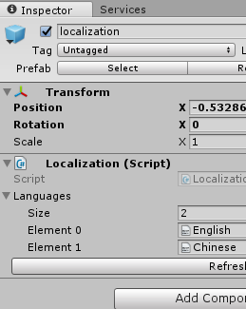
Inspector of The localization gameObject

Each level got a gameObject named localization
We attach localization text file in its inspector panel.
Open English.txt
In the file,each line refer to a phase which needs to be localized
Like
phaseName = phaseContext
For example: btnOK = OK

In game, you do the localization by
xxx.text=Localization.Instance.GetString ("btnOK");

6.2 Detect your language
public int GetSystemLaguage(){
int returnValue = 0;
switch (Application.systemLanguage) {
case SystemLanguage.Chinese:
returnValue = 1;
break;
case SystemLanguage.ChineseSimplified:
returnValue = 1;
break;
case SystemLanguage.ChineseTraditional:
returnValue = 1;
break;
default:
returnValue = 0;
break;
}
returnValue = 0;//test
return returnValue;
}

gameData.cs

GameData.cs / GetSystemLanguage()
This function get system language by switch branches.
You should add the language cases only when your localization file(txt) is ready. Otherwise if the system did not find the right translation file, it would throw errors.
For default testing
returnValue = 0;//test
This line is uncommented. The language will always be English .If you may not have time to deal with your own native translation or you did not want a localization function for your game,just leave it uncommented.

7. Basic knowledge of Developers

7.1 build and submit a game on app store with unity.
https://www.youtube.com/watch?v=C3izqF6h_aY

7.2 How to Set up a chartboost id
https://answers.chartboost.com/hc/en-us/articles/201219435-iOS-SDK-Download

8. support
More game templates and information,please visit:
HitCode (hold ctrl and click on it)
Please write to me by E-mail if got questions
E-mail:liangwei191@yahoo.com

Remember,attach your payment provements (invoice sceenshot or anything you feel appropriate)
Otherwise I would not reply for it.
Thank you very much.

