

Siem Reap Angkor Adventure

System

I. Login 3

II. Tour 3

3.1. Tour Category 3

2.1. Tour Item 4

2.1.1. Rate Plan Setup 5

III. Setup 6

9.3. Country 6

9.3. City 6

9.3. User 7

9.3. Company Profile 8

IV. Blog 8

V. Extra service 9

VI. About Us 10

VII. Chose Us 11

VIII. Slide 11

IX. Booking Engine 12

9.3. Allotment 12

9.3. Rate Plan 13

9.3. Customer Booking 16

X. Gallery 17

# Login

Input username and password to start using the system

Username: admin

Password: 123456

Backend: <http://siemreap-angkor.com/backend/web/index.php>

Frontend: <http://siemreap-angkor.com>

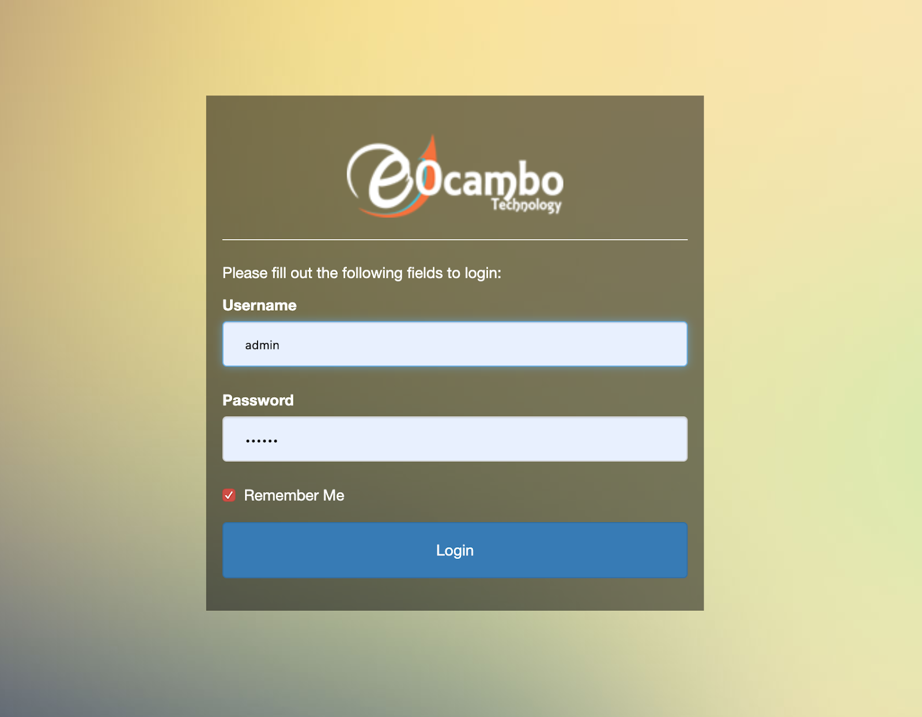

# Tour

## Tour Category

You can create **tour category** by click

* Tour
* Tour category
* Add new
* Input info
* save

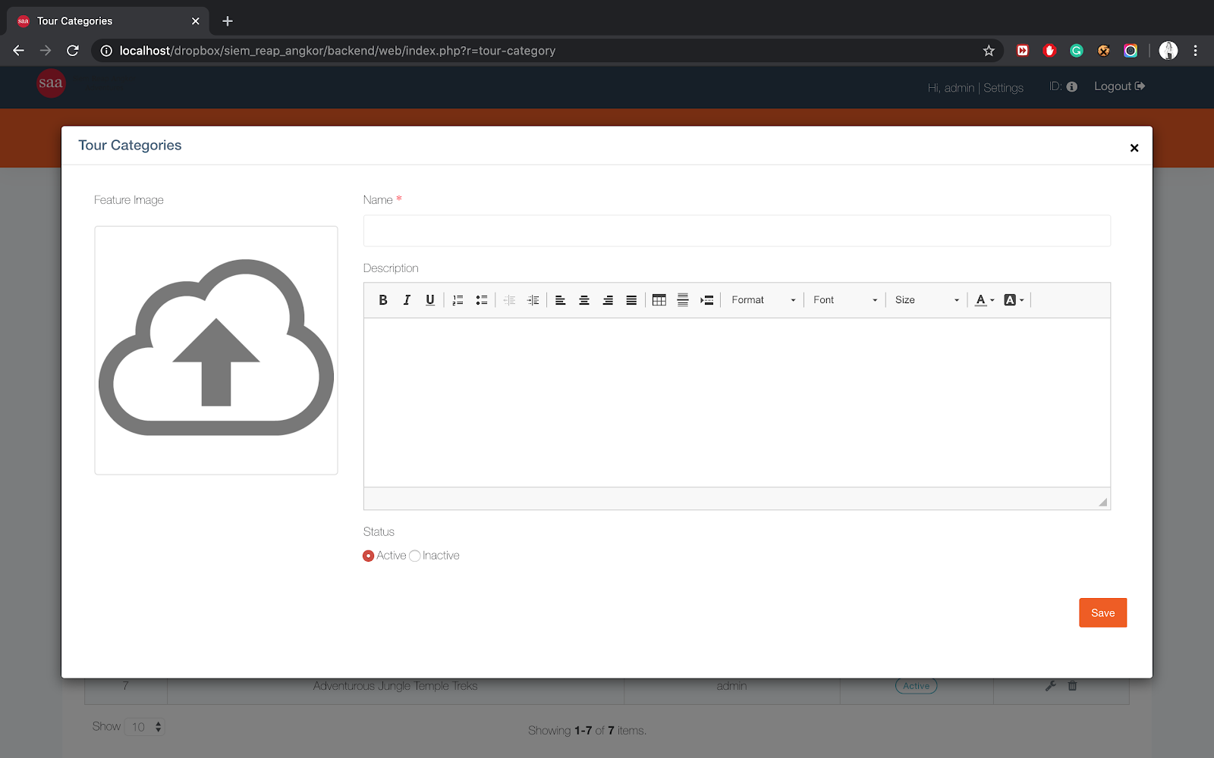

## Tour Item

You can create **tour item** by click:

* Tour
* Tour item
* Add new
* Tour item tab
* Input Info
  + Note: Is show: is use to append it into frontend > home page
* Save

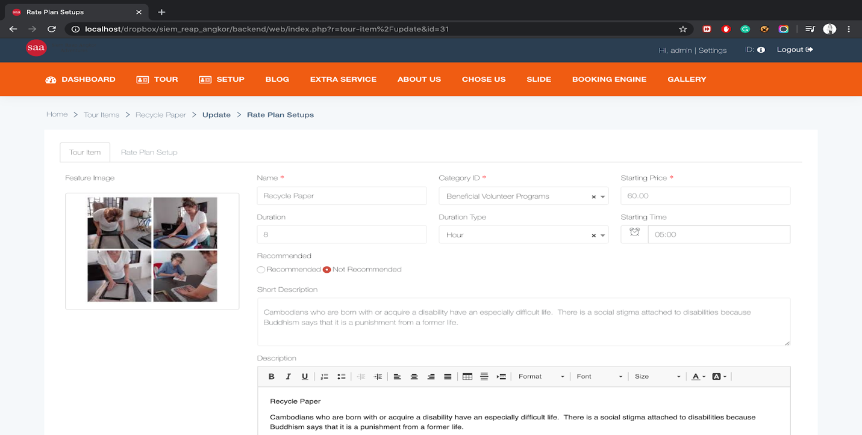

### Rate Plan Setup

**Rate plan setup** is use for create sub of **tour item** so need to have tour item first to create rate plan setup. You can create **rate plan setup by**

* Tour
* Tour item
* Click update (Pen Icon) on tour item that need
* Input info
* save

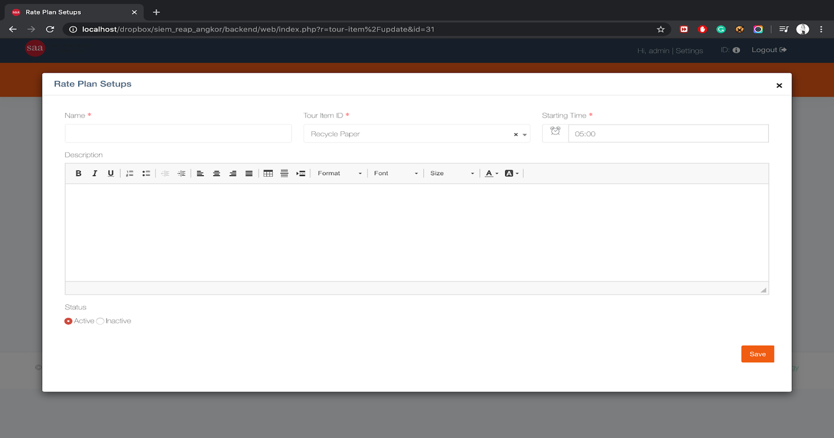

# Setup

## Country

You can create country by click:

* Setup
* Country
* Add new
* Input info
* Save

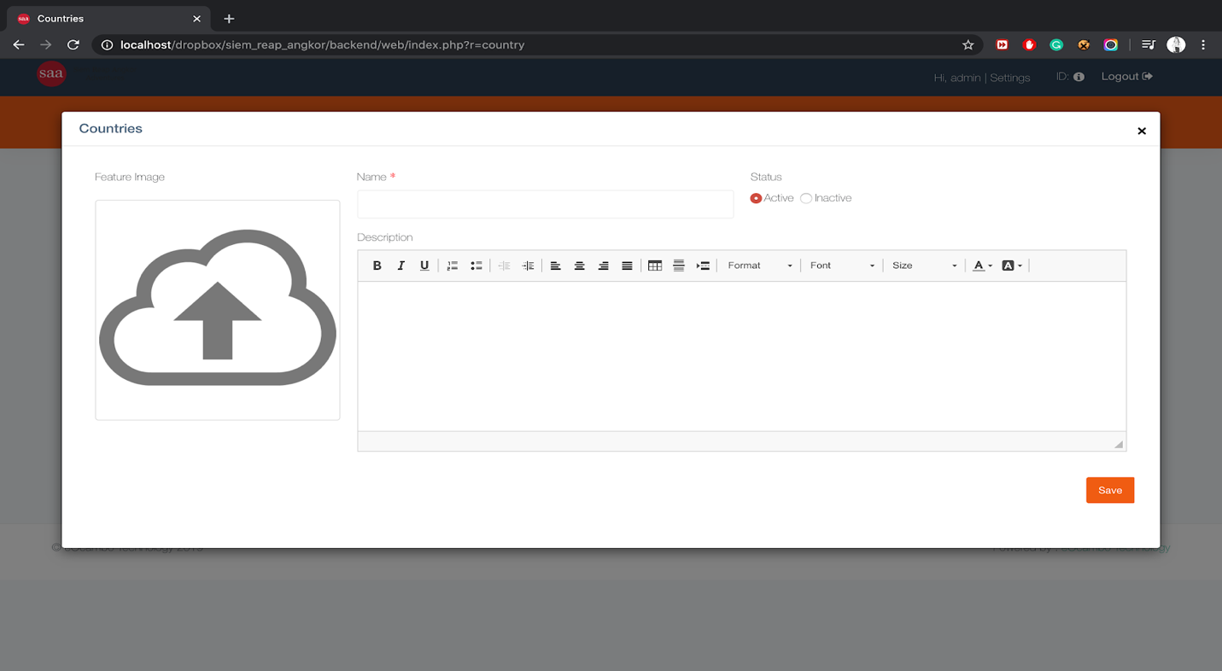

## City

You can create city by

* Setup
* City
* Add new
* Input info
* Save

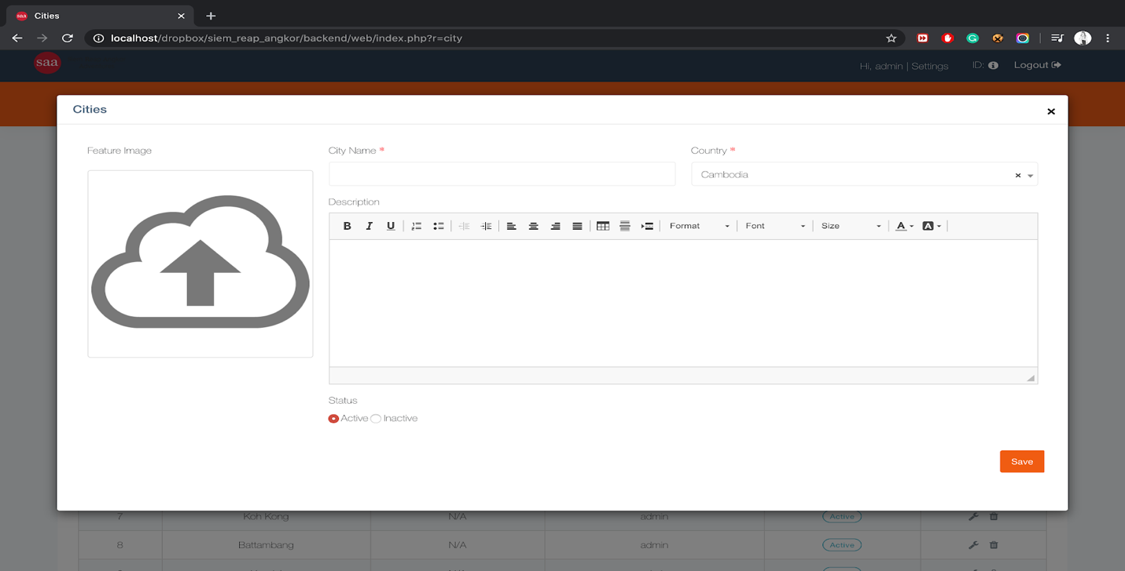

## User

User management is the feature use for control on user (Create, Update, Delete) and also you can change password, to do this you can go by click

* Setup
* User
* Add new
* Input info
  + And the password and confirm password you might write the same
* 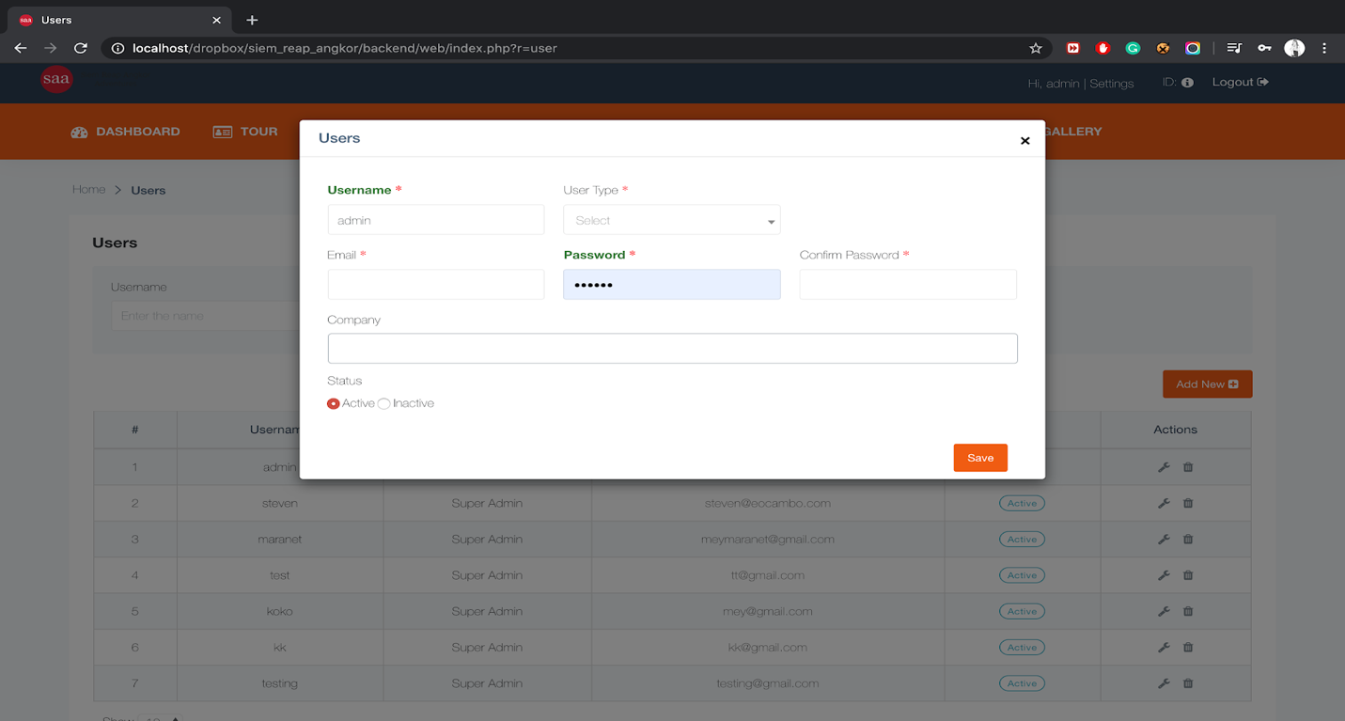Save

## Company Profile

Company profile is the feature use for control on company profile (Create, Update, Delete) to do this you can go by click

* Setup
* Company Profile
* Add new
* Input info
  + And the password and confirm password you might write the same
* Save

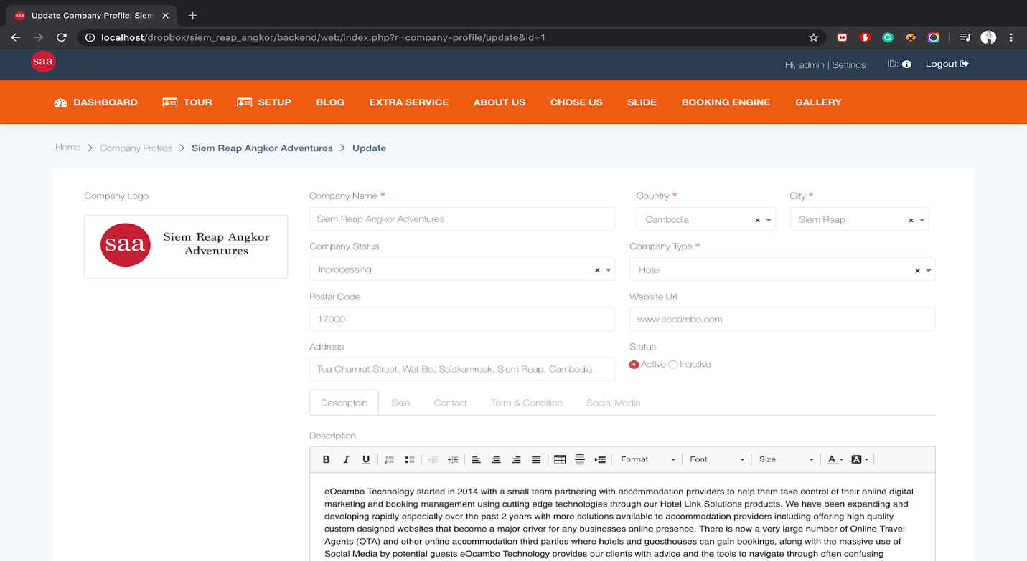

# Blog

You can create blog by

* Blog
* Add new
* Input info
* Save

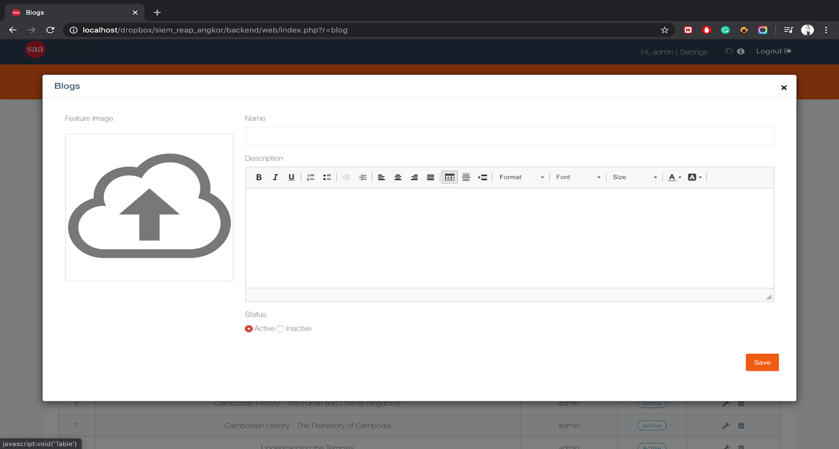

# Extra service

Extra service is the feature use for create more service beside of tour item, so that customer can chose to include to their tour booking, You can create **extra service** by click:

* Extra service
* Add new
* Input info
* Save

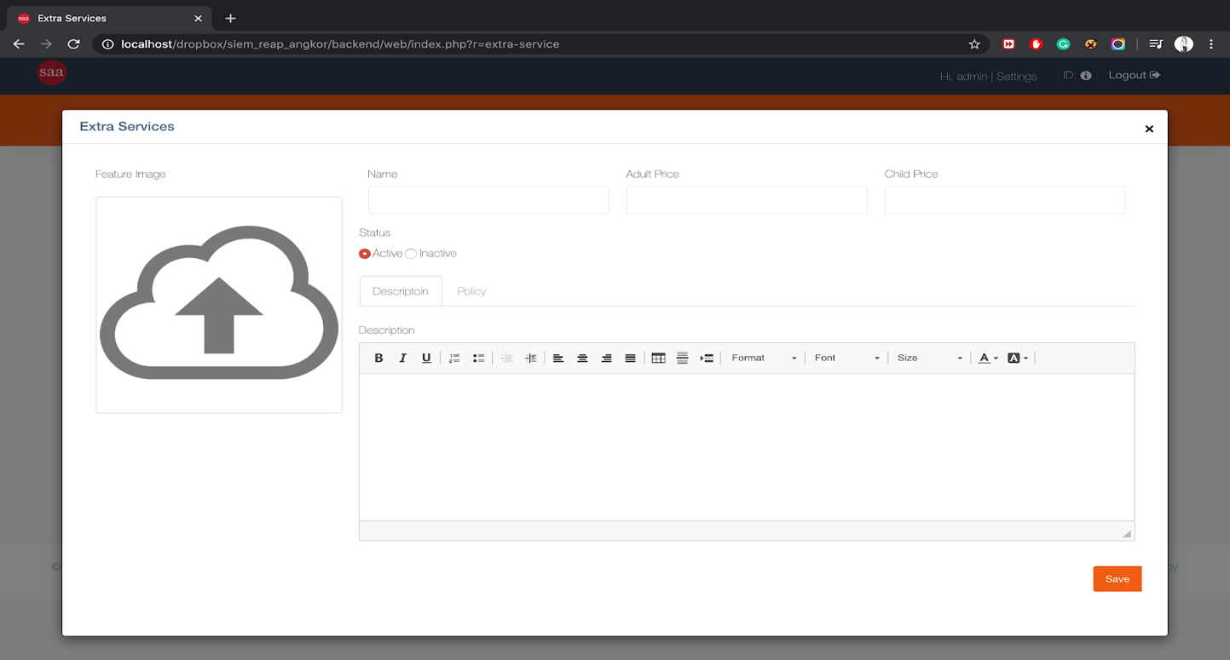

# About Us

About us is the feature use for input data to the frontend end about the company info, You can update **about us info** by simply way by

* About us
* Edit info
* 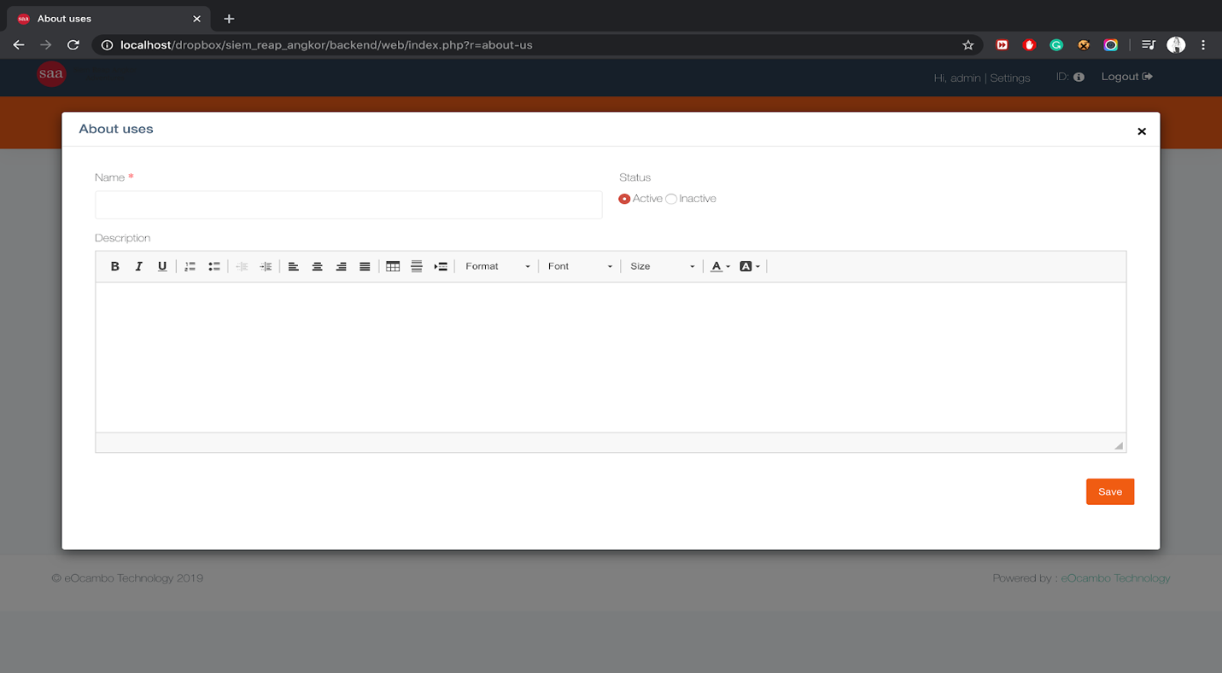Save

# Chose Us

You can update **about us info** in the simply way by click:

* About us
* Edit info
* 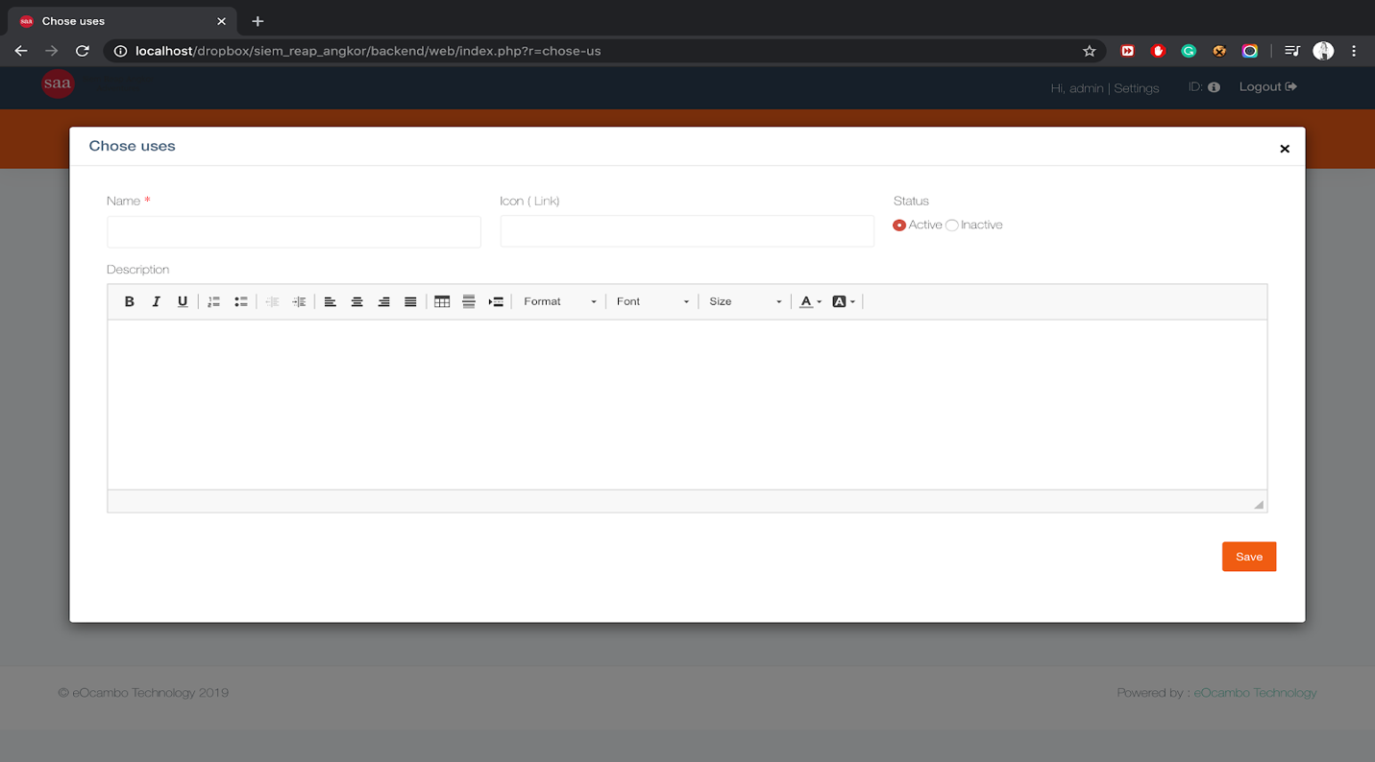Save

# Slide

Slide is the feature that will appear to the home page, to edit the slide go to click

* Slide
* Add files: chose the file from your local. And you can upload multiple file
* Save

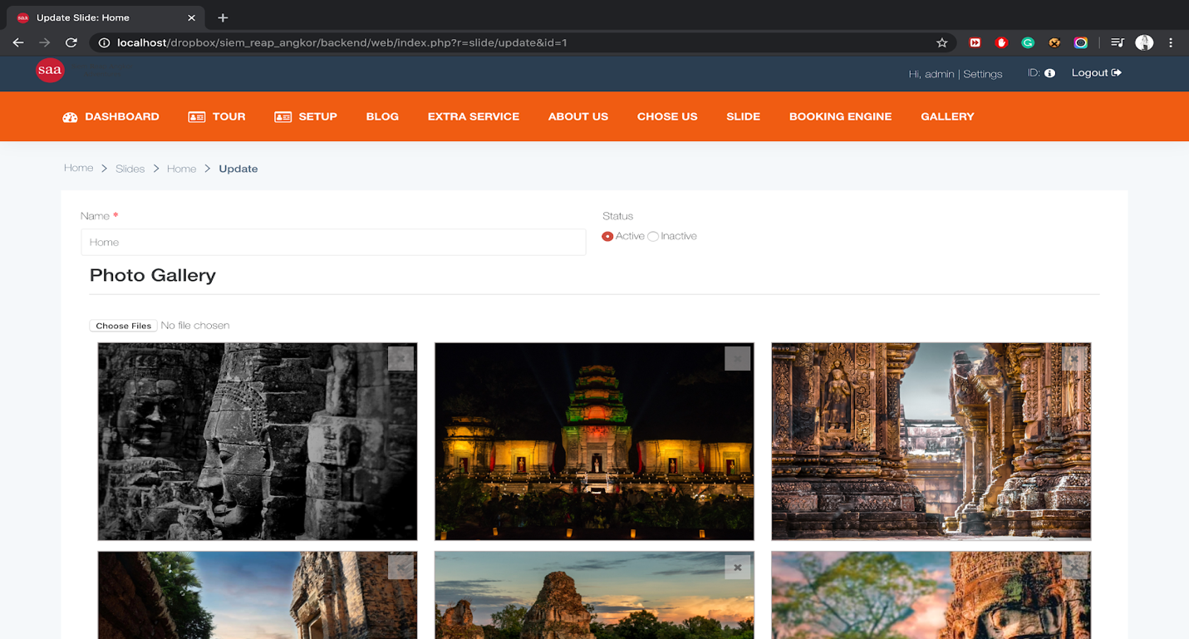

# Booking Engine

Booking engine is the feature that manage to tour item rate and availability.

And also control to customer info for whom have been booking directly on the website in the frontpage part.

## Allotment

Allotment is use for put the tour item to make it as availability that customer can filter and have a booking. If you not yet have tour item or rate setup plan (Tour item setup) you might go to create it first.So after you have created you can go through:

* Select Month
* Select Year
* Select Tour Item (Tour item rate setup)
* Click filter
  + Select from date
  + Select to date
  + Input number: number here is about the available for maximum people. Ex: 23people only, so just put 23

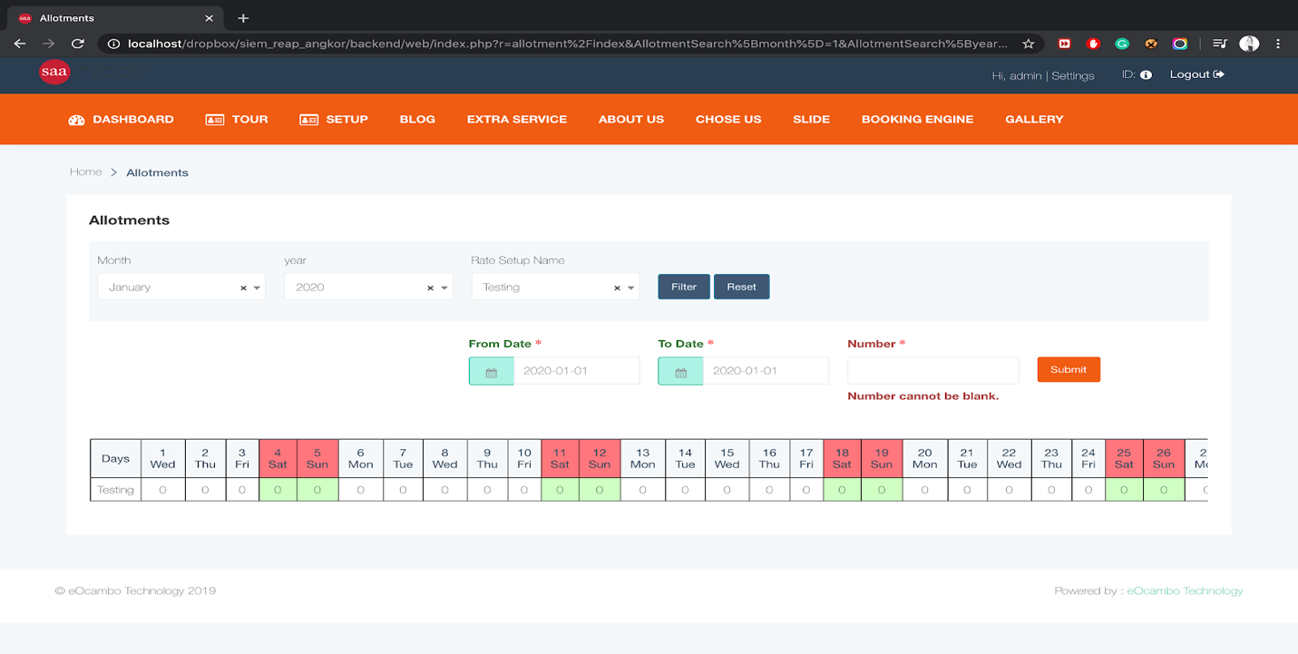

## Rate Plan

Rate plan is use for put the price of each tour item to available that customer can filter and have a booking. If you not yet have tour item, rate setup plan (Tour item setup), allotment. you might go to create first, So after you have created you can go through:

* Select Month
* Select Year
* Select Tour Item (Tour item rate setup)
* Click filter
  + Select from date
  + Select to date
  + Rate Info:
    - From: input between people, from people
    - To: input between people, to people
    - Cost adult: original cost of adult
    - Cost child: original cost of child
    - Mark-up adult: the value input for profit from the original adult cost
    - Mark-up child: the value input for profit from the original child cost
    - Price Adult: is the total adult price (auto calculate)
    - Price Child: is the total child price (auto calculate)
      * The icon “+” is use to add more between people and another rate
    - Save

This is the picture when you first create rate plan

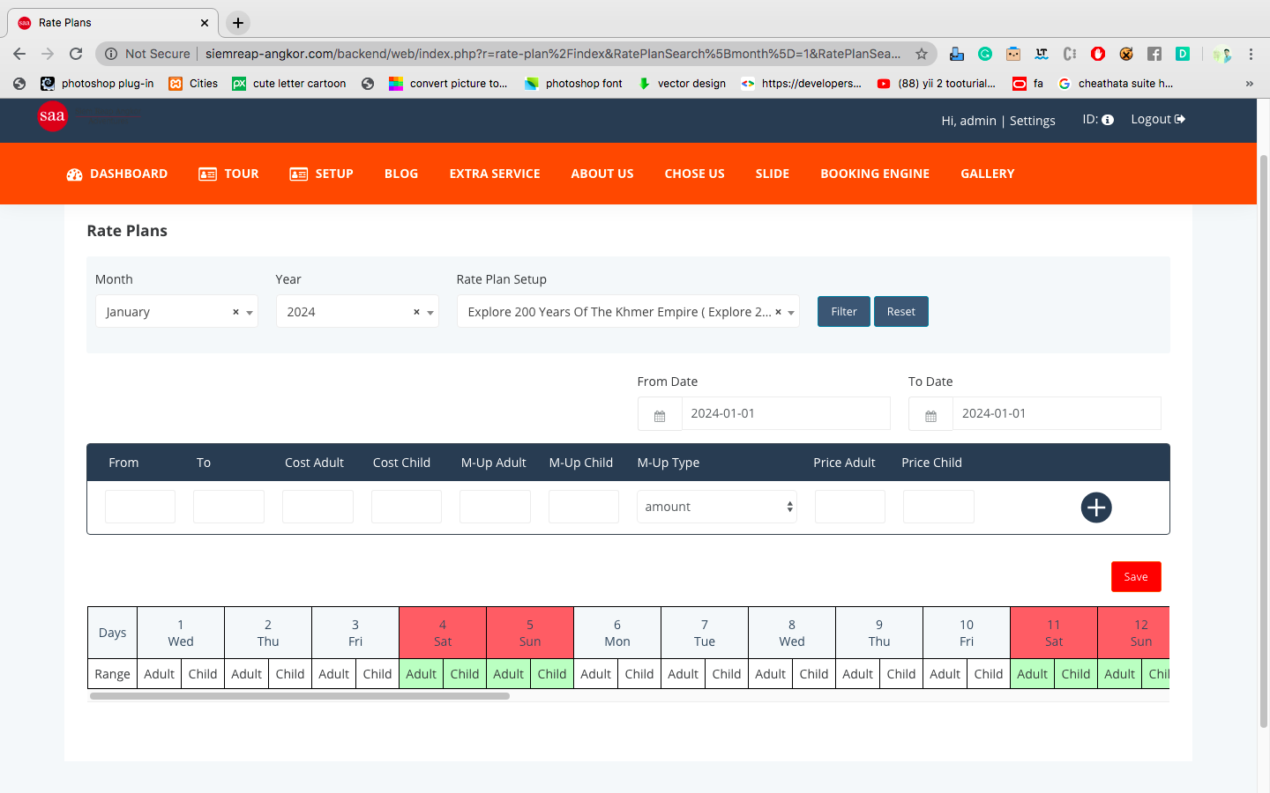

* For update rate plan
  + Select Month
  + Select Year
  + Filter
  + Click update

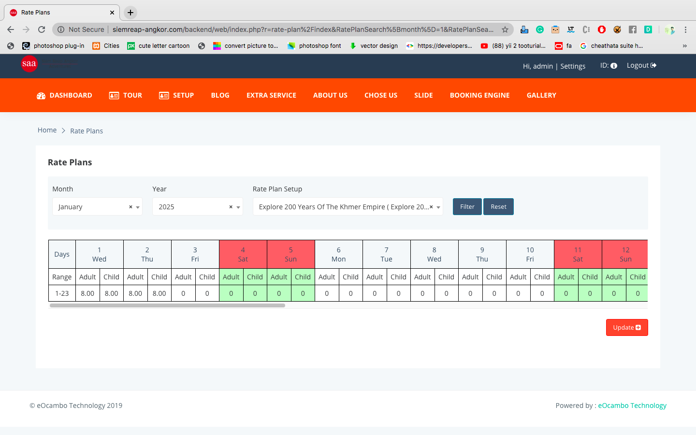

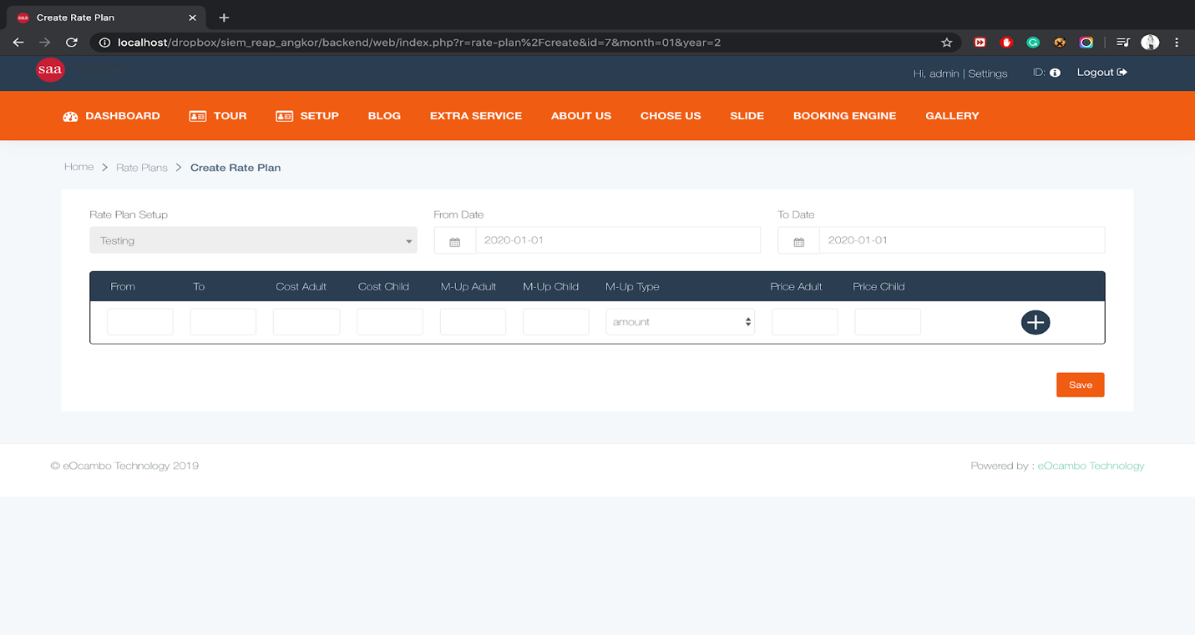

## Customer Booking

Customer booking use for manage the customer info whom booking and also service listing or message from customer. To view that info just goes by:

* Booking engine
* Customer Booking
* To View more info: Click on customer name

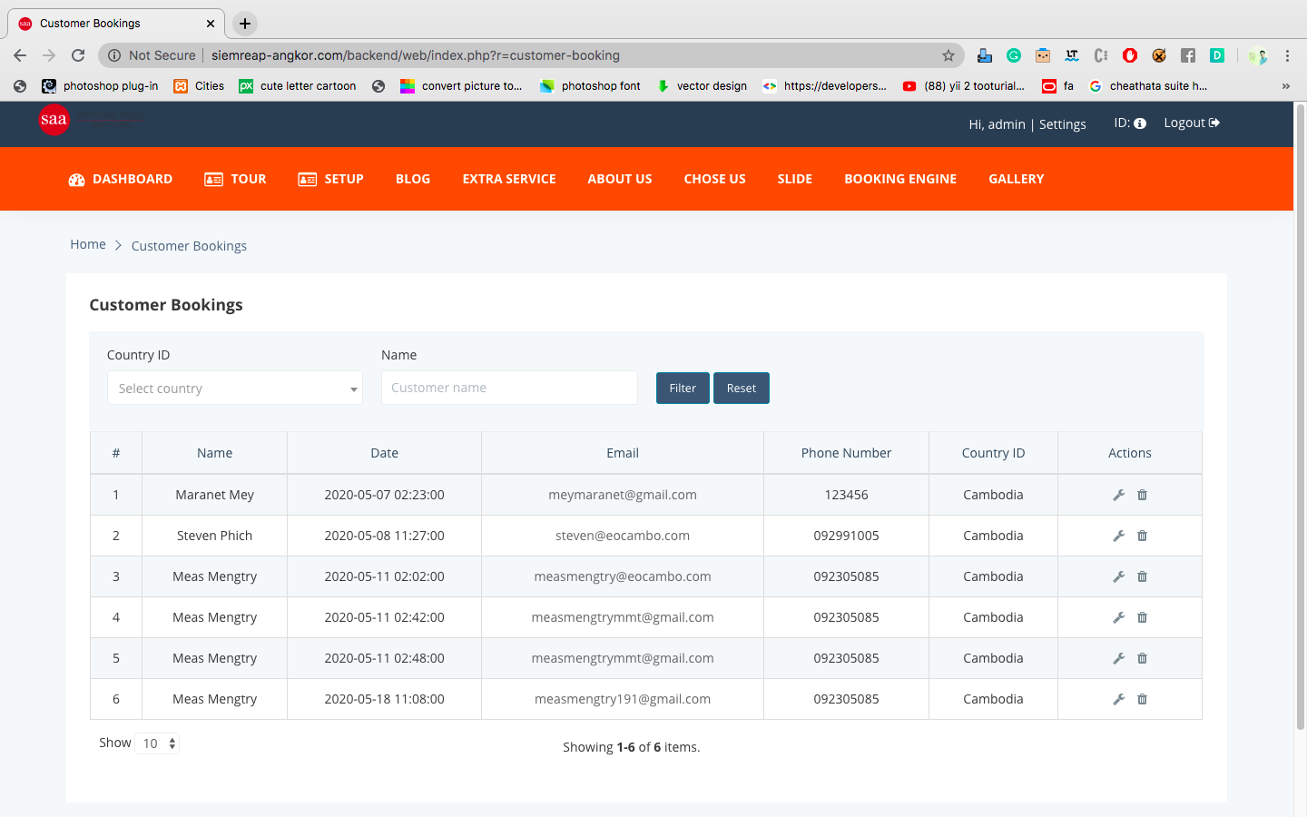

# Gallery

Gallery is the feature that control to bunch of images to show on frontend. To create go by:

* Gallery
* Add new
* Input name: name here will be appear as gallery title to cover image
* Upload image: you can upload multiple images
* Note: the gallery maximum is 8. So when total is 8, the add new button will be disappear.

