Emily Schultz
ess2183
COMS 4735
Visual Interfaces to Computers

Assignment 1: Visual Combination Lock

Introduction
This assignment was to create a visual combination lock, which took a series of visual images and determined if the user had placed them in a predetermined sequence of poses and locations. The program takes a series of one to ten images of a user’s hand, and based upon a preset combination determines if the user has unlocked the lock. This report is divided into five parts, following the outline of the assignment: Domain engineering, Data reduction, Parsing and performance, Creativity, and Code listing.

Domain Engineering
The first part of the project was to take pictures of the hand performing various gestures. These photos would later be organized into several different sequences, and the program would determine the correctness of the sequence. I began by placing a solid black piece of matte black fabric on a flat surface. I set up overhead lighting of adequate brightness so that there would be no shadows to potential distract my program later on. Additionally, I wore a long-sleeved black shirt in order to hide the skin of my arms from the photos, akin to what was done for the Kjeldsen project. I chose a black background because the hand I was using for the testing of my system (my own hand) is very pale, and therefore most likely to contrast with a black background, rather than white.
Once I had set up the photo studio to take the clearest photos possible, I used the camera on my iPhone to take photos of my hand performing different gestures in different locations on the background (a subset of these photos are shown in Sec. 2,3, and 4). My camera automatically stored these on my computer as .png files, so the first step of my program was converting them to .ppm files, since .ppm files allowed me to access the RGB values of each individual pixel of the photo. I chose to use Python as my programming language for this assignment, and it has a number of imaging packages available, with the main package being the Python Imaging Library, but I also used Scipy and Numpy as well. These are common Python packages, so there should be no issue with their use.

Data Reduction
Now that the photos of the different gestures were in a usable file format, it was time to reduce the data to only the parts that were truly necessary. My initial files were 640x478, and that was clearly way more pixels than necessary. The extra pixels would only slow down runtime without any considerable increase in performance. First I reduced the size of the image to 100x75, maintaining the aspect ratio of the image as closely as possible. This size is still large enough to see the different gestures, while not getting caught up in too many pixels.
Because in the domain engineering step I set up my images to have a white hand on a black background, it was fairly simple to convert this to a binary image. I smoothed the image beforehand, because there is always the possibility of a few white specks of lint on the black background, and I didn’t want these to throw off the later calculations. I looked at a histogram of the pixel values at this point and determined that values greater than 180 on average were consistently in the hand portion of the image, while values below this threshold were in the background. I used this as my threshold and converted to a binary (black versus white) image, where values above it were transformed to (255, 255, 255) and values below to (0, 0, 0).
Next, we needed a way to test if it was more like a fist or like a palm. I computed the center of mass of the skin pixels by calculating the sum of all the x and y pixel locations that were skin (white) and averaging them by the total number of pixels. This gave a fairly accurate value for the center of mass of the hand. This step was used when determining the location of the gesture. If a value was small in x and y, it was in the upper left corner, if it was large in x and y, lower right, and so forth. Not all locations were checked for under the grammar I designed (see Step 3). Although this center of mass was useful for location of hand, I needed to use more sophisticated methods to differentiate the gestures (this became especially necessary for Step 4).
Next I used the bounding box method to determine the size of the image. I had the area from the center of mass calculation, so I used that combined with the bounding box to form a rough estimate of the gesture. For example, if I bounding box was large relative to the area, I could tell the image was likely a splayed hand, and if the bounding box was small relative to the area, I knew it was probably a fist, since the fist would have a tight bounding box. This was enough to differentiate between the ‘splay palm down hand in center’ and the ‘closed fist in corner’ needed for the first part of the assignment. A more elaborate system was needed for the creativity part (see Step 4).

Parsing and Performance
The initial grammar was determined to be ‘hand splayed palm down in center’ followed by ‘fist in any corner’. I determined that this sequence at any time during the sequence of images would be sufficient at this phase. I first determine the gesture, before attempting the location, using the bounding box-to-area ratio (from now on referred to as BBAR) discussed in Step 2. From analysis of the gestures and some initial images, I determined that the best values for my setup were for a BBAR of 1.45 or less to be considered a fist, and a BBAR of 2.0 or greater to be considered a splayed hand. I came up with these values with some tinkering with some initial data, and found them to be fair representations of the ratios for those different gestures.
Next I needed to determine location for my grammar. To define the ‘center’ versus ‘corner’ dynamics, I used the values for center of mass from before. Since all the images were the same size at this point (100 x 75), I determined the locations naturally from this coordinate system, and modified them slightly based on observed patterns in initial data. For fist the center of mass is really in the center of the gesture, while for splayed hands the center of mass actually lies a bit lower in the palm. Because of this, the locations have some tolerances built in, which is necessary since humans aren’t perfect. For the corners, I considered for x-wise: 40 and lesser to be left, 60 and greater to be right; and for y-wise: 33 and lesser to be up, 45 and greater to be down. Thus these boundaries naturally form four corners. Notice that there is, however, gap room between the corner sections. These areas are grey zones. I don’t think they would be considered corners. I think any user who knew the combination would be quite careful about making sure their hand was in a corner, whereas someone who was trying to break into the lock without the combination would try to skirt the lines and find overlaps without committing to a location. The nature of the problem required the strict nature of the boundaries. Similarly, I determined the center to be, x-wise: between 35 and 65; and y-wise: between 25 and 53. Again, there’s a little more tolerance in the up/down direction than in the left/right direction, because of center of mass calculations fluctuating a bit by gesture. Notice there are overlaps in the regions of center and corners. These regions will qualify as either, depending on what is required for the grammar. So if the center of mass ends up at (62, 27) it could be corner if the fist is supposed to be corner, or center if the splayed hand needs it to be center. The next page contains a list of ten sample runs, seven of which were successful, and three of which were not.

10 Sample Runs: (7 Successful Sequences with Correct Outputs)
Correct: ‘Hand Splayed palm down in center’ followed by ‘Closed Fist in any corner’
- 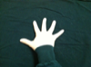, 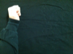 YES
- 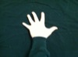, 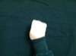 NO
- , 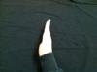, 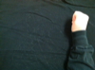 NO
4. , , 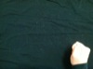 YES
5. 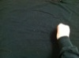, 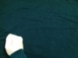, , 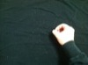, 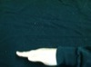 NO
6. , 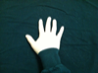, YES
7. , 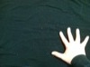, NO
(3 Failures with Explanations)
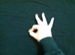
8.

FALSE POSITIVE- OUTPUT: YES, CORRECT: NO
A human would clearly notice that the symbol in the center is not a splayed hand, but rather an “OK” symbol (implemented in Part 4). However, because of the process to differentiate splay from fist in Part 3 only involves the ratio of area of skin to bounding box area, the “OK” gets mislabeled as a splay center, since it BBAR is roughly equivalent to that of a splayed hand. This is clearly an error in the classification step, since the program called it a splay center.

9. 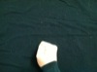, 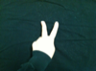,
FALSE POSITIVE- OUTPUT: YES, CORRECT: NO

Again, a Peace sign is not a splayed hand, but it sure does seem like one to the computer. It got the fists correct, but identified the Peace sign as a splayed hand center, thus changing the result from NO to YES. This problem with only checking the ratio is modified during the creativity step to give the program more versatility and less false positives for gestures it hasn’t learned.

10. , 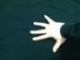, 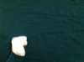
FALSE NEGATIVE- OUTPUT: NO, CORRECT: YES

I was initially confused as to why the sideways hand wouldn’t be recognized by the program, but then I determined that although it was recognized as splay, the sideways orientation made the center of mass shift to the right rather than down, and so the hand is no longer in the center of the image. This is an issue with location that leads to the false negative, rather than pose recognition like the other two. It failed because we assumed the hand would be up and down for the splay, and the center of mass would only shift down a bit, but in this case it shifts right.

Creativity
To further extend the system I had created and implement some new aspects for my image processing, I chose to add some new gestures for creativity. I decided on four new poses as a fair challenge extension to the first part: “O” circle, horizontal karate chop, vertical karate chop, and “OK” sign.
I also chose to modify the correct combination and grammar a bit here to account for the new poses. I no longer care about positions, except in the case of a fist, where a fist in the lower right corner means ‘this is wrong no matter what’. I thought this would be an interesting added feature, to cancel an attempted access, even if correct code has already been entered. The correct sequence is now ‘Vertical Chop’, ‘Circle’, and “OK”, consecutively without interruption.
I used two different tests to differentiate the now six different symbols (Fist, Splay, Okay, Circle, Vertical Chop, Horizontal Chop): connected components, bounding box width to height ratio. The bounding box width to height ratio (BBWH) is a basic extension from Step 3’s BBAR, except it allows us to differentiate between a horizontal chop (with a BBWH greater than four ~ very rectangular), a splayed hand (with a BBWH between 1.5 and 3.0 ~ somewhat rectangular) and a fist (with a BBWH between 0.7 and 1.2 ~ relatively square). The same is true for the connected component gestures, circle (same bounds as fist) and “OK” symbol (same bound as splayed hand). The vertical chop has a very rectangular BBWH as well, but with this number be very small instead of very large for the case of horizontal chop). I also had to test for location for the fist, so for that I used the center of mass calculations from before. These values are very empirical, based on a trial set of images I took before testing, with some modification as necessary to give it better performance.
For connected components, I wanted to know the number of connected black components, since we see where the background is connected in the holes, so I had to invert the image before checking the number of connected components. You want to see two components for “OK” and Circle, because they have a hole in their middles.
For the automatic cancel, I chose not to even look at the remaining photos, since they were pointless and would only waste running time. If I couldn’t classify a gesture (there are no overlaps), then it was assumed it was an unknown gesture, and used as an incorrect gesture would be normally. This allows the system to be extended in the future. Below are 10 new trials of the new system, including seven successful runs and three failures.
Correct combination is: ‘Vertical Chop’, then ‘Circle O’, then ‘OK’ Symbol

7 Correct:
1. 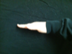, 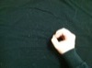, NO
2. , 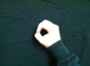, YES
3. , , NO
4. 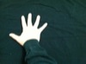, , , , YES
5. 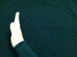, , NO
6. , , , , YES
7. , , , 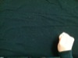 NO

3 Failures:

8. , ,

FALSE POSITIVE- OUTPUT: YES, CORRECT: NO

Here the system says that the user has displayed a correct password, when in fact they have not. The problem lies with the fact that the splayed hand is partially cut off at the pinky/palm, leading to two distinct components of background. When we test this image, it reads like an “OK” sign, because there are two pieces of background separate from each other. The problem is with hands that go out of bounds, which this system didn’t check for.

9. , ,

FALSE NEGATIVE- OUTPUT: NO, CORRECT: YES

On this input, the system says that the user has no displayed a correct password, but she did (or tried to lazily because she’s a human and prone to error). The circle gesture gets incorrectly identified as a fist because the circle portion of the “O” is not facing the camera. The slant of the hand, along with the smoothing process before the binary reduction makes this “O” look like a fist, and the center is lost. Since it sees a fist, it doesn’t think it is the right combination, when clearly it is. The issue lies with the fact that the computer can’t adjust its angle to the picture, and humans are fallible.

10. , , , 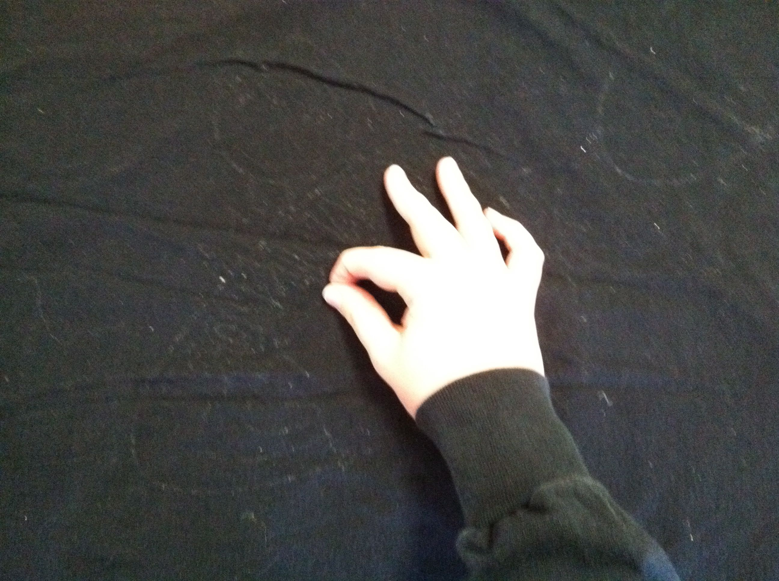

FALSE NEGATIVE- OUTPUT: NO, CORRECT: YES

With this error, it’s all about the camera angle. The last “OK” sign is a bit distorted, and therefore there are actually three separate sections of black background. The system only looks for one circle (and in fact the gesture only has one, but the picture adds another by the pinky finger), and when it finds two circles separate from the background it classifies it as unknown. Then, the otherwise correct input becomes incorrect, because of the system trying to allow for future new gestures and being as specific as possible, but actually just failing to recognize an “OK”.

