Gross Color Matching Results:
Image | Original  Number | Most Similar Image | Similar  Number | Least Similar Image | Dissimilar  Number
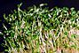 | 01 | 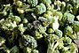 | 10 | 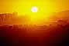 | 26
 | 02 | 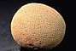 | 39 |  | 30
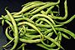 | 03 | 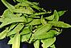 | 4 |  | 15
 | 04 |  | 3 |  | 15
 | 05 |  | 6 | 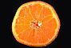 | 18
 | 06 | 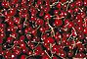 | 11 | 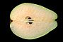 | 22
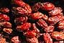 | 07 | 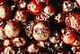 | 9 |  | 30
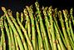 | 08 |  | 24 |  | 30
 | 09 |  | 7 |  | 30
 | 10 |  | 1 |  | 15
 | 11 |  | 9 | 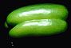 | 37
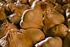 | 12 |  | 2 |  | 30
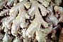 | 13 |  | 10 |  | 18
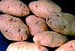 | 14 |  | 39 |  | 26
 | 15 |  | 7 |  | 4
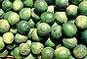 | 16 |  | 1 |  | 15
 | 17 |  | 25 |  | 37
 | 18 | 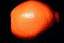 | 35 |  | 30
 | 19 |  | 8 |  | 31
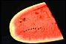 | 20 |  | 17 |  | 30
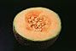 | 21 |  | 2 |  | 31
 | 22 | 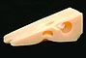 | 34 |  | 31
 | 23 |  | 5 |  | 30
 | 24 |  | 3 |  | 31
 | 25 |  | 28 |  | 37
 | 26 | 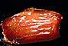 | 40 |  | 22
 | 27 |  | 30 |  | 18
 | 28 |  | 25 |  | 30
 | 29 |  | 30 |  | 15
 | 30 |  | 29 |  | 15
 | 31 |  | 32 |  | 22
 | 32 |  | 3 |  | 15
 | 33 |  | 40 |  | 30
 | 34 |  | 22 |  | 31
 | 35 |  | 18 |  | 30
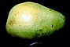 | 36 | 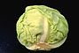 | 38 |  | 31
 | 37 |  | 4 |  | 15
 | 38 |  | 36 |  | 31
 | 39 |  | 2 |  | 30
 | 40 |  | 7 |  | 27

Overall Most Similar:
1 and 10
Overall Least Similar:
22 and 31

