Step 3 Output:

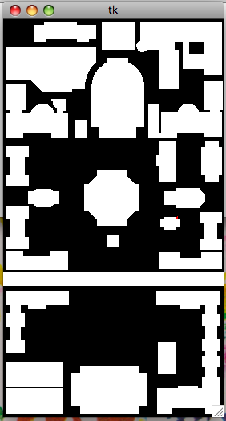
Largest Cloud at (128, 103) (2935 pixels) Smallest Cloud at (217, 247) (36 pixels)
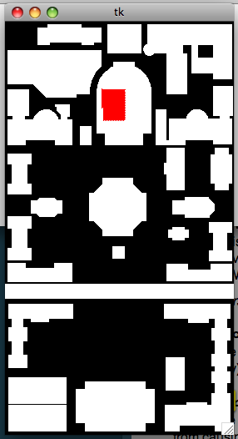

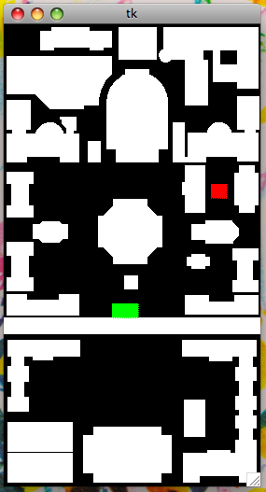
Three Pairs (S and G) and their descriptions:

Pair 1:

S: location (231, 173) ; Cloud Size 1180
East of and Near to 9 (Avery), North of 12 (Low Library),
North of 13 (St. Paul's Chapel), East of 17 (Buell & Maison Francaise)
G: location (136, 303) ; Cloud Size 1206
Near to 19 (Dodge), North of 21 (College Walk)

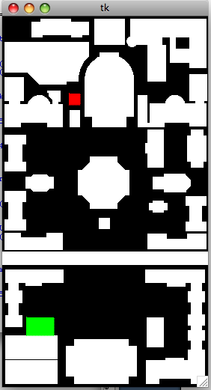

Pair 2:

S: location (96, 107) ; Cloud Size 1057
East of 7 (Chandler & Havemeyer),
North of and Near to 8 (Computer Center)
G: location (40, 412) ; Cloud Size 2033
North of and Near to 25 (Lerner Hall),
North of 26 (Butler Library)

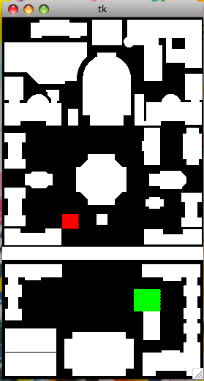

Pair 3:

S: location (207,385) ; Cloud Size 1712
North of and Near to 24 (Lion's Court),
North of and East of 26 (Butler Library)
G: location (99,272) ; Cloud Size 1149
North of and East of and Near to 19 (Dodge)

