Emily Schultz
ess2183
COMS 4735
March 12, 2013
Assignment 2: Visual Information Retrieval

Introduction:
The goal of this assignment was visual information retrieval, using a variety of algorithms to explore different ways of defining ‘sameness’. A set of 40 images, all with black backgrounds, of fruits, vegetables, and distractors, was used as the input and output for this assignment. There were four phases of this assignment: Gross color matching (1), Gross texture matching (2), Combination of color and texture with clustering (3), and Dendrogram (4). For this project, I programmed in Python and made using of the Python Imaging Library (PIL), as well as Numpy and Scipy, which are well-known and well-documented Python libraries that we were allowed to use.

Step 1: Gross Color Matching

The first stage of the program involved comparing images strictly on their total color distributions. The color space consists of 16M colors (256 x 256 x 256), so needed to split up the space into bins. I chose to take 52 bins, each of size 5, for each of the three color axes (R, G, B). I made this decision because it seemed to me, from a human perspective, that a change in any pixel value of only 5 in any direction was small enough that it was not a remarkable difference in the color, yet it allowed us to reduce the image to a more manageable histogram size. I initially tried with bins of size 10, however with bins as large as 10 there are colors that are clearly different being marked as the same, and the results from the matching proved to be worse than for bins of size 5, so 5 was ultimately the victor. It reduced the image down to the order of 100K bins rather than 16M, and yet not too small that the nuances of the images’ colors are lost.
The second design decision I had to make for this section was what to do with the background. Because all of the images have a black background, if I compared the images taking into account the black, all I would be doing is measuring the size of the foreground objects. Clearly, this is not what we wanted to do. Instead, I decided to ignore all pixels that were deemed black. Granted, this method would ignore pixels within the image that have black as part of the image rather than the background, but these images are the distractors rather than the fruits and vegetables that were the focus of the project, and these losses are offset by the gains in color recognition when ignoring black.
Because black in the images is not the same as pure black of the RGB color wheel (0,0,0), I had to decide exactly what the bounds on ‘black’ were. I decided by looking at a typical series of black pixel values for some of the images, and based on these pixels I noticed that in general the color black would have R, G, and B values all less than 40. Although looking at a the RGB color wheel a case could be made that values where just one of the pixels is 40 while the others are zero (such as 40,0,0) really aren’t black but dark red (or green/blue), I looked into this possibility and found that pixels with a value of 0 for any of the three were either clearly out of the black range (other values much greater than 40), or clearly in the black range (other values much less than 40). This made 40 a natural cut-off for black, and it seems to have worked rather well for the color matching.
Now that I was ignoring the ‘black’ pixels, I found every pixel value in a given image, sorted it into the appropriate bin, and formed a three dimensional histogram of the results: [R][G][B] with the value being the number of pixels that fall in that bin for this image. I used a normalized L1 comparison to compare each image’s histogram to the histogram of every other image. This was achieved by dividing each histogram by the total sum of the counts across all bins in the image (since we removed black and each image had a different amount of black I had to normalize in this manner), then taking the sum of the absolute value of the difference between one normalized histogram (for image A) and a second normalized histogram (for image B) and then dividing by two so that the results would be a number between 0 and 1. I ended up having to take 1 minus this result in order to fit into the guidelines of this assignment: where 0 means the image share no pixel colors in common, and 1 means that the images have the exact same color pixels, but perhaps scrambled.
On Pages ___ you will see the results of this gross color matching formula. For each of the 40 images, the image most similar to it and the most different from it are paired side-by-side, and then the images most similar overall and most different overall in the database are also pictured.
I think that the matching did very well for color, with a lot of obviously correct pictures, and a few that surprised me. It seemed strange that the purple spiral would be very similar to the blue spiral picture (31, 32), however since these are such bright and rich colors, perhaps it’s because there isn’t another bright blue or bright purple picture for them to pair with, so they pair with another brightly colored image. However, on the whole I would say that the colors are very similar among the images chosen for most similar, and this is very easy to verify as a human. I am very pleased with these color matching results.

Step 2: Gross Texture Matching

Next I wanted to compare the edginess distribution, or gross texture matching, based on the images gray scale textural similarity. I computed the gray scale value from (R+G+B)/3, then computed the Laplacian by applying a mask to all the non-edge pixels, where the new value of a given pixel would be equal to 8 times its original value minus each of its 8 neighbors values. Then I formed one-dimensional histogram of these values for each image, and compared them with the sum of the absolute value of the difference (L1 norm) as in Step 1. Again, if a pixel was black initially (same value of 40 was used to define black), then I would ignore its value in the histogram, because I didn’t want this to effect the texture of the actual subject of the image.
I chose the number of bins largely based on trial and error, and then based on a relativity with the Color Matching portion for part 3. I compared results from bin counts as small as 100 bins and as large as 1000 bins. Overall, when comparing 100 bins to 1000 bins I found that the formula would sometimes key in on important aspects of an image if I increased the number of bins, but sometimes it would focus on something irrelevant, and have somewhat extraneous results, therefore making a larger number of bins less accurate. Because of this gain/loss from more bins, I decided to choose 408 bins in the end. Ultimately, this seemed like a good compromise between too many bins that pick up irrelevant details and too few bins, which could miss things. Additionally, 408 gave me a relatively similar ratio of bins to maximum value as gross color matching. In Step 1, the ratio of 255: 52 ~ 5 while for gross texture matching the ratio 8*255 = 2040, so 2040: 408 ~ 5. I wanted these to have approximately equal sparseness in their respective spaces for Step 3 when we combine them.
Ultimately I found that 3 images composed all of the least similar space: 26, 1, and 8, which makes sense when you look at these images since one has a very gradual change, one has a very mixed up but changing space, and the third has a very linear and changing space. Since the images in general are of fruit and other symmetrical and not necessarily overly texturized subjects, these would be the oddballs of the bunch, although I was surprised that some other images didn’t make it into the section of least similar for at least one image. Also, I suppose as a human being my perception of texture is skewed, because I found some of the pairings to be odd, but it probably has to also do with the fact that I prefer color matching to texture matching. Since I only saw some of the best values change, and only by a small margin, when I changed the number of bins, I think that my texture measure is accurate, although I don’t think it focuses in on exactly what I would focus on as a human. Also textures with small images can be a bit dicey. The results are on Pages ___.
Step 3: Combination and Clustering

For the third part of the assignment, I combined the color and texture matching aspects into a formula S = r * T + (1-r) * C , where T is the texture value and C is the color value (both from 0 to 1), yielding S the combined value (also from 0 to 1). To determine the value of r, I ran the formula on values of r between 0.0 and 1.0, increasing by 0.05 every iteration. I used the value of overall max – overall min as my metric for choosing the best r because I wanted an r where even the worst was still pretty good, and the best was of course very good. There were clearly other options, but this metric would at least guarantee me that all my values fall within a particular value, if we know the worst and the best. Below is a graph of my findings:
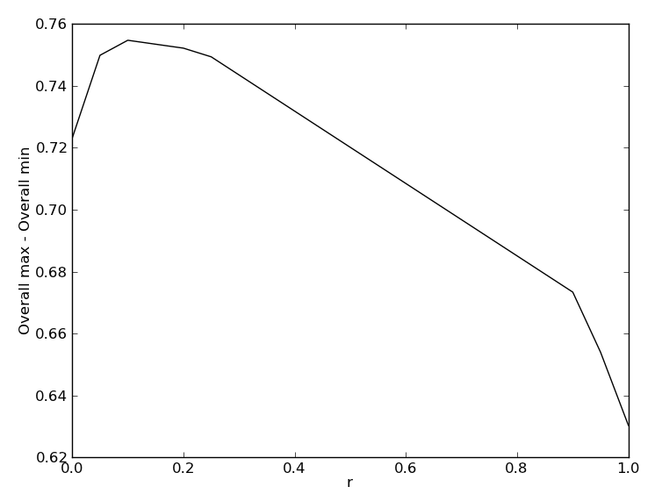
R value vs. Overall max – Overall min

Since I wanted (overall max – overall min) to be at its highest, I chose r to be 0.15, which is the value of the peak of the graph. I think this makes sense for me based on what I saw from the images and the two matching methods. I much prefer the color method to the texture method, because I believe it to be most accurate, and the values of the graph support this theory. So this justification means S = 0.15 T + 0.85 C was my combined equation.
For the next part of Step 3 I have two dendrograms. I used python’s scipy package, which has a built-in dendrogram method, and it is great. It allowed me to set up linking matrices based on complete link and single link, and then output those directly into a dendrogram plot. My linear sum is just the Euclidean distance (or 2-norm), because it is a built-in function of the scipy package. Euclidean takes the square root of the sum of the squares of each distance, where distances D are defined by 1-S. The complete link and single link dendrograms are on pages __ and __ respectively.
Looking at both dendrograms, they both clearly have groupings of color, and then the hard to match images are oddballs around. However, we can clearly see that the dendrogram for single-link has a shorter total distance (1.2) than the dendrogram for complete-link (2.4). This is contrary to the typical result where single link is worse, at least in terms of distance. However, the complete-link dendrogram seems to form more of a color spectrum where each is fully related to the other, giving a strong picture of the relationships between images, whereas the single-link doesn’t as much.

Step 4: Creativity – Dendrogram

For the final creative step, I chose to plot each image in same relative to a reference image, where each image is placed proportionally horizontally away from it based on its color dissimilarity, and proportionally away from it vertically based on its textural dissimilarity.
I chose my reference image to be the image with smallest overall average distance to the rest of the images. If any image was going to serve as the origin, I wanted it to be the one that was closest to all the other images. This way, although a single image might be farther, I knew that for the most part the rest of the images would at least not also be very far. I wanted to know that I had the smallest bounded box in a plane of points in 2D, so I picked the smallest average distance. In the end, any method of choosing a reference image would have worked since we are plotting all these points relative to it, and this method seemed easiest to determine from a programming perspective.
Once that decision was made, my x values were based on the difference in color, and the y values were based on the difference in texture between the reference image and all the other images, where distance was determined from D = 1 – S. This kept the scaling of the distance measures between 0 and 1, where 0 means in exactly the same color/texture location as the reference image, and 1 means exactly opposite from the reference image. The plot is on Page __.
Looking at the plot, I think it demonstrates a lot of the relationships that are not as visible when just looking at texture or color, and explains some of the odd occurrences in the texture section. The textures in general aren’t as far apart as the colors, and since they are more difficult to understand as a human, it makes sense that I would question some of the results when they would switch based on the number of bins. However, many of the images have very similar texture values, so a simple change in the number of bins could lead one image to become more similar to another. This is why the design decisions I made earlier were so important. Also it’s interesting to see spatially the relationships between color and texture in space. There are groups by color that may have an oddball image thrown in based more on the texture than anything else since it doesn’t fit in elsewhere. I think this visualization is probably the strongest of the images I’ve made for understanding the relationships. Looking at the vertical schema we can see a color spectrum as we move left to right, from red to purple/blue, where similar images clump together. Similarly, looking at horizontal schema, we see a line (around 0.25-0.3) where we have a lot of circular textures (berries, corn, beans), with stringier, messier textures for higher values of texture, and smoother, circular patterns for smaller values for texture. I don’t think this result was as visible from the texture and color matching alone.
I also think it’s interesting that the image that ended up being closest to all the others was the one that was actually the farthest from most of them. The cat pumpkin has a very unique texture and color makeup, yet because it’s similarly far from all of them it ends up being closest, because it’s not far away from itself like the others are.

Conclusions:

Overall I think this was a very successful project, capable of discerning the texture and color difference among a group of images, and it ran fairly quickly (under a minute), which is good consider all the cross-validation involved in a project like this. The final step really illustrated how well the two parts of the assignment could be combined. However, in real life, humans organize images less by color and texture, and more by subject, which requires more complicated algorithms.

