Homework#Week04#CI

Meng-Hsin, Wu

2022/3/12

## First, we need to check the original datasets.

## [1] "Density of fish and copepod"

## Fish Copepod  
## 1 137.323397 1119.00  
## 2 20.967624 1153.00  
## 3 0.000000 1719.00  
## 4 0.000000 855.00  
## 5 180.713557 1246.00  
## 6 88.350447 2123.00  
## 7 632.524771 1159.00  
## 8 73.601882 1497.00  
## 9 1021.901114 1351.00  
## 10 555.772710 960.00  
## 11 259.699980 2946.00  
## 12 138.891900 1900.00  
## 13 146.961237 1508.00  
## 14 977.864100 4043.00  
## 15 995.930081 4919.00  
## 16 578.515045 6332.00  
## 17 374.820023 2101.00  
## 18 962.493541 4823.00  
## 19 310.241093 1588.00  
## 20 422.532680 2895.00  
## 21 580.981357 3870.00  
## 22 824.689747 1354.00  
## 23 957.400711 5492.00  
## 24 495.898379 7918.00  
## 25 76.489933 1270.00  
## 26 53.158747 358.10  
## 27 26.059357 261.78  
## 28 23.715205 80.67  
## 29 2.520000 46.06  
## 30 9.238857 41.74  
## 31 3.319892 9.26  
## 32 3.677130 49.70  
## 33 16.124499 25.74  
## 34 10.976537 46.67

## Question_1: Computing coefficients

Let’s calculate slope and intercept between fish and copepods.

## [1] "Slope= 0.116299932859911"

## [1] "Intercept= 93.0646558597569"

## Question_1: The 95% CI of beta 1

Using percentile and bootstrapping

## [1] "The 95% CI falls between 0.0701032182776309 and 0.188300949025144"

## Question_1: The 95% CI of beta 1

Using BC

## [1] "The 95% CI falls between 0.0730783882935485 and 0.19301894452721"

## Question_1: The 95% CI of beta 1

Using BCa

## [1] 0.06542887 0.18202819

## [1] "The 95% CI falls between 0.065428868157658 and 0.182028193545316"

## Make comparison between three methods

## Percentile_CI BC_CI BCa_CI  
## 1 0.07010322 0.07307839 0.06542887  
## 2 0.18830095 0.19301894 0.18202819

## [1] "0 is not included in these CIs, the coefficient is significantly different from 0"

## Before Question_2, check the species data

The density of O.venusta and C.pauper.

## OV CP  
## 1 447.6000 0.0000  
## 2 438.1400 0.0000  
## 3 0.0000 0.0000  
## 4 1804.0500 0.0000  
## 5 7874.7200 473.4800  
## 6 5604.7200 467.0600  
## 7 6641.0700 1205.3600  
## 8 434.1300 0.0000  
## 9 8227.5900 972.7200  
## 10 2496.0000 307.2000  
## 11 30550.0200 14170.2600  
## 12 10697.0000 4161.0000  
## 13 4901.0000 4358.1200  
## 14 18557.3700 2910.9600  
## 15 71423.8800 12149.9300  
## 16 28240.7200 62180.2400  
## 17 15127.2000 19098.0900  
## 18 4340.7000 23246.8600  
## 19 21469.7600 11338.3200  
## 20 60244.9500 11724.7500  
## 21 11571.3000 31772.7000  
## 22 14677.3600 7541.7800  
## 23 82050.4800 53492.0800  
## 24 136031.2400 48537.3400  
## 25 2857.5000 355.6000  
## 26 0.0000 376.0050  
## 27 0.0000 0.0000  
## 28 62.1159 103.2576  
## 29 193.4520 96.7260  
## 30 69.7058 174.4732  
## 31 17.6866 12.6862  
## 32 413.0070 96.4180  
## 33 125.6112 178.6356  
## 34 247.3510 101.7406

## Question_2: Compute CI

## Using CI(theta1-theta2) and BCa

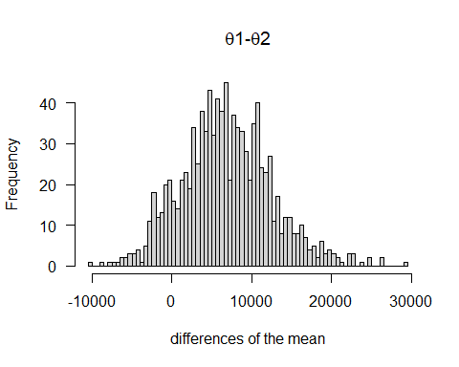

## [1] "CI of differences of mean falls between -2450.97591764706 and 19974.0695852941"

## [1] "0 is included in this CI, no significant difference between the two species"