Homework#03_R10241209_Answer

Meng-Hsin, Wu

2022/3/5

## Data review

Let’s check the original datasets. First, it’s the dataset with density of fish and copepod at each station

## Fish Copepod  
## 1 137.323397 1119.00  
## 2 20.967624 1153.00  
## 3 0.000000 1719.00  
## 4 0.000000 855.00  
## 5 180.713557 1246.00  
## 6 88.350447 2123.00  
## 7 632.524771 1159.00  
## 8 73.601882 1497.00  
## 9 1021.901114 1351.00  
## 10 555.772710 960.00  
## 11 259.699980 2946.00  
## 12 138.891900 1900.00  
## 13 146.961237 1508.00  
## 14 977.864100 4043.00  
## 15 995.930081 4919.00  
## 16 578.515045 6332.00  
## 17 374.820023 2101.00  
## 18 962.493541 4823.00  
## 19 310.241093 1588.00  
## 20 422.532680 2895.00  
## 21 580.981357 3870.00  
## 22 824.689747 1354.00  
## 23 957.400711 5492.00  
## 24 495.898379 7918.00  
## 25 76.489933 1270.00  
## 26 53.158747 358.10  
## 27 26.059357 261.78  
## 28 23.715205 80.67  
## 29 2.520000 46.06  
## 30 9.238857 41.74  
## 31 3.319892 9.26  
## 32 3.677130 49.70  
## 33 16.124499 25.74  
## 34 10.976537 46.67

## Question_1

Then let’s compute the mean and SE(mean) value of fish and copepod following normal theory.

## [1] "Mean density of fish: 322.451633316735"

## [1] "Mean density of copepod: 1972.37411764706"

## [1] "SE(mean) of fish: 61.2310707375046"

## [1] "SE(mean) of copepod: 342.554903173053"

## Question_1: Bootstrap

Now let’s compute the mean and SE(mean) of fish and copepod according to the bootstrap dataset.

## [1] "Bootstrap mean of fish density: 328.016055785203"

## [1] "Bootstrap mean of Copepod density: 1964.75537382353"

## [1] "Bootstrap SE(mean) of fish density: 59.6314903661863"

## [1] "Bootstrap SE(mean) of copepod density: 340.204529807882"

## Question_1: Histogram of bootstrapped mean

Let’s check the distribution of our bootstrapped mean of fish and copepod. 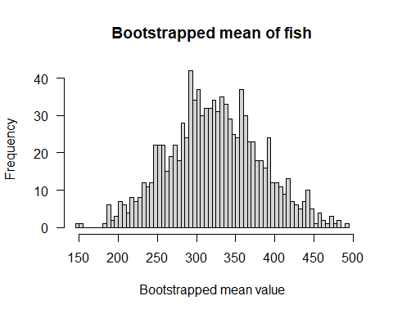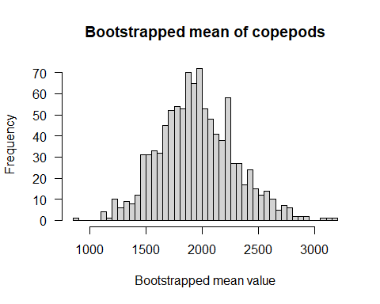

## Question_2

Now let’s use bootstrapping to compute median and SE(median) of fish and copepod density

## [1] "Median of fish density: 142.9265688"

## [1] "Median of Copepod density: 1352.5"

## [1] "Bootstrap median of fish density: 174.092942346445"

## [1] "Bootstrap median of Copepod density: 1379.25155"

## [1] "Bootstrap SE(median) of fish density: 95.680857298942"

## [1] "Bootstrap SE(median) of Copepod density: 196.353882393833"

## Question_2: Histogram for bootstrapped medians

Let’s plot the distribution of bootstrapped median of fish and copepod density. 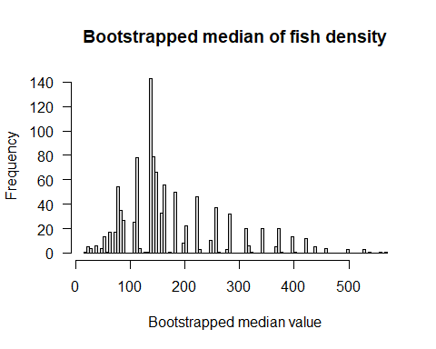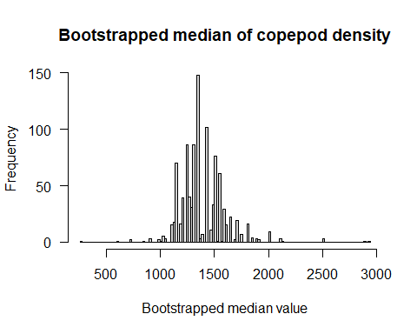

## Question_3

Plot the relationship between fish and copepod with regression line. 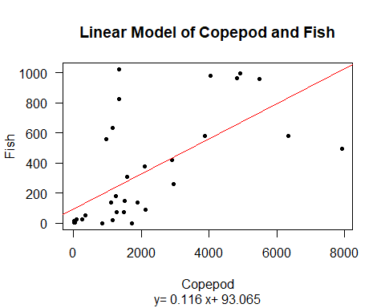

## Question_3: Coefficients

Compute beta_1 and beta_0 within the formula of the linear model.

## [1] "Correlation coefficient (beta_1): 0.116299932859911"

## [1] "Intercept (beta_0): 93.0646558597569"

## Question_3: Bootstrapped SE of coefficients

Let’s compute SE(beta_1) and SE(beta_0) from bootstrapped dataset respectively.

## [1] "SE(beta_1): 0.0311714634715548"

## [1] "SE(beta_0): 62.6268787673594"

## Question_3: Histograms of bootstrapped coefficients

Let’s plot the distribution of the two coefficients from the bootstrapped dataset. 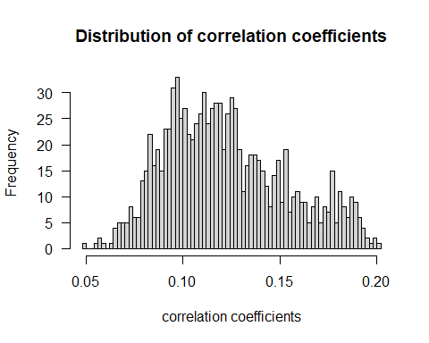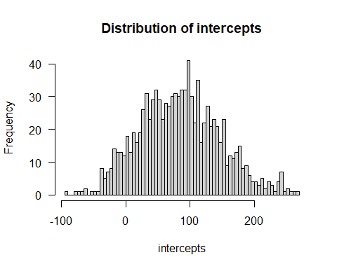

## Continued_1

Compute the mean and SE(mean) of fish and copepod density from jackknife dataset.

## [1] "Jackknife mean of fish density: 322.451633316735"

## [1] "Jackknife mean of copepod density: 1972.37411764706"

## [1] "Jackknife SE(mean) of fish density: 61.2310707375046"

## [1] "Jackknife SE(mean) of copepod density: 342.554903173053"

## Continued_1: Histogram for Jackknife

Try to plot the histogram of jackknife means of fish and copepod. 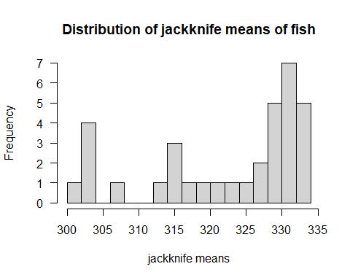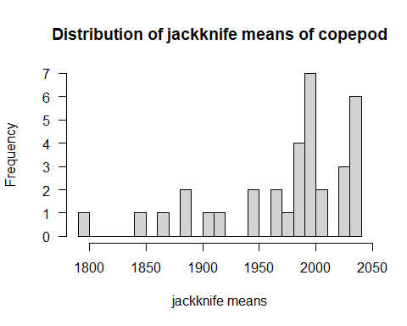

## Continued_2

The regression coefficients calculated from formula are as answers in Question_3. Let’s compute the SE(beta_1) and SE(beta_0) from jackknife datasets.

## [1] "Jackknife SE(correlation coefficient(beta_1)): 0.0380002961498038"

## [1] "Jackknife SE(Intercept(beta_0)): 69.2732921810956"

## Continued_2: Histogram of jackknife coefficients

Let’s plot the distribution of the two jackknife coefficients. 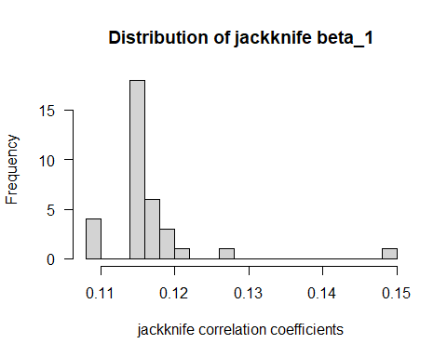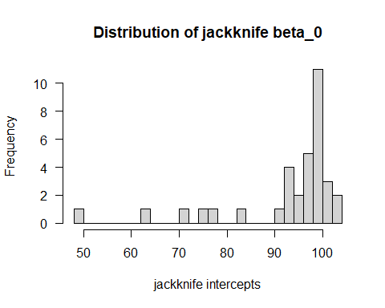

## Continued_3: Comparison

Compare the estimates from bootstrapping, jackknife and normal theory.

## mean median SE_mean SE_median  
## Normal theory 322.4516 142.9266 61.23107 NA  
## Bootstrapping 328.0161 174.0929 59.63149 95.68086  
## Jackknife 322.4516 NA 61.23107 NA

## mean median SE_mean SE_median  
## Normal theory 1972.374 1352.500 342.5549 NA  
## Bootstrapping 1964.755 1379.252 340.2045 196.3539  
## Jackknife 1972.374 NA 342.5549 NA

## coefficient SE_Bootstrapping SE_Jackknife  
## beta 1 0.1162999 0.03117146 0.0380003  
## beta 0 93.0646559 62.62687877 69.2732922

We can notice that bootstrapping can generate more data if the original dataset is a small or median size dataset. Jackknife method can only generate n sets of resampled data that n equals to the size of the original dataset. Therefore from the histogram we can notice the the histogram of jackknife cannot welly represent the condition in population unless we increase the sampling size. In addition, the parameters in bootstrapped data are distributed in a pattern close to normal distribution. Generally speaking, Jackknife and normal theory show identical values of the targeted parameters. The values generated from bootstrapping are slightly different from those generated from normal theory and jackknife method, which could be resulted from the higher resampling size. However, the differences among the three method is small.