目录
1. 文档错误 1
2. Zeebe和camunda的区别 2
3. Zbctl handler 2
4. https://zeebe.io/what-is-zeebe/ 3
6. the same zeebe job type, placed in different unrelated workflows 7
7. Docker knowledge 7
8. Grpc 7
9. Zeebe kafka 7

Zeebe和camunda的区别
https://zeebe.io/faq/#how-is-zeebe-different-from-camunda-bpm

Zbctl handler
zbctl provides a command to spawn simple job workers using an external command or script. The job worker will receive the payload for every job as a JSON object on stdin and must also return its result as JSON object on stdout if it handled the job successfully.
In this example, we'll also use the unix command cat which just outputs what it receives on stdin.
./bin/zbctl --insecure create worker initiate-payment --handler cat

[root@192 zeebe-docker-compose-0.22.1]# ./bin/zbctl --insecure create worker initiate-payment --handler cat

2021/01/14 10:59:59 Activated job 2251799813685284 with variables {"orderId":"1234","orderValue":99}
2021/01/14 10:59:59 Activated job 2251799813685276 with variables {"orderId":"2345","orderValue":100}
2021/01/14 10:59:59 Handler completed job 2251799813685276 with variables {"orderId":"2345","orderValue":100}
2021/01/14 10:59:59 Handler completed job 2251799813685284 with variables {"orderId":"1234","orderValue":99}

这里的cat是handler的参数，就是接受payload作为入参，如果job成功就输出他，这里的payload就是最早的时候的创建instance的时候的参数

Job type
the same zeebe job type, placed in different unrelated
workflows
https://forum.zeebe.io/t/zeebe-job-type-and-execution-concern/1281

What is zeebe
https://zeebe.io/what-is-zeebe/

You can think of Zeebe’s approach to workflow orchestration as a state machine. When a workflow instance progresses to a certain task, Zeebe sends a message to notify the responsible worker service then waits for the worker to complete the task.
Once a task is completed, the worker service notifies Zeebe, and the flow continues with the next step. If the worker fails to complete the task, the workflow remains at the current step, potentially retrying the task until it eventually succeeds or escalating to a different team if human intervention is required.

Job worker/job/broker
https://docs.camunda.io/docs/product-manuals/zeebe/technical-concepts/architecture#job-worker
A job worker is a Zeebe client that uses the client API to first activate jobs, and then upon completion either complete or fail the job.

Brokers
- Assigning jobs to job workers

https://docs.camunda.io/docs/product-manuals/concepts/job-workers

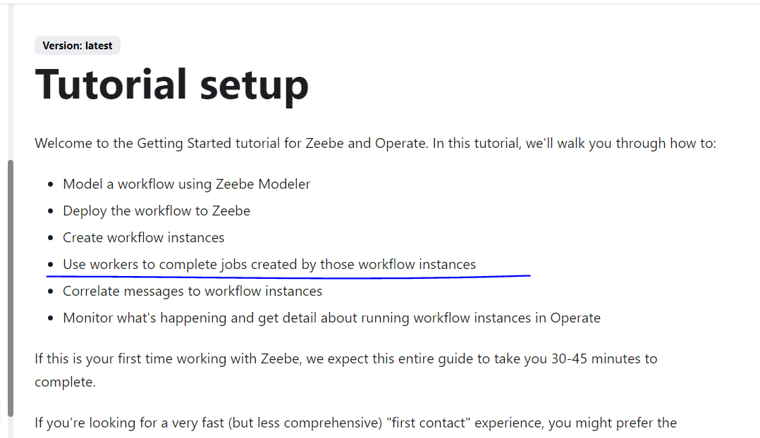
Workflow instance算是有几个job，然后client那边是job worker去执行这些job
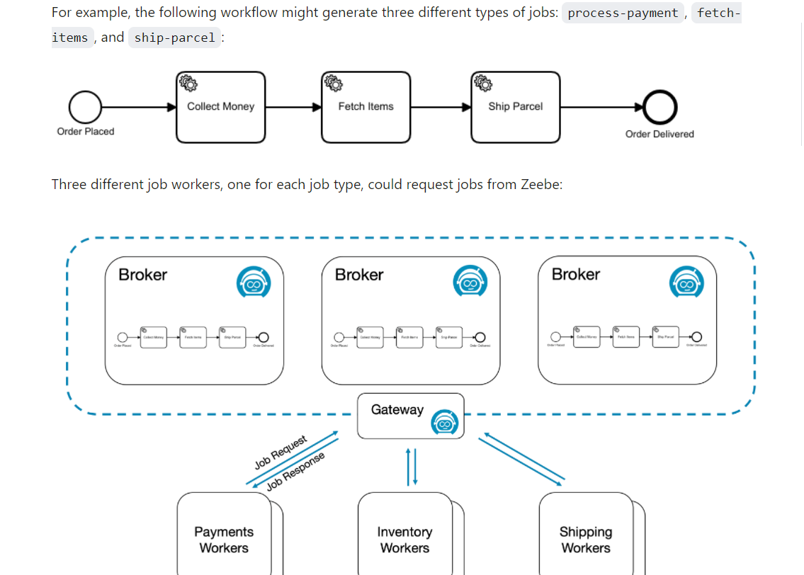

https://docs.camunda.io/docs/product-manuals/zeebe/deployment-guide/getting-started/create-a-workflow
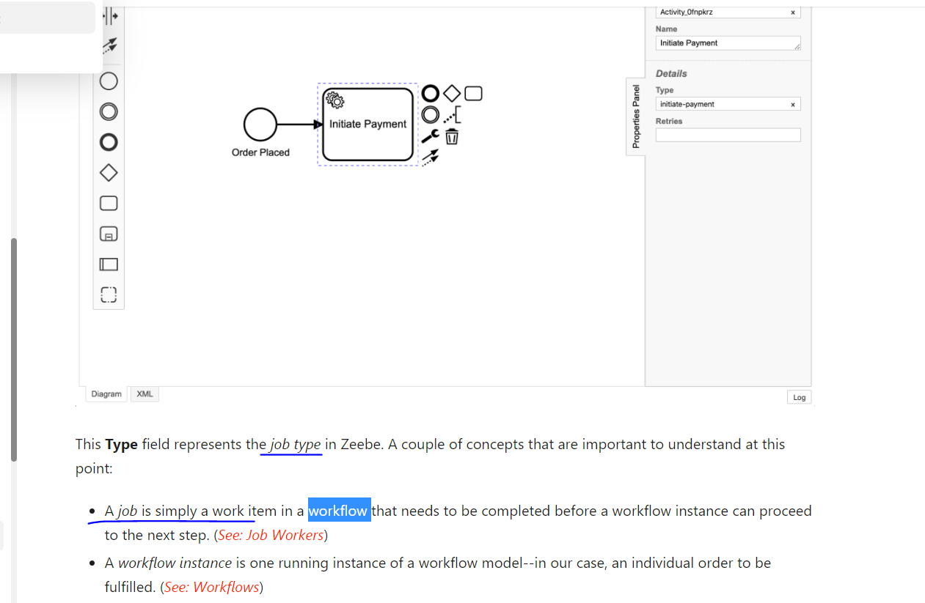
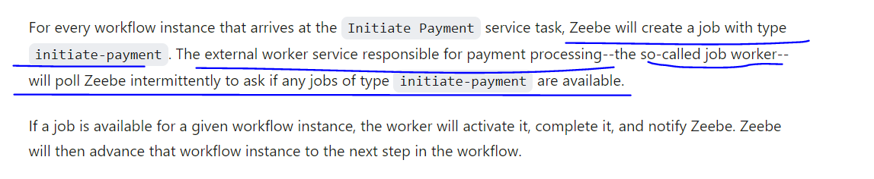

Command的客户端是主动执行命令去执行job，但是java的client应该是可以轮询的

Docker knowledge

Docker compose启动失败，可以尝试删除volume
https://stackoverflow.com/questions/34658836/docker-is-in-volume-in-use-but-there-arent-any-docker-containers
https://forum.zeebe.io/t/error-while-trying-to-deploy-a-workflow-after-upgrading-to-latest-docker-compose/1235/2

进入指定的目录，删除docker compose相关的volume
[root@192 operate-simple-monitor]# docker-compose down --volumes

检查
docker volume ls

Zeebe hazelcast port
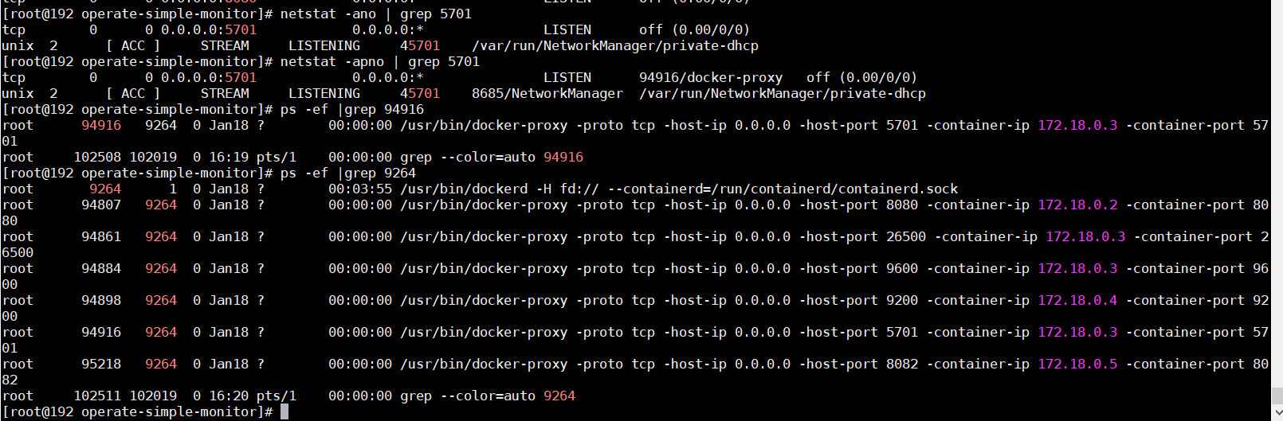

docker exec -it 775c7c9ee1e1 /bin/bash
docker rm $(docker ps -a -q) Remove all stopped containers
./zbctl status --insecure --address 127.0.0.1:26500

启动 docker-compose up -d && docker-compose logs -f

停止 docker-compose down

Grpc
http://hengyunabc.github.io/thinking-about-grpc-http2/

Zeebe kafka
https://github.com/zeebe-io/kafka-connect-zeebe
这里的connect只是一个插件，在kafka内部的consumer应该还是可以写逻辑的，比如处理支付的逻辑
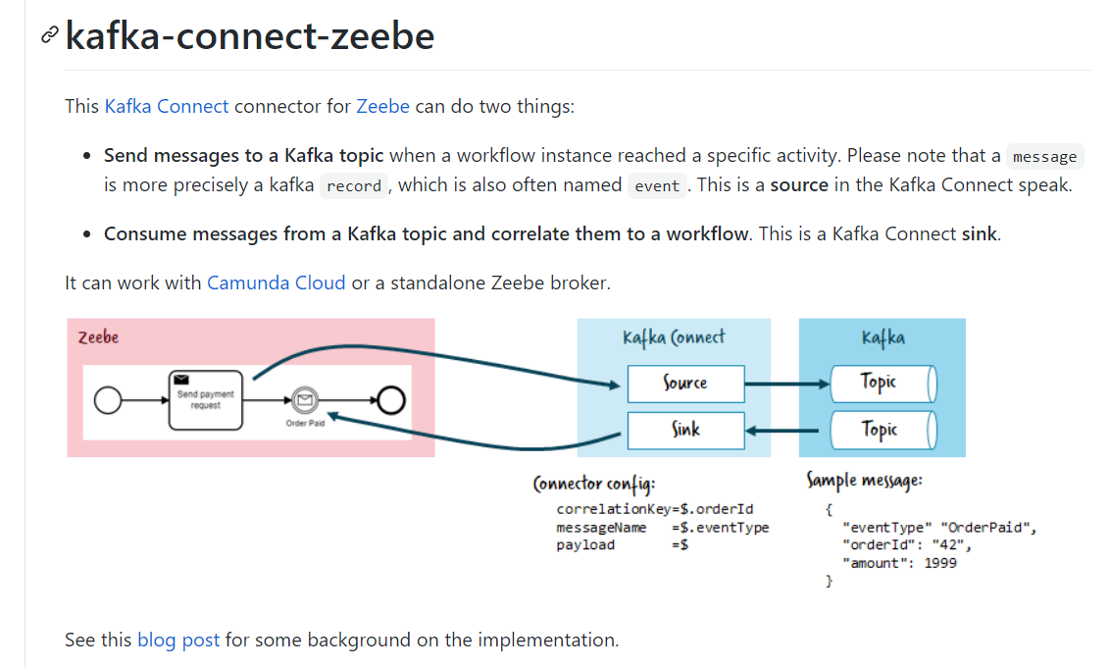
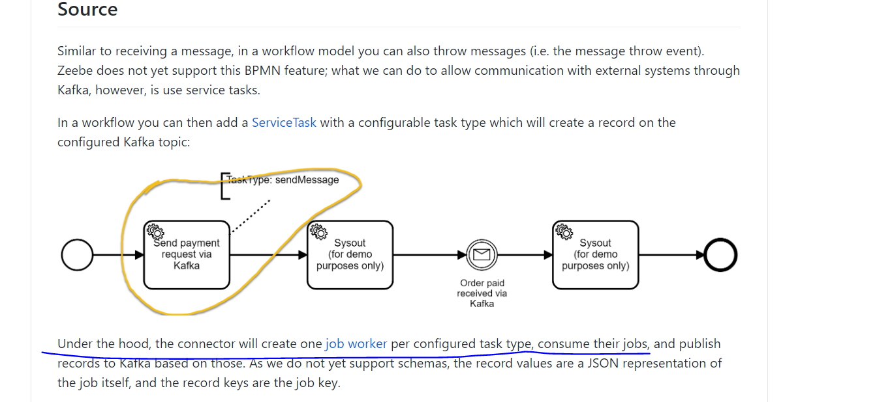

Source connect激活zeebe jobs就意味着需要创建job worker来执行逻辑
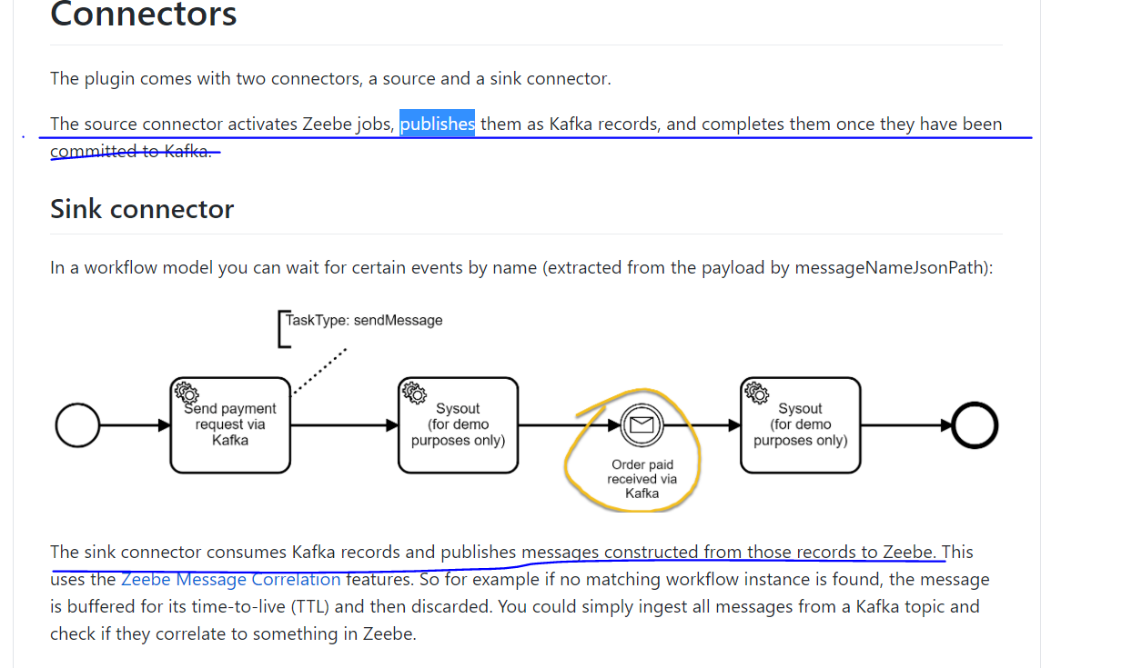

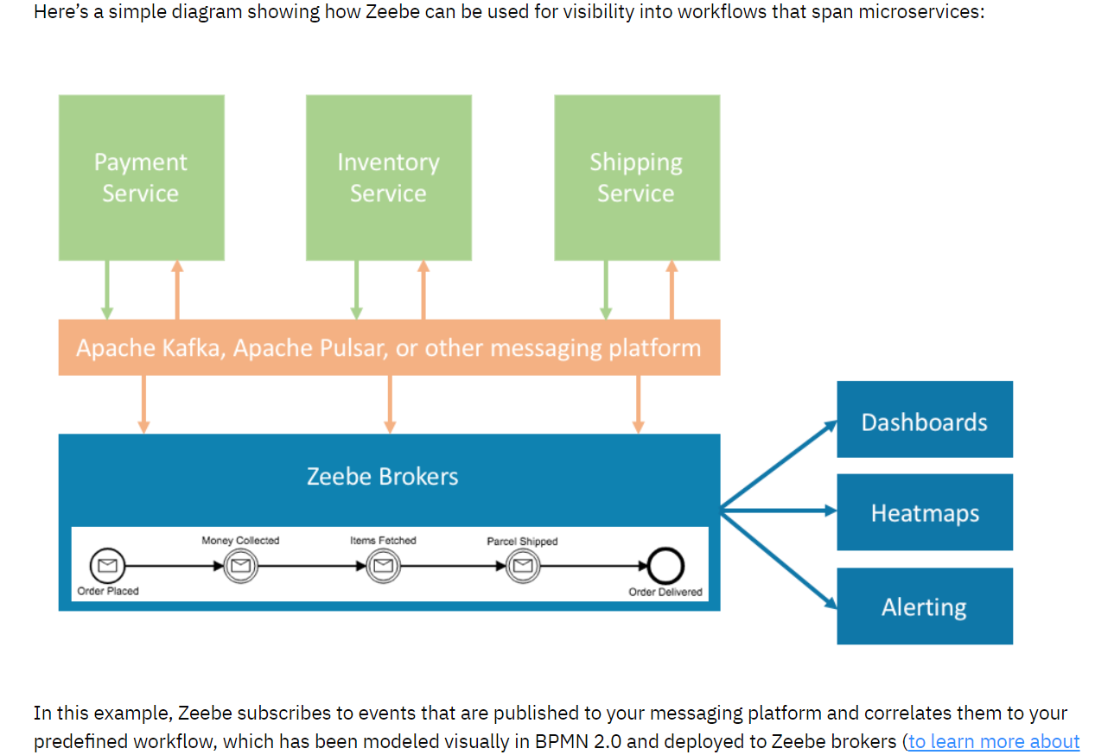

https://forum.zeebe.io/t/how-to-complete-a-task-later-asynchronously/116/3
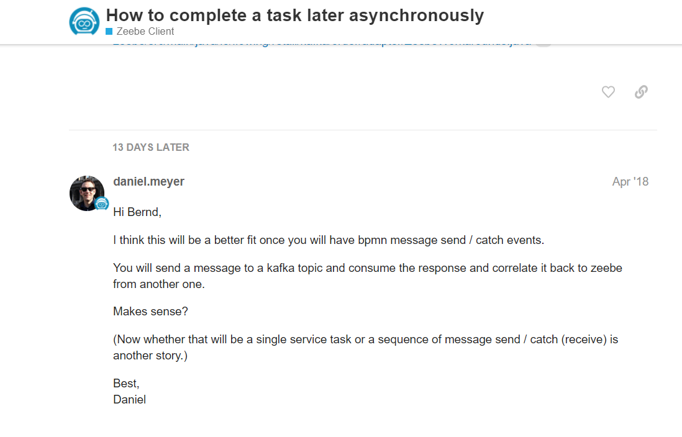

https://blog.bernd-ruecker.com/zeebe-loves-kafka-d82516030f99

https://zeebe.io/blog/2019/08/official-kafka-connector-for-zeebe/

https://zeebe.io/blog/2019/08/official-kafka-connector-for-zeebe/

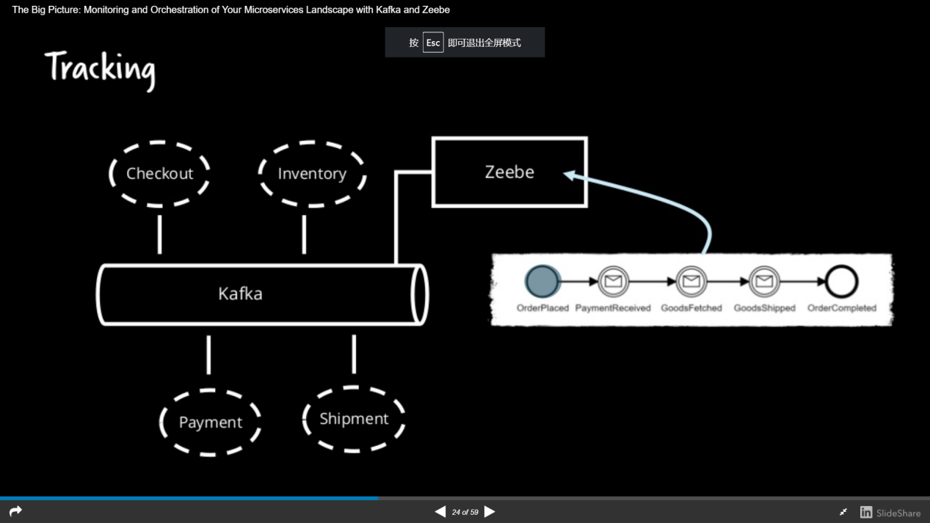
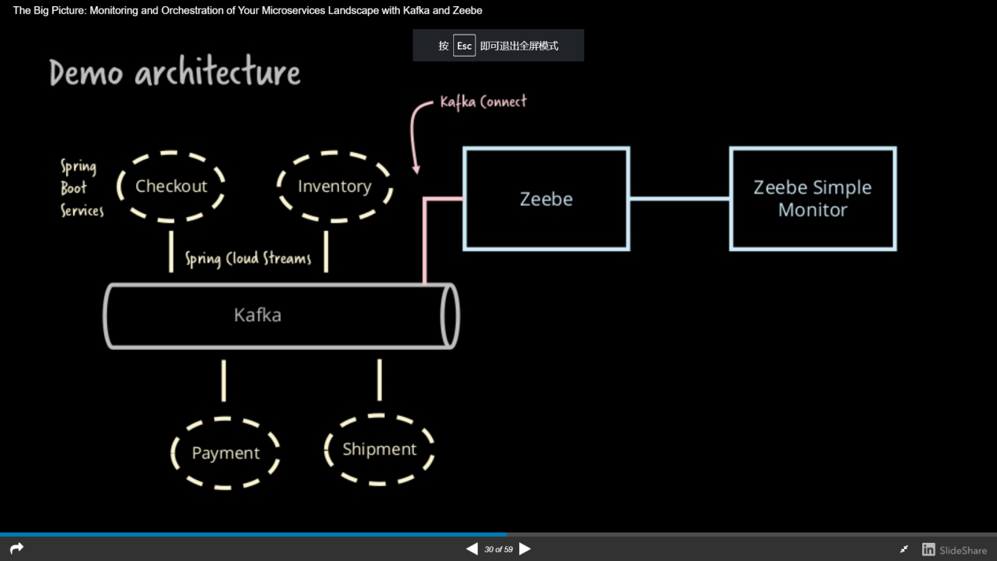

Zeebe architecture
https://zeebe.io/what-is-zeebe/

First, Zeebe does not require a central database component and instead leverages event sourcing, meaning that all changes to a workflow’s state are captured as events and stored in an append-only log. In Zeebe, this log is called a “topic”. Topics are written directly to the filesystem on the server where Zeebe is running, and the current state of a workflow can be derived from the events stored in a topic.

Zeebe uses a client / server model. The server (broker) is a remote engine that runs as its own program on a Java Virtual Machine. The broker is responsible for storing topics related to workflows, distributing work items to clients when appropriate, and exposing a workflow event stream to Zeebe clients via pub-sub. Zeebe clients can be embedded in an application in order to connect to the broker.

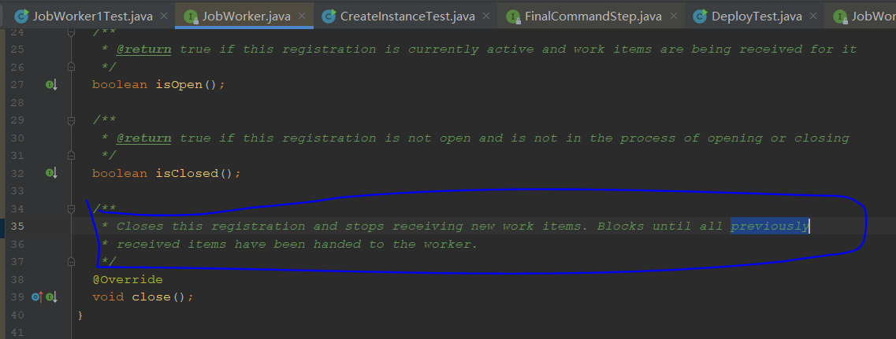

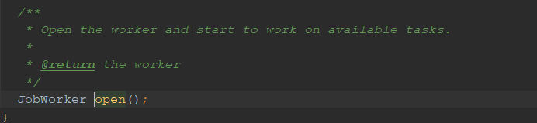
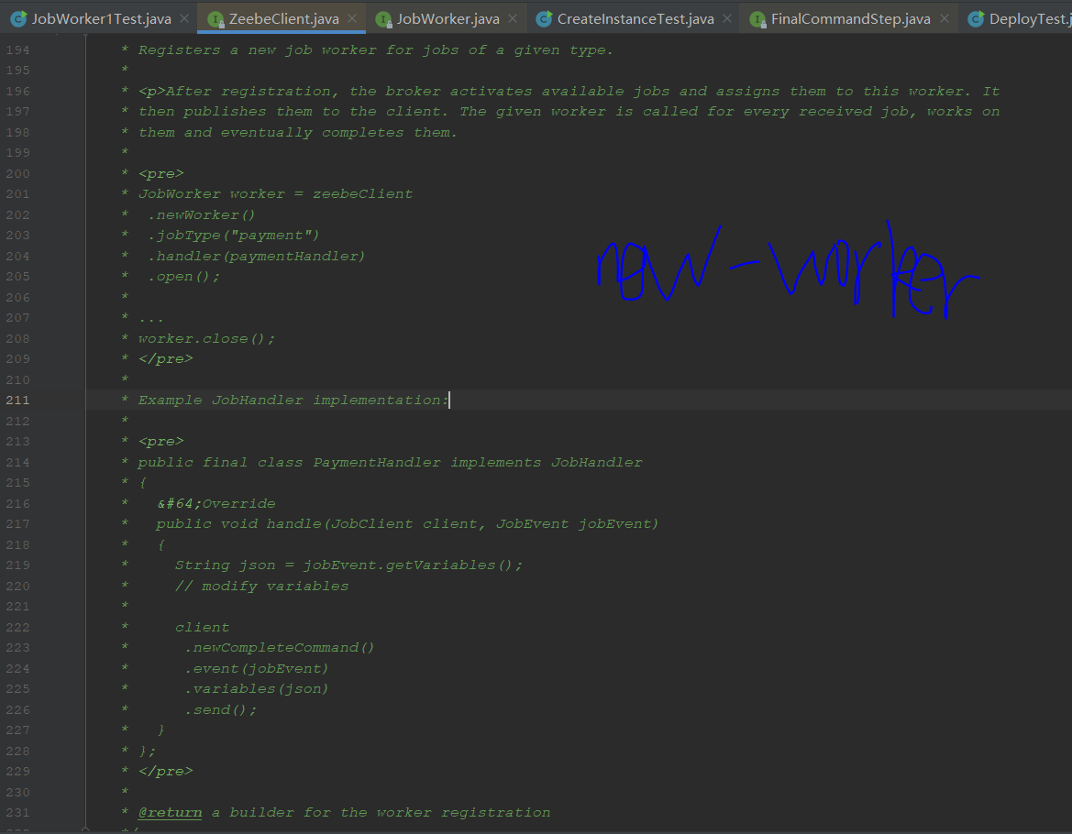

Zeebe is fully message-driven
Zeebe brokers and clients communicate entirely via publish-subscribe, making it possible to adhere to the principle of loose coupling and to enable asynchronous communication between Zeebe and the microservices that participate in a workflow. Zeebe’s subscription protocol includes a backpressure mechanism to ensure that clients aren’t overloaded with work from Zeebe.

Currently, all communication between Zeebe brokers and external services is handled by Zeebe’s clients. Zeebe’s client protocol is programming language-agnostic, meaning that clients can be generated easily in many common programming language.

Client applications can be scaled up and down completely separately from Zeebe - the Zeebe brokers do not execute any business logic.
Clients are libraries that you embed in an application (e.g. a microservice that executes your business logic) to connect to a Zeebe cluster.
Clients connect to the Zeebe gateway via gRPC, which uses HTTP/2-based transport. To learn more about gRPC in Zeebe, check out the Zeebe API (gRPC).

Zeebe client
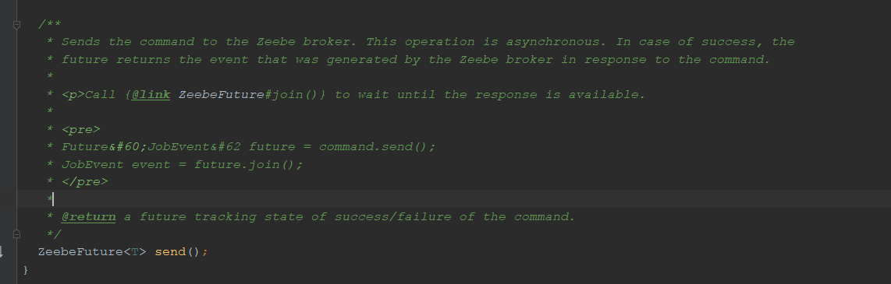
JobWorker worker = client
.newWorker()
.jobType("initiate-payment")
.handler((jobClient, job) ->
{
// business logic code
System.out.println("job" + job.getVariables());
ZeebeFuture future = jobClient.newCompleteCommand(job.getKey())
.send();
// future.join();
System.out.println("work1 handler finished");
System.out.println("future.isDone()=" + future.isDone());
})
.open();
这里的join如果不调用，那么下面返回的就是false，否则就是true，因为join会block 会 wait until the response is available.

Zeebe exporter

zeebe-hazelcast-exporter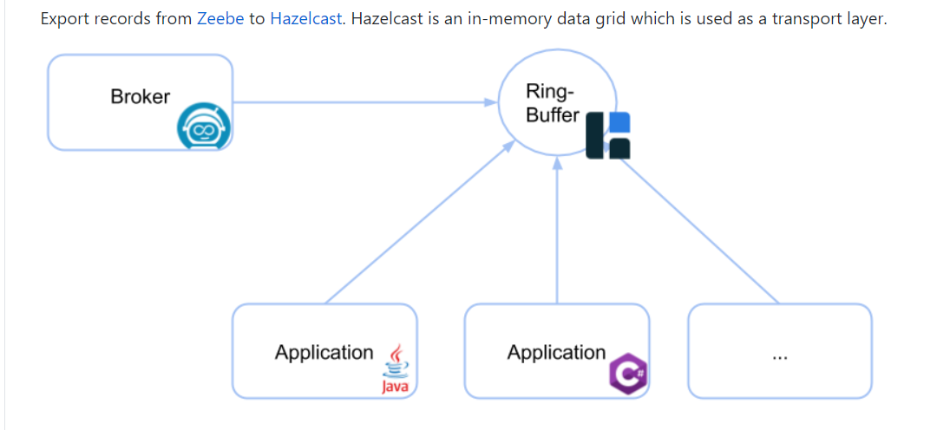
The Java and C# connector modules provide a convenient way to read the records from the ringbuffer.
Connect to Hazelcast and register a listener
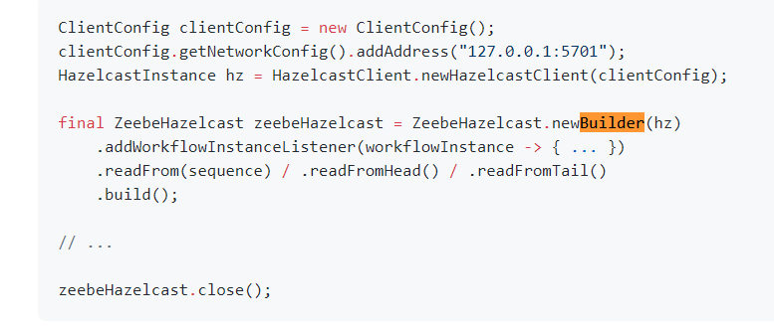
Exporter会处理每一个到zeebe stream的记录
比如这个Hazelcast 会把这些记录写入到自己的ring buffer,然后外部的工具比如simple monitor可以监听这个数据，然后写入到自己的db

下面是elasticsearch的exporter
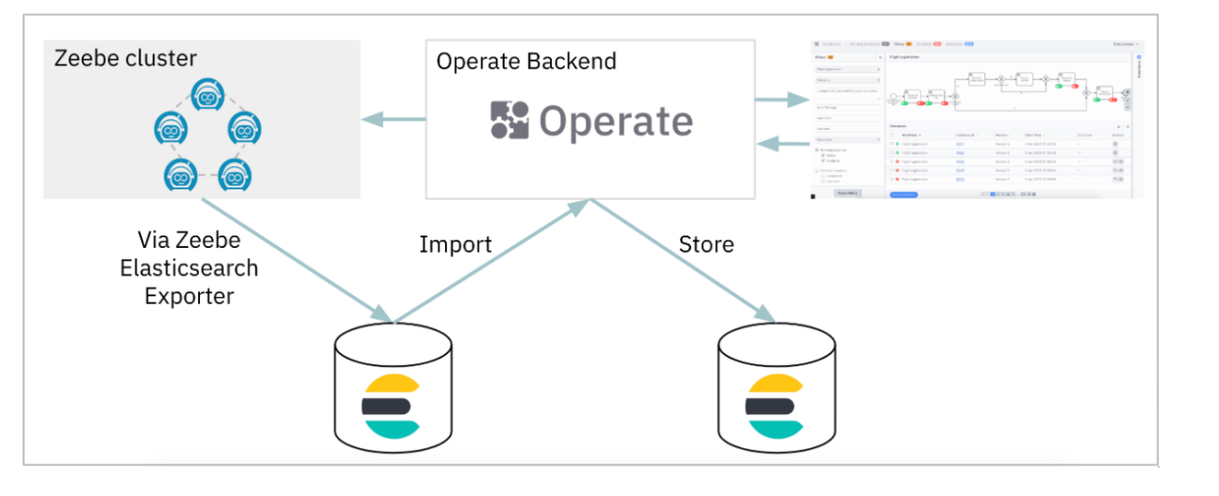
可以看到数据被exporter写入到了es里面，然后operate只是从es里面读取和写入数据

Zeebe cluster
Data is divided into partitions (shards). Each partition has a number of replicas. Among the replica set, a leader is determined by the raft protocol which takes in requests and performs all of the processing. All other brokers are passive followers. When the leader becomes unavailable, the followers transparently select a new leader.
https://docs.camunda.io/docs/product-manuals/zeebe/deployment-guide/operations/setting-up-a-cluster/
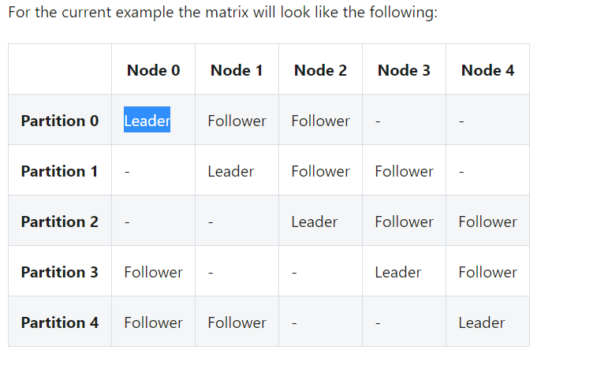
每个分区都可以看到在三个节点有副本，但是只有一个node是leader

从这个图片可以看到每个node都有三个分区，因为每个分区都有三个副本
所以最后的情况会是每个node都会有三个分区，但是只有一个分区是leader

如果没有副本，5个node每一个node一个分区，后来因为副本为3，所以每个分区会复制两个副本，并选择一个作为leader

如上图，如果node4 down了，node4上有分区4作为leader，所以会重新选举分区4在node0和node1上面的副本作为leader
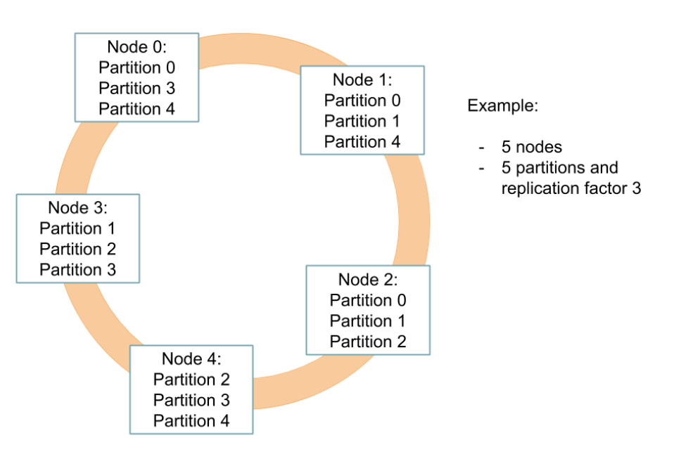

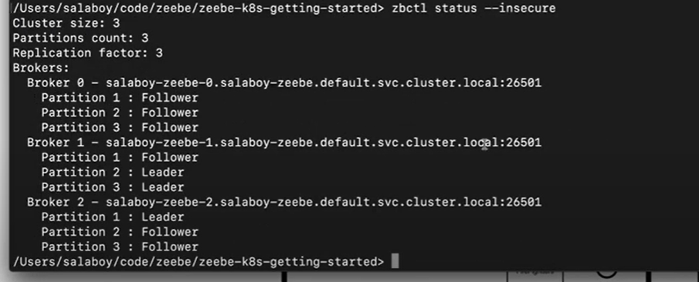

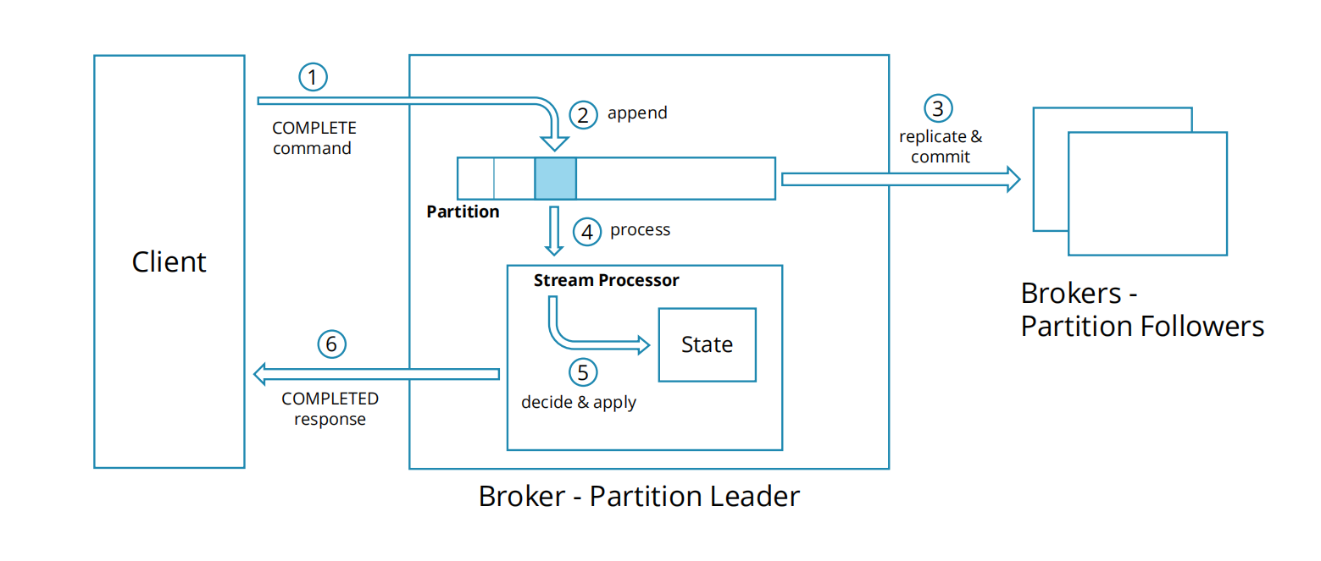
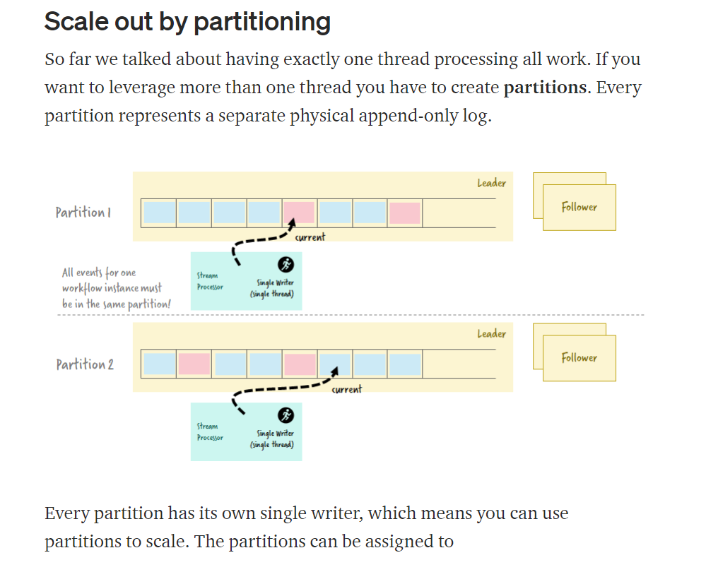

UI tools
K8s端口转发
https://kubernetes.io/zh/docs/tasks/access-application-cluster/port-forward-access-application-cluster/

8082 simple monitor
8080 operate
5601 kibana

Local simple monitor:
http://localhost:8082/h2-console

elastic search
GET zeebe-record_deployment_0.25.1_2021-01-29/_search
{
"query": {
"match_all": {}
}
}

K8s
