Spring Boot Actuator provides dependency management and auto-configuration for Micrometer, an application metrics facade that supports numerous monitoring systems like Prometheus.

Micrometer is like the slf4j in log world.

Spring boot actuator document:

<https://docs.spring.io/spring-boot/docs/current/reference/html/production-ready-features.html#production-ready-enabling>

1. Create a spring boot project in <https://start.spring.io/.>

<dependency>  
 <groupId>org.springframework.boot</groupId>  
 <artifactId>spring-boot-starter-actuator</artifactId>  
 </dependency>

1. Test the health endpoint.(the jsonview chrome plugin is suggested)

<http://localhost:8080/actuator/health>

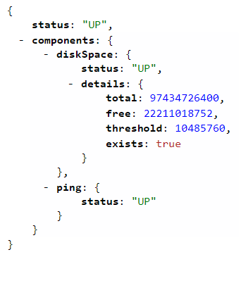

1. Integrate prometheus

Add micrometer-registry-prometheus dependency

<dependency>  
 <groupId>io.micrometer</groupId>  
 <artifactId>micrometer-registry-prometheus</artifactId>  
 </dependency>

1. Test the prometheus endpoint

<http://localhost:8080/actuator/prometheus>

1. Run the prometheus

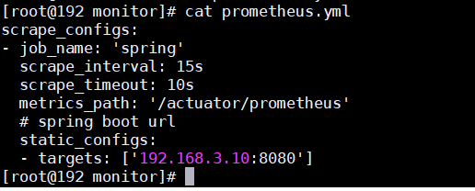

docker run \

-p 9090:9090 \

-v /root/software/monitor/prometheus.yml:/etc/prometheus/prometheus.yml \

prom/prometheus

[http://192.168.159.142:9090/](http://192.168.159.142/) is prometheus url.

<http://192.168.3.10:8080/> is spring boot url.

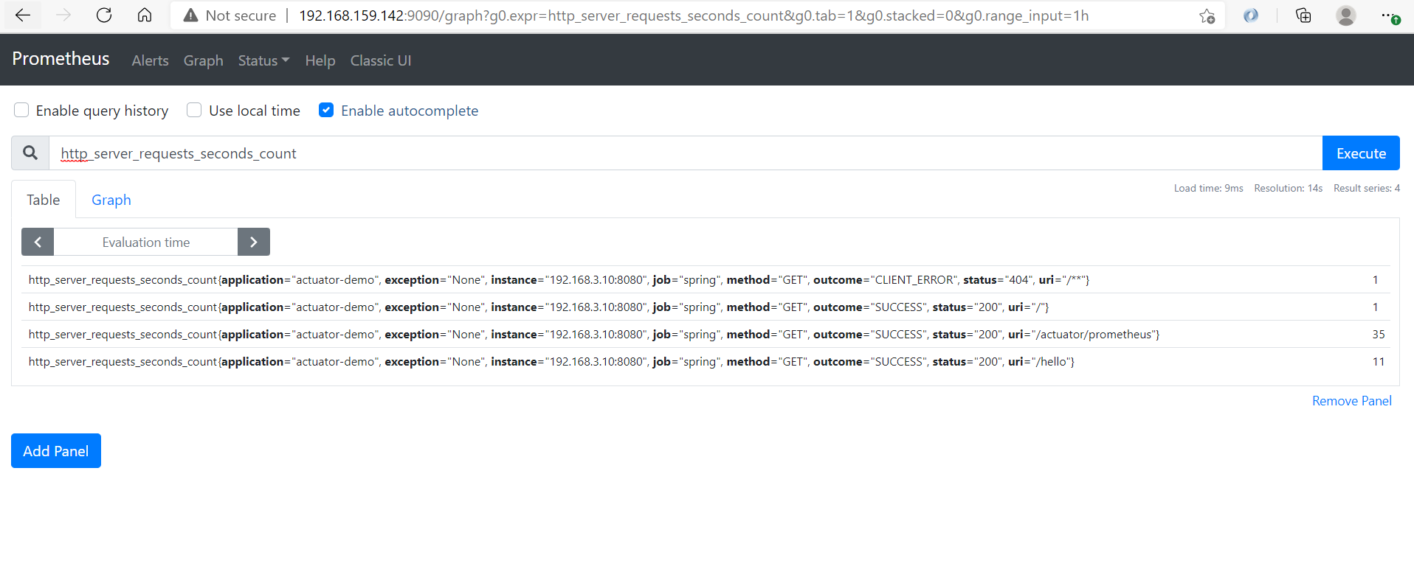

1. Install grafana(to have a better dashboard ui experience)

docker run -d -p 3000:3000 grafana/grafana

<http://192.168.159.142:3000/>

Add Data Source

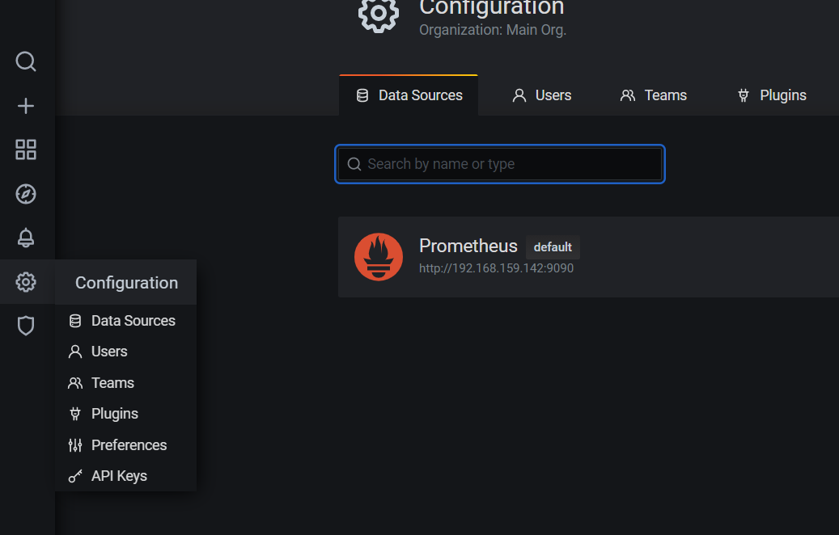

Add dashboard

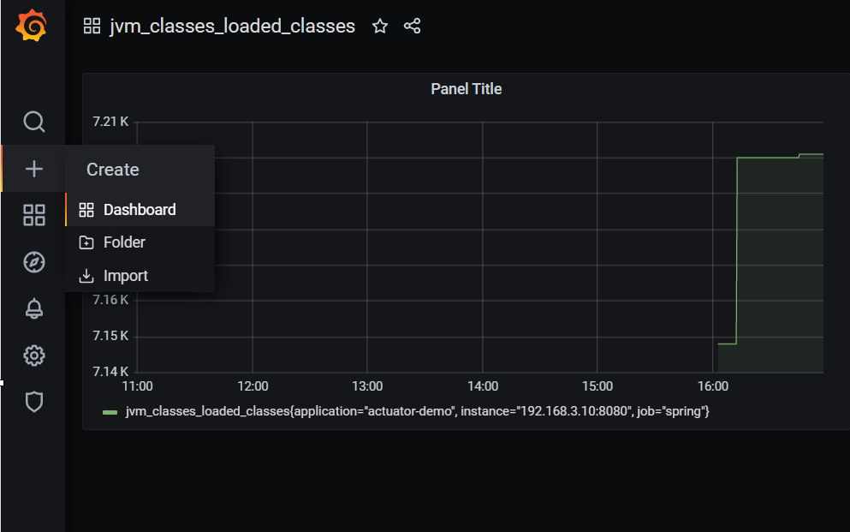

Note:

1. <http://localhost:8080/actuator/prometheus>

Exposes metrics in a format that can be scraped by a Prometheus server. Requires a dependency on micrometer-registry-prometheus.

1. Prometheus actuator endpoint

This endpoint is enabled when the micrometer-registry-prometheus jar is added.

