3.1 Surface Cracks

Fig. ? summarized all the 3D representation of surface crack listed in Tabel ? in 10 times of deformation. All cases have an expansion of around 0.5% one-dimensionally. Surface cracking results shows a clear difference react to different given expansion mechanism. All cases except DEFA30I100, which applied uniformed expansion all over mortar part, have generated localized cracks in a map pattern in the surface.

In ASR expansion, with less percentage of aggregate which generates expansion, cracks represented become more localized. This can be seen by both decreasing reactive aggregate percentage and decreasing total aggregate percentage.

In DEF expansion, though no localized cracking is shown in uniformed expansion case, localized surface crack in map pattern can be seen with the application of intensified expanse in the inner part of the model. Aggregate percentage here does not have a significant influence in the localization of surface cracking.

3.2 Internal Cracks and Stresses Generation

Inner stress and crack here are presented to better understand the generation of surface cracking pattern. Data collected from the cross sections view at z = 50 mm are chosen.

For ASR expansion, as the initial strain is given between reactive aggregates and surrounding elements, the reactive aggregates are under compressive stress, while the mortar part is under tensile stress. Along with deformation, cracks started to generate between aggregates and between the surface and adjacent aggregates. Though here in the section view empty space do appears between aggregate and surrounding mortar, but this is not considered as cracks since it only represents spring elongation due to initial strain given.

For DEF expansion, stress mainly distributed only in the mortar. With the uniformed expansion, compressive stress and tensile stress uniformly distributed in all mortar parts. Gaps are generated between mortar and aggregates as deformation happens. No stress further transform into the aggregates once they are detached with mortar. The whole model increasing its volume without generating inner cracks. With center intensified zone applied, the inner part which expanse more than the surrounding suffer from compressive strength, while the mortar located in outer part mainly suffer from tensile stress. Along with deformation, cracks start to generate in the tensile zone, which causing surface cracking in the 3D views. However, no localized cracks are found in the compressive zone.

4.1 Residual Compressive Strength with Expansion

After expansion, compressive strength is simulated by 3D RBSM. The uniaxial compressing test is carried out, the same way in the 3D RBSM analysis (Nagai et al. 2005), with the top and bottom loading boundaries, are fixed in the lateral direction.

Fig. 2D concrete specimen (Fig. 21)

Maximum Compressive is recorded for model given different expansion mechanism and in different volume changes. Experimental results from ?????????? are referenced here for comparison.

Fig. ASR, Fig DEF

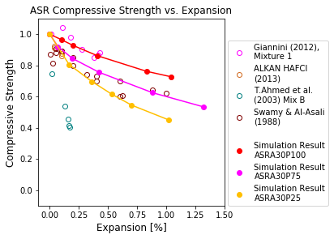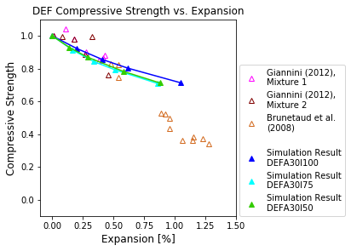

Compressive strength in both ASR and DEF decrease gradually as introducing larger expansion.

For ASR, though the experimental data collected here are having significantly scattered, simulation results still lay on the range close to some of the experimental data. Given various aggregate percentage and ASR reactive aggregate percentage, the residual compressive strength in the same expansion ratio also different. Generally, by decreasing the total percentage of ASR reactive aggregate, residual compressive strength becomes more sensitive to expansion.

For DEF, no large scatter in compressive strength is presenting with a set of various expansion intensified zone. Though uniformly expanded model (DEFA30I100) does show a significant difference in expansion behavior comparing to others, its residual compressive strength changing with expansion does not show large differences.

4.2 Residual Elastic Modulus with expansion

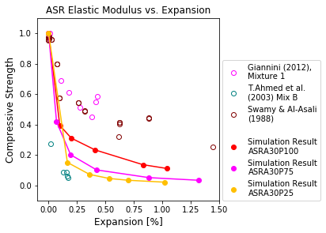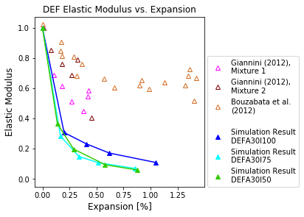

Fig shows the simulation results of Residual Elastic Modulus, with experimental results from ?????????? are referenced here as a comparison.

Through simulation results of residual compressive strength are close to the distribution of experimental results, simulation results in residual elastic modulus show relatively large scatter comparing to experimental results.

In order to simulate residual elastic modulus appropriately, this simulation model required to be further improved. For ASR expansion, mechanical properties of ASR gel should be included in the simulation, since ASR gel filled in some of the gaps between aggregate and mortar. Similarly, properties of ettringite should also be considerate in DEF expansion. These products of expansion reactions may not significantly influence the maximum compressive strength obtained in simulation, but highly possible to influence the residual elastic modulus.

4.3 Numerically Analysis of Cracking behavior related to Residual Mechanical properties

The aim of this section is to analysis the decrease in mechanical properties and cracking behavior. As in 3D RBSM simulation cracks are presented by separation of adjacent elements, cracking behavior in RBSM simulation can be analyzed numerically. Cracks are able to be grouped up by their cracking width and measured by the number of interfaces since the size of all elements is close.

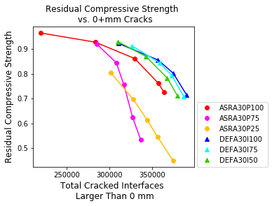 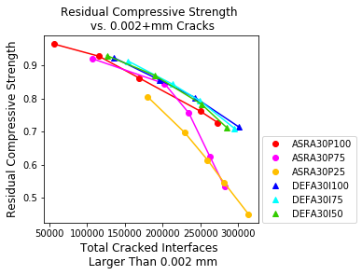

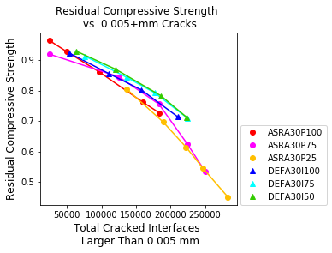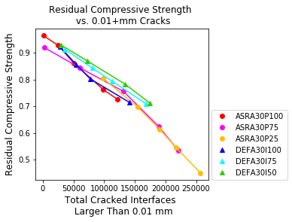

Fig. shows the relationship between residual compressive strength and number of cracked interfaces, for both ASR and DEF expansion. As can be noticed from Fig.xx, residual compressive strength is not correlated with the total number of all cracked interfaces, it almost linearly changes with the number of cracked interfaces which have a crack width larger than 0.01 mm. This relationship indicated that the damage in compressive strength during expansion behavior is mainly due to the generation of relatively larger cracks.

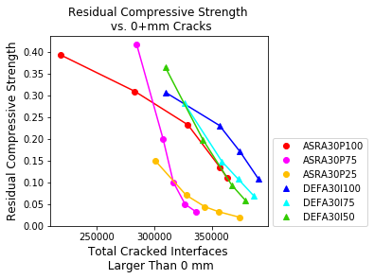 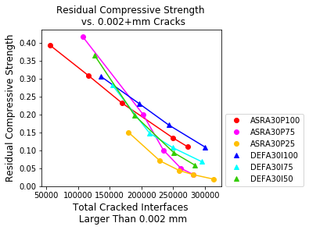

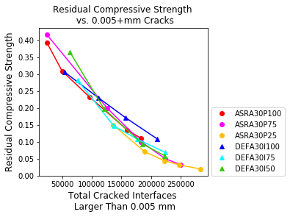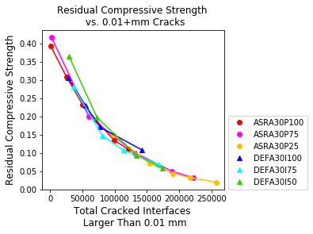

A similar relationship is also observed in residual elastic modulus of expansion damage models. Shown in Fig.xx, residual compressive strength shows a strong relationship with number of cracked interfaces which have a crack width larger than 0.01 mm.