Readme for E3SMv3 model class in EMC²
(Notes from code)

The E3SMv3 model class is generated to facilitate the application of EMC² to E3SMv3 model data that does not have outputs of snow properties.

The demo data and Jupyter notebook to demonstrate the usage of this new model class is at ./examples/example_data/e3smv3_comble_anx.2020-03-01.demo.nc and ./examples/Test_EMC2_demo_w_E3SMv3.ipynb.

Key setup in Jupyter notebook to use E3SMv3 model class:

Generate instrument class objects. In this example, HSRL and KAZR are used. Among other radar and lidar instruments, EMC² includes instrument sub-classes for the full ARM radar and lidar instrument suite. Note that in the case of the KAZR class object (as in the case of different radar object) we specify the ARM site string to initialize the KAZR class object with the correct radar attributes.

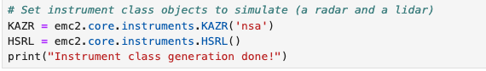
* Note the radar attributes for KAZR at anx site need be justified. Here is for demonstration purpose only. Correct radar attributes for ARM sites are listed in ./EMC2/emc2/core/instruments.py

Specify the path for model data.
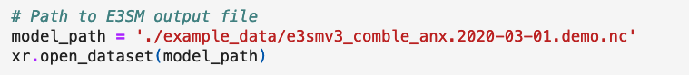

Load data file using emc2.core.model.E3SMv3 object.
- Because E3SM operates a cube-sphere grid, data is not provided in a strict lat-lon grid (two spatial dimensions) but rather on a column basis (one spatial dimension). We need to inform EMC² about that by setting all_appended_in_lat=True.
- The regional output file has appended strings at the end of every field name, the result of post-processing machinery. By setting appended_str=True, EMC² can remove these strings by using one of EMC²'s internal methods invoked during initialization.
- single_ice_class: If True, assuming model microphysics incorporate a single ice class (e.g., in P3 implemented in E3SMv3).
- include_rain_in_rt: If True, including the rain class (`pl`) in the forward calculations. By default, set to False given that the rain class is excluded from the E3SM radiative scheme calculations.

Run subcolumn generator and instrument simulator.
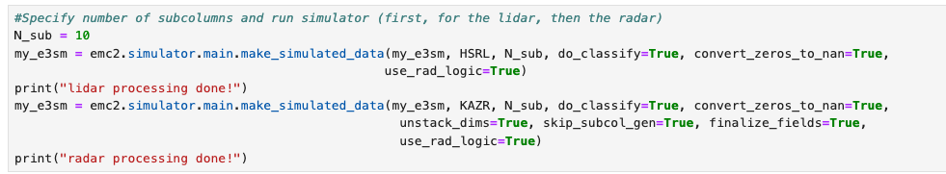

- Note that because the model output contains the spatial dimension stacked onto the time dimension, we wish to unstack these dimensions once all simualtor operations are done by setting unstack_dims=True.

- use_rad_logic = True: Run radiation approach. use_rad_logic = False: Run microphysics approach
- do_classify: Run hydrometeor classification routines when True.
- skip_subcol_gen: Skip the subcolumn generator. In this example code, subcolumn has been generated when calling the HSRL simulator. Therefore, subcolumn generator is skipped for KAZR.
- finalize_fields: set absolute 0 values in “sub_col”-containing fields to np.nan, enabling analysis and visualization.

HSRL and KAZR are used in this demo script.
Other lidar and radar instruments available in the emc² package are:
- CSAPR
- XSACR
- WACR
- RL (ARM Raman lidar)
- CEIL
- NEXRAD
- CALIOP

*Note HSRL also works for MPL.

To switch the used instruments, change the setting of instrument class objects from KAZR and HSRL to other options listed above.

Readme for SCREAM model class in EMC²
(Key arguments are specified in E3SMv3 instruction above)

The SCREAM model class is generated to facilitate the consistent treatment for hydrometeor fractions from SCREAM model output. For example, liquid cloud fraction is calculated using the simplified higher-order closure (SHOC) parameterization which accounts for the liquid cloud subcolumn distribution. On the other hand, ice cloud fraction is diagnosed as binary values (i.e., 1 or 0) based on cloud ice number and mass mixing ratios. Such inconsistent treatments make it challenging to reasonably apply subcolumn distribution assumption embedded in EMC² to SCREAM model data. To address this issue, we introduced a postprocessing approach to use binary values for all hydrometeor fractions from SCREAM. In addition, we also partition snow hydrometeor from simulated cloud ice using diagnosed precipitating ice fraction in SCREAM. Note that the postprocessing only works when one subcolumn is used in the forward calculation of radar and lidar signals.

To download the emc2 branch for scream:
> git clone https://github.com/mengz1993/EMC2.git
> git checkout mengzhang-emc2-scream

The demo data and Jupyter notebook to demonstrate the usage of this new model class is at ./examples/example_data/scream_dp_comble_anx.2020-03-01.demo.nc and ./examples/Test_EMC2_demo_w_SCREAM.ipynb.

Key setup in Jupyter notebook to use SCREAM model class:

Generate instrument class objects. In this example, HSRL and KAZR are used.


Specify the path for model data.
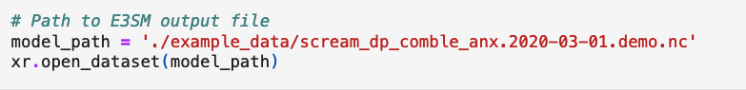

Load data file using emc2.core.model.SCREAM object.
- N_sub = 1: use one subcolumn in the forward calculation.

Run subcolumn generator and instrument simulator.
