**Object Relational Mapping with JPA**

General part

* *Describe how you have handled persistence in the last three semesters. The considerations should include all relevant layers. File IO, Relational Databases, local storage and cookies in browsers.*
* *Explain the rationale behind the topic Object Relational Mapping and the Pros and Cons in using a ORM*
* *Explain the JPA strategy for handling Object Relational Mapping and important classes/annotations involved.*
* *Outline some of the fundamental differences in Database handling using plain JDBC versus JPA*

CA or Semester Project

For a real exam exercise, this will be a small part where you are expected to talk, in about 5 minutes, about one of the semester CA’s or the semester project (related to the topic for this question).

Practical part

The model below is an initial model for a system than can handle orders. An order refers to a customer and a number of order lines. Each order line has a quantity and it refers to an item type. The item type has a name, a description and a price. The price for each order line is the quantity times the price. The total price for an order is the sum of all its order lines.

1. Examine and understand the diagram. 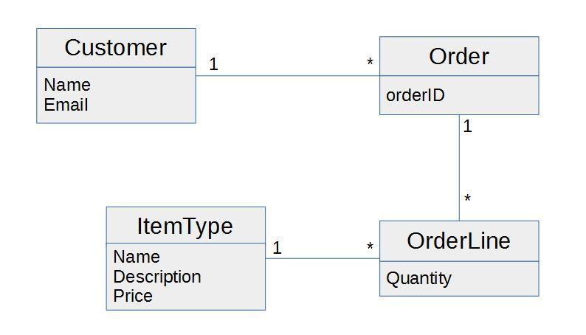
2. Create a Maven Java Application with NetBeans, and use Object Relational Mapping (JPA) to implement the OO classes and the corresponding Database Tables[1].
3. Create a façade and implement as many of the methods below as you have time for (not necessarily in the given order):

* Create a Customer
* Find a Customer
* Get all Customers
* Create an Order
* Add an Order to a Customer
* Find an Order
* Create an ItemType
* Create an OrderLine
* Find the total price of an order ….

1. You don't necessarily need to implement all Entity-classes before you start on part-3. Make sure to implement some of the methods in part-3 before you stop).