**Object Relation Mapping and JPQL**

General part

* *Explain the rationale behind the topic Object Relational Mapping and the Pros and Cons in using a ORM*.
* Discuss how we usually have queried a relational database
* Discuss the methods we can use to query a JPA design and compare with what you explained above

CA or Semester Project

For a real exam exercise, this will be a small part where you are expected to talk, in about 5 minutes, about one of the semester CA’s or the semester project (related to the topic for this question).

Practical part start (requires the script-file:[ExamPreparationJPQL.sql](https://github.com/Cphdat3sem2017f/StartcodeExercises/blob/master/ORM-JPA/ExamPreparationJPQL.sql))

*This exercise requires you to setup a MySQL database as described below:*

* Create a new MySQL database ***jpqlexam***, either from within Netbeans or using MySQL Workbench.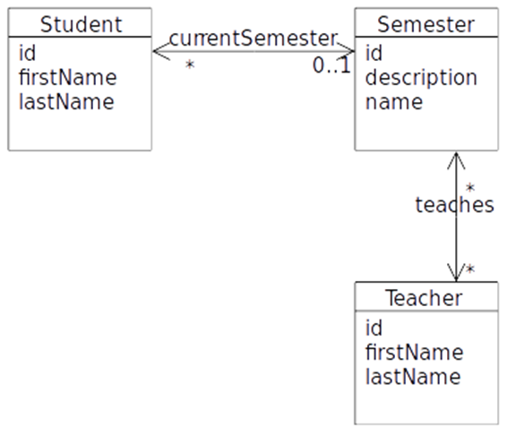
* Create a new Maven java project with NetBeans.
* In this project create a folder **scripts** and copy the file *Jpqlexam.sql*  into this folder and execute the script on the *jpqlexam* database.

This script creates four tables which simulates a very simple semester system with students, teachers and semesters, as sketched in this model. The script inserts 6 students, 3 semesters and 3 teachers, and assigns relationships between them.

A)

Use NetBeans to create the matching Entity Classes.

B)

Investigate the generated Entity classes and observe the NamedQueries generated by the Wizard.

C)

Create the Dynamic Queries (or if possible, a named Query generated by the wizard) to solve the following problems:

1. **Find** all Students in the system
2. **Find** all Students in the System with the first name Anders
3. **Insert** a new Student into the system
4. **Assign** a new student to a semester
5. **Find** all Students in the system with the last name And
6. **Find** the total sum of students, for a semester given the semester name.
7. **Find** the total number of students in all semesters.
8. **Find** the teacher who teaches the most semesters.