## React with routing

**General part**

**https://www.themarketingtechnologist.co/react-router-an-introduction/**

**Practical part**

The task is to create a small application with three routes and matching views (there is no “top-menu” in this example). The app must have an initial view with a welcome message + a Link to a view that renders a list of all users. When "details" are pressed it must present a details view for the selected user. This is all sketched in the figure below.

The data sample provided on next page include links to fetch both a thumbnail and a full size picture for all users.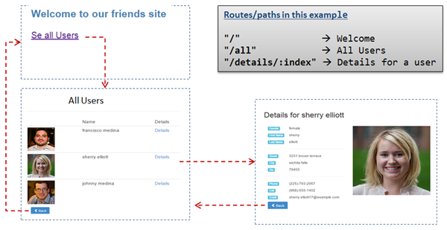

Complete the exercise following these steps (don't consider styling, until the all components/routes are implemented):

**1)** Create a new project with create-react-app and import required dependencies in App.js as:

Import {BrowserRouter as Router, Route, Link, Switch} from "react-router-dom"

**2)** Paste the json formatted data into a file: data/data.json. Read data into your App component like this:

import data from "./data/data.json"

**3)** In App.js, add this to the Render method

<Router>

<Switch>

//Add Your Routes here

</Switch>

</Router>

**4)** Implement the Welcome Component (consider whether it should be a class or a functional Component), and the Route- handler to forward requests to this page (use the paths, given in the figure above)

**5)** Implement the All users Component and the Route-handler that will lead to this view.

**6)** Implement the Details Component and the Route-handler that will lead to this view

**7)** When everything works as expected, style the application (not necessarily as on the screenshots above).

*Data for the exercise (paste into a file* ***data.json****, in a folder* ***data****)*

{  
 **"users"**: [  
 {  
 **"gender"**: **"male"**,  
 **"title"**: **"mr"**,  
 **"first"**: **"francisco"**,  
 **"last"**: **"medina"**,  
 **"street"**: **"2748 w dallas st"**,  
 **"city"**: **"flowermound"**,  
 **"state"**: **"new jersey"**,  
 **"zip"**: **"77511"**,  
 **"email"**: **"francisco.medina65@example.com"**,  
 **"dob"**: **"454252284"**,  
 **"phone"**: **"(757)-889-2571"**,  
 **"cell"**: **"(113)-542-2123"**,  
 **"picture"**: {  
 **"large"**: **"http://api.randomuser.me/portraits/men/22.jpg"**,  
 **"thumbnail"**: **"http://api.randomuser.me/portraits/thumb/men/22.jpg"** }  
 },  
 {  
 **"gender"**: **"female"**,  
 **"title"**: **"mrs"**,  
 **"first"**: **"sherry"**,  
 **"last"**: **"elliott"**,  
 **"street"**: **"3251 brown terrace"**,  
 **"city"**: **"wichita falls"**,  
 **"state"**: **"washington"**,  
 **"zip"**: **"79455"**,  
 **"email"**: **"sherry.elliott17@example.com"**,  
 **"dob"**: **"224238139"**,  
 **"phone"**: **"(225)-793-2067"**,  
 **"cell"**: **"(968)-555-1402"**,  
 **"picture"**: {  
 **"large"**: **"http://api.randomuser.me/portraits/women/37.jpg"**,  
 **"thumbnail"**: **"http://api.randomuser.me/portraits/thumb/women/37.jpg"** }  
 },  
 {  
 **"gender"**: **"male"**,  
 **"title"**: **"mr"**,  
 **"first"**: **"johnny"**,  
 **"last"**: **"medina"**,  
 **"street"**: **"1313 samaritan dr"**,  
 **"city"**: **"redding"**,  
 **"state"**: **"new hampshire"**,  
 **"zip"**: **"43269"**,  
 **"email"**: **"johnny.medina76@example.com"**,  
 **"dob"**: **"259176886"**,  
 **"phone"**: **"(991)-957-7139"**,  
 **"cell"**: **"(502)-773-1487"**,  
 **"picture"**: {  
 **"large"**: **"http://api.randomuser.me/portraits/men/90.jpg"**,  
 **"thumbnail"**: **"http://api.randomuser.me/portraits/thumb/men/90.jpg"** }  
 }  
 ]  
}

|  |
| --- |
|  |

**(SOS fetch link if data doesn’t work: https://jsonplaceholder.typicode.com/posts/1)**