SQL Assignment -1

1. select count (*) ,concat(first_name ,' ', last_name) as actor_name from public.actor

group by actor_name

having count(*) > 1 ;

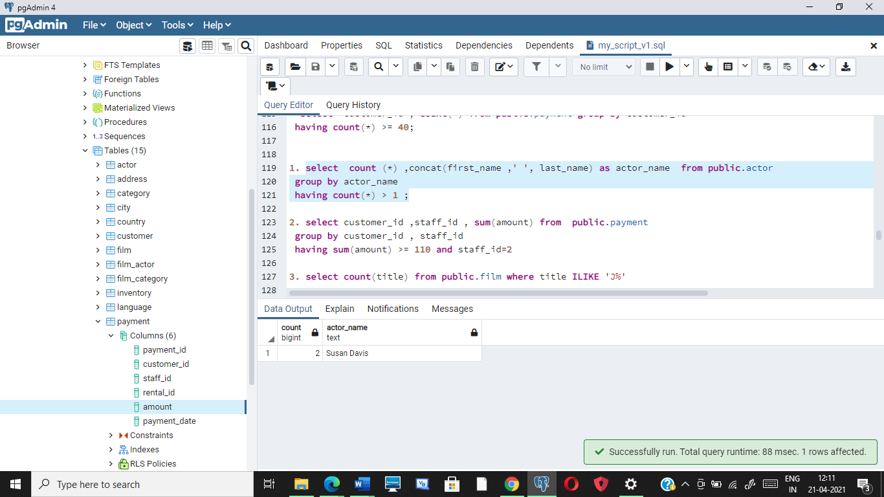

2. select customer_id ,staff_id , sum(amount) from public.payment

group by customer_id , staff_id

having sum(amount) >= 110 and staff_id=2

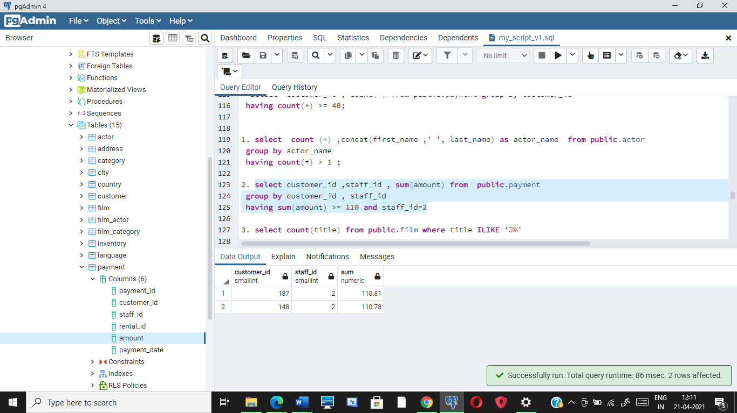

3. select count(title) from public.film where title ILIKE 'J%'

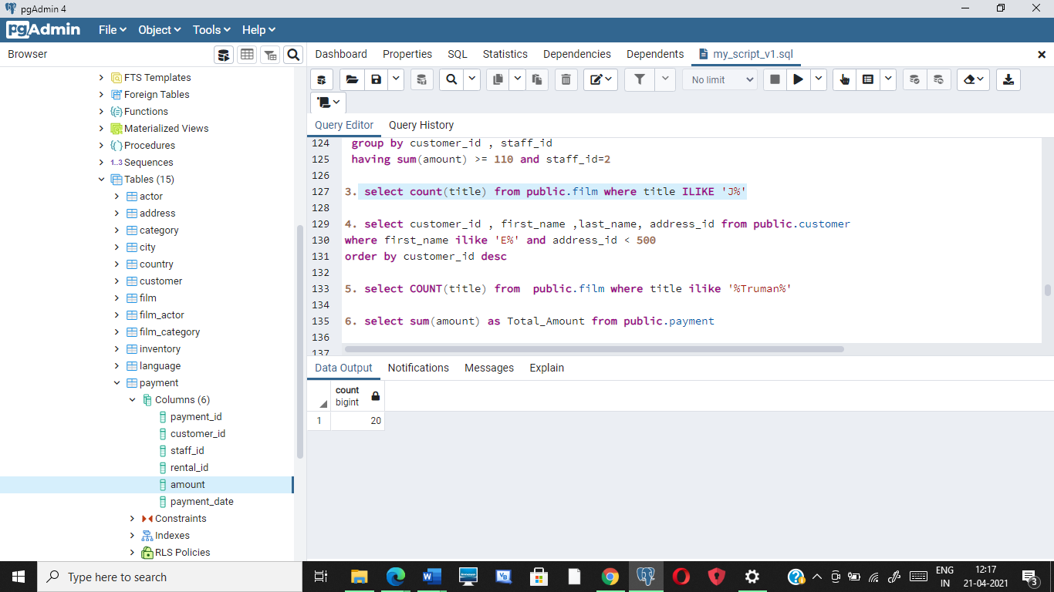

4. select customer_id , first_name ,last_name, address_id from public.customer

where first_name ilike 'E%' and address_id < 500

order by customer_id desc

Answer : customer_id= 434 First_Name = "Eddie" Last_Name "Tomlin" Address_Id= 439

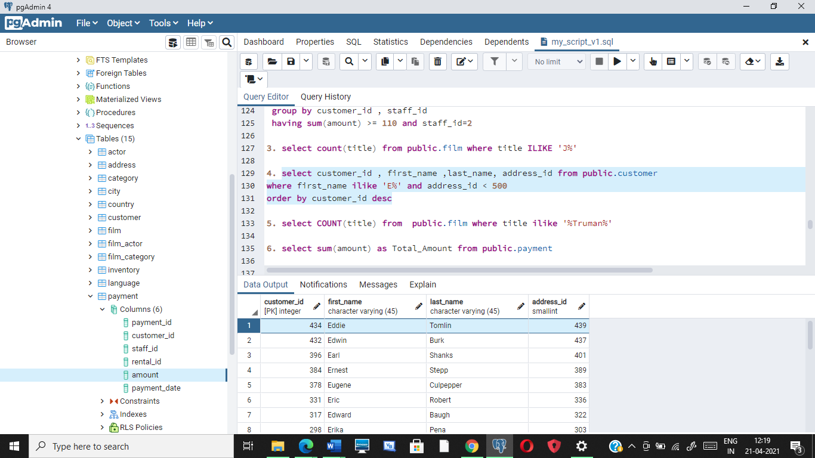

5. select COUNT(title) from public.film where title ilike '%Truman%'

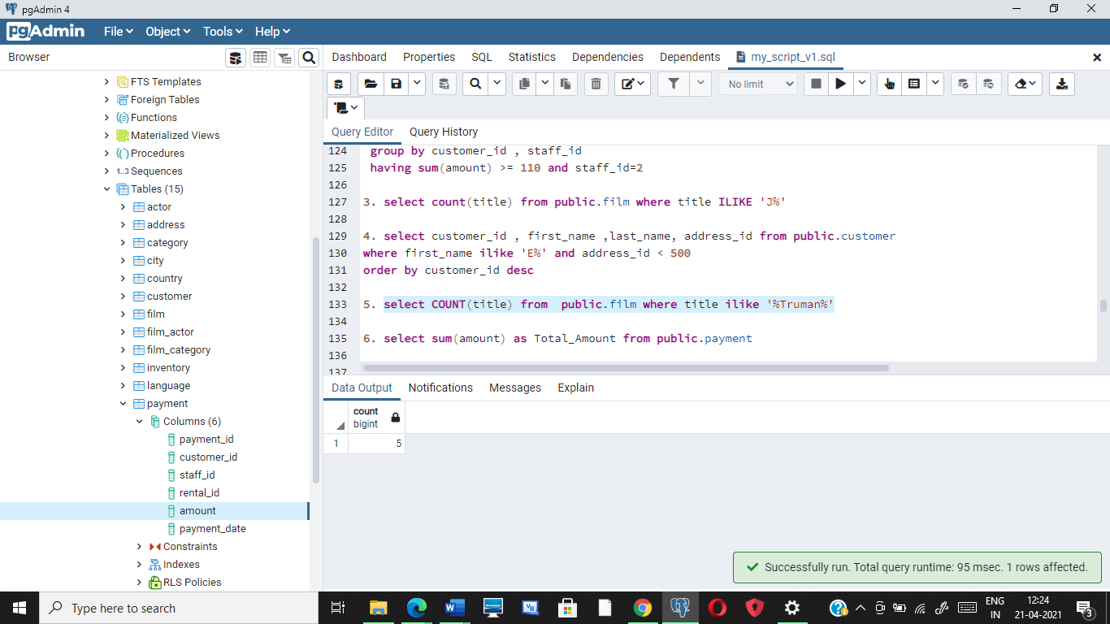

6. select sum(amount) as Total_Amount from public.payment

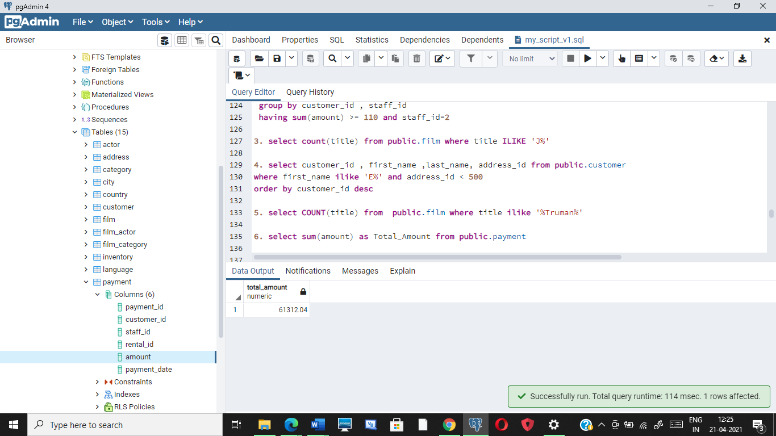

7 and 8. select customer_id , sum(amount) from public.payment

group by customer_id

order by sum(amount) desc

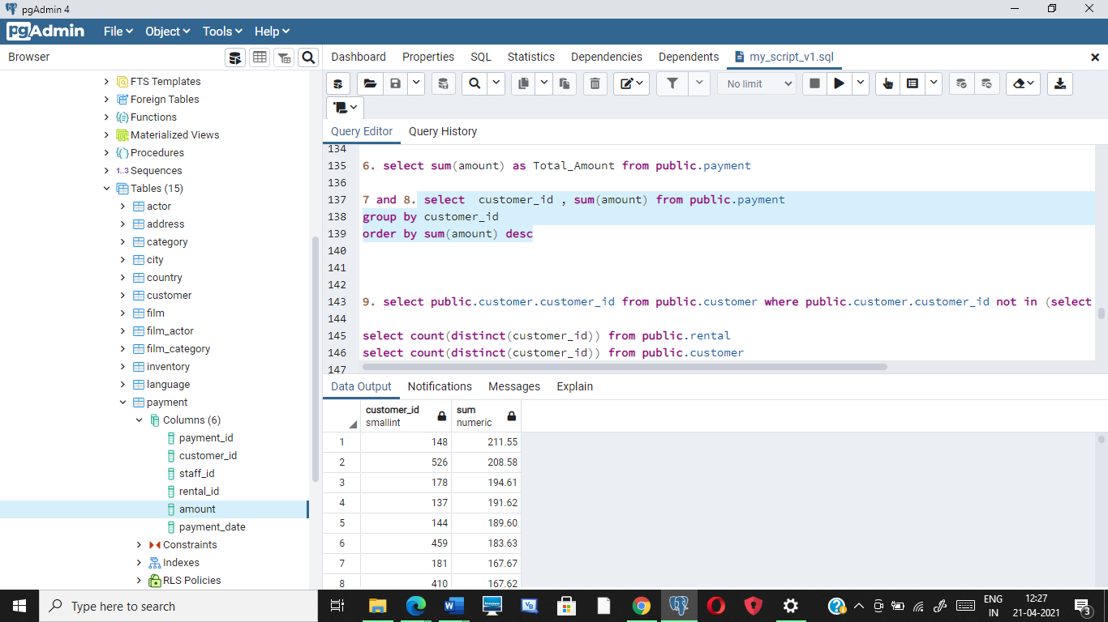

8. Highest Total payment done is : $ 211.55

9. select public.customer.customer_id from public.customer where public.customer.customer_id not in (select public.rental.customer_id from public.rental)

select count(distinct(customer_id)) from public.rental

select count(distinct(customer_id)) from public.customer

Answer : All the customers have rented . There is no customer who has not rented

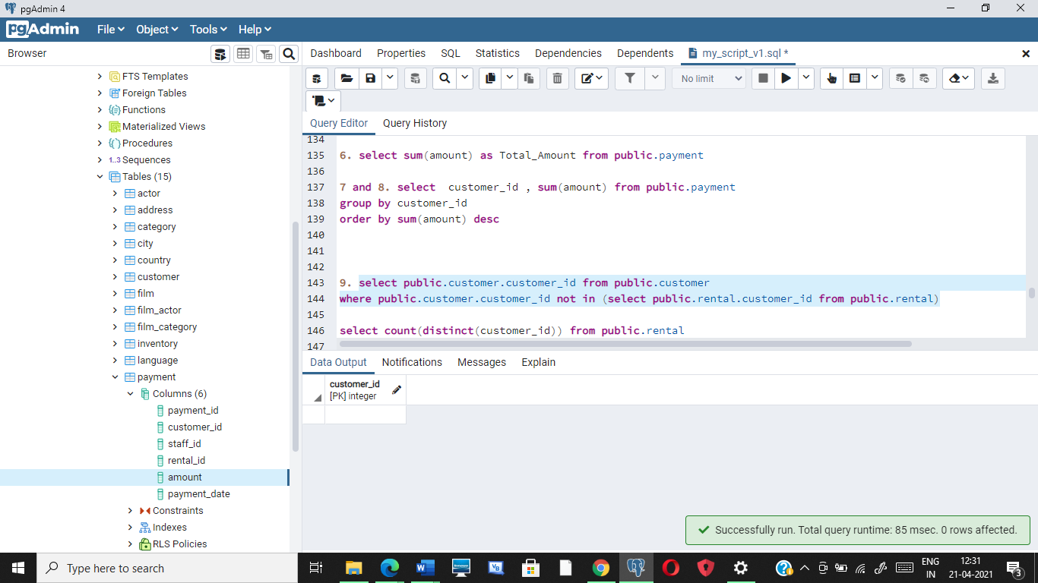

10. select count(payment_id) from public.payment where amount > 5

select payment_id ,amount from public.payment where amount > 5

Answer : Payment transactions greater than $5 = 3618

