**Final SQL Project - Employees**

---1. Write a query to display the names (first_name, last_name) using alias name “First Name", "Last Name"

select first_name as "First Name" , last_name as "Last Name" from public.employees ;

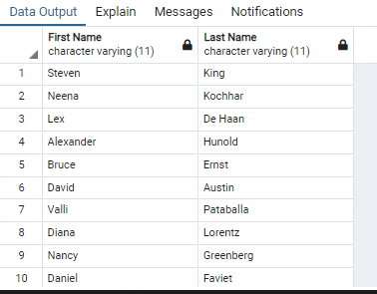

------ 2. Write a query to get unique department ID from employee table

select distinct department_id from public.employees order by department_id;

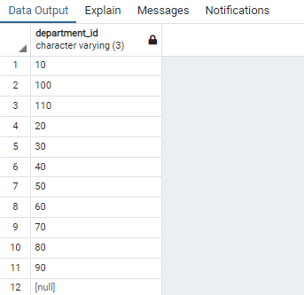

-------3. Write a query to get all employee details from the employee table order by first name, descending

select * from public.employees order by first_name desc;

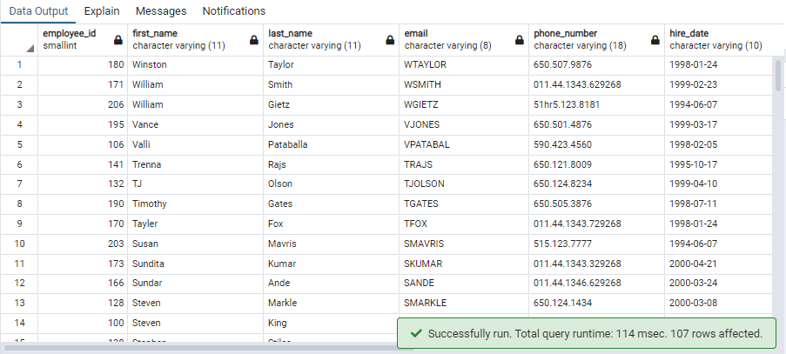

------4. Write a query to get the names (first_name, last_name), salary, PF of all the employees (PF is calculated as 15% of salary)

select concat(first_name,' ', last_name) as Name , salary , round((15*salary)/100,2) as PF from public.employees ;

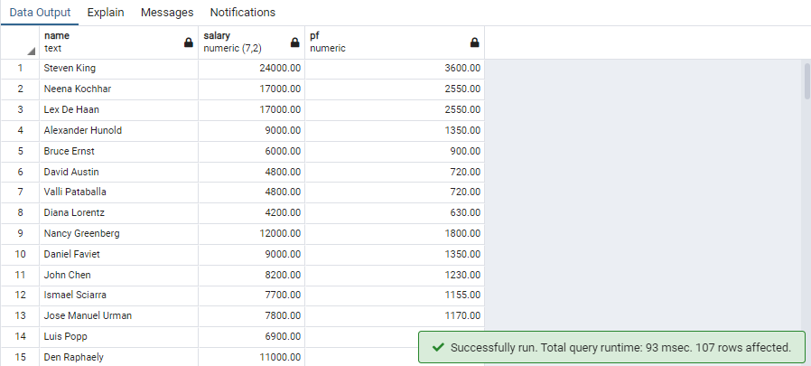

---5. Write a query to get the employee ID, names (first_name, last_name), salary in ascending order of salary

select employee_id , concat(first_name,' ', last_name) as Name , salary from public.employees order by salary asc;

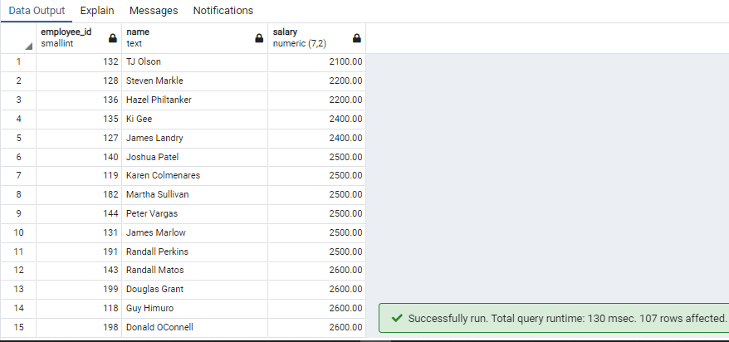

----6. Write a query to get the total salaries payable to employees

select sum(salary) from public.employees ;

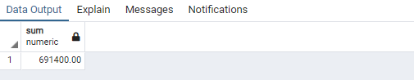

---7. Write a query to get the maximum and minimum salary from employees table

select max(salary) as "Maximum Salary" , min(salary) as "Minimum Salary" from public.employees;

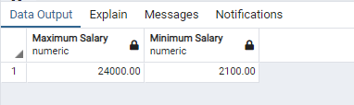

-----8. Write a query to get the average salary and number of employees in the employees table

select round(avg(salary),2) as "Average Salary" , count(employee_id) as "Number of Employees" from public.employees;

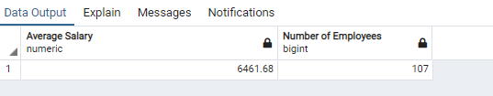

-----9. Write a query to get the number of employees working with the company

select count(*) from public.employees where employee_id not in (select distinct(employee_id) from public.job_history);

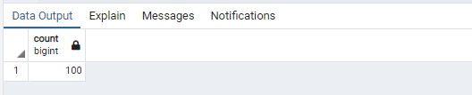

-----10. Write a query to get the number of jobs available in the employees table

select count(public.employees.job_id) as "Job Count" ,public.employees.job_id ,job_title from public.employees

inner join public.jobs

on public.employees.job_id =public.jobs.job_id

group by public.employees.job_id , public.jobs.job_title;

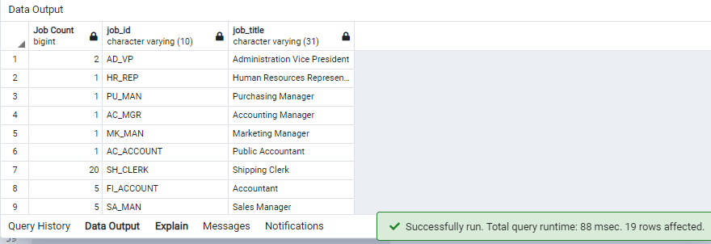

------11. Write a query get all first name from employees table in upper case

select Upper(first_name) from public.employees ;

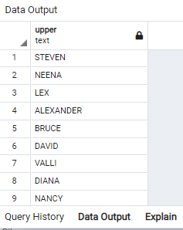

----12. Write a query to get first name from employees table after removing white spaces from both side

select trim(from first_name) from public.employees ;

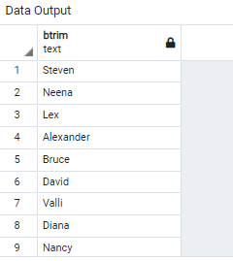

-----13. Write a query to get the length of the employee names (first_name, last_name) from employees table

select length(concat(first_name,last_name )) , concat(first_name,last_name ) as Employee_name from public.employees ;

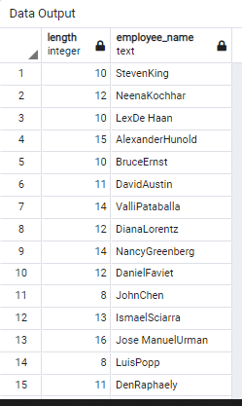

-----14. Write a query to display the name (first_name, last_name) and salary for all employees whose salary is not in the range $10,000 through $15,000

select concat(first_name , ' ', last_name) as Employee_Name , salary from public.employees where salary not between 10000 and 15000;

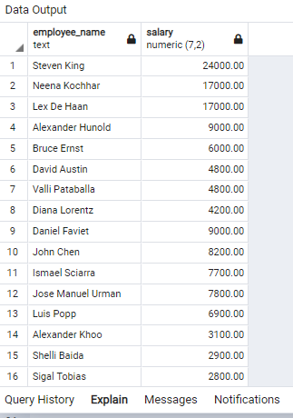

-----15. Write a query to display the name (first_name, last_name) and salary for all employees whose salary is not in the range $10,000 through $15,000 and are in department 30 or 100

select concat(first_name , ' ', last_name) as Employee_Name , department_id, salary from public.employees where public.employees.department_id = '30' or department_id='100' and salary not between 10000 and 15000 ;

