**BCSE203E WEB PROGRAMMMING**

**LAB EXERCISE -10**

**JAVA SCRIPT**

**NAME: M.MENMANGAI**

**REGISTRATION NO: 23BCE1022**

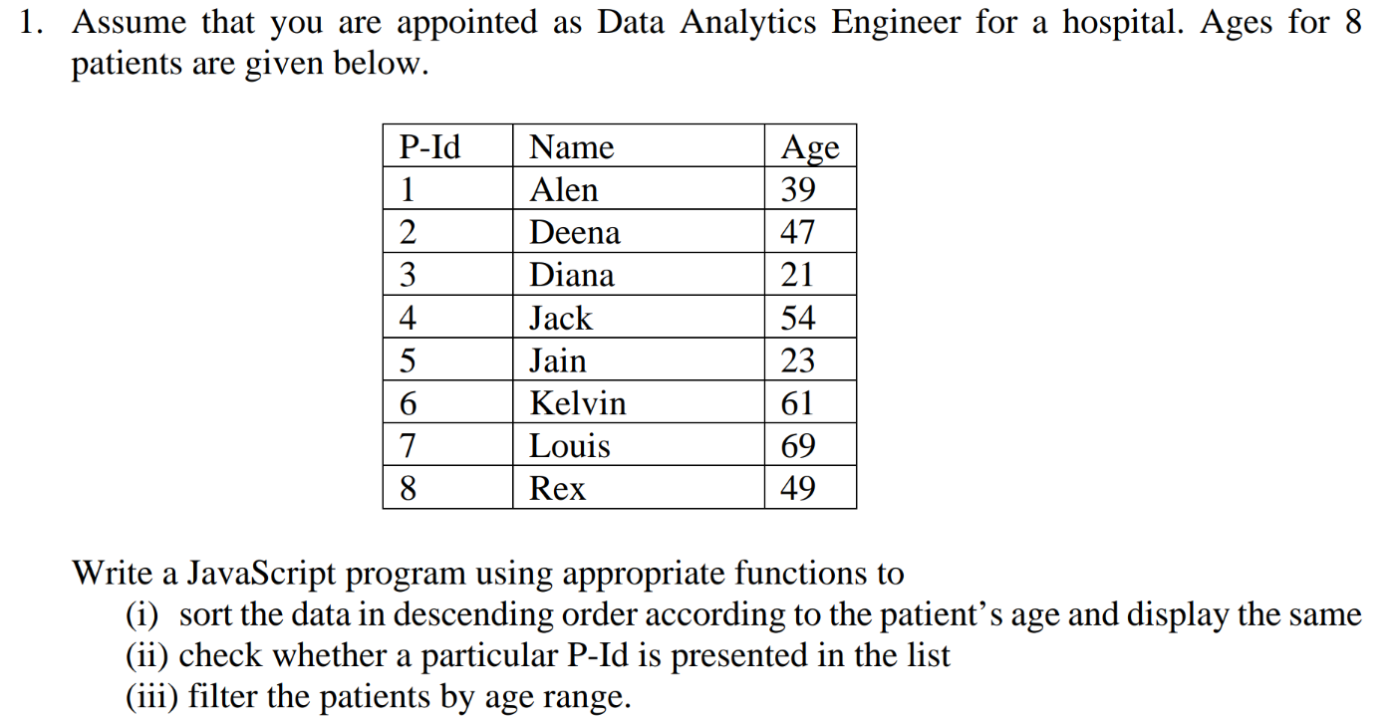

CODE:

<!DOCTYPE html>

<html lang="en">

<head>

<meta charset="UTF-8">

<meta name="viewport" content="width=device-width, initial-scale=1.0">

<title>Patient Data Management</title>

<style>

body {

font-family: Arial, sans-serif;

margin: 20px;

}

table {

width: 100%;

border-collapse: collapse;

margin: 10px 0;

}

th, td {

border: 1px solid black;

padding: 8px;

text-align: center;

}

th {

background-color: #f2f2f2;

cursor: pointer;

}

button {

padding: 10px;

margin: 5px;

background-color: green;

color: white;

border: none;

cursor: pointer;

}

input {

padding: 5px;

margin: 5px;

}

</style>

</head>

<body>

<h2>Patient Data</h2>

<button onclick="sortPatients()">Sort by Age (Descending)</button>

<h3>Check if P-Id Exists</h3>

<input type="number" id="checkId" placeholder="Enter P-Id">

<button onclick="checkPatient()">Check</button>

<p id="checkResult"></p>

<h3>Filter Patients by Age Range</h3>

<input type="number" id="minAge" placeholder="Min Age">

<input type="number" id="maxAge" placeholder="Max Age">

<button onclick="filterByAge()">Filter</button>

<h3>Patient List</h3>

<table id="patientTable">

<thead>

<tr>

<th>P-Id</th>

<th>Name</th>

<th>Age</th>

</tr>

</thead>

<tbody id="tableBody"></tbody>

</table>

<script>

// Patient data

let patients = [

{ P_Id: 1, Name: "Alen", Age: 39 },

{ P_Id: 2, Name: "Deena", Age: 47 },

{ P_Id: 3, Name: "Diana", Age: 21 },

{ P_Id: 4, Name: "Jack", Age: 54 },

{ P_Id: 5, Name: "Jain", Age: 23 },

{ P_Id: 6, Name: "Kelvin", Age: 61 },

{ P_Id: 7, Name: "Louis", Age: 69 },

{ P_Id: 8, Name: "Rex", Age: 49 }

];

// Display patients in table

function displayPatients(data) {

let tableBody = document.getElementById("tableBody");

tableBody.innerHTML = "";

data.forEach(patient => {

let row = `<tr>

<td>${patient.P_Id}</td>

<td>${patient.Name}</td>

<td>${patient.Age}</td>

</tr>`;

tableBody.innerHTML += row;

});

}

// (i) Sort patients by age in descending order

function sortPatients() {

patients.sort((a, b) => b.Age - a.Age);

displayPatients(patients);

}

// (ii) Check if a P-Id exists

function checkPatient() {

let pId = parseInt(document.getElementById("checkId").value);

let exists = patients.some(patient => patient.P_Id === pId);

document.getElementById("checkResult").textContent = exists ? `P-Id ${pId} is present.` : `P-Id ${pId} is not found.`;

}

// (iii) Filter patients by age range

function filterByAge() {

let minAge = parseInt(document.getElementById("minAge").value);

let maxAge = parseInt(document.getElementById("maxAge").value);

let filteredPatients = patients.filter(patient => patient.Age >= minAge && patient.Age <= maxAge);

displayPatients(filteredPatients);

}

// Load data on page load

displayPatients(patients);

</script>

</body>

</html>

OUTPUT:

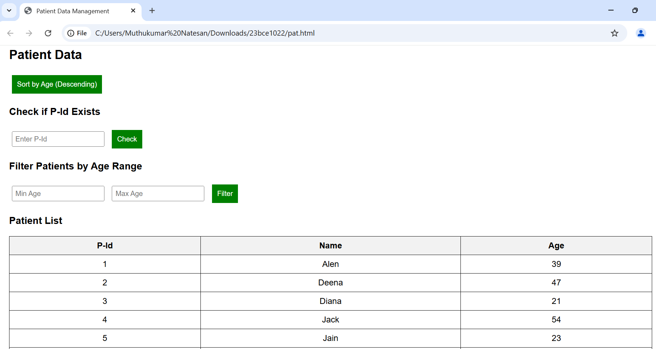

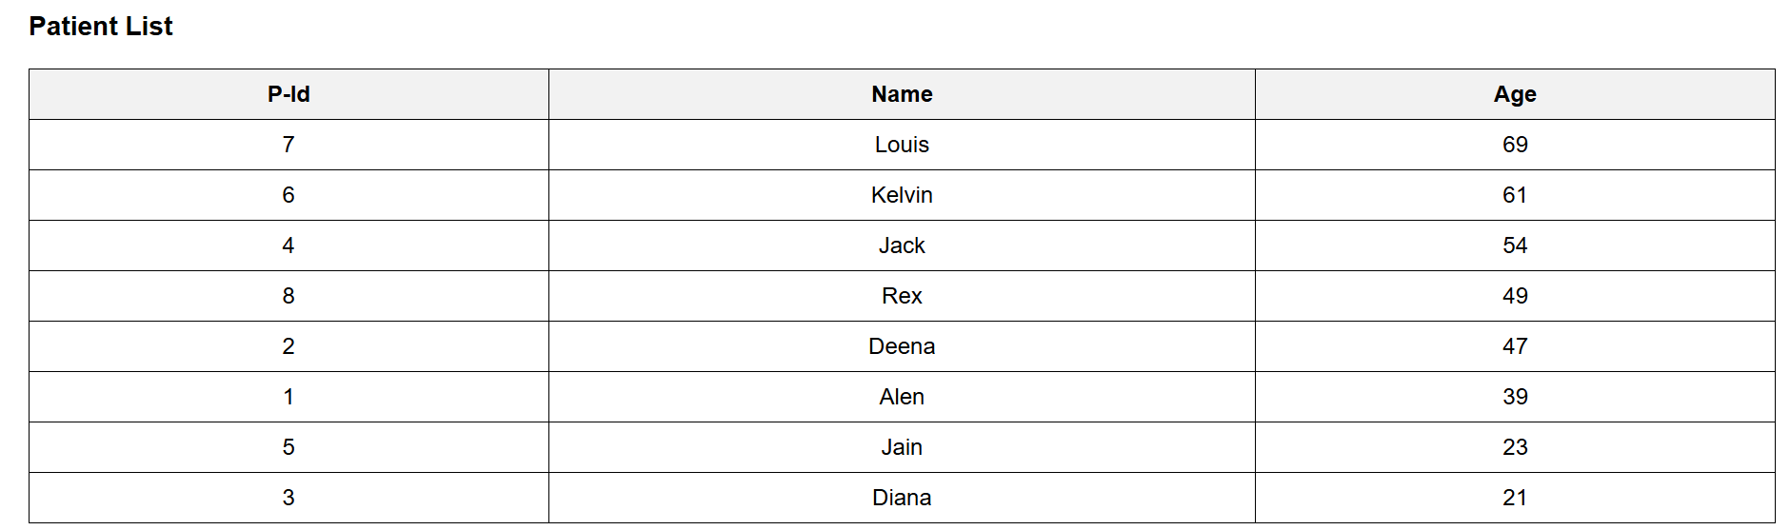 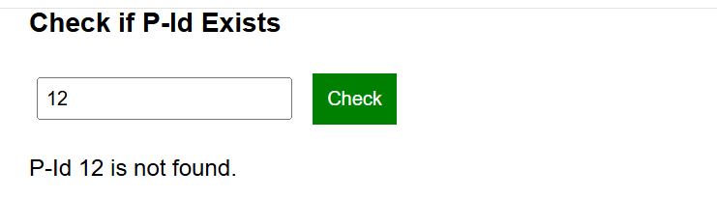 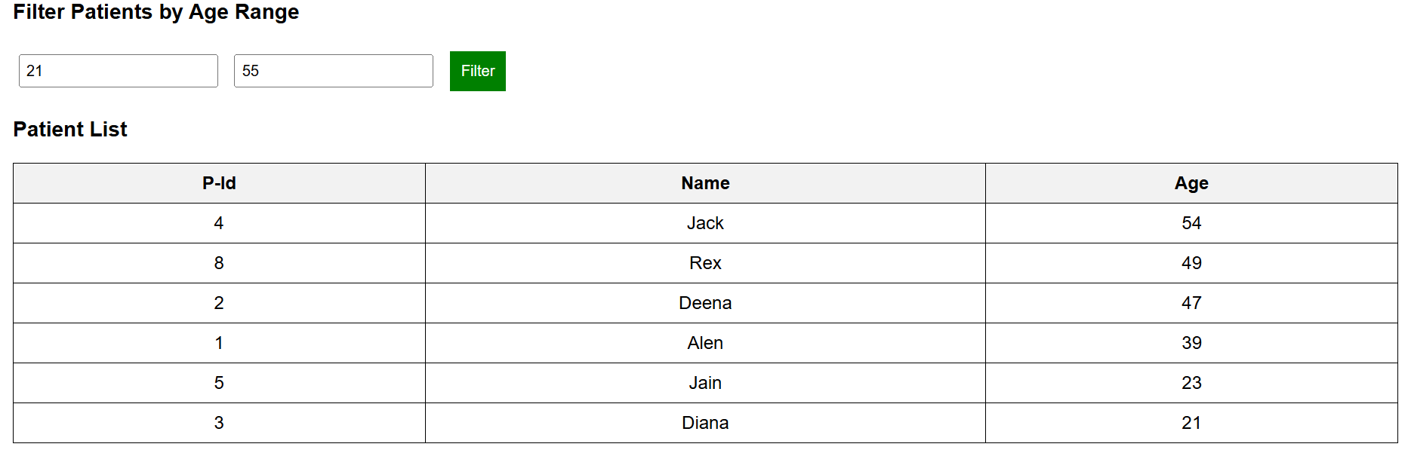

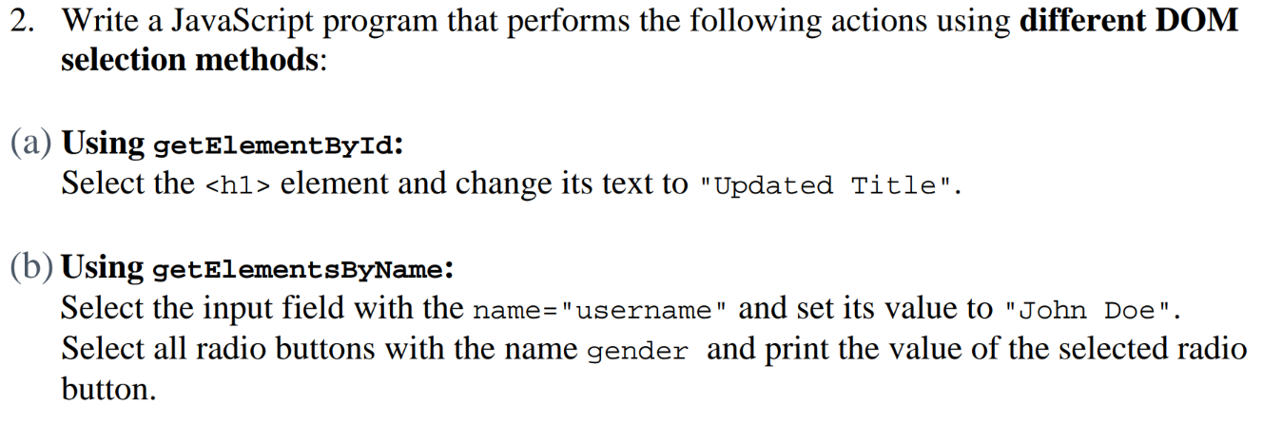 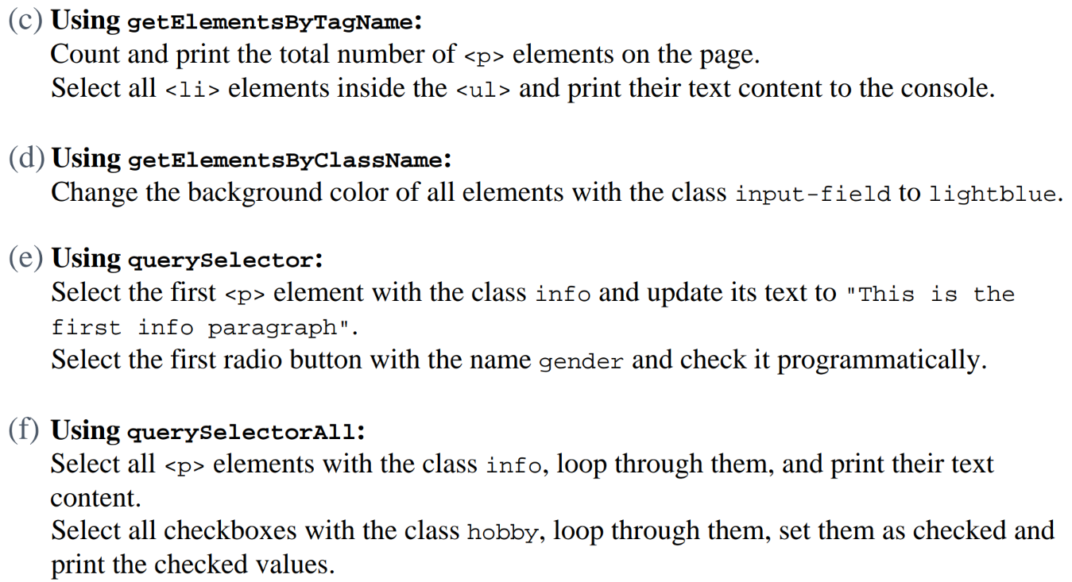

CODE:

<!DOCTYPE html>

<html lang="en">

<head>

<meta charset="UTF-8">

<meta name="viewport" content="width=device-width, initial-scale=1.0">

<title>DOM Selection Methods</title>

<style>

body {

font-family: Arial, sans-serif;

margin: 20px;

}

table {

width: 100%;

border-collapse: collapse;

margin: 10px 0;

}

th, td {

border: 1px solid black;

padding: 8px;

text-align: left;

}

th {

background-color: #f2f2f2;

}

.input-field {

padding: 5px;

width: 100%;

}

.info {

font-style: italic;

color: blue;

}

button {

padding: 10px;

margin-top: 10px;

background-color: green;

color: white;

border: none;

cursor: pointer;

}

</style>

</head>

<body>

<!-- (a) Using getElementById -->

<h1 id="title">Original Title</h1>

<!-- (b) Using getElementsByName -->

<h2>User Information</h2>

<table>

<tr>

<th>Label</th>

<th>Input</th>

</tr>

<tr>

<td>Username:</td>

<td><input type="text" name="username" class="input-field" placeholder="Enter your name"></td>

</tr>

<tr>

<td>Gender:</td>

<td>

<input type="radio" name="gender" value="Male"> Male

<input type="radio" name="gender" value="Female"> Female

</td>

</tr>

</table>

<!-- (c) Using getElementsByTagName -->

<h2>Paragraphs</h2>

<p>Paragraph 1</p>

<p>Paragraph 2</p>

<p>Paragraph 3</p>

<h2>List of Items</h2>

<ul>

<li>Item 1</li>

<li>Item 2</li>

<li>Item 3</li>

</ul>

<!-- (d) Using getElementsByClassName -->

<h2>Input Fields</h2>

<table>

<tr>

<td><input type="text" class="input-field" placeholder="Field 1"></td>

</tr>

<tr>

<td><input type="text" class="input-field" placeholder="Field 2"></td>

</tr>

</table>

<!-- (e) Using querySelector -->

<h2>Information Section</h2>

<p class="info">This is some information.</p>

<!-- (f) Using querySelectorAll -->

<h2>More Information</h2>

<p class="info">Another info paragraph.</p>

<h2>Select Hobbies</h2>

<table>

<tr>

<td><input type="checkbox" class="hobby" value="Reading"> Reading</td>

</tr>

<tr>

<td><input type="checkbox" class="hobby" value="Gaming"> Gaming</td>

</tr>

<tr>

<td><input type="checkbox" class="hobby" value="Traveling"> Traveling</td>

</tr>

</table>

<button onclick="applyChanges()">Apply Changes</button>

<script>

function applyChanges() {

// (a) Using getElementById

document.getElementById("title").textContent = "Updated Title";

// (b) Using getElementsByName

document.getElementsByName("username")[0].value = "John Doe";

const genderRadios = document.getElementsByName("gender");

for (let radio of genderRadios) {

if (radio.checked) {

console.log("Selected Gender:", radio.value);

}

}

// (c) Using getElementsByTagName

const paragraphs = document.getElementsByTagName("p");

console.log("Total <p> elements:", paragraphs.length);

const listItems = document.getElementsByTagName("ul")[0].getElementsByTagName("li");

for (let item of listItems) {

console.log("List Item:", item.textContent);

}

// (d) Using getElementsByClassName

const inputFields = document.getElementsByClassName("input-field");

for (let field of inputFields) {

field.style.backgroundColor = "lightblue";

}

// (e) Using querySelector

const firstInfoParagraph = document.querySelector(".info");

if (firstInfoParagraph) {

firstInfoParagraph.textContent = "This is the first info paragraph";

}

const firstGenderRadio = document.querySelector("input[name='gender']");

if (firstGenderRadio) {

firstGenderRadio.checked = true;

}

// (f) Using querySelectorAll

const infoParagraphs = document.querySelectorAll(".info");

infoParagraphs.forEach(para => console.log("Info Paragraph:", para.textContent));

const hobbyCheckboxes = document.querySelectorAll(".hobby");

hobbyCheckboxes.forEach(checkbox => {

checkbox.checked = true;

console.log("Checked Hobby:", checkbox.value);

});

}

</script>

</body>

</html>

OUTPUT:

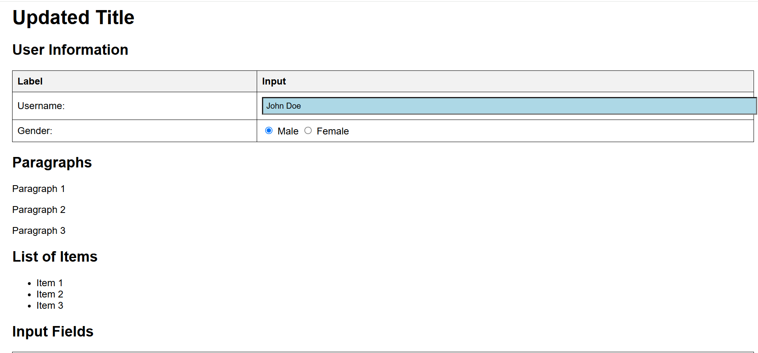 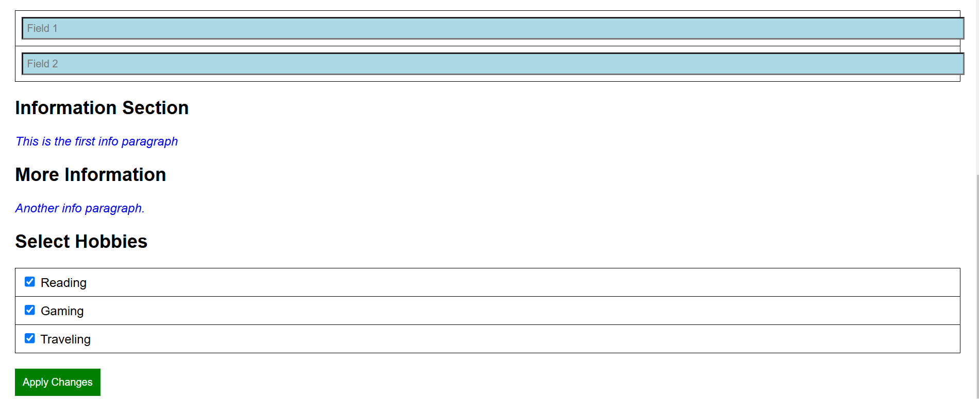

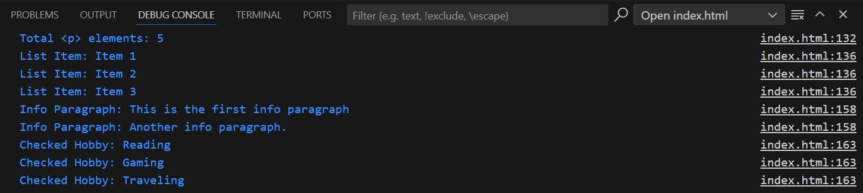

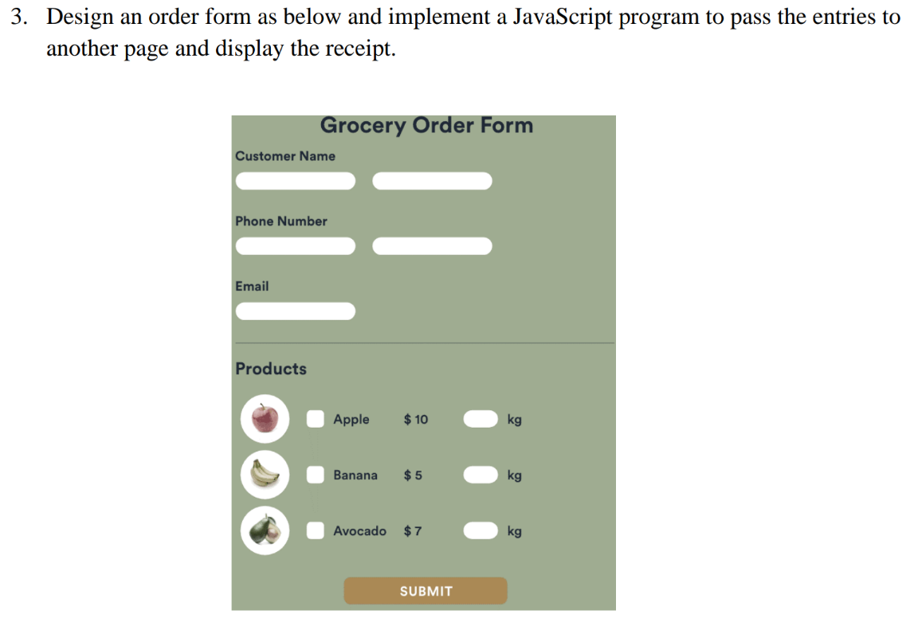

CODE:

order.html:

<!DOCTYPE html>

<html lang="en">

<head>

    <meta charset="UTF-8">

    <meta name="viewport" content="width=device-width, initial-scale=1.0">

    <title>Grocery Order Form</title>

    <style>

        body {

            font-family: Arial, sans-serif;

            background-color: #d1d5b8;

            text-align: center;

        }

        .container {

            background-color: #79866d;

            padding: 20px;

            border-radius: 10px;

            width: 400px;

            margin: auto;

            color: white;

        }

        input, button {

            margin: 5px;

            padding: 8px;

            border-radius: 5px;

            border: none;

        }

        .product {

            display: flex;

            align-items: center;

            justify-content: space-between;

            margin: 5px;

        }

        button {

            background-color: #b68d4c;

            color: white;

            font-size: 16px;

            cursor: pointer;

        }

    </style>

</head>

<body>

    <div class="container">

        <h2>Grocery Order Form</h2>

        <label>Customer Name:</label>

        <input type="text" id="name"><br>

        <label>Phone Number:</label>

        <input type="text" id="phone"><br>

        <label>Email:</label>

        <input type="email" id="email"><br>

        <h3>Products</h3>

        <div class="product">

            <input type="checkbox" id="apple" value="Apple" data-price="10">

            <label for="apple">Apple - $10/kg</label>

            <input type="number" id="appleQty" min="0" placeholder="kg">

        </div>

        <div class="product">

            <input type="checkbox" id="banana" value="Banana" data-price="5">

            <label for="banana">Banana - $5/kg</label>

            <input type="number" id="bananaQty" min="0" placeholder="kg">

        </div>

        <div class="product">

            <input type="checkbox" id="avocado" value="Avocado" data-price="7">

            <label for="avocado">Avocado - $7/kg</label>

            <input type="number" id="avocadoQty" min="0" placeholder="kg">

        </div>

        <button onclick="submitOrder()">SUBMIT</button>

    </div>

    <script>

        function submitOrder() {

            let name = document.getElementById("name").value;

            let phone = document.getElementById("phone").value;

            let email = document.getElementById("email").value;

            let products = [];

            let items = [

                { id: "apple", qtyId: "appleQty" },

                { id: "banana", qtyId: "bananaQty" },

                { id: "avocado", qtyId: "avocadoQty" }

            ];

            items.forEach(item => {

                let checkbox = document.getElementById(item.id);

                let qty = document.getElementById(item.qtyId).value;

                let price = checkbox.dataset.price;

                if (checkbox.checked && qty > 0) {

                    products.push({ name: checkbox.value, qty, price });

                }

            });

            let orderData = {

                name,

                phone,

                email,

                products

            };

            localStorage.setItem("order", JSON.stringify(orderData));

            window.location.href = "receipt.html";

        }

    </script>

</body>

</html>

receipt.html:

<!DOCTYPE html>

<html lang="en">

<head>

<meta charset="UTF-8">

<meta name="viewport" content="width=device-width, initial-scale=1.0">

<title>Order Receipt</title>

<style>

body {

font-family: Arial, sans-serif;

background-color: #d1d5b8;

text-align: center;

}

.container {

background-color: #79866d;

padding: 20px;

border-radius: 10px;

width: 400px;

margin: auto;

color: white;

}

table {

width: 100%;

margin-top: 10px;

border-collapse: collapse;

}

th, td {

border: 1px solid white;

padding: 8px;

text-align: center;

}

th {

background-color: #b68d4c;

}

</style>

</head>

<body>

<div class="container">

<h2>Order Receipt</h2>

<p><strong>Customer Name:</strong> <span id="custName"></span></p>

<p><strong>Phone Number:</strong> <span id="custPhone"></span></p>

<p><strong>Email:</strong> <span id="custEmail"></span></p>

<h3>Ordered Products</h3>

<table>

<thead>

<tr>

<th>Product</th>

<th>Quantity (kg)</th>

<th>Price ($)</th>

<th>Total ($)</th>

</tr>

</thead>

<tbody id="orderDetails"></tbody>

</table>

<h3>Total Amount: $<span id="totalAmount">0</span></h3>

</div>

<script>

document.addEventListener("DOMContentLoaded", function() {

let order = JSON.parse(localStorage.getItem("order"));

if (order) {

document.getElementById("custName").textContent = order.name;

document.getElementById("custPhone").textContent = order.phone;

document.getElementById("custEmail").textContent = order.email;

let orderDetails = document.getElementById("orderDetails");

let totalAmount = 0;

order.products.forEach(product => {

let total = product.qty * product.price;

totalAmount += total;

let row = `<tr>

<td>${product.name}</td>

<td>${product.qty}</td>

<td>$${product.price}</td>

<td>$${total}</td>

</tr>`;

orderDetails.innerHTML += row;

});

document.getElementById("totalAmount").textContent = totalAmount;

}

});

</script>

</body>

</html>

OUTPUT:



