**BCSE203E WEB PROGRAMMMING**

**LAB EXERCISE -3**

**HTML IMAGE MAPPING**

**NAME: M.MENMANGAI**

**REGISTRATION NO: 23BCE1022**

**1. Map the images using HTML image mapping with the proper title such as (5 marks) Note: Use title property for <area> tag**

**Sun: Ball of Fire**

**Venus: Morning Star**

**Earth: Blue planet**

**Jupiter: Largest planet**

**Saturn: Ring Planet**

**Pluto: Dwarf Planet**

**My Space: Your Name and Register No.**

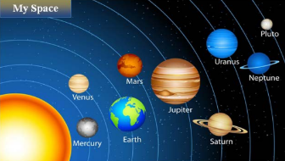

**Display the details of earth and sun in new web pages by providing appropriate hotspots and links. Provide appropriate link to "My space" to HTML page (Qn.2)**

**CODE:**

<!DOCTYPE html>

<html>

<head>

    <title>23BCE1022</title>

</head>

<body>

    <img src="solar.jpg" usemap="#imgmap" >

    <map name="imgmap">

        <area title="My Space: Menmangai 23BCE1022" shape="rect" coords="-1,46,197,-1" href="myspace.html">

        <area title="Sun:Ball of fire" shape="circle" coords="38,403,163" href="https://science.nasa.gov/sun/">

        <area title="Mercury" shape="circle" coords="241,333,30" href="https://science.nasa.gov/mercury/">

        <area title="Venus:Morning Star" shape="circle" coords="218,219,28" href="https://science.nasa.gov/venus/">

        <area title="Earth:Blue Planet" shape="circle" coords="355,298,51" href="https://science.nasa.gov/earth/facts/">

        <area title="Mars" shape="circle" coords="362,173,35" href="https://science.nasa.gov/mars/">

        <area title="Jupiter: Largest Planet" shape="circle" coords="491,211,67" href="https://science.nasa.gov/jupiter/">

        <area title="Saturn: Ring Planet" shape="poly" coords="627,295,641,304,649,317,660,327,693,343,670,348,641,346,627,355,608,355,591,351,583,336,561,329,539,315,565,313,582,313,595,299" href="https://science.nasa.gov/saturn/">

        <area title="Uranus" shape="circle" coords="621,113,41" href="https://science.nasa.gov/uranus/">

        <area title="Neptune" shape="poly" coords="729,194,745,189,757,172,782,164,756,158,734,138,717,139,703,146,694,160,692,168,672,176,699,182,704,192" href="https://science.nasa.gov/neptune/">

        <area title="Pluto: Dwarf Planet" shape="circle" coords="748,66,17" href="https://science.nasa.gov/dwarf-planets/pluto/">

    </map>

</body>

</html>

**OUTPUT:**

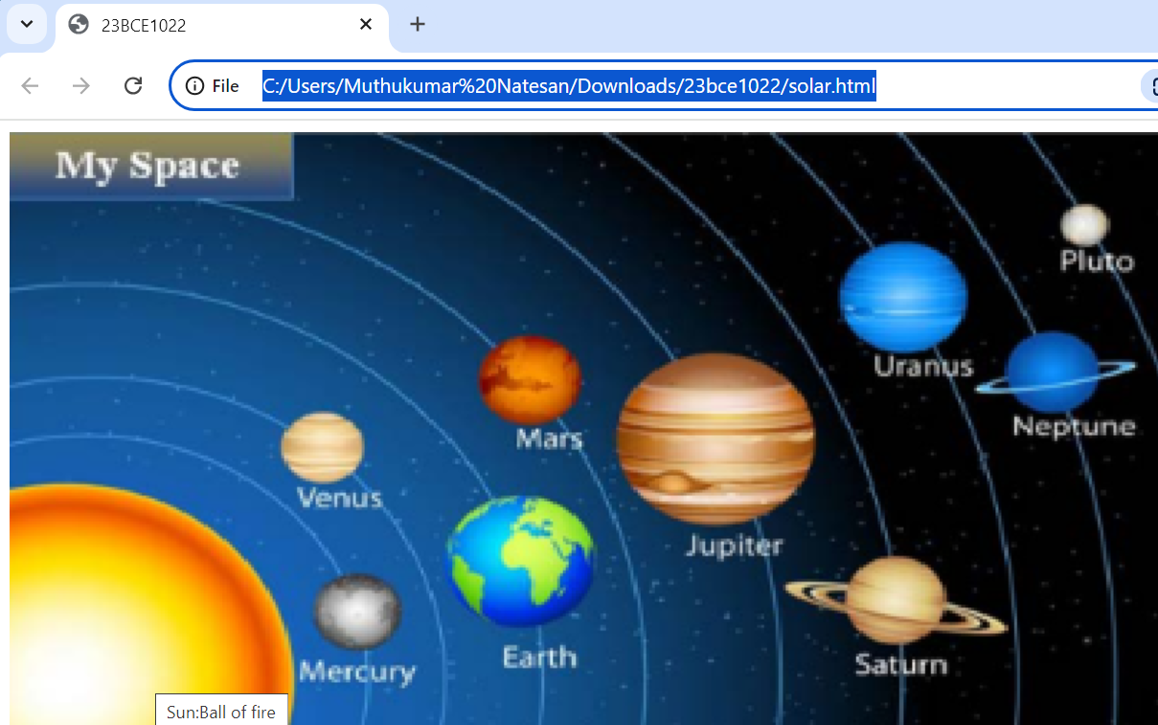

**2. Display your image when clicking on 'MySpace' and provide two sentences about yourself using lists and semantic tags. Spot a portion of your face and attach your signature using image mapping.**

**CODE:**

<!DOCTYPE html>

<html>

<head>

    <title>Spot and Attach Signature</title>

</head>

<body>

    <section>

        <h2>About Me</h2>

        <ul>

            <li>I am a fast learner and when I start something, I like to see things through till the end.</li>

            <li>I love coding, drawing and listening to music. I feel liberated when I perform those activities.</li>

        </ul>

    </section>

    <h3>Click to Attach My Signature</h3>

    <img src="menmangai.jpg" usemap="#me" alt="myself">

    <map name="me">

        <area shape="poly" coords="0,1284,2,1167,87,1131,228,1090,335,1061,371,1036,435,957,381,830,344,817,325,740,301,616,330,591,320,497,326,332,360,257,448,144,569,104,755,121,894,193,971,358,976,448,966,568,988,603,978,678,970,737,958,786,937,818,906,874,922,903,934,971,953,1008,1042,1060,1118,1073,1283,1124,1362,1197,1413,1284" alt="Photo Area" href="signature.jpg">

    </map>

</body>

</html>

**OUTPUT:**

 



