**BCSE203E WEB PROGRAMMMING**

**LAB EXERCISE -5**

**SEMANTIC TAGS, FRAMES AND MEDIA ELEMENTS**

***NAME: M.MENMANGAI***

***REGISTRATION NO: 23BCE1022***

**1. Design a web page using HTML frames to divide it into multiple sections, including a header, navigation, main content, aside, and footer. In the main content frame,**

**create a professional resume using semantic HTML5 tags. Incorporate the following elements:**

**1. <header>: For the top section, showcasing your name, professional title, and a tagline.**

**2. <nav>: To provide navigation links for easy access to various sections of the resume (e.g., About Me, Education, Experience, Skills).**

**3. <section>: To structure key content areas, such as education, work experience, and technical skills.**

**4. <article>: To detail specific achievements, projects, or publications.**

**5. <aside>: To display supplementary information, such as quick facts, a brief profile summary, or links to a portfolio.**

**6. <figure>: To include images (e.g., profile photo or project visuals) with captions. 7. <progress>: To visually represent proficiency levels for different skills.**

**8. <meter>: To highlight measurable achievements, certifications, or milestones. 9. <details> and <summary>: To toggle additional information, such as hobbies, extracurricular activities, or future goals.**

**10. <footer>: To include contact details, social media links, and additional resources.**

**Ensure the page is divided as follows:**

**• The header is displayed in a dedicated frame at the top.**

**• The navigation is shown in a vertical frame on the left.**

**• The main content occupies the central frame.**

**• The aside is placed in a frame on the right for supplementary information.**

**The footer is displayed in a frame at the bottom.**

**Focus on creating a visually appealing, accessible, and well-structured layout. The sample webpage is shown below.**

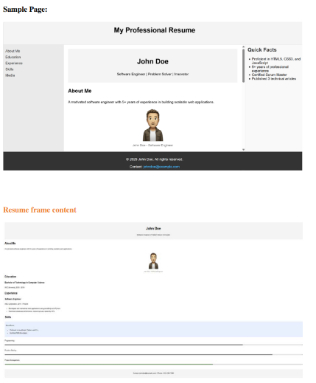

CODE:

**resume.html:**

<!DOCTYPE html>

<html>

<head>

    <title>23BCE1022</title>

</head>

<frameset rows="10%,80%,10%">

    <frame name="top" src="f1.html" noresize="noresize" scrolling="no"/>

    <frameset cols="15%,60%,25%">

        <frame name="left" src="f2.html" noresize="noresize" name="navigation" scrolling="no"/>

        <frame name="center" src="f3.html" noresize="noresize" name="content" scrolling="yes" />

        <frame name="right" src="f4.html" noresize="noresize" scrolling="no" />

    </frameset>

    <frame name="bottom" src="f5.html" noresize="noresize" scrolling="no"/>

</frameset>

</html>

**f1.html:**

<!DOCTYPE html>

<html>

<head>

    <title>23BCE1022</title>

</head>

<body style="background-color:#eaeded">

    <h1 style="text-align: center;">My Professional Resume</h1>

</body>

</html>

**f2.html:**

<!DOCTYPE html>

<html>

<head>

    <title>23BCE1022</title>

</head>

<body style="background-color: #eaeded;font-size: large;">

    <nav>

        <a href="f3.html#aboutMe" target="center">About Me</a><br>

        <a href="f3.html#education" target="center">Education</a><br>

        <a href="f3.html#experience" target="center">Experience</a><br>

        <a href="f3.html#skills" target="center">Skills</a><br>

        <a href="f3.html#AddInfo" target="center">Additional Information</a><br>

        <a href="elements.html" target="center">Media</a><br>

    </nav>

</body>

</html>

**f3.html:**

<!DOCTYPE html>

<html>

<head>

    <title>23BCE1022</title>

</head>

<body>

    <header style="border: 1px solid white;background-color:#e6c329 ;text-align: center;">

        <h2>M Menmangai</h2>

        <h4 style="font-weight: lighter;">Software Engineer | Problem Solver | Innovator |Developer</h4>

    </header>

    <section id="aboutMe">

        <h2><u>About Me</u></h2>

    <p style="font-weight: lighter;">A hard-working Computer Science graduate with a strong foundation in software development, eager to apply my academic knowledge and skills in real-life applications. Excited to contribute innovative solutions and advance my experience in the industry.</p>

    <figure style="margin: 0 auto;text-align: center; ">

        <img src="C:\Users\Muthukumar Natesan\Downloads\23bce1022\menmangai.jpg" width="200px" height="200px">

        <figcaption>M Menmangai- Software Engineer</figcaption>

    </figure>

    </section>

    <section id="education">

        <h2><u>Education</u></h2>

        <h3>Bachelor's Degree in Computer Science (2023-2027)</h3>

        <p>VIT University,Chennai</p>

        <h3>Bachelor's Degree in DataScience and it's Applications (2024-2028)</h3>

        <p>IIT Madras</p>

    </section>

    <section id="experience">

        <h2><u>Experience</u></h2>

        <h3>Internship - Software Development Intern</h3>

        <p>XYZ Technologies, Chennai (May 2024 - July 2024)</p>

        <ul>

            <li>Collaborated with the ABC team to develop a web application.</li>

            <li>Assisted in debugging and testing software, identifying and resolving issues to improve functionality.</li>

            <li>Worked with databases to manage and optimize queries.</li>

        </ul>

        <h3>Academic Projects</h3>

        <p>University Projects during Bachelor's Degree</p>

        <ul>

            <li>Developed a website as a project to enhance my HTML, CSS, and JavaScript skills.</li>

            <li>Worked on a group project to create a simple e-commerce platform using Python and Django.</li>

        </ul>

    </section>

    <section id="skills">

        <h2><u>Skills</u></h2>

        <h3>Profeciency level for Skills</h3>

        HTML&nbsp<progress value="75" max="100"></progress><br>

        CSS&nbsp<progress value="65" max="100"></progress><br>

        JavaScript&nbsp<progress value="60" max="100"></progress><br>

        Python&nbsp<progress value="80" max="100"></progress><br>

    </section>

    <section>

        <h3>Certifications and Achievements</h3>

        <p>Certified Python Developer</p>

        <meter value="90" min="0" max="100" low="50" high="80" optimum="90"></meter>

        <p>AWS Certified Solutions Architect</p>

        <meter value="75" min="0" max="100" low="50" high="80" optimum="90"></meter>

    </section>

    <article>

        <h3>Programming</h3>

        <p>C,C++,Java,Python,HTML,CSS,JavaScript,SQL</p>

    </article>

    <article>

        <h3>Problem Solving</h3>

        <p>Analyze the problem well and provide fast and low-impact solutions for the same. </p>

    </article>

    <article >

        <h3>Project Management Skills</h3>

        <p>Managed 10+ projects</p>

    </article>

    <section id="AddInfo">

        <h3><u>Additional Information</u></h3>

        <details>

            <summary>Hobbies</summary>

            <ul>

                <li>Drawing</li>

                <li>Coding in competitive sites</li>

                <li>Reading newspapers</li>

            </ul>

        </details>

        <details>

            <summary>Extracurricular Activities</summary>

            <ul>

                <li>Participated in  hackathons and won prizes</li>

                <li>Participated in public speaking competitions</li>

                <li>Volunteered for community events</li>

            </ul>

        </details>

        <details>

            <summary>Future Goals</summary>

            <p>I aim to develop open-source projects to help the community.</p>

        </details>

    </section>

    <footer style="border: 2px solid white;text-align: center;background-color: rgb(218, 142, 50);">

        <p>Contact menmangai.m2023@vitstudent.ac.in | Phone +91 63744 72496</p>

    </footer>

</body>

</html>

**f4.html:**

<!DOCTYPE html>

<html>

<head>

    <title>23BCE1022</title>

</head>

<body style="background-color: #eaeded;font-size: medium;">

    <aside>

        <h1>Quick facts</h1>

    <ul>

        <li>Profecient in HTML5,CSS3,JavaScript,C,C++,Python</li>

        <li>Managed 10+ projects</li>

        <li>Certified Software Engineer</li>

        <li>Published 3 research papers</li>

    </ul>

    </aside>

</body>

</html>

**f5.html:**

<!DOCTYPE html>

<html>

<head>

    <title>23BCE1022</title>

</head>

<body style="background-color: rgb(56, 54, 54);text-align: center;">

    <h5 style="color: white;"> 2025 M Menmangai. All rights reserved</h5>

    <h5 style="color: white;">Contact: <a href="mailto:menmangai.m2023@vitstudent.ac.in">menmangai.m2023@vitstudent.ac.in</a></h5>

</body>

</html>

**OUTPUT:**

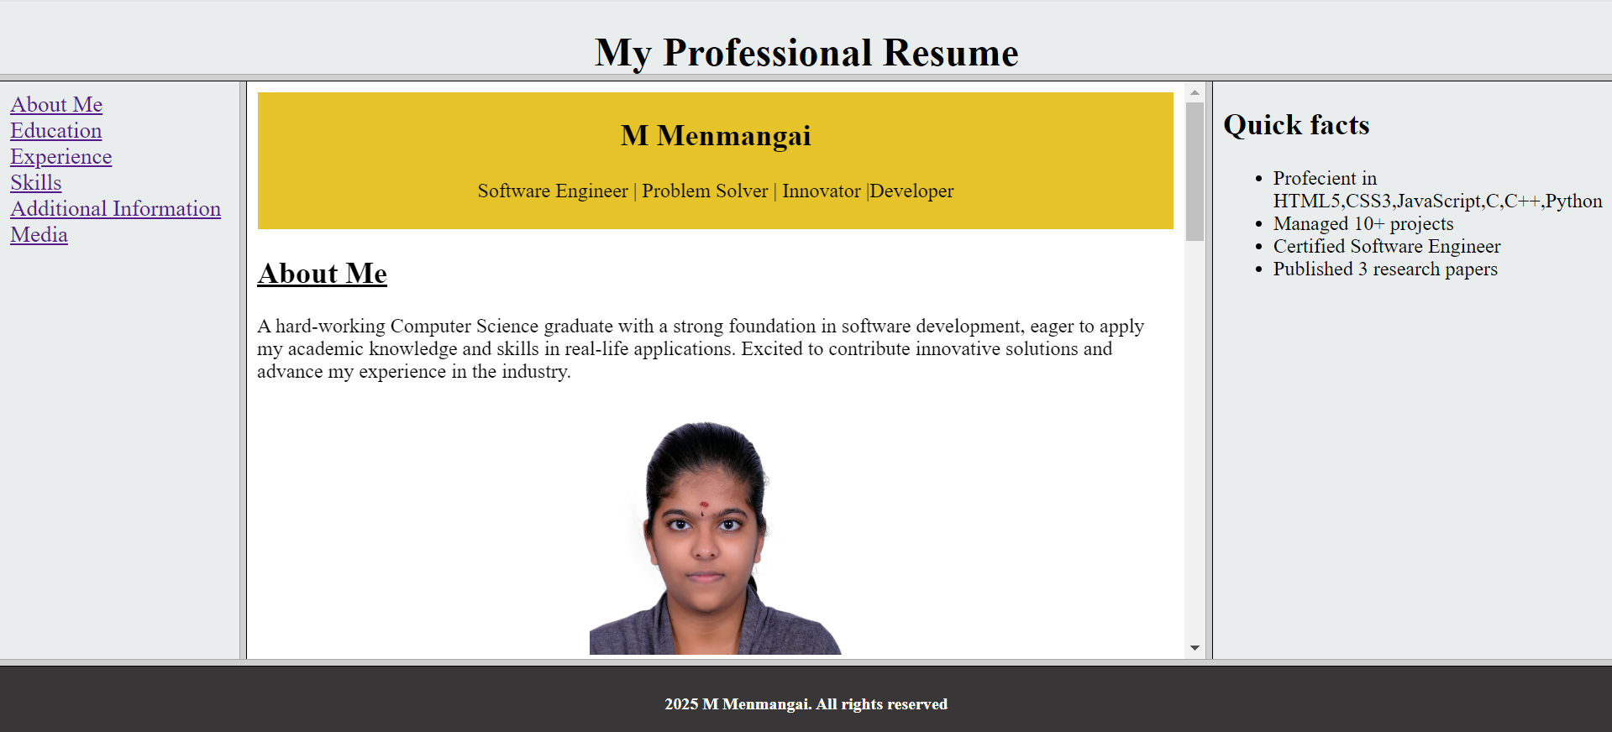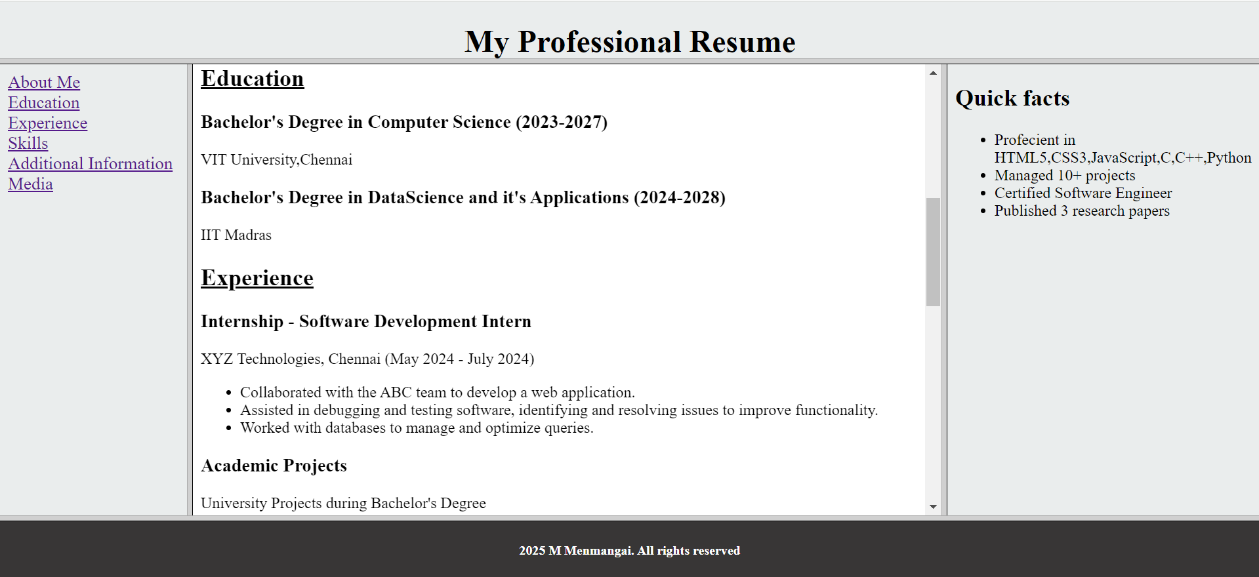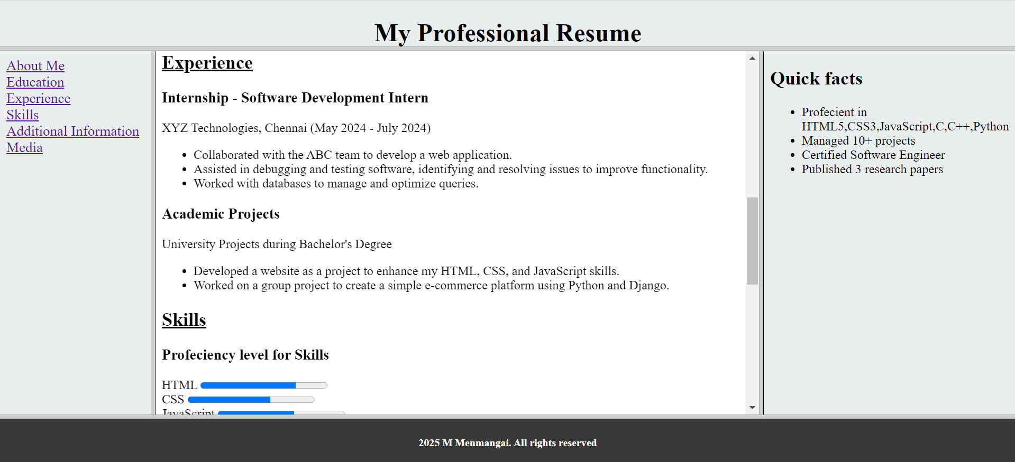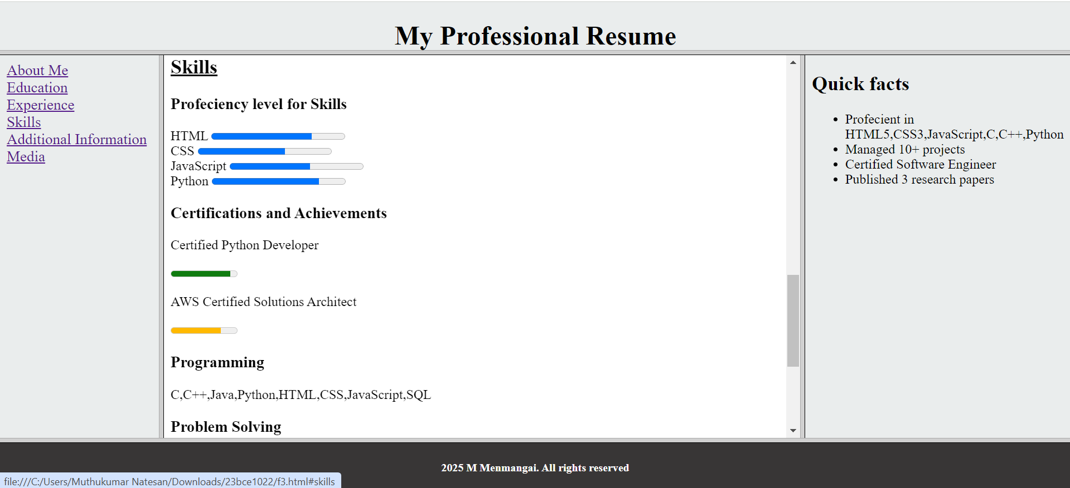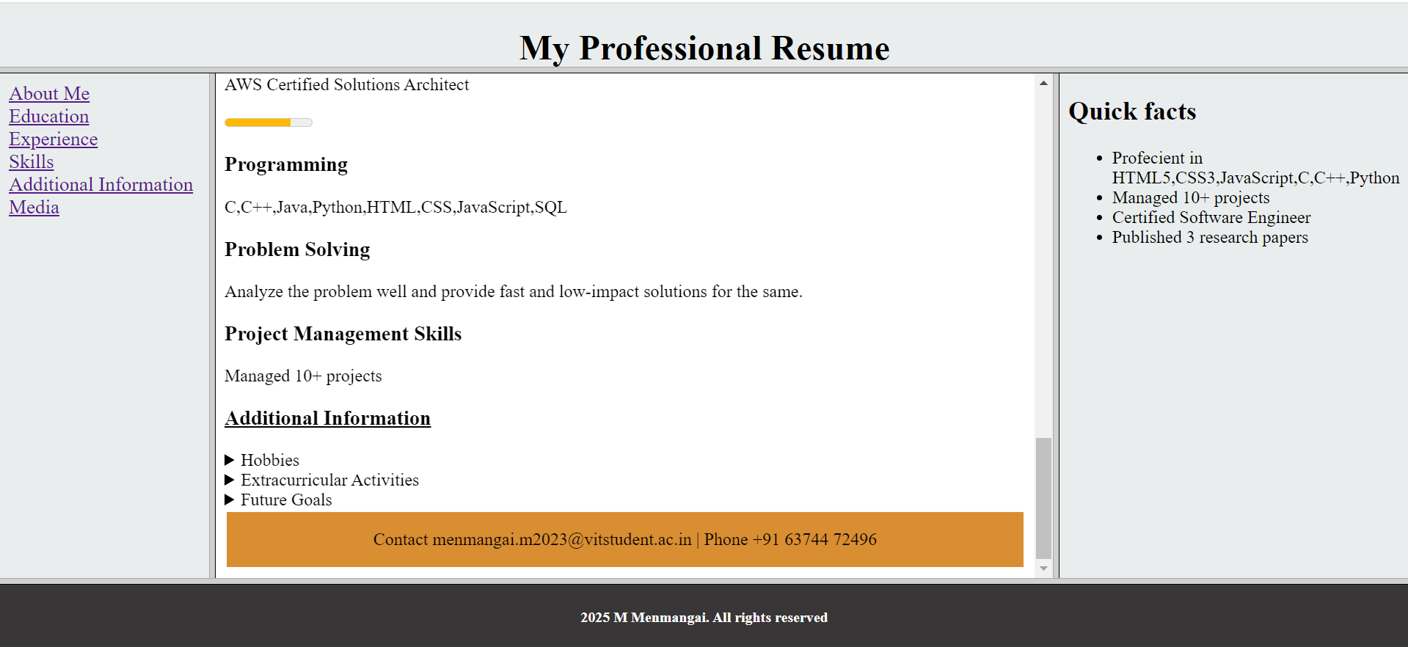

**2. Display media and graphic elements (given below) on the centre frame by clicking the navigation link Media (Audio, Video, SVG and Canvas). Use iframe for displaying SVG**

CODE:

**elements.html:**

<!DOCTYPE html>

<html>

<head>

    <title>23BCE1022</title>

</head>

<frameset cols="50%,70%">

    <frame name="top" src="f6.html" noresize="noresize" />

    <frame name="bottom" src="f7.html" noresize="noresize" />

</frameset>

<body>

</body>

</html>

**f6.html:**

<!DOCTYPE html>

<html>

<head>

    <title>23BCE1022</title>

</head>

<body>

    <h2><u>Audio</u></h2>

    <audio controls>

        <source src="C:\Users\Muthukumar Natesan\Downloads\23bce1022\rhythm-alchemy-274968.mp3" type="audio/mp3">

    </audio>

    <br>

    <h2><u>Video</u></h2>

    <video id="myvid" width="350" height="200" controls>

        <source src="C:\Users\Muthukumar Natesan\Downloads\23bce1022\12924539_1080_1920_24fps.mp4" type="video/mp4">

    </video>

    <br>

    <h2>Canvas</h2>

    <canvas id="myCanvas" width="350" height="200" style="border:1px solid #000000;background: linear-gradient(to bottom, #b9832c, #e4a9c3);">

    </canvas>

    <script>

        const canvas = document.getElementById("myCanvas");

        const ctx = canvas.getContext("2d");

        const canvasWidth = canvas.width;

        const canvasHeight = canvas.height;

        const laptopX = canvasWidth / 2 - 100;

        const laptopY = canvasHeight / 2 - 50;

        ctx.fillStyle = "grey";

        ctx.fillRect(laptopX, laptopY, 200, 100);

        ctx.fillStyle = "black";

        ctx.fillRect(laptopX + 5, laptopY + 5, 190, 90);

        ctx.fillStyle = "grey";

        ctx.fillRect(laptopX - 30, laptopY + 100, 260, 10);

        ctx.beginPath();

        ctx.globalAlpha = 0.6;

        const centerX = laptopX + 100;

        const centerY = laptopY + 50;

        const radius = 30;

        ctx.arc(centerX - radius * 0.2, centerY, radius, 0, 2 * Math.PI);

        ctx.fillStyle = "yellow";

        ctx.fill();

        ctx.beginPath();

        ctx.arc(centerX + radius * 0.2, centerY, radius, 0, 2 * Math.PI);

        ctx.fillStyle = "yellow";

        ctx.fill();

        ctx.globalAlpha = 1.0;

    </script>

</body>

</html>

**f7.html:**

<!DOCTYPE html>

<html >

<head>

    <title>23BCE1022</title>

</head>

<body>

    <h1>My House using SVG</h1>

    <svg width="1000" height="1000">

        <rect x="75" y="150" width="280" height="220" style="fill:#836c5d; stroke-width:3; stroke:rgb(18, 8, 8);" />

        <rect x="110" y="180" width="40" height="40" style="fill:rgb(118, 216, 133); stroke-width:3; stroke:black;" />

        <rect x="285" y="180" width="40" height="40" style="fill:aqua; stroke-width:3; stroke:black;" />

        <polygon points="75,150 215,40 355,150" style="fill:red; stroke-width:3; stroke:black;" />

        <rect x="180" y="250" width="80" height="120" style="fill:#c2e01b; stroke-width:3; stroke:black;" />

        <rect x="170" y="360" width="100" height="20" style="fill:rgb(168, 40, 40); stroke-width:3; stroke:black;" />

        <rect x="180" y="350" width="80" height="10" style="fill:rgb(218, 9, 113); stroke-width:3; stroke:black;" />

        <circle cx="210" cy="110" r="20" stroke="black" stroke-width="4" fill="yellow" />

        <polygon points="450,70 460,100 430,85 470,85 440,100" style="fill:yellow; stroke-width:2; stroke:black;" />

        <circle cx="505" cy="80" r="18" fill="yellow" stroke-width="2" stroke="black"/>

        <circle cx="520" cy="80" r="20" fill="white" />

      </svg>

      <iframe src="home.svg" width="1000" height="1000" style="border: none;"></iframe>

</body>

</html>

**home.svg:**

<svg width="1000" height="1000">

  <rect x="75" y="150" width="280" height="220" style="fill:#873600; stroke-width:3; stroke:black;" />

  <rect x="110" y="180" width="40" height="40" style="fill:aqua; stroke-width:3; stroke:black;" />

  <rect x="285" y="180" width="40" height="40" style="fill:aqua; stroke-width:3; stroke:black;" />

  <polygon points="75,150 215,40 355,150" style="fill:red; stroke-width:3; stroke:black;" />

  <rect x="180" y="250" width="80" height="120" style="fill:#641e16; stroke-width:3; stroke:black;" />

  <rect x="170" y="360" width="100" height="20" style="fill:grey; stroke-width:3; stroke:black;" />

  <rect x="180" y="350" width="80" height="10" style="fill:grey; stroke-width:3; stroke:black;" />

  <circle cx="210" cy="110" r="20" stroke="black" stroke-width="4" fill="yellow" />

  <polygon points="450,70 460,100 430,85 470,85 440,100" style="fill:yellow; stroke-width:2; stroke:black;" />

  <circle cx="505" cy="80" r="18" fill="yellow" stroke-width="2" stroke="black"/>

  <circle cx="520" cy="80" r="20" fill="white" />

</svg>

**OUTPUT:**



